**Student:** Giusppe Esposito

**Student number:** 22702705

**-Structure of the Facts:**

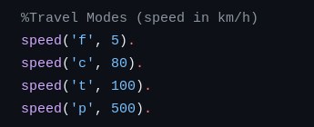

These facts defines the speed for each travel mode:

-’f’ stands for on foot, with speed 5 km/h

-’c’ stands for by car, with speed 80 km/h

-’t’ stands for by train, with speed 100 km/h

-’p’ stands for by plane, with speed 500 km/h.

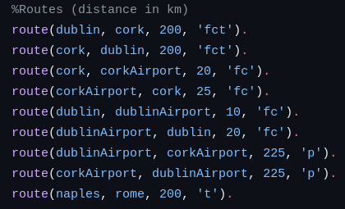

Each route facts of this form:

**route(PointA, PointB, Dist, TravelMode).**

-Establish a direct one way connection from **PointA** to **Point B**,

-The distance of this connection is **Dist** (an integer in Km),

-And travel modes that we can use are the characters in **TravelMode.**



The set of previous facts roughly represents this graph above.

So there is a circle between Points ( Dublin, Dublin-airport, Cork and Cork-airport), and then two detached points (Naples and Rome).

**-Structure of the Predicates and Rules:**

The goal of the program is to *“Write a Prolog predicate journey(S, D, M) that calculates the quickest journey between S and D only using the travel modes included in the string M. Your predicate must be able to handle cycles in a set of facts.”*

**-This is the main predicate:**

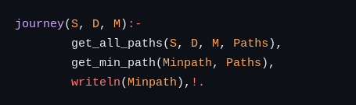

This predicate use:

**get_all_paths(S, D, M, Paths)**: to get a list of all the paths called **Paths** where each element is of the form [time, path], where time is the time needed to travel the path, and path is the list of points that leads you from S (start) to D (destination).

**get_min_path(Minpath, Paths)**: to get the quickest path **MinPath**, by selecting the element with the smallest time.

**writelen(Minpath)**: And finally it prints the Minpath.

**-How does get_all_paths work?**



It just uses the built-in function [findall](https://www.swi-prolog.org/pldoc/man?predicate=findall/3), to fill the variable **Paths** with all the returned result from **build_path()** predicate.

**-How does build_path work?**

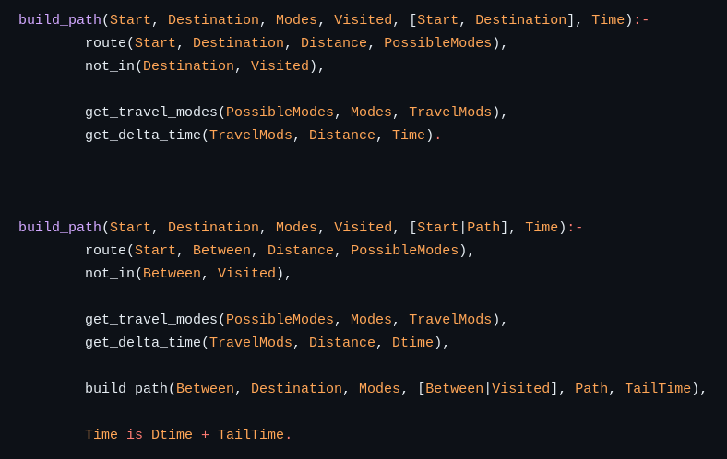

The general from of this predicate is

**build_path(Start, Destination, Modes, Visited, Path, Time):**

**Start** is the point where we start;

**Destination** is the point that we want to reach;

**Modes** are the travel Modes that we can use;

**Visited** is a list to store all the place already visited to avoid loop, due to cycle in the graph, we start that as **[Start],** than we update it;

**Path** is a list of all the point that we go through to get to our Destination;

**Time** is the amount of time needed to walk **Path**.

This predicate is divided in two rules:

1)The first is the base case, where there is a direct link between the **Start** and **Destination** (see first line), defined by a route fact in the datPathabase.

First it updated the **Path** so it became [Start, Destination].

The route() call gives us access to the **Distance** between Start and Destination and **PossibleModes** that we can use.

Then we check if the **Destination** is already visited to avoid a loop using **not_in()**.

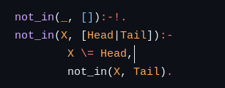

Then we get a list of characters that represent all the possible travel modes called **TravelModes**, by using **get_travel_modes()**, this predicate just take the intersection of the modes that we want to use (**Modes**), and the modes that we need to use (**PossibleModes**), and store that in the list **TravelModes**. And it fails if there is no intersection. *Because for example if I want to use a plane to go from A to B, but the only way allowed is on foot, I can't go there.*

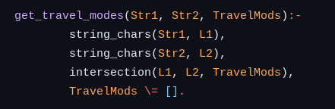

In the end we set the variable **Time** using

**get_delta_time(TravelModes, distance, Time)**, that is just calculating the time to go from Start to Destination, using the quickest TravelMode speed, get with **get_max_speed()**.

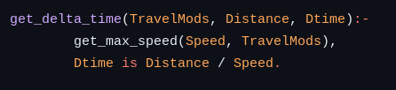

We are setting and not updating the **Time** variable because we are in the base case, so the last recursion call before starting go back, during the backtracking we are going to update **Time**. This technique is the opposite one that we use to build the **Path.** In fact, we update the path before the recursion call.

Therefore in the last call (the base case) the **Path** is already complete.

2)The second is the recursive where there is no direct link between **Start** and **Destination**

The approach is:

-we search for some point **Between**,that is directly reachable from **Start**,

-we do the same check and get the data as Time is Dtime + TailTime.in the base case (**not_in()**, **get_travel_modes()**, **get_delta_time()**)

-Then we recall the function to search if there is a link from **Between** to **Destination**

NOTE: that we are updating the path before the recursive call in fact is becomes **[Start, Path]**, where **Path** is whatever is going to return the recursive call,

and we are updating the **Time** after the recursive call: **Time is Dtime + TailTime.**

**-How does get_min_path work and get_max_speed?**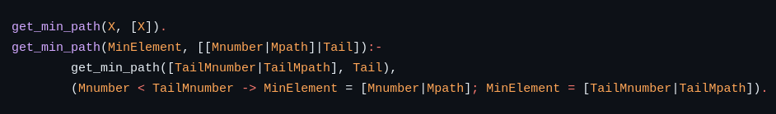

Given a list of elements [Time, Path], it gives you the element with the smaller time, so the quickest.

It works with the assumption that the minimum element of a list composed of just one element is the element itself.

Then we just simplify the problem by saying that the minimum element (**MinElement**) between head and tail is whatever is less between the value of Time in the head(**Mnumber**), and the minimum of the Tail(**TailMnumber**)

.

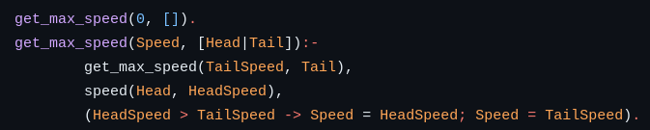

It basically uses the same strategy of **get_min_path()**, but the assumption is that the max element in an empty list is 0, and then it checks for the greater value.

**-Reference:**

Everything in this file is considered my own work with the except of the following resources:

**[1]“SWI-Prolog -- findall/3,” *www.swi-prolog.org*.** [**https://www.swi-prolog.org/pldoc/man?predicate=findall/3**](https://www.swi-prolog.org/pldoc/man?predicate=findall/3) **(accessed Apr. 05, 2024).**

**[2]“SWI-Prolog -- -%3E/2,” *www.swi-prolog.org*.** [**https://www.swi-prolog.org/pldoc/man?predicate=-%3E/2**](https://www.swi-prolog.org/pldoc/man?predicate=-%3E/2) **(accessed Apr. 05, 2024).**

**[3]“SWI-Prolog -- string_chars/2,” *Swi-prolog.org*, 2020.** [**https://www.swi-prolog.org/pldoc/man?predicate=string_chars/2**](https://www.swi-prolog.org/pldoc/man?predicate=string_chars/2) **(accessed Apr. 05, 2024).**

**‌[4]W. F. Clocksin and C. S. Mellish, *Programming in Prolog*. Berlin ; New York: Springer-Verlag, 2003.**

**‌[5]“Prolog Guide - Metainterpreters,” *kti.ms.mff.cuni.cz*.** [**http://kti.ms.mff.cuni.cz/~bartak/prolog/graphs.html#dijkstra**](http://kti.ms.mff.cuni.cz/~bartak/prolog/graphs.html#dijkstra) **(accessed Apr. 05, 2024).**

**[6]“Find the shortest path in between nodes,” *SWI-Prolog*, May 12, 2020.** [**https://swi-prolog.discourse.group/t/find-the-shortest-path-in-between-nodes/2315/3**](https://swi-prolog.discourse.group/t/find-the-shortest-path-in-between-nodes/2315/3) **(accessed Apr. 05, 2024).**

**‌**

**‌**

**‌**

**‌**