CHAPTER I
PROJECT CONTEXT AND RESEARCH DESIGN

Rationale of the Study
Land use decisions shape the safety, sustainability, and future of every community. In Cebu City, the agency responsible for ensuring those decisions are made responsibly is the Community Environment and Natural Resources Office (CENRO), located at Pier 3, Cebu City, a field office of the Department of Environment and Natural Resources (DENR) that processes tree cutting permits, land clearing permits, and development clearances for the entire city. Situated in one of the most rapidly urbanizing and disaster-exposed provinces in the Philippines, CENRO handles applications involving land areas that may overlap with flood zones, landslide-prone slopes, protected forests, and legally mandated river easements, making the accuracy and consistency of every permit decision a matter of genuine public consequence.
Despite the significance of its mandate, the office currently utilizes a predominantly manual and paper-based permit evaluation process which, while functional, has not yet fully incorporated digital and geospatial tools that can enhance environmental risk assessment. Applications are submitted and processed through traditional workflows, and site evaluations are conducted without an automated system for verifying whether locations intersect with hazard or restricted zones (Calo Juros & Lim, 2025). Although spatial risk data is available from agencies such as NAMRIA, MGB, and PAGASA, its application remains dependent on the evaluating officer’s experience and familiarity with local conditions rather than a standardized geospatial analysis framework (Lagmay et al., 2017). There is also no unified digital platform to centralize records, standardize hazard assessments, or maintain a fully traceable history of permit decisions.
The challenge of integrating geospatial hazard data into regulatory permit workflows is widely documented. Even in well-resourced planning contexts, spatial decision support systems remain largely research-oriented rather than operational tools embedded in day-to-day government processes (Esmail and Geneletti, 2020). Across municipalities in multiple countries, most building permit systems have not integrated GIS-based spatial compliance checks into their workflows, resulting in decisions that remain dependent on manual assessment, a condition associated with longer processing times, inconsistent outcomes, and limited audit accountability (Aljobaly, Abdulaal, and Maatouk, 2025). Furthermore, without automated spatial hazard classification embedded in permit processing, risk-based land-use decisions are difficult to standardize and defend (Mohammed, Hussein, and Abood, 2024; Parsian et al., 2021).
These findings establish that the gap between available geospatial technology and its operational use in permit evaluation is a recognized global challenge in environmental governance.
In the Philippines, this gap is equally present despite national investments in geospatial infrastructure. Through Project NOAH, LiDAR-derived hazard maps have been produced and disseminated across the archipelago; however, their application within frontline permit evaluation at the local government level remains limited and largely manual (Lagmay et al., 2017). At the CENRO level, even in offices that have adopted digital land records management systems, spatial risk data from NAMRIA is not systematically applied to individual permit applications. Instead, decisions continue to rely on officers’ familiarity with local conditions rather than a standardized geospatial analysis framework (Calo-Juros and Lim, 2025). This results in processing times that vary across applications, inconsistent risk assessments, and permit records that are difficult to audit or defend (Calo-Juros & Lim, 2025; Lagmay et al., 2017).
At the local level, CENRO Cebu City operates an established permit evaluation process that is compliant with existing regulatory requirements. However, the process relies on manual, paper-based workflows in which permit applications are submitted physically, evaluated without automated spatial verification, and tracked through non-digitized records. Each application requires the evaluating officer to manually cross-check the proposed project location against known hazard conditions, a process dependent on individual knowledge rather than a standardized system, resulting in longer processing times (Calo-Juros & Lim, 2025). Applications that could be immediately flagged by an automated hazard classification system instead await manual review, while the absence of a centralized digital platform leaves records, evaluation histories, and decision trails fragmented and difficult to consolidate. The increasing frequency of flooding and landslide events in Cebu and nearby provinces in 2022 and 2024, which resulted in casualties and displacement, further underscores the urgency of addressing this gap (ReliefWeb, 2024; Pacheco et al., 2025).
It is in response to this gap, observed across international, national, and local contexts, that GeoPermit was developed. GeoPermit is a web-based geospatial land permit evaluation system designed to complement and strengthen the existing process at CENRO. By digitizing the permit submission workflow, automating spatial hazard cross-referencing, and providing a centralized evaluation dashboard with audit trails and spatial reports, GeoPermit addresses key limitations: prolonged processing time, variability in assessment, and fragmented record-keeping. With GeoPermit, a permit application that would otherwise take hours or days to manually screen against hazard data can be classified within seconds of coordinate submission, reducing workload, shortening processing time, and producing a documented and traceable permit decision record.

Background of the Study
The management of land use and environmental permits is among the most critical responsibilities of local government units in the Philippines. As the country continues to experience rapid urbanization, particularly in highly exposed provinces like Cebu, the demand for a permit evaluation process that is both efficient and environmentally responsive has grown significantly. CENRO, as a field unit of the DENR, sits at the center of this responsibility. CENRO is mandated to evaluate and approve land-use permit applications, including tree cutting permits, land clearing permits, and development clearances, ensuring that each approved activity complies with environmental regulations, particularly in areas that are ecologically sensitive or prone to natural hazards (DENR, 2022).
Currently, CENRO handles these applications through a manual, paper-based evaluation process. Applicants need to submit physical documents and personally coordinate with the office, while CENRO personnel review the requirements and conduct on-site inspections when necessary. Although this process is functional and follows existing regulatory requirements, it does not use an integrated digital system for spatial data management and automated hazard analysis. These capabilities have become increasingly important as the number of permit applications continues to grow and the risks of uninformed land-use approvals become more evident (RA No. 10121, 2010). The process has no automated way to compare proposed project locations with official hazard boundary datasets. As a result, each risk assessment often depends on the evaluating officer’s knowledge and familiarity with local conditions rather than a standardized geospatial framework (Calo-Juros & Lim, 2025). This reliance can lead to inconsistent evaluations and longer processing times compared to what an automated system could provide (Aljobaly et al., 2025).
The limitations of manual permit evaluation workflows are not unique to CENRO Cebu City, they reflect a documented pattern observed at both national and international levels. Even in CENRO offices that have adopted digital land records management systems, spatial risk data from national agencies such as NAMRIA and the Mines and Geosciences Bureau (MGB) remains systematically unused in individual permit evaluations, with decisions continuing to rely on officer judgment rather than validated geospatial datasets (Calo-Juros and Lim, 2025). Across municipalities in multiple countries, most building permit systems have not meaningfully integrated GIS-based spatial compliance checks into their evaluation workflows, a gap consistently associated with longer processing times, inconsistent outcomes, and limited audit accountability (Aljobaly, Abdulaal, and Maatouk, 2025). These findings confirm that the challenges facing CENRO Cebu City are part of a broader, well-documented gap between available geospatial technology and its operational use in regulatory permit processes.
The urgency of addressing this gap is underscored by the increasing frequency and intensity of natural disasters in the Philippines. Cebu City and its surrounding areas have experienced repeated flooding and landslide incidents, including severe events in 2022 and 2024 that resulted in casualties and widespread displacement (ReliefWeb, 2024). These incidents highlight the real-world consequences of permit decisions made without adequate spatial risk assessment developments approved in hazard-prone or ecologically restricted areas that later become sources of vulnerability for the communities that inhabit them. The recurrence of such events in the Philippines reflects systemic gaps in land-use governance that must be addressed through more systematic, data-driven approaches to permit evaluation at the local government level (Pacheco et al., 2025).
In response to these challenges, Geographic Information Systems (GIS) have emerged as powerful and proven tools for improving environmental decision-making in regulatory contexts. GIS enables the integration, visualization, and analysis of geographic data, providing planners and regulators with objective, spatially explicit insights that manual review processes cannot consistently produce. The integration of remote sensing and GIS technologies has significantly enhanced environmental assessment by offering near-real-time data on land cover, hazard susceptibility, and ecological conditions (Singh & Bhadauria, 2024). Web-based GIS platforms in particular offer accessible and scalable solutions that allow real-time spatial analysis without requiring specialized desktop software, making them well-suited for integration into frontline government permit workflows (Lagmay et al., 2017). Technologies such as Leaflet.js, OpenStreetMap, PostgreSQL with PostGIS, Turf.js, and GeoJSON have made it possible to develop full-featured geospatial systems within standard web environments, with recent studies confirming the effectiveness of spatial data-driven screening in environmental decision-making (Cilliers et al., 2022).
It is within this context that GeoPermit was conceived and developed. GeoPermit: An Intelligent Geospatial-Based Land Permit Evaluation and Automated Hazard Classification System for Environmental Risk Management is a web-based geospatial platform designed to modernize and strengthen the land-use permit evaluation process of CENRO Cebu City by building upon, not replacing the established workflows already in place. The system enables applicants to submit permit applications digitally and identify project locations through an interactive map interface. Once coordinates are submitted, GeoPermit automatically analyzes them against official hazard and environmental restriction datasets, including flood zones, landslide-prone areas, protected forests, and river easements, and generates a color-coded risk classification of Low, Moderate, or High Risk (Nilo et al., 2023; Balistoy et al., 2022). Applications identified as restricted are automatically flagged, while eligible submissions are routed to a dedicated CENRO officer evaluation dashboard complete with spatial reports, audit trail records, and a full history of how each permit decision was reached (UP NOAH Center, 2017). By automating the most time-consuming and inconsistency-prone step in the current workflow, the spatial risk assessment, GeoPermit directly reduces processing time, lessens the administrative workload of evaluating officers, and provides the standardized, traceable, and defensible permit evaluation process that CENRO Cebu City and the communities it serves require.

Objectives of the Study
The general objective of this study is to design, develop, and evaluate GeoPermit, a web-based geospatial land permit evaluation and automated hazard classification system, to support CENRO Cebu City in processing environmentally sensitive land-use permit applications with greater accuracy, efficiency, and transparency. Specifically, this study aims to:
- Analyze the existing land permit evaluation workflow of CENRO Cebu City and identify key operational and environmental risk assessment gaps.
- Design and implement a digital permit submission module that allows applicants to submit land-use applications and pinpoint project locations via an interactive web map.
- Develop a geospatial analysis engine that cross‑references submitted coordinates against official hazard datasets sourced from NAMRIA, MGB, PAGASA, DENR, and GeoRisk Philippines, including flood zones, landslide‑prone areas, protected forests, and river easements (Aljobaly et al., 2025).
- Develop and implement a rule‑based hazard classification algorithm that applies spatial functions (e.g., ST_Within, ST_Intersects) to assign color‑coded risk levels (Low, Moderate, High) to permit applications based on validated spatial analysis results (Parsian et al., 2021).
- Build a CENRO officer evaluation dashboard with spatial reports, application queuing, and audit trail functionality to support informed decision-making.
- This study utilizes the ISO/IEC 25010:2023 framework to assess the quality of the GeoPermit system.

Scope and Limitation of the Study
This study focuses on the design, development, and evaluation of GeoPermit, a web-based geospatial land permit evaluation and automated hazard classification system developed for the Community Environment and Natural Resources Office in Cebu City. The system aims to improve the efficiency, transparency, and accuracy of the land permit evaluation process through digital permit submission and automated spatial hazard assessment.

Scope of the Study
- Workflow Assessment Module
The study includes a workflow analysis component that:
1.1 Reviews the existing land permit evaluation process at CENRO Cebu City
1.2 Identifies operational inefficiencies and environmental risk assessment gaps
1.3 Documents baseline requirements to guide the design of GeoPermit
1.4 Provides the foundation for aligning system features with real-world workflows
- Permit Application and User Module
The system enables applicants to:
2.1 Register and log into the system
2.2 Start new land permit applications through an online request form
2.3 Identify project location using an interactive web-based map
2.4 View the hazard classification results of selected location
2.5 System generates required document checklist
2.6 Submit Final application
2.7 System generates tracking number
2.8 Schedule appointment
2.9 Track applications status
- GIS-Based Hazard Analysis Module
The system incorporates a geospatial analysis component that:
3.1 Integrates hazard datasets such as flood zones, landslide-prone areas, protected forests, and river easements.
3.2 Performs spatial intersection analysis between submitted coordinates and hazard datasets
3.3 Generates automated hazard classification levels (Low, Moderate, High Risk)
3.4 Displays hazard layers and risk indicators on the interactive map interface
- CENRO Evaluation Dashboard
The system allows CENRO officers to:
4.1 Log into the administrative dashboard
4.2 Review submitted land permit applications
4.3 View mapped project locations through the geospatial interface
4.4 Access automatically generated hazard classification results
4.5 Approve, reject, or request revisions for permit applications
4.6 Generate spatial reports related to permit evaluations
4.7 Maintain audit trail records of permit decisions
- System Administration Module
The system includes administrative functions that:
5.1 Manage user accounts and access privileges
5.2 Maintain hazard datasets and spatial layers
5.3 Monitor system activities and application records
5.4 Generate system reports and permit statistics

Limitations of the Study
- The system utilizes preloaded hazard datasets and does not include real-time environmental monitoring or hazard detection capabilities.
- The system is specifically designed for the operations of CENRO Cebu City and is not intended for deployment in other regional or national offices without further customization.
- The accuracy of hazard classification is dependent on the availability and quality of government-provided geospatial datasets.
- The system operates as a web-based platform and therefore requires a stable internet connection for optimal performance.
- The system functions as a decision support tool and does not automate permit approval processes, as final decisions remain under the authority of CENRO officers.
- In terms of data privacy, the system handles personally identifiable information (PII), including applicant and land parcel data. While data protection principles aligned with the Data Privacy Act of 2012 (RA 10173) are considered in the system design, the full implementation of comprehensive data privacy frameworks and institutional compliance mechanisms is beyond the scope of this study and is expected to be managed by the implementing agency.

Significance of the Study
The development of GeoPermit carries significant implications for multiple stakeholders involved in or affected by the land permit evaluation process in Cebu City and, by extension, other CENRO jurisdictions across the Philippines.
For CENRO Cebu City, the system provides a direct operational benefit by automating the most labor-intensive and error-prone aspect of permit evaluation, namely, the spatial assessment of environmental risk. By reducing manual workloads and consolidating permit data within a single digital platform, GeoPermit allows CENRO officers to focus on substantive regulatory review rather than administrative processing, thereby improving the overall quality and consistency of permit decisions.
For permit applicants, GeoPermit introduces a transparent and accessible submission process that eliminates the need for multiple office visits, provides immediate spatial feedback on the environmental risk profile of their proposed project site, and offers a clear, trackable record of their application status. This transparency can reduce disputes and build greater public trust in the permit evaluation process.
For local communities and the broader public, the system’s automated hazard classification mechanism serves as an additional safeguard against the approval of developments in environmentally vulnerable or restricted areas. By systematically flagging applications in flood zones, landslide-prone areas, and ecologically sensitive zones, GeoPermit contributes directly to disaster risk reduction and environmental conservation efforts in Cebu City (Balistoy et al., 2022; Jacinto et al., 2023; Nilo et al., 2023; Republic Act No. 10121, 2010).
For policymakers, DENR regional/national offices, and LGU planners, GeoPermit provides a replicable framework for integrating geospatial hazard datasets into regulatory workflows. The system’s reporting and audit trail functions can support evidence-based policymaking, enhance compliance monitoring, and inform land-use planning decisions at both local and national levels. By aligning with existing mandates under the DENR and disaster risk reduction policies, GeoPermit demonstrates how digital governance tools can strengthen institutional capacity and improve environmental regulation.
For the academic community and future researchers, this study contributes to the growing body of literature on the application of geospatial information systems in public sector governance, environmental management, and e-government development in developing countries (Esmail & Geneletti, 2020; Fedra, 1993). It also demonstrates a replicable framework for integrating open-source GIS technologies into regulatory workflows, which may inform future capstone research, policy studies, or system development initiatives.

RESEARCH DESIGN

Method
This study adopts a developmental research design, which is appropriate for projects that aim to design, construct, and evaluate a functional information system prototype. Beyond producing a working system, developmental research emphasizes documenting the processes, decisions, and evaluations that shape the product, making it well-suited for a capstone study. The primary objective is to develop GeoPermit as a functional, evaluable system and assess its effectiveness in addressing land permit evaluation gaps at CENRO Cebu City, Pier 3.
A mixed-methods approach was employed, combining quantitative data from structured survey questionnaires with quantitative and qualitative insights from observation, stakeholder consultation, and user feedback during system testing. The quantitative component measures performance using the framework ISO/IEC 25010: 2023 is an internationally recognised standard that provides a comprehensive framework for evaluating software product quality. It defines a structured model that categorises software quality into nine key characteristics: functional suitability, performance efficiency, compatibility, usability, reliability, security, maintainability, safety, and portability (ISO, 2023). While the qualitative component captures contextual insights on workflow alignment and user experience that numerical scores alone cannot represent.
The developmental process follows the Agile Software Development methodology, an iterative and incremental SDLC model that prioritizes adaptability, stakeholder collaboration, and progressive delivery. GeoPermit’s modular architecture aligns with Agile’s sprint-based cycle, allowing each module to be planned, designed, developed, tested, reviewed, and deployed before moving to the next. Agile also accommodates evolving geospatial datasets from agencies like NAMRIA, MGB, PAGASA, DENR, and GeoRisk Philippines, while its embedded testing ensures spatial queries and hazard classification are validated incrementally.
The Agile cycle applied in this study consists of six phases: Planning, Design, Development, Testing, Sprint Review, and Deployment. Together with the developmental research design and mixed-methods evaluation, this framework ensures systematic development, comprehensive validation, and timely delivery of GeoPermit. Ultimately, it provides a technically rigorous and operationally responsive solution that addresses spatial and procedural gaps in CENRO Cebu City’s land permit evaluation process, fulfilling the academic requirements of a capstone project.

Flow of the Study
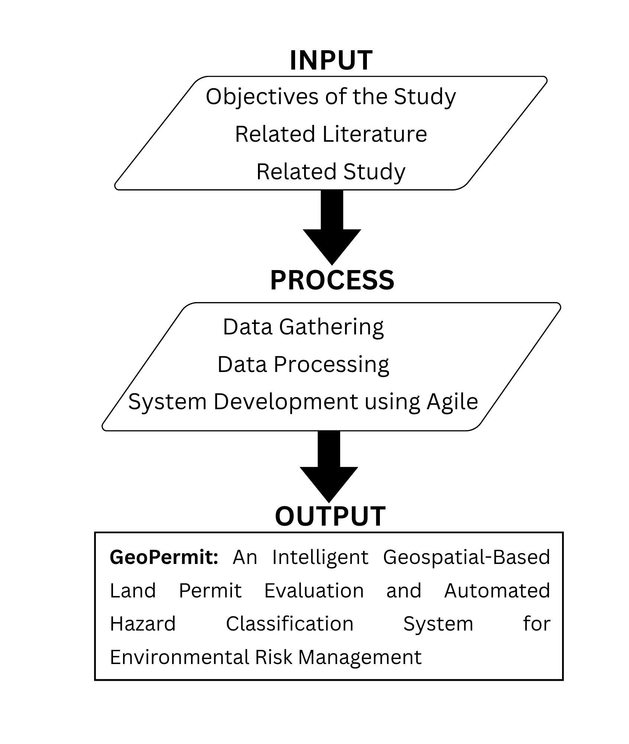

Figure 1: Flow of the Study

Environment

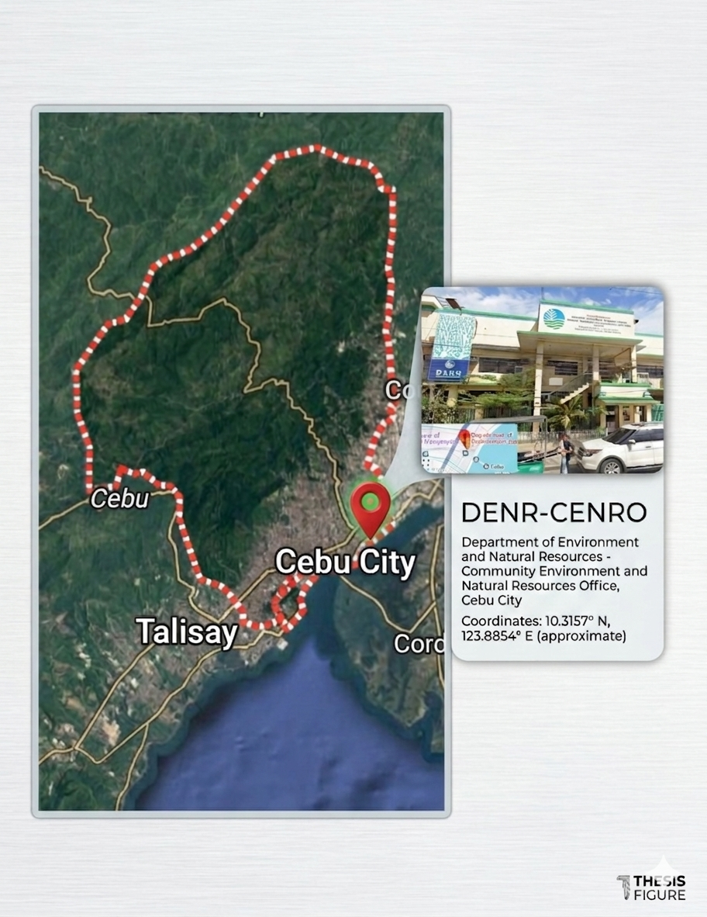

Figure 2: Environment of the Study

The project will be conducted within the CENRO in Cebu City, which has the primary responsibility of regulating the classification of lands, enforcing environmental compliance, and processing the approval of permits pertaining to lands within its jurisdiction. This office plays a vital role in the implementation of environmental policies and the protection of land resources within the area. The proposed GeoPermit system will be implemented using a web-based application that will be accessible to the CENRO personnel using their desktop computers, while applicants will be able to use their desktop or mobile devices to access the system.
The system is developed and tested in a local development environment hosted on the developer’s workstation prior to development, System evaluation, including user acceptance testing (UAT) and quality assessment, is conducted within the CENRO Cebu City office premise or in a simulated operational setting that replicates the actual permit processing workflow.

Respondents
The respondents of this study consist of three primary stakeholder groups who are directly involved in or affected by the GeoPermit system, namely land applicants or developers, CENRO officers, and technical evaluators. Land applicants or developers serve as the primary end-users of the system, as they are responsible for submitting permit applications, uploading required documents, and identifying project locations through the geospatial interface. Their participation is essential in evaluating the system’s usability, accessibility, and overall user experience, particularly in terms of ease of submission, clarity of hazard feedback, and transparency of application tracking.
CENRO officers act as the system’s administrative and decision-making users, responsible for reviewing applications, analyzing hazard classification results, and issuing final decisions such as approval, rejection, or revision requests. Their feedback is crucial in assessing the system’s functional suitability, reliability, and effectiveness in supporting informed and consistent permit evaluation. As the key authority in the workflow, their interaction with the system ensures that governance, compliance, and environmental considerations are properly integrated.
In addition, technical evaluators, including IT professionals are involved to assess the system from a technical perspective. They evaluate aspects such as system performance, maintainability, security, and overall architectural design. Their inclusion strengthens the study by ensuring that the system not only meets user requirements but also adheres to established software quality standards.
The combination of these respondent groups provides a comprehensive evaluation of GeoPermit, balancing user experience, operational effectiveness, and technical robustness. This multi-perspective approach ensures that the system is practical, reliable, and suitable for real-world implementation in land permit evaluation processes.

Research Instrument
Designed to assess GeoPermit's software quality across five characteristics most relevant to its function as a web-based geospatial land permit evaluation system: Functional Suitability, Performance Efficiency, Usability, Reliability, and Security.
The instrument is divided into two parts:
Part I – Respondent Profile This section The primary instrument used in this study is a researcher-made evaluation questionnaire developed based on the ISO/IEC 25010 Software Product Quality Model. The questionnaire collected basic background information about the respondent, including their role in relation to the system (applicant, CENRO permit officer, or GIS specialist), their level of experience with web-based systems, and their familiarity with permit evaluation processes. This information is used to contextualize the evaluation responses and ensure that feedback reflects the perspective of actual end-users of GeoPermit within the CENRO Cebu City operational environment.
Part II – System Evaluation Proper This section contains the evaluation indicators organized under the five ISO/IEC 25010:2023 quality characteristics. Each indicator is rated by the respondent using a five-point Likert scale ranging from 1 (Strongly Disagree) to 5 (Strongly Agree). The total number of indicators per characteristic is as follows:

Table 1: Quality Characteristics Overview

ISO/IEC 25010:2023 Characteristic | No. of Indicators | Primary Respondents
Functional Suitability | 5 | CENRO Specialist, GIS Specialist
Performance Efficiency | 5 | CENRO Officers, Applicant
Compatibility | 6 | Applicant, CENRO Officers
Interaction Capability | 5 | CENRO Officers
Reliability | 5 | CENRO Officers, GIS Specialist
Security |  | IT Specialists
Maintainability |  | IT Specialists
Flexibility |  | IT Specialists
Safety |  | IT Specialists
Total |  | To be updated
The indicators under each characteristic were formulated to reflect the specific operational context of GeoPermit and CENRO Cebu City. Indicators under Functional Suitability, for instance, assess whether the system correctly performs automated hazard classification and covers all required permit types. Usability indicators are framed around the non-technical background of both permit applicants and CENRO officers who may have no prior GIS experience. Security indicators are oriented toward the protection of permit records, applicant data, and the integrity of hazard classification outputs produced by the system.
Prior to final administration, the instrument was subjected to content validation by the study's research adviser and selected subject matter experts to ensure that each indicator accurately reflects the corresponding ISO/IEC 25010 sub-characteristic and is appropriate for the intended respondent group. Revisions were made based on the feedback received before the questionnaire was finalized and administered.

Treatment of Data
The data to be collected from the three respondent groups namely, land permit applicants and developers, CENRO officers, and technical evaluators including IT professionals and information systems faculty, will be processed and analyzed using descriptive statistical methods. These methods are aligned with the research instruments and the ISO/IEC 25010 software quality evaluation framework adopted in this study.
For quantitative data gathered through the System Quality Evaluation Questionnaire and the Technical and Maintainability Evaluation Form, the researchers will compute the weighted mean for each quality characteristic to determine the overall perception of system quality. The computed weighted means will be compared against established scoring ranges to determine their corresponding descriptive interpretations. In addition, overall mean scores per respondent group will be calculated to obtain an aggregate system quality rating from the perspectives of applicants, CENRO officers, and technical evaluators. Standard deviation will also be used to measure the variability of responses, while frequency counts and percentage distributions will be generated to provide a detailed breakdown of responses and identify specific system features that may require improvement.
For qualitative data obtained from open-ended responses and user acceptance testing, thematic analysis will be conducted. Recurring themes related to usability, workflow alignment, interface clarity, and system responsiveness will be identified and categorized. Particular emphasis will be placed on feedback from CENRO officers due to their role as primary users of the system.
All statistical analyses will be performed using Microsoft Excel to ensure a systematic and organized approach in computing weighted means, overall averages, standard deviations, and frequency-percentage distributions.

Scoring Procedures
The evaluation responses collected from the respondents will be scored and interpreted using a structured and standardized procedure to ensure consistency and objectivity in assessing the quality of the GeoPermit system.
Step 1: Response Scale Assignment
Each respondent will rate the evaluation indicators using a five-point Likert scale, with corresponding numerical values as follows: Outstanding (5), Satisfactory (4), Acceptable (3), Needs Improvement (2), and Poor (1).
Step 2: Computation of Weighted Mean (Per Indicator)
The weighted mean for each indicator will be calculated by multiplying the frequency of responses by their respective scale values, summing the results, and dividing by the total number of respondents. The formula to be used is:
x̄ = Σ(f × x) / n
where x̄ represents the weighted mean, f is the frequency of responses, x is the scale value, and n is the total number of respondents.
Step 3: Computation of Weighted Mean (Per Characteristic)
The weighted means of all indicators under each ISO/IEC 25010:2023 quality characteristic will be averaged to obtain a single score representing that characteristic. The ISO 25010 provides a detailed framework for evaluating software and system quality. It defines a product quality model that categorizes essential quality characteristics and their sub-characteristics, which are integral to measuring a system’s ability to meet functional, performance, and user-specific requirements (Ariningsih & Muhammad, 2024).
Step 4: Overall Weighted Mean
An overall weighted mean will be computed by averaging the scores of all evaluated characteristics. This value will represent the general system quality rating of GeoPermit based on respondent evaluation.
Step 5: Interpretation of Results
The computed weighted mean values will be interpreted using the following scale:

Table 2: Interpretation of Results
Scale | Weighted Mean Range | Descriptive Interpretation | Evaluation Description
5 | 4.21 - 5.00 | Outstanding | Accepted
4 | 3.41 – 4.20 | Satisfactory | Accepted
3 | 2.61 – 3.40 | Acceptable | For review
2 | 1.81 – 2.60 | Needs Improvement | Not Accepted
1 | 1.00 – 1.80 | Poor | Not Accepted
Step 6: Acceptance Criteria
The GeoPermit system will be considered acceptable for implementation if the overall weighted mean achieves a minimum score of 3.50, corresponding to a Satisfactory rating. Any characteristic falling below this threshold will be identified and recommended for further system improvement.
This scoring procedure ensures consistent and objective interpretation of results across all respondent groups, providing a standardized basis for evaluating GeoPermit in relation to ISO/IEC 25010:2023 quality characteristics. An overall weighted mean of at least 3.50, equivalent to a Very Satisfactory rating, will serve as the minimum acceptable performance benchmark for the system.

Definition of Terms
These terms are defined operationally as used in this study:
Access Control. A mechanism that restricts system access based on user roles.
Administrator. The authorized personnel responsible for managing the system, reviewing applications, and approving or rejecting requests.
Applicant. A user who submits permit applications and monitors their status through the system.
Approval Process. The workflow in which applications are reviewed and either approved or rejected by the administrator.
Authentication. The process of verifying a user’s identity before granting access to the system.
Authorization. The process of assigning access rights and permissions to users based on user roles.
Client-Side. The part of the system that runs on the user’s device, such as the web interface.
Dashboard. A central interface that displays summarized information, updates, and system data for users.
Data Management. The process of organizing, storing, and maintaining system data.
Data Validation. The process of ensuring that user inputs are accurate, complete, and properly formatted.
Database. A structured collection of data used to store user information and permit records.
Efficiency. The ability of the system to perform tasks with minimal time and resource usage.
End-User. Individuals who interact with the system, including administrators and applicants.
Flood-Prone Area. A location that is highly susceptible to flooding due to environmental or geographical conditions.
Functionality. The system’s ability to perform its intended tasks accurately and completely.
GeoPermit System. A web-based application developed to facilitate, manage, and evaluate permit applications using geospatial data and mapping technologies.
Geofencing. A technology that creates virtual geographic boundaries to determine whether a location falls within restricted or allowed zones.
Geospatial Data. Information associated with a specific geographic location used for mapping and spatial analysis.
Hazard Mapping. The process of identifying and mapping areas that are at risk of natural hazards.
Interpretation Scale. A range used to describe the meaning of computed results.
Land Susceptibility. The level of vulnerability of a land area to hazards such as flooding, landslides, or soil erosion.
Likert Scale. A rating scale used to measure the level of agreement of respondents.
Location Tagging. The process of assigning geographic coordinates to a specific application or record.
Map Integration. The incorporation of mapping tools or services into the system to support location-based functionalities.
Map Visualization. The graphical representation of geographic data to display spatial relationships.
Notification System. A feature that sends updates to users regarding their application status.
Permit Application Module. A component of the system that allows users to submit, edit, and manage permit applications.
Questionnaire. A set of structured questions used to gather evaluation data.
Reliability (Instrument). The consistency of the evaluation tool in producing stable and dependable results.
Reliability (System). The consistency of the system in performing its functions without errors.
Respondents. Individuals selected to evaluate the system and provide feedback.
River Easement. A legally defined buffer zone along riverbanks where development is restricted to prevent environmental risks and ensure public safety.
Server. A system that hosts the application and processes user requests.
Status Tracking. A feature that enables users to monitor the progress of their applications.
System Evaluation Checklist (SEC). A structured questionnaire used to assess the effectiveness, usability, and performance of the system.
System Maintenance. The process of updating, improving, and fixing the system after deployment.
System Performance. The speed, responsiveness, and stability of the system during operation.
System Security. Measures implemented to protect the system from unauthorized access and data breaches.
User Account. A registered profile that allows users to securely access the system.
User Interface (UI). The visual components of the system that allow users to interact with it.
Usability. The ease with which users can learn and effectively use the system.
Validity. The extent to which the questionnaire measures what it is intended to measure.
Web-Based System. A system that operates through a web browser and requires an internet connection.
Weighted Mean. A statistical method used to compute the average score of responses.
Zoning Compliance. The adherence of a land or project to local government zoning regulations and land-use policies.

