

Software Testing

Project Submission # 1

Group #: 4

Roll #: MSCS-20001

MSCS-20013

MSCS-20065

# Environment Setup

1. Download maven from here: <https://maven.apache.org/download.cgi>
2. Download and install the mysql workbench from here: <https://dev.mysql.com/downloads/installer/>
3. Download jdk1.8+
4. In the .\timesheet-master\build.bat, set the JAVA_HOME to jdk path and similarly set MAVEN_HOME to the maven path.
5. In the .\timesheet-master\run.bat, set the JAVA_HOME and set CATALINA_HOME to absolute path appended by ".\PaySystem\apache-tomcat-7.0.108-windows-x64\apache-tomcat-7.0.108".
6. Open Command prompt, navigate to project repository i.e .\Paysystem\timesheet-master\ and execute build.bat.
7. This will build the project.
8. Open mysql workbench and enter following two queries:

DROP DATABASE paysystem;

Create DATABASE paysystem;

1. When the database is created for first time, only execute the create query.
2. Execute run.bat.

# Application Running

After the local server is running, go to <http://localhost:8090/> or you can just go to the application <http://localhost:8090/PaySystem>

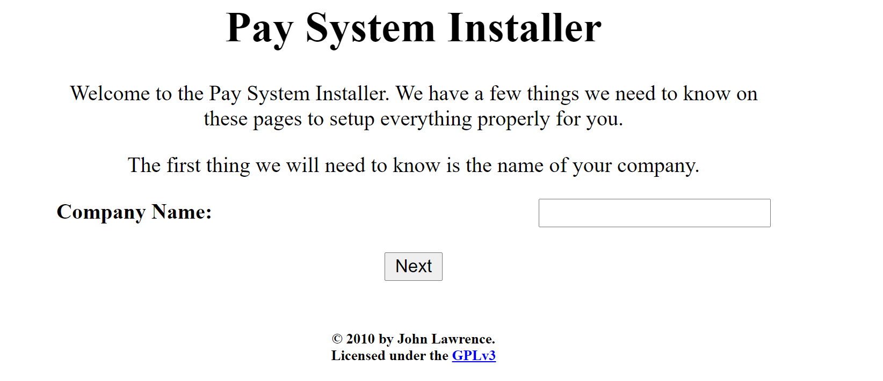

Enter the company name, and then click next.

Then you will be redirected to add information about the database. To avoid confusion, username and password are kept same.

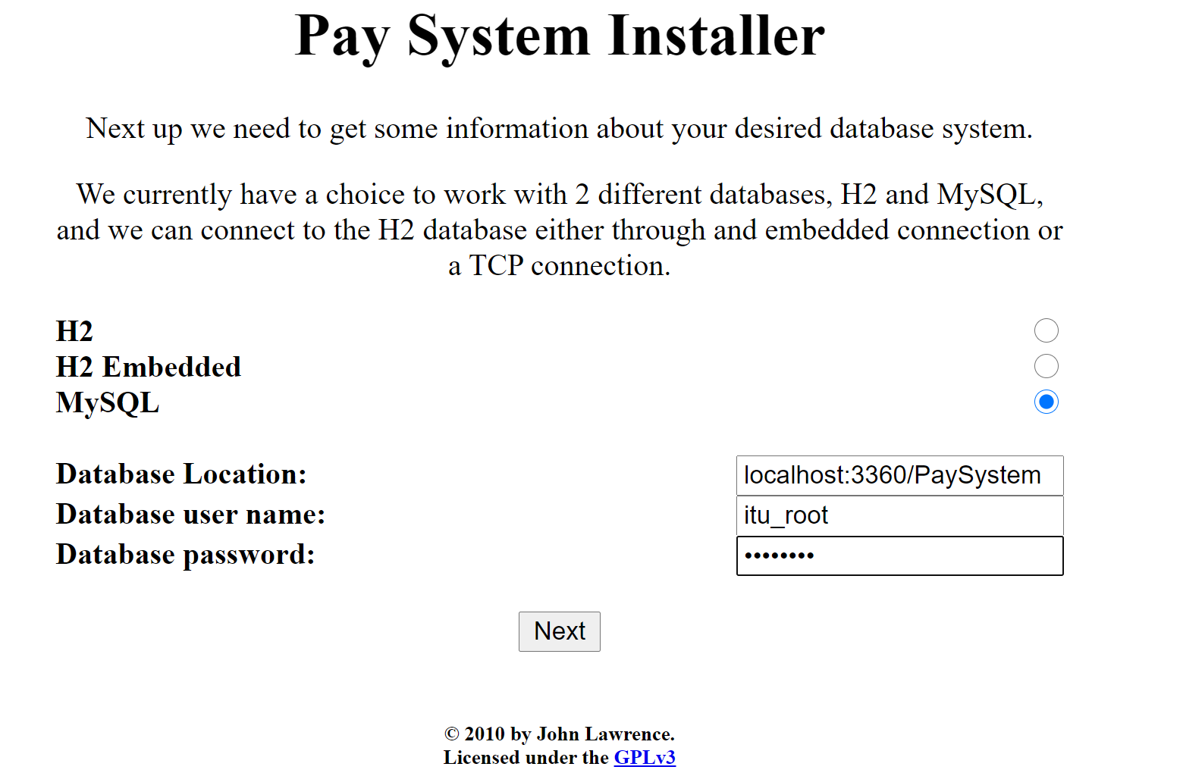

You will be redirected to add username and password for the user purpose.

