**Software Testing**

**Project Report**

Session: Spring 2021

**Danish Hasan** MSCS20001

**Abu Bakar** MSCS-20013

**Musa Khan** MSCS-20065

**Awais** MSCS-20074

**Employee Time Reporting**

Department of Computer Science

**Information Technology University Lahore**

**Pakistan**



## Project Description

### Environment Setup

1. Download maven from here: <https://maven.apache.org/download.cgi>
2. Download and install the mysql workbench from here: <https://dev.mysql.com/downloads/installer/>
3. Download jdk1.8+
4. In the .\timesheet-master\build.bat, set the JAVA_HOME to jdk path and similarly set MAVEN_HOME to the maven path.
5. In the .\timesheet-master\run.bat, set the JAVA_HOME and set CATALINA_HOME to absolute path appended by ".\PaySystem\apache-tomcat-7.0.108-windows-x64\apache-tomcat-7.0.108".
6. Open Command prompt, navigate to project repository i.e .\Paysystem\timesheet-master\ and execute build.bat.
7. This will build the project.
8. Open mysql workbench and enter following two queries:
   1. drop database paysystem;
   2. create database paysystem;
9. When the database is created for first time, only execute the create query.
10. Execute run.bat.

### Description

The project is a lighter version of a pay system for managing the expenses of the employees.

* Adding the new employees in the database.
* Adding the time worked for a specific employee.
* Configuring the database settings.
* Managing the groups in the company.
* Generate the ADP reports of the employees.

### Application Running

After the local server is running, go to <http://localhost:8090/> or you can just go to the application <http://localhost:8090/PaySystem>

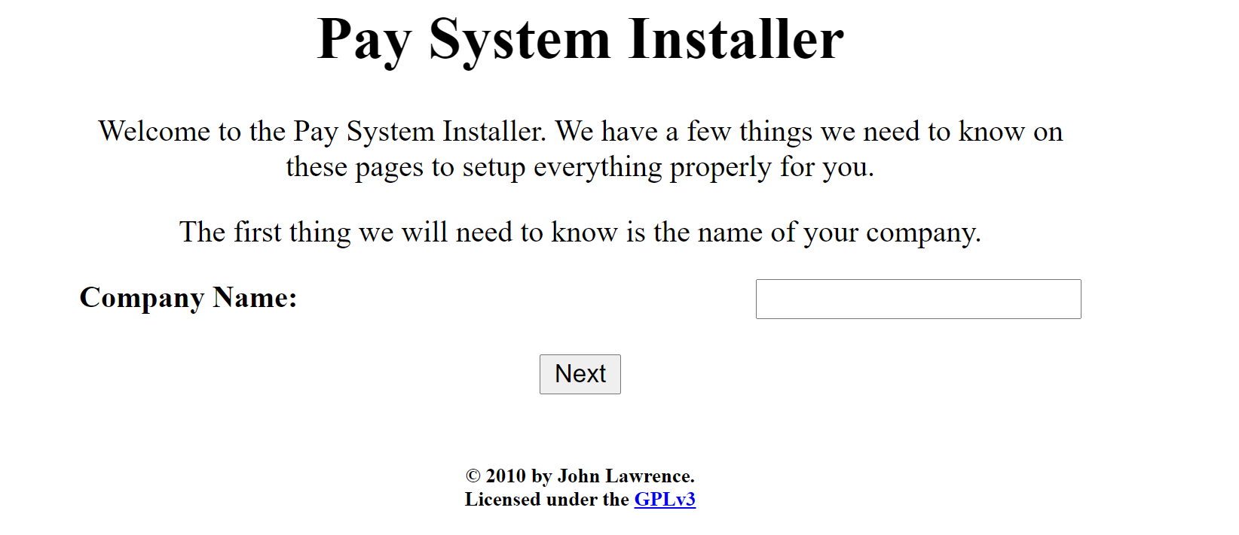

Enter the company name, and then click next.

Then you will be redirected to add information about the database. To avoid confusion, database username and database password are kept same.

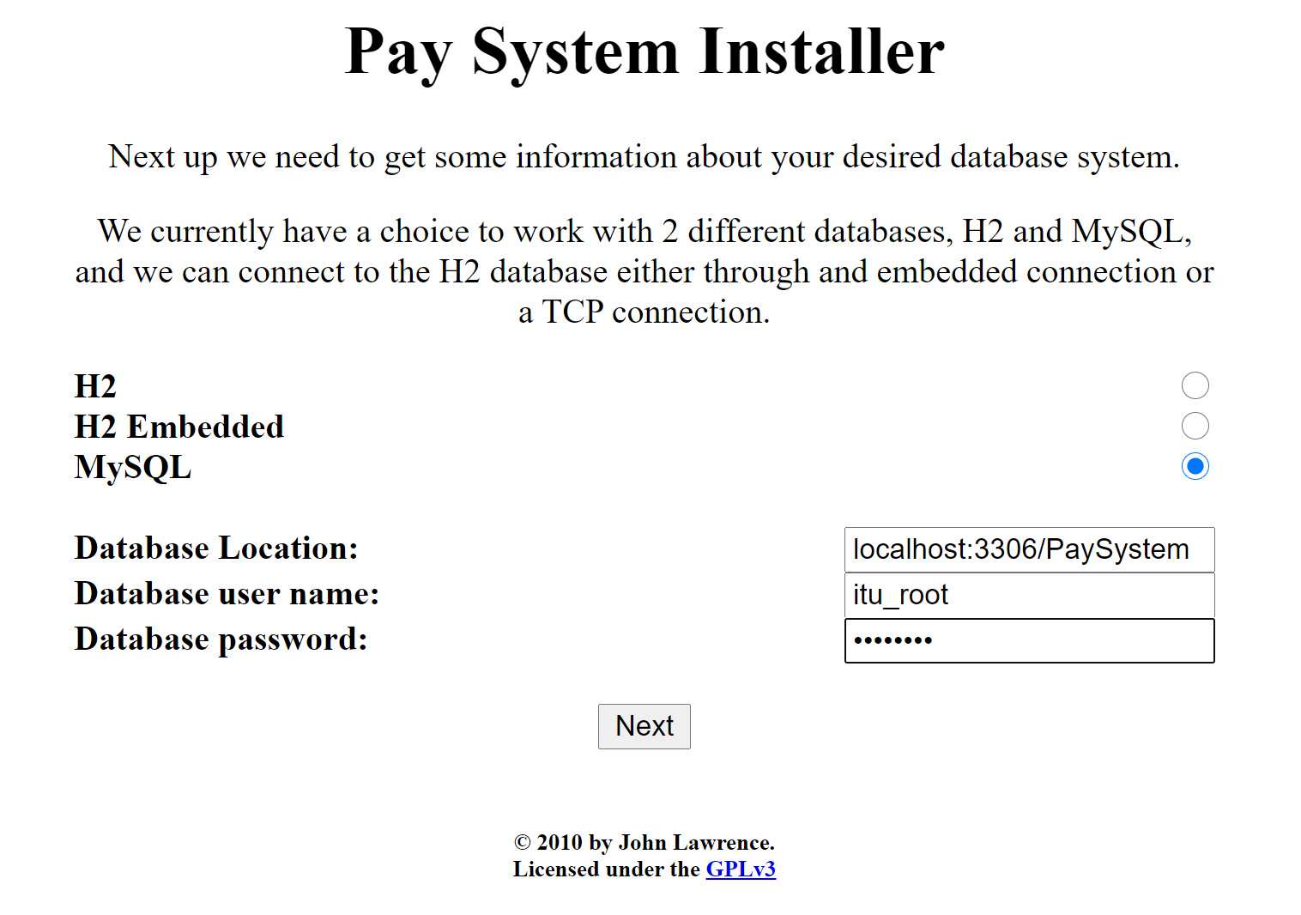

You will be redirected to add username and password for the user purpose. These are also kept same.

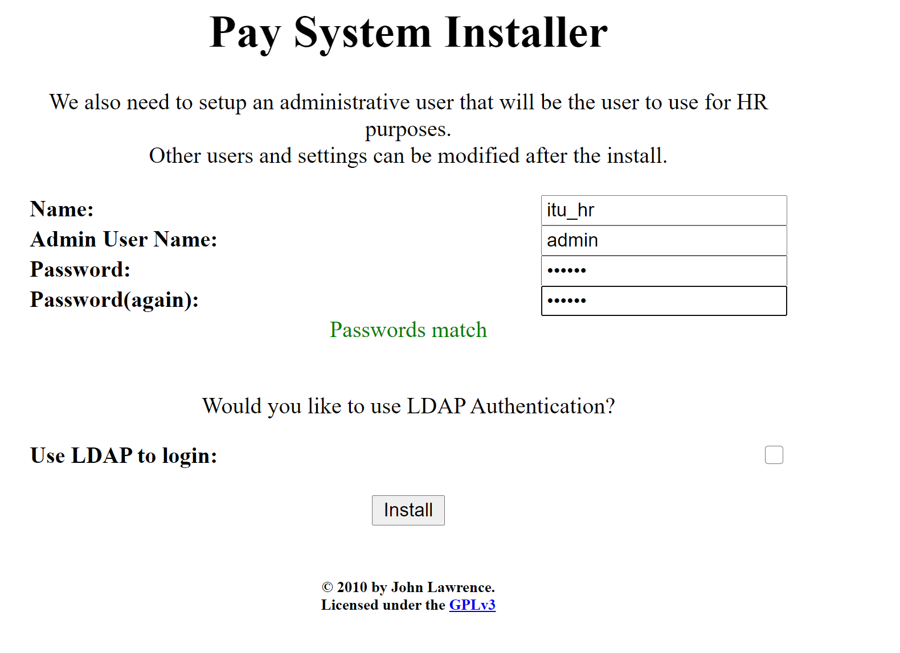

You will be redirected to the login page.

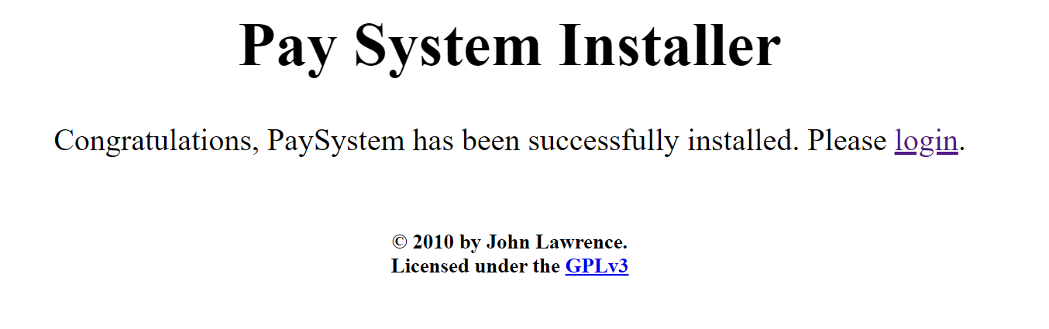

After clicking login, Login using the username you set earlier.

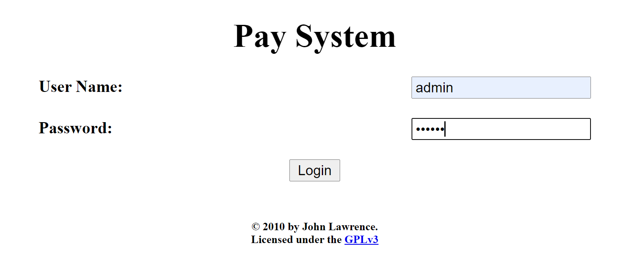

After login you will be directed to the dashboard. Below is the full dashboard.

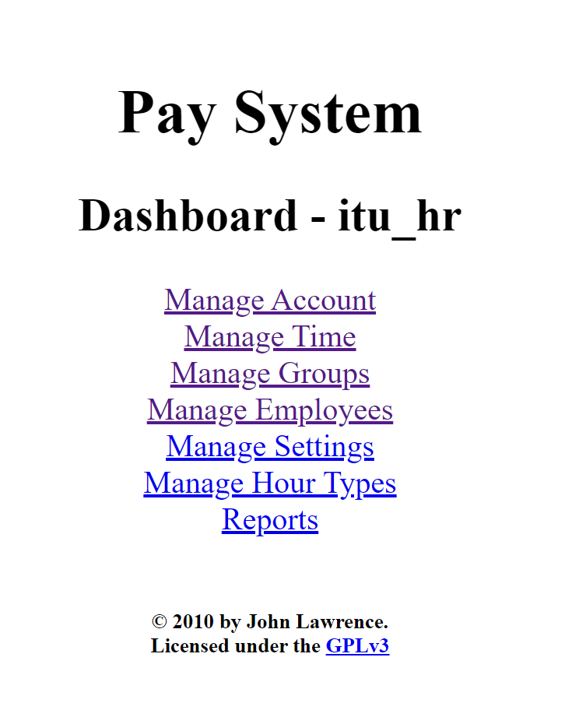

In the manage account section, you can add the wage.

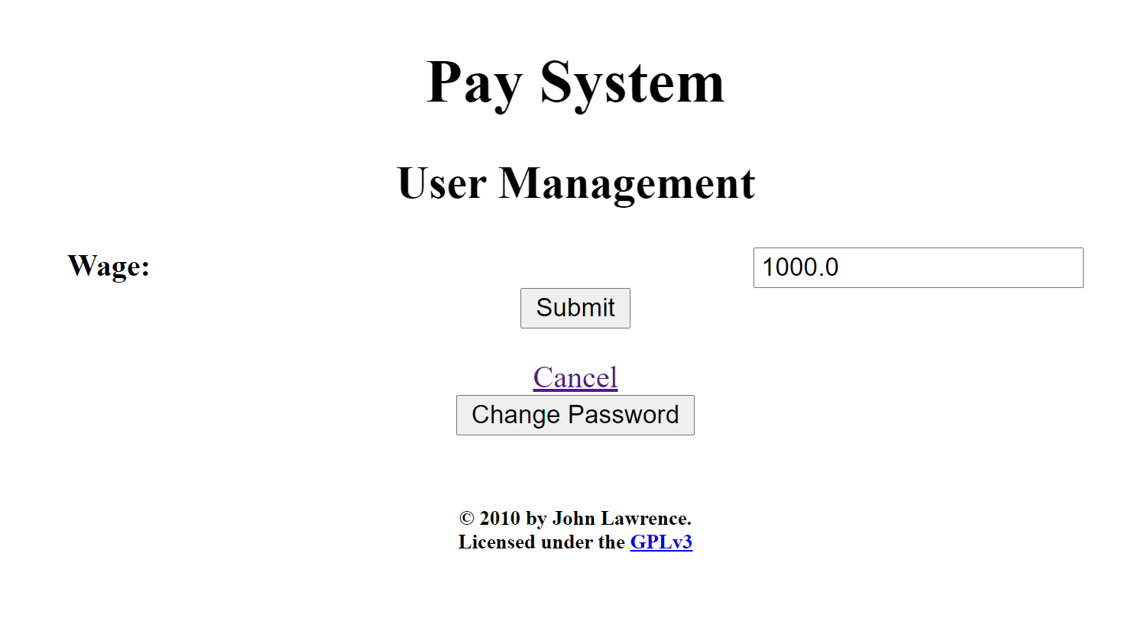

In the manage employee section, you can add/delete the employees.

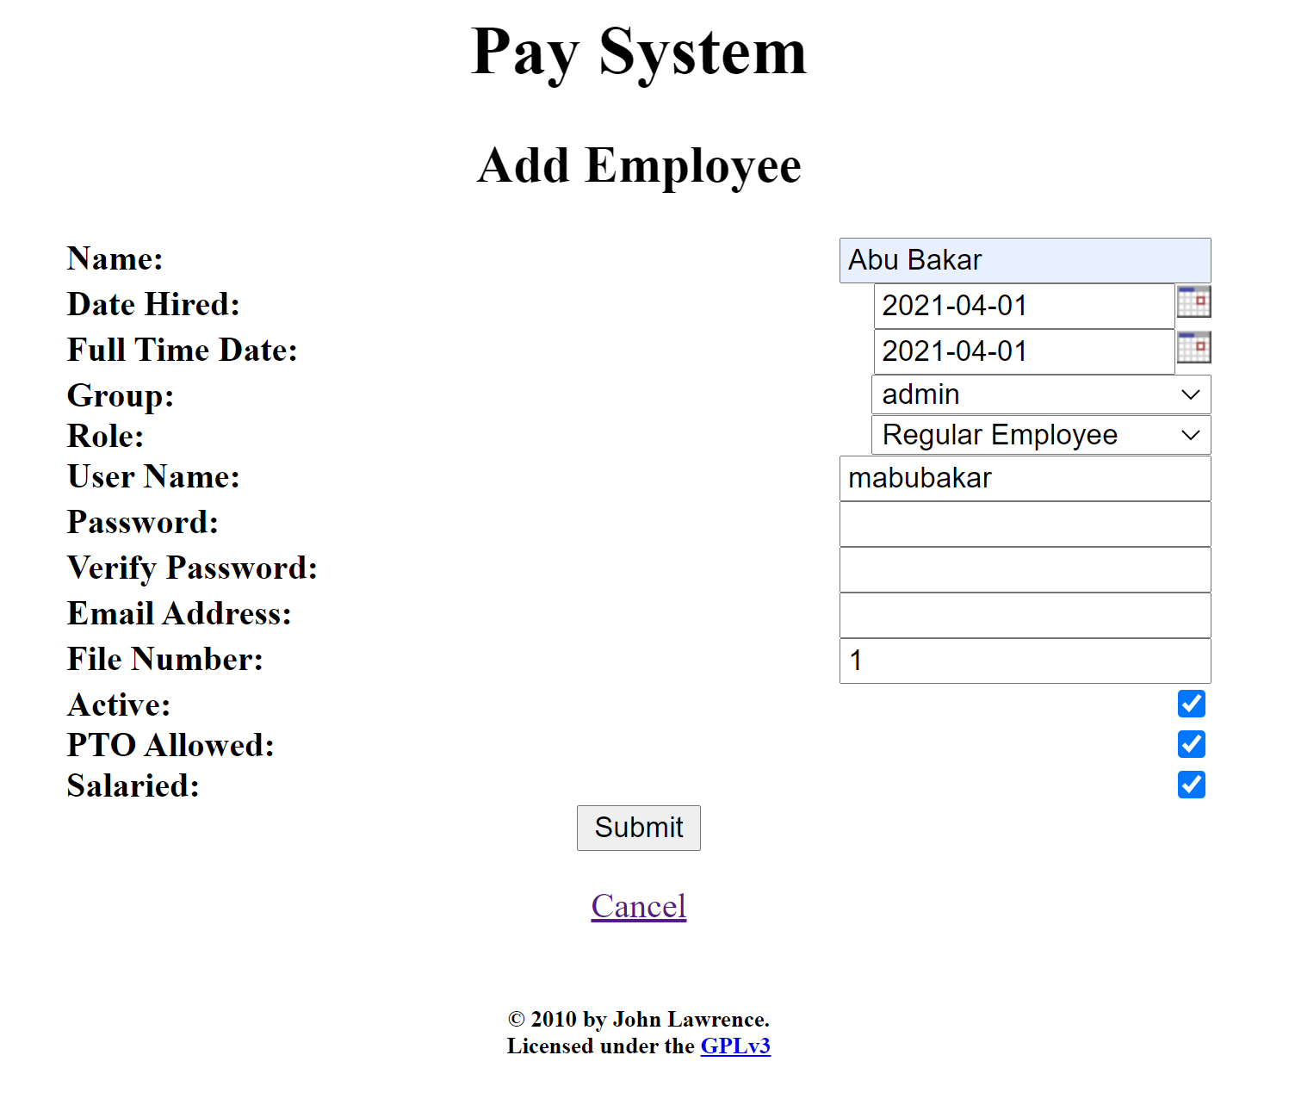

In the manage settings section, you can change the settings.

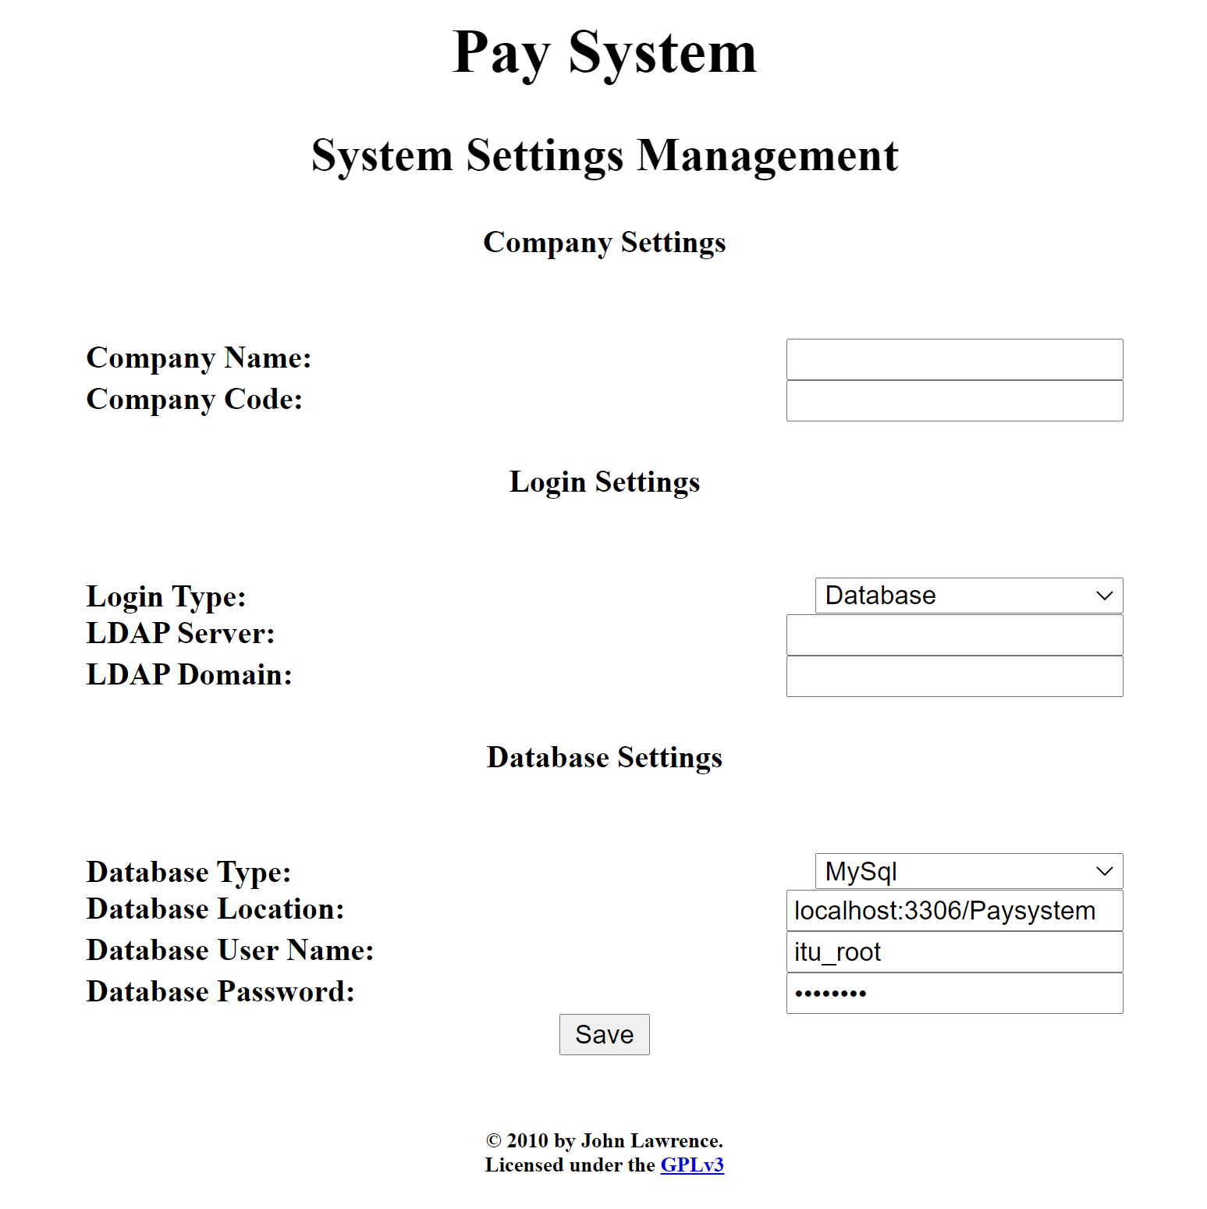

In the hour management section, you can add/delete/edit the hour types.

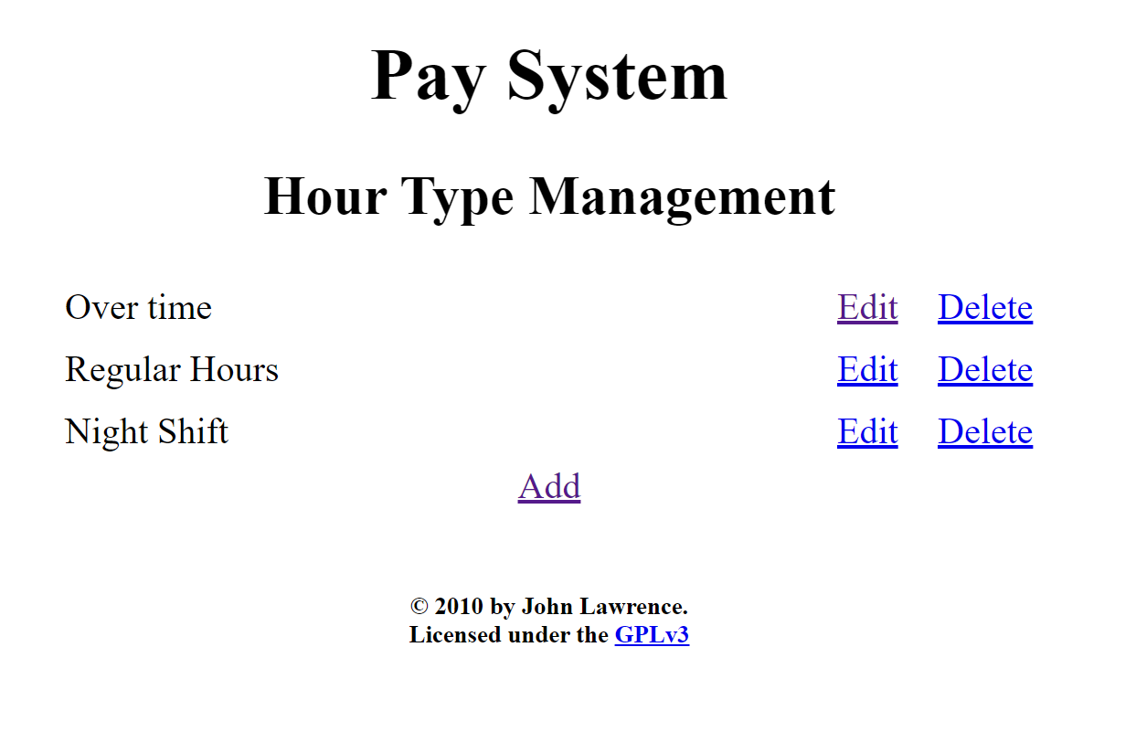

In the group management section, you can add/delete/edit the groups.

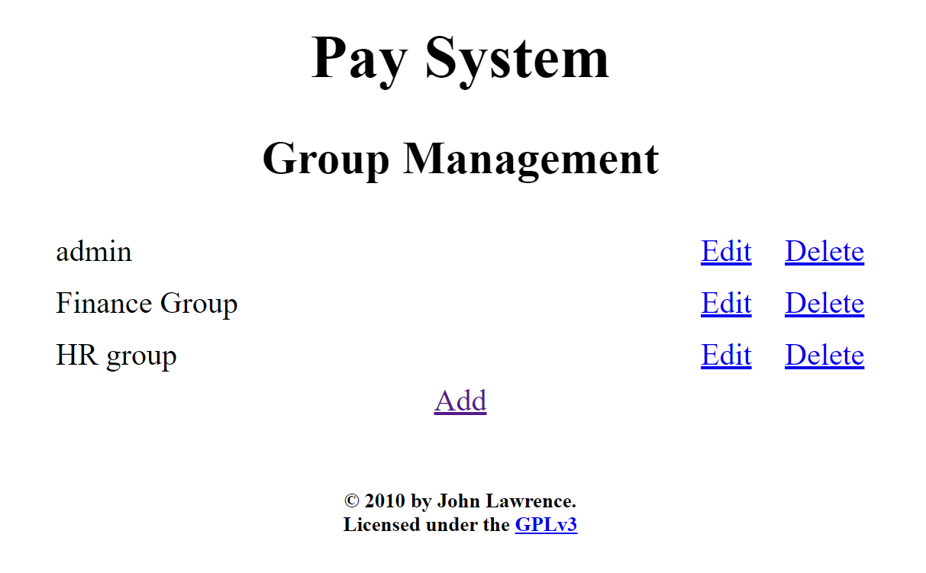

In the report section, you can generate the reports.

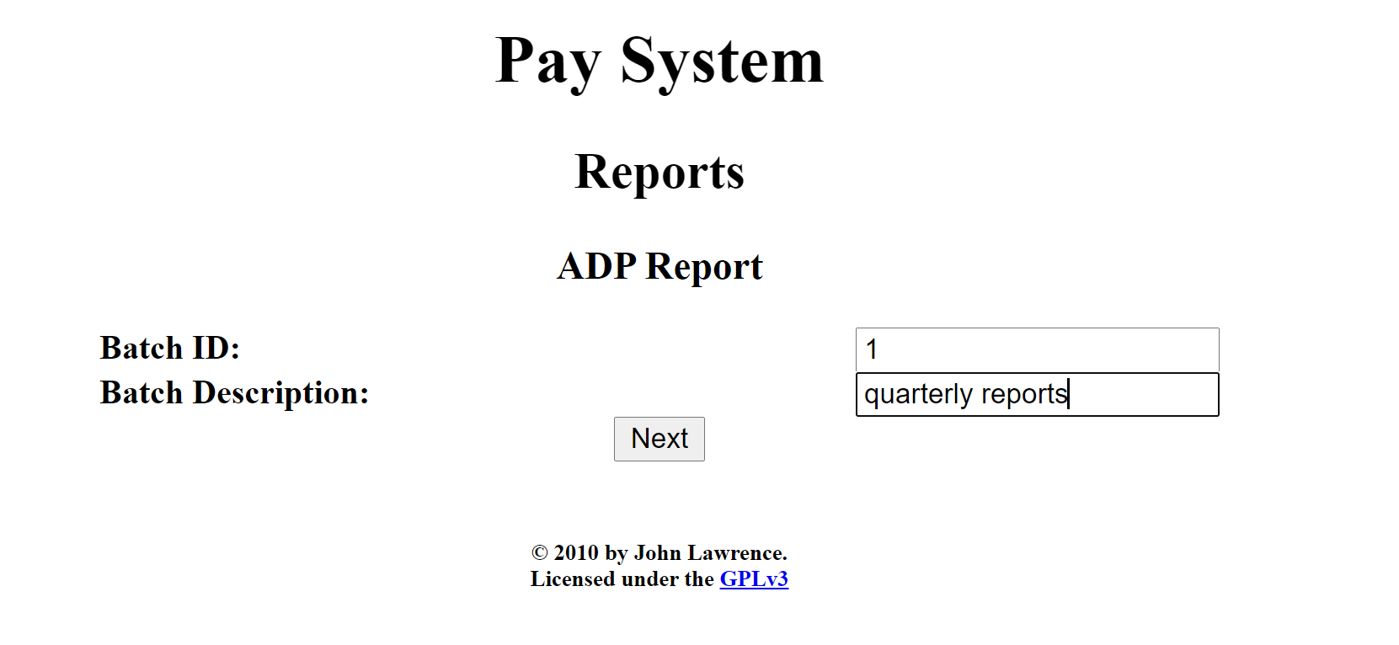

For the report generation, you can add the data for the employee.

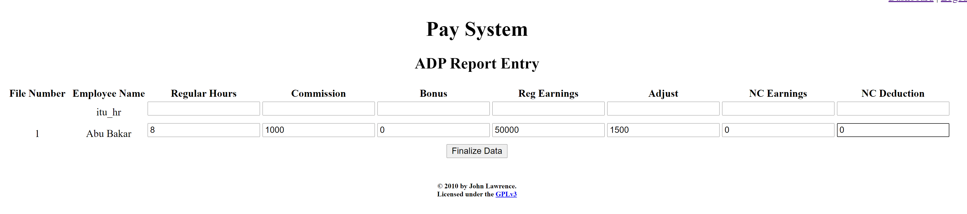

After clicking the finalize data, a csv file is downloaded.

## White-Box Testing

**Function 1:**

Encodes a byte array into Base64 format.

Note: map[] table is populated in another constructor function.

**Source Code:**

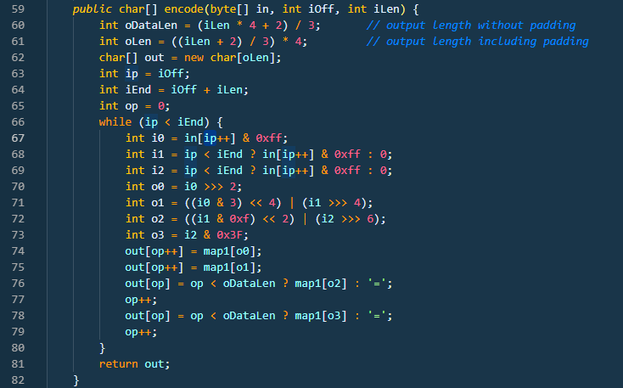

**CFG:**

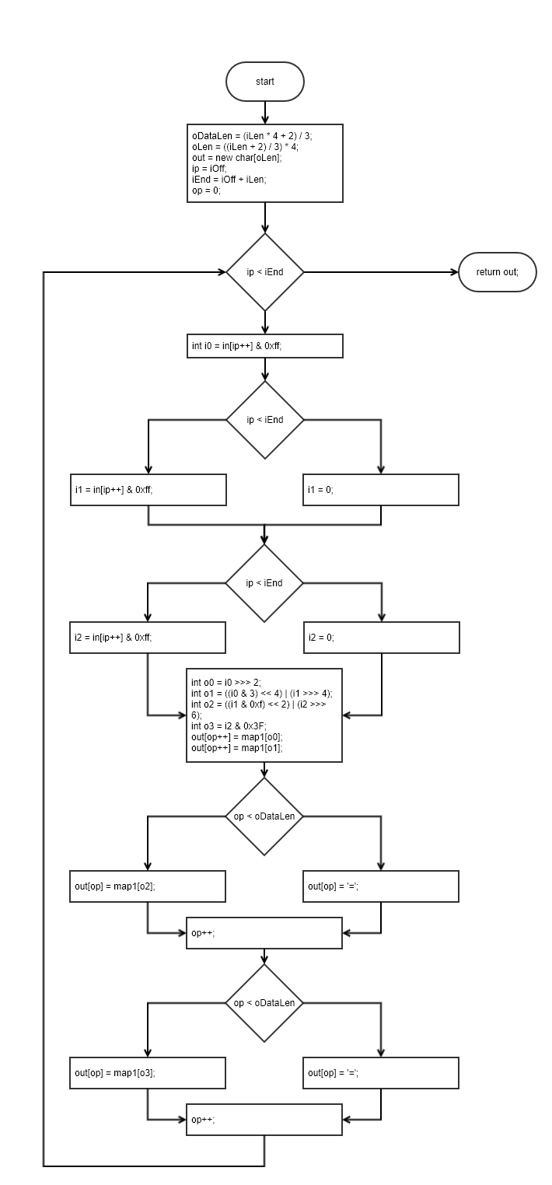

**Statement Coverage:**

|  |  |  |  |  |  |
| --- | --- | --- | --- | --- | --- |
| **Test case#** | **Input** | **Output** | **Expected Output** | **Pass/Fail** | **Comments/Remarks** |
| **1** | In[] = {‘A’, ‘B’, ‘C’};  iOff = 0;  iLen = 3; | QUJD | QUJD | Pass | Covers all statements |

**Branch Coverage:**

|  |  |  |  |  |  |
| --- | --- | --- | --- | --- | --- |
| **Test case#** | **Input** | **Output** | **Expected Output** | **Pass/Fail** | **Comments/Remarks** |
| **1** | In[] = {‘A’, ‘B’, ‘C’};  iOff = 0;  iLen = 3; | QUJD | QUJD | Pass | Covers 66TF, 68T, 69T, 76T, 78T |
| **2** | In[] = {‘A’, ‘B’, ‘C’};  iOff = 0;  iLen = 1; | QQ== | QQ== | Pass | Covers 66TF, 68F, 69F, 76F, 78F |

**Condition Coverage with Short Circuit Evaluation:**

|  |  |  |  |  |  |
| --- | --- | --- | --- | --- | --- |
| **Test case#** | **Input** | **Output** | **Expected Output** | **Pass/Fail** | **Comments/Remarks** |
| **1** | In[] = {‘A’, ‘B’, ‘C’};  iOff = 0;  iLen = 3; | QUJD | QUJD | Pass | Covers 66TF, 68T, 69T, 76T, 78T |
| **2** | In[] = {‘A’, ‘B’, ‘C’};  iOff = 0;  iLen = 1; | QQ== | QQ== | Pass | Covers 66TF, 68F, 69F, 76F, 78F |

**Function 2:**

**Source Code:**

\jdk\src\java.base\share\classes\java\time\Duration.java

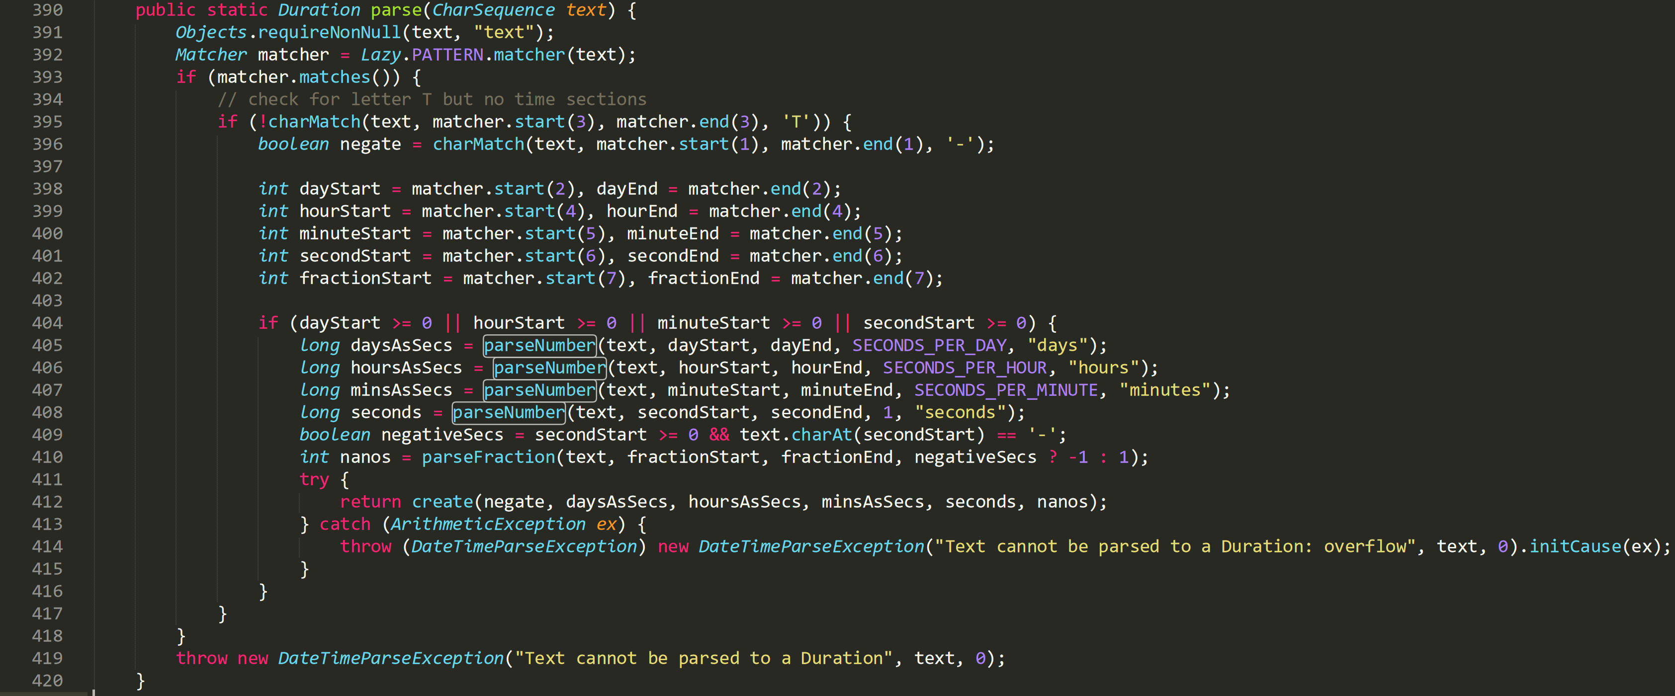**CFG:**

Paste your CFG here.

**Statement Coverage:**

|  |  |  |  |  |  |
| --- | --- | --- | --- | --- | --- |
| **Test case#** | **Input** | **Output** | **Expected Output** | **Pass/Fail** | **Comments/Remarks** |
| **1** | PT6H | 6 hours | 6 hours | Pass | Covers statements from 391 to 395, 398 to 412 |
| **2** | G3D | Exception | Exception | Pass | Covers statement 419 |
| **3** | -P2D | -2 days | -2 days | Pass | Covers statement 396 |

**Branch Coverage:**

|  |  |  |  |  |  |
| --- | --- | --- | --- | --- | --- |
| **Test case#** | **Input** | **Output** | **Expected Output** | **Pass/Fail** | **Comments/Remarks** |
| **Cell 1** | Cell 2 | Cell 3 |  |  |  |
| **Cell 4** | Cell 5 | Cell 6 |  |  |  |

**Condition Coverage with Short Circuit Evaluation:**

|  |  |  |  |  |  |
| --- | --- | --- | --- | --- | --- |
| **Test case#** | **Input** | **Output** | **Expected Output** | **Pass/Fail** | **Comments/Remarks** |
| **Cell 1** | Cell 2 | Cell 3 |  |  |  |
| **Cell 4** | Cell 5 | Cell 6 |  |  |  |

**Function 3:**

**Source Code:**

\jdk\src\java.base\share\classes\java\math\MutableBigInteger.java

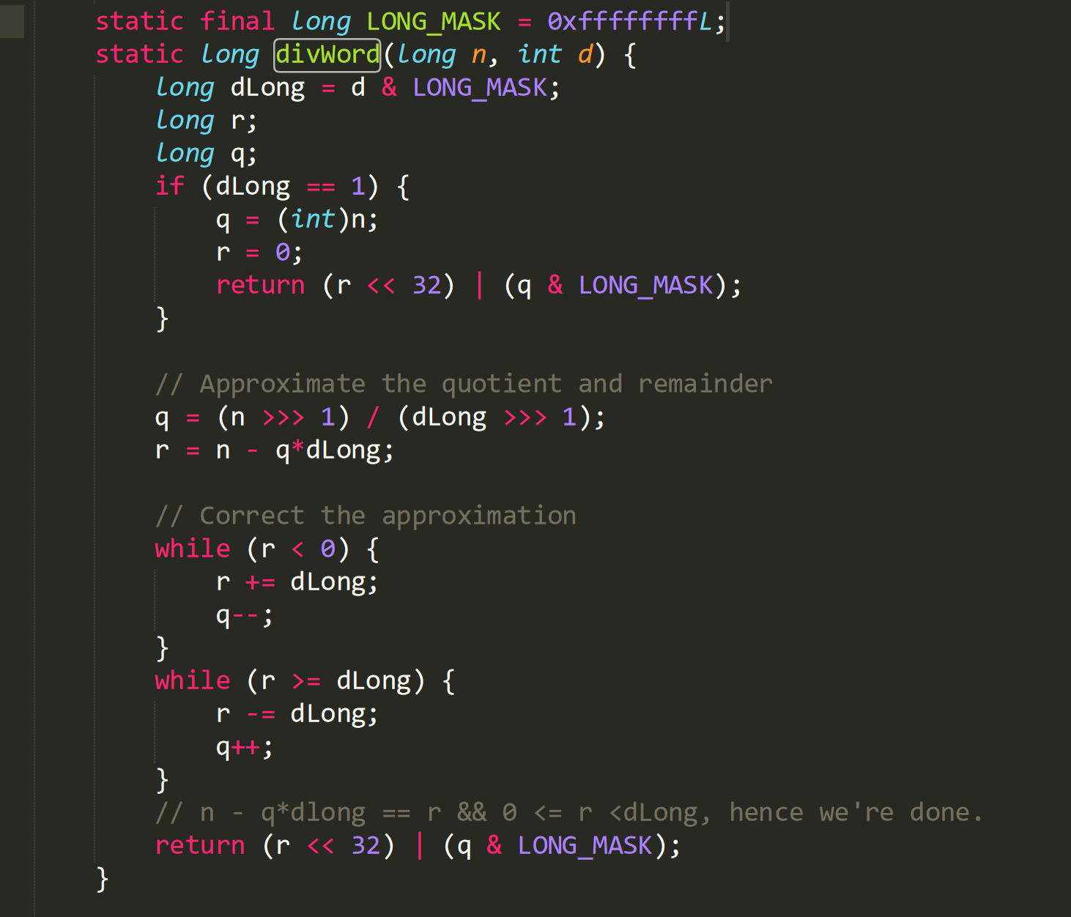

**CFG:**

Paste your CFG here.

**Statement Coverage:**

|  |  |  |  |  |  |
| --- | --- | --- | --- | --- | --- |
| **Test case#** | **Input** | **Output** | **Expected Output** | **Pass/Fail** | **Comments/Remarks** |
| **Cell 1** | Cell 2 | Cell 3 |  |  |  |
| **Cell 4** | Cell 5 | Cell 6 |  |  |  |

**Branch Coverage:**

|  |  |  |  |  |  |
| --- | --- | --- | --- | --- | --- |
| **Test case#** | **Input** | **Output** | **Expected Output** | **Pass/Fail** | **Comments/Remarks** |
| **Cell 1** | Cell 2 | Cell 3 |  |  |  |
| **Cell 4** | Cell 5 | Cell 6 |  |  |  |

**Condition Coverage with Short Circuit Evaluation:**

|  |  |  |  |  |  |
| --- | --- | --- | --- | --- | --- |
| **Test case#** | **Input** | **Output** | **Expected Output** | **Pass/Fail** | **Comments/Remarks** |
| **Cell 1** | Cell 2 | Cell 3 |  |  |  |
| **Cell 4** | Cell 5 | Cell 6 |  |  |  |

**Function 4:**

Decodes a byte array from Base64 format.

Note: map2[] table is populated in another constructor function.

**Source Code:**

timesheet-master\src\main\java\timeSheet\util\properties\Base64Coder.java

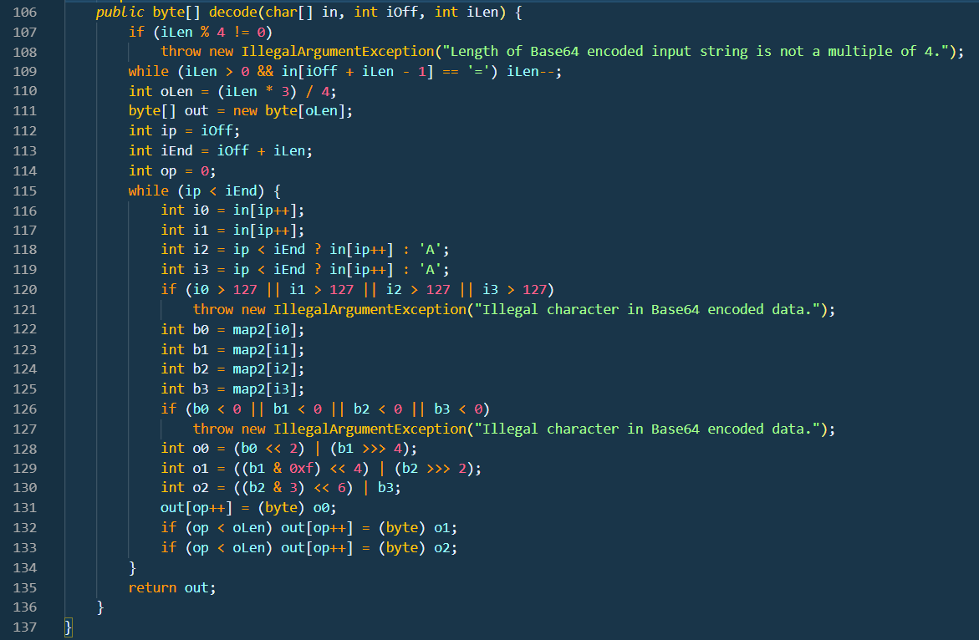

**CFG:**

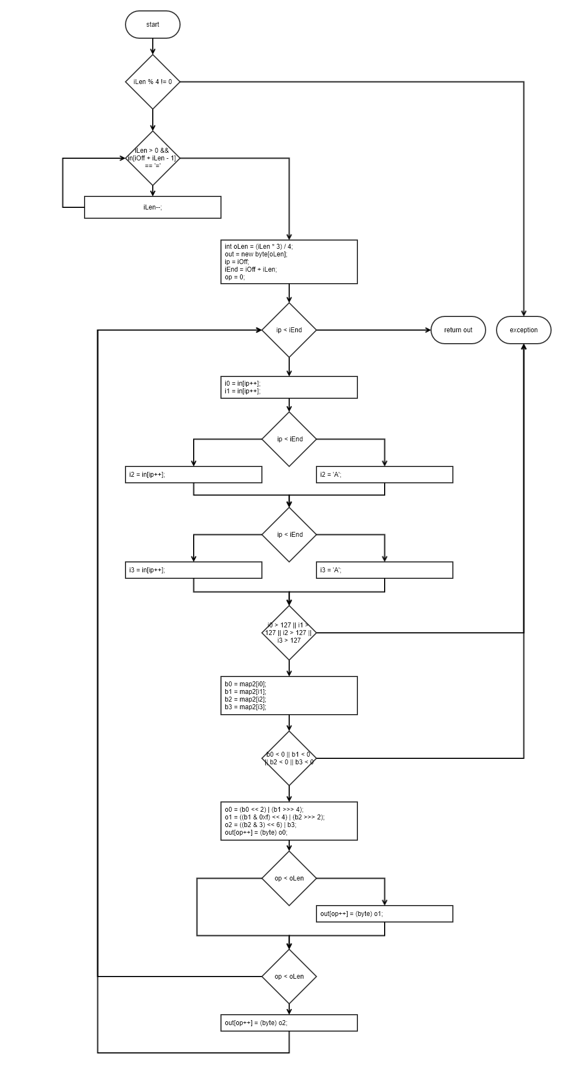

**Statement Coverage:**

Exception cases are not covered under sir’s guidance.

|  |  |  |  |  |  |
| --- | --- | --- | --- | --- | --- |
| **Test case#** | **Input** | **Output** | **Expected Output** | **Pass/Fail** | **Comments/Remarks** |
| **1** | In[] = ‘QUJD’  iOff = 0  iLen = 4 | ‘ABC’ | ‘ABC’ | Pass | No padding |
| **2** | In[] = ‘QQ==’  iOff = 0  iLen = 4 | ‘A’ | ‘A’ | Pass | Padded with == |

**Branch Coverage:**

Exception cases are not covered under sir’s guidance.

|  |  |  |  |  |  |
| --- | --- | --- | --- | --- | --- |
| **Test case#** | **Input** | **Output** | **Expected Output** | **Pass/Fail** | **Comments/Remarks** |
| **1** | In[] = ‘QUJD’  iOff = 0  iLen = 4 | ‘ABC’ | ‘ABC’ | Pass | 109F, 115TF, 118T, 119T, |
| **2** |  |  |  |  |  |

**Condition Coverage with Short Circuit Evaluation:**

Exception cases are not covered under sir’s guidance.

|  |  |  |  |  |  |
| --- | --- | --- | --- | --- | --- |
| **Test case#** | **Input** | **Output** | **Expected Output** | **Pass/Fail** | **Comments/Remarks** |
| **1** | Cell 2 | Cell 3 |  | Pass |  |
| **2** | Cell 5 | Cell 6 |  | Pass |  |

**Function 5:**

**Source Code:**

https://github.com/openjdk/jdk/blob/master/src/java.base/share/classes/java/io/InputStream.java

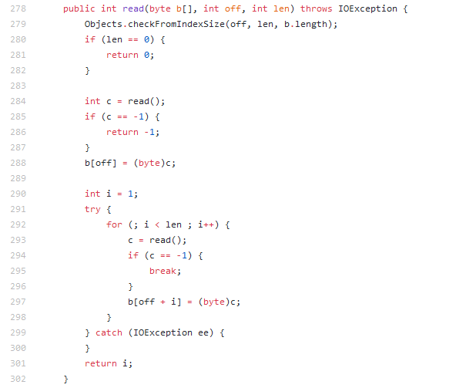

**CFG:**

Paste your CFG here.

**Statement Coverage:**

|  |  |  |  |  |  |
| --- | --- | --- | --- | --- | --- |
| **Test case#** | **Input** | **Output** | **Expected Output** | **Pass/Fail** | **Comments/Remarks** |
| **Cell 1** | Cell 2 | Cell 3 |  |  |  |
| **Cell 4** | Cell 5 | Cell 6 |  |  |  |

**Branch Coverage:**

|  |  |  |  |  |  |
| --- | --- | --- | --- | --- | --- |
| **Test case#** | **Input** | **Output** | **Expected Output** | **Pass/Fail** | **Comments/Remarks** |
| **Cell 1** | Cell 2 | Cell 3 |  |  |  |
| **Cell 4** | Cell 5 | Cell 6 |  |  |  |

**Condition Coverage with Short Circuit Evaluation:**

|  |  |  |  |  |  |
| --- | --- | --- | --- | --- | --- |
| **Test case#** | **Input** | **Output** | **Expected Output** | **Pass/Fail** | **Comments/Remarks** |
| **Cell 1** | Cell 2 | Cell 3 |  |  |  |
| **Cell 4** | Cell 5 | Cell 6 |  |  |  |

**Function 6:**

**Source Code:**

**CFG:**

Paste your CFG here.

**Statement Coverage:**

|  |  |  |  |  |  |
| --- | --- | --- | --- | --- | --- |
| **Test case#** | **Input** | **Output** | **Expected Output** | **Pass/Fail** | **Comments/Remarks** |
| **Cell 1** | Cell 2 | Cell 3 |  |  |  |
| **Cell 4** | Cell 5 | Cell 6 |  |  |  |

**Branch Coverage:**

|  |  |  |  |  |  |
| --- | --- | --- | --- | --- | --- |
| **Test case#** | **Input** | **Output** | **Expected Output** | **Pass/Fail** | **Comments/Remarks** |
| **Cell 1** | Cell 2 | Cell 3 |  |  |  |
| **Cell 4** | Cell 5 | Cell 6 |  |  |  |

**Condition Coverage with Short Circuit Evaluation:**

|  |  |  |  |  |  |
| --- | --- | --- | --- | --- | --- |
| **Test case#** | **Input** | **Output** | **Expected Output** | **Pass/Fail** | **Comments/Remarks** |
| **Cell 1** | Cell 2 | Cell 3 |  |  |  |
| **Cell 4** | Cell 5 | Cell 6 |  |  |  |

**Function 7:**

**Source Code:**

**CFG:**

Paste your CFG here.

**Statement Coverage:**

|  |  |  |  |  |  |
| --- | --- | --- | --- | --- | --- |
| **Test case#** | **Input** | **Output** | **Expected Output** | **Pass/Fail** | **Comments/Remarks** |
| **Cell 1** | Cell 2 | Cell 3 |  |  |  |
| **Cell 4** | Cell 5 | Cell 6 |  |  |  |

**Branch Coverage:**

|  |  |  |  |  |  |
| --- | --- | --- | --- | --- | --- |
| **Test case#** | **Input** | **Output** | **Expected Output** | **Pass/Fail** | **Comments/Remarks** |
| **Cell 1** | Cell 2 | Cell 3 |  |  |  |
| **Cell 4** | Cell 5 | Cell 6 |  |  |  |

**Condition Coverage with Short Circuit Evaluation:**

|  |  |  |  |  |  |
| --- | --- | --- | --- | --- | --- |
| **Test case#** | **Input** | **Output** | **Expected Output** | **Pass/Fail** | **Comments/Remarks** |
| **Cell 1** | Cell 2 | Cell 3 |  |  |  |
| **Cell 4** | Cell 5 | Cell 6 |  |  |  |

**Function 8:**

**Source Code:**

**CFG:**

Paste your CFG here.

**Statement Coverage:**

|  |  |  |  |  |  |
| --- | --- | --- | --- | --- | --- |
| **Test case#** | **Input** | **Output** | **Expected Output** | **Pass/Fail** | **Comments/Remarks** |
| **Cell 1** | Cell 2 | Cell 3 |  |  |  |
| **Cell 4** | Cell 5 | Cell 6 |  |  |  |

**Branch Coverage:**

|  |  |  |  |  |  |
| --- | --- | --- | --- | --- | --- |
| **Test case#** | **Input** | **Output** | **Expected Output** | **Pass/Fail** | **Comments/Remarks** |
| **Cell 1** | Cell 2 | Cell 3 |  |  |  |
| **Cell 4** | Cell 5 | Cell 6 |  |  |  |

**Condition Coverage with Short Circuit Evaluation:**

|  |  |  |  |  |  |
| --- | --- | --- | --- | --- | --- |
| **Test case#** | **Input** | **Output** | **Expected Output** | **Pass/Fail** | **Comments/Remarks** |
| **Cell 1** | Cell 2 | Cell 3 |  |  |  |
| **Cell 4** | Cell 5 | Cell 6 |  |  |  |

**Function 9:**

**Source Code:**

**CFG:**

Paste your CFG here.

**Statement Coverage:**

|  |  |  |  |  |  |
| --- | --- | --- | --- | --- | --- |
| **Test case#** | **Input** | **Output** | **Expected Output** | **Pass/Fail** | **Comments/Remarks** |
| **Cell 1** | Cell 2 | Cell 3 |  |  |  |
| **Cell 4** | Cell 5 | Cell 6 |  |  |  |

**Branch Coverage:**

|  |  |  |  |  |  |
| --- | --- | --- | --- | --- | --- |
| **Test case#** | **Input** | **Output** | **Expected Output** | **Pass/Fail** | **Comments/Remarks** |
| **Cell 1** | Cell 2 | Cell 3 |  |  |  |
| **Cell 4** | Cell 5 | Cell 6 |  |  |  |

**Condition Coverage with Short Circuit Evaluation:**

|  |  |  |  |  |  |
| --- | --- | --- | --- | --- | --- |
| **Test case#** | **Input** | **Output** | **Expected Output** | **Pass/Fail** | **Comments/Remarks** |
| **Cell 1** | Cell 2 | Cell 3 |  |  |  |
| **Cell 4** | Cell 5 | Cell 6 |  |  |  |

**Function 10:**

**Source Code:**

**CFG:**

Paste your CFG here.

**Statement Coverage:**

|  |  |  |  |  |  |
| --- | --- | --- | --- | --- | --- |
| **Test case#** | **Input** | **Output** | **Expected Output** | **Pass/Fail** | **Comments/Remarks** |
| **Cell 1** | Cell 2 | Cell 3 |  |  |  |
| **Cell 4** | Cell 5 | Cell 6 |  |  |  |

**Branch Coverage:**

|  |  |  |  |  |  |
| --- | --- | --- | --- | --- | --- |
| **Test case#** | **Input** | **Output** | **Expected Output** | **Pass/Fail** | **Comments/Remarks** |
| **Cell 1** | Cell 2 | Cell 3 |  |  |  |
| **Cell 4** | Cell 5 | Cell 6 |  |  |  |

**Condition Coverage with Short Circuit Evaluation:**

|  |  |  |  |  |  |
| --- | --- | --- | --- | --- | --- |
| **Test case#** | **Input** | **Output** | **Expected Output** | **Pass/Fail** | **Comments/Remarks** |
| **Cell 1** | Cell 2 | Cell 3 |  |  |  |
| **Cell 4** | Cell 5 | Cell 6 |  |  |  |

**Function 11:**

**Source Code:**

**CFG:**

Paste your CFG here.

**Statement Coverage:**

|  |  |  |  |  |  |
| --- | --- | --- | --- | --- | --- |
| **Test case#** | **Input** | **Output** | **Expected Output** | **Pass/Fail** | **Comments/Remarks** |
| **Cell 1** | Cell 2 | Cell 3 |  |  |  |
| **Cell 4** | Cell 5 | Cell 6 |  |  |  |

**Branch Coverage:**

|  |  |  |  |  |  |
| --- | --- | --- | --- | --- | --- |
| **Test case#** | **Input** | **Output** | **Expected Output** | **Pass/Fail** | **Comments/Remarks** |
| **Cell 1** | Cell 2 | Cell 3 |  |  |  |
| **Cell 4** | Cell 5 | Cell 6 |  |  |  |

**Condition Coverage with Short Circuit Evaluation:**

|  |  |  |  |  |  |
| --- | --- | --- | --- | --- | --- |
| **Test case#** | **Input** | **Output** | **Expected Output** | **Pass/Fail** | **Comments/Remarks** |
| **Cell 1** | Cell 2 | Cell 3 |  |  |  |
| **Cell 4** | Cell 5 | Cell 6 |  |  |  |

**Function 12:**

**Source Code:**

**CFG:**

Paste your CFG here.

**Statement Coverage:**

|  |  |  |  |  |  |
| --- | --- | --- | --- | --- | --- |
| **Test case#** | **Input** | **Output** | **Expected Output** | **Pass/Fail** | **Comments/Remarks** |
| **Cell 1** | Cell 2 | Cell 3 |  |  |  |
| **Cell 4** | Cell 5 | Cell 6 |  |  |  |

**Branch Coverage:**

|  |  |  |  |  |  |
| --- | --- | --- | --- | --- | --- |
| **Test case#** | **Input** | **Output** | **Expected Output** | **Pass/Fail** | **Comments/Remarks** |
| **Cell 1** | Cell 2 | Cell 3 |  |  |  |
| **Cell 4** | Cell 5 | Cell 6 |  |  |  |

**Condition Coverage with Short Circuit Evaluation:**

|  |  |  |  |  |  |
| --- | --- | --- | --- | --- | --- |
| **Test case#** | **Input** | **Output** | **Expected Output** | **Pass/Fail** | **Comments/Remarks** |
| **Cell 1** | Cell 2 | Cell 3 |  |  |  |
| **Cell 4** | Cell 5 | Cell 6 |  |  |  |