**Software Testing**

**Project Report**

Session: Spring 2021

**Danish Hasan** MSCS-20001

**Abu Bakar** MSCS-20013

**Musa Khan** MSCS-20065

**Awais** MSCS-20074

**Employee Time Reporting**

Department of Computer Science

**Information Technology University Lahore**

**Pakistan**



## Project Description

### Environment Setup

1. Download maven from here: <https://maven.apache.org/download.cgi>
2. Download and install the mysql workbench from here: <https://dev.mysql.com/downloads/installer/>
3. Download jdk1.8+
4. In the .\timesheet-master\build.bat, set the JAVA_HOME to jdk path and similarly set MAVEN_HOME to the maven path.
5. In the .\timesheet-master\run.bat, set the JAVA_HOME and set CATALINA_HOME to absolute path appended by ".\PaySystem\apache-tomcat-7.0.108-windows-x64\apache-tomcat-7.0.108".
6. Open Command prompt, navigate to project repository i.e .\Paysystem\timesheet-master\ and execute build.bat.
7. This will build the project.
8. Open mysql workbench and enter following two queries:
   1. drop database paysystem;
   2. create database paysystem;
9. When the database is created for first time, only execute the create query.
10. Execute run.bat.

### Description

The project is a lighter version of a pay system for managing the expenses of the employees.

* Adding the new employees in the database.
* Adding the time worked for a specific employee.
* Configuring the database settings.
* Managing the groups in the company.
* Generate the ADP reports of the employees.

### Application Running

After the local server is running, go to <http://localhost:8090/> or you can just go to the application <http://localhost:8090/PaySystem>

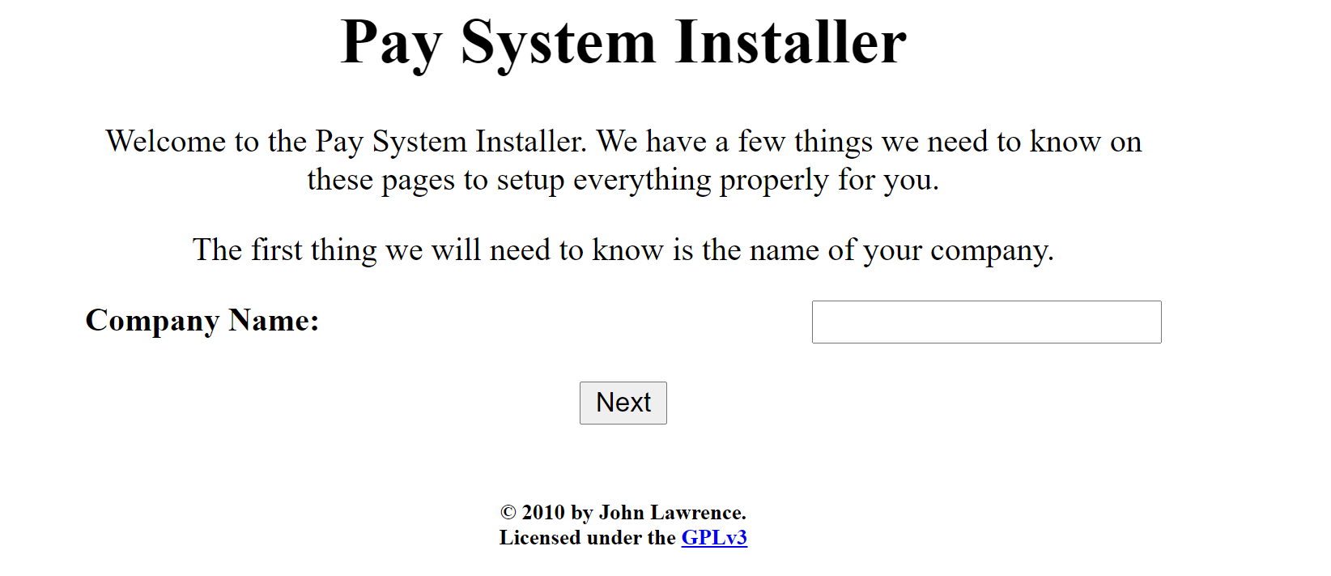

Enter the company name, and then click next.

Then you will be redirected to add information about the database. To avoid confusion, database username and database password are kept same.

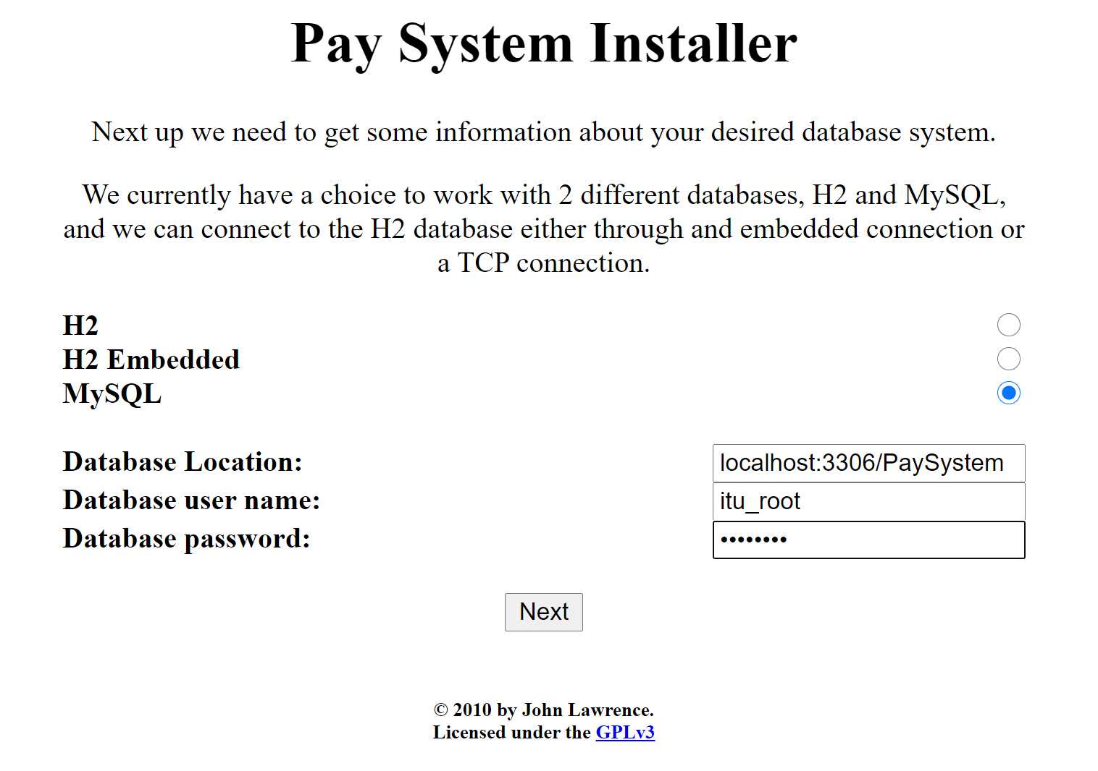

You will be redirected to add username and password for the user purpose. These are also kept same.

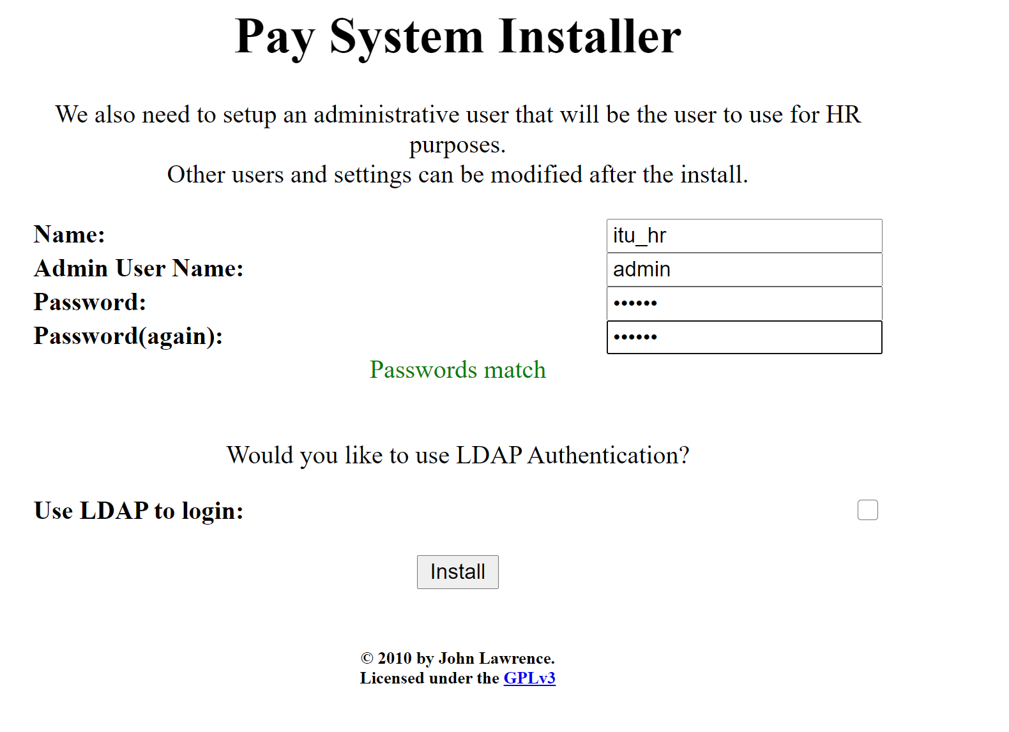

You will be redirected to the login page.

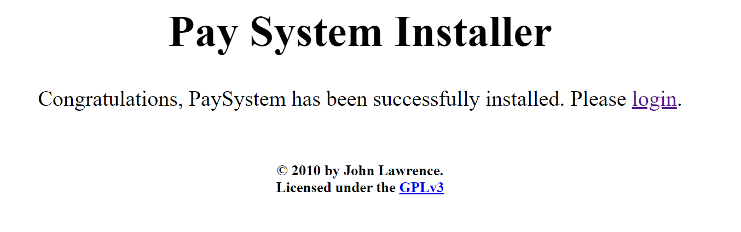

After clicking login, Login using the username you set earlier.

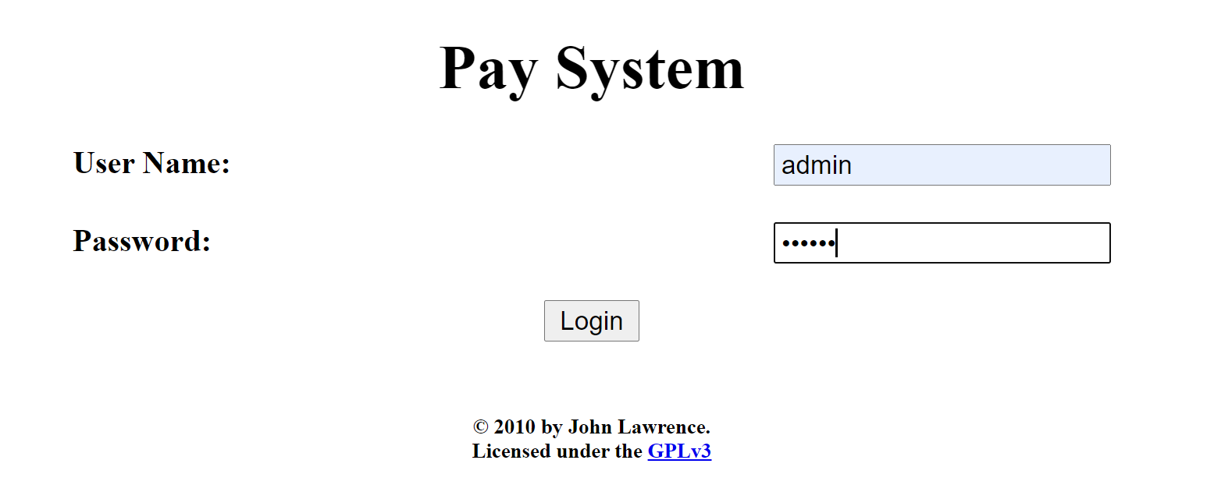

After login you will be directed to the dashboard. Below is the full dashboard.

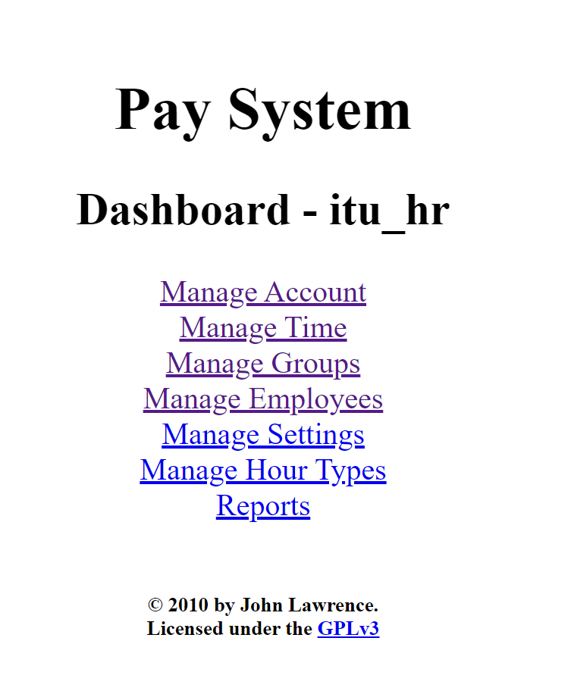

In the manage account section, you can add the wage.

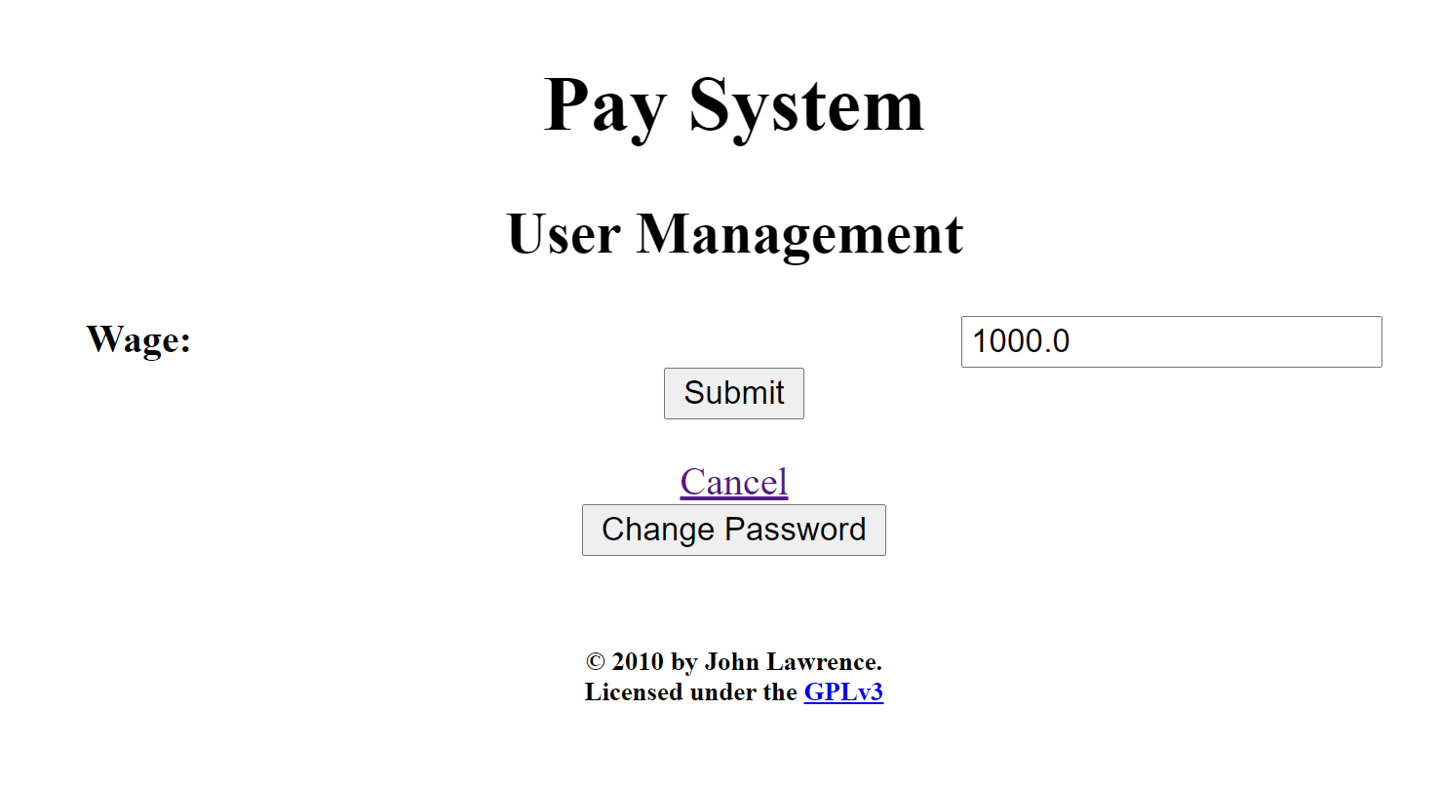

In the manage employee section, you can add/delete the employees.

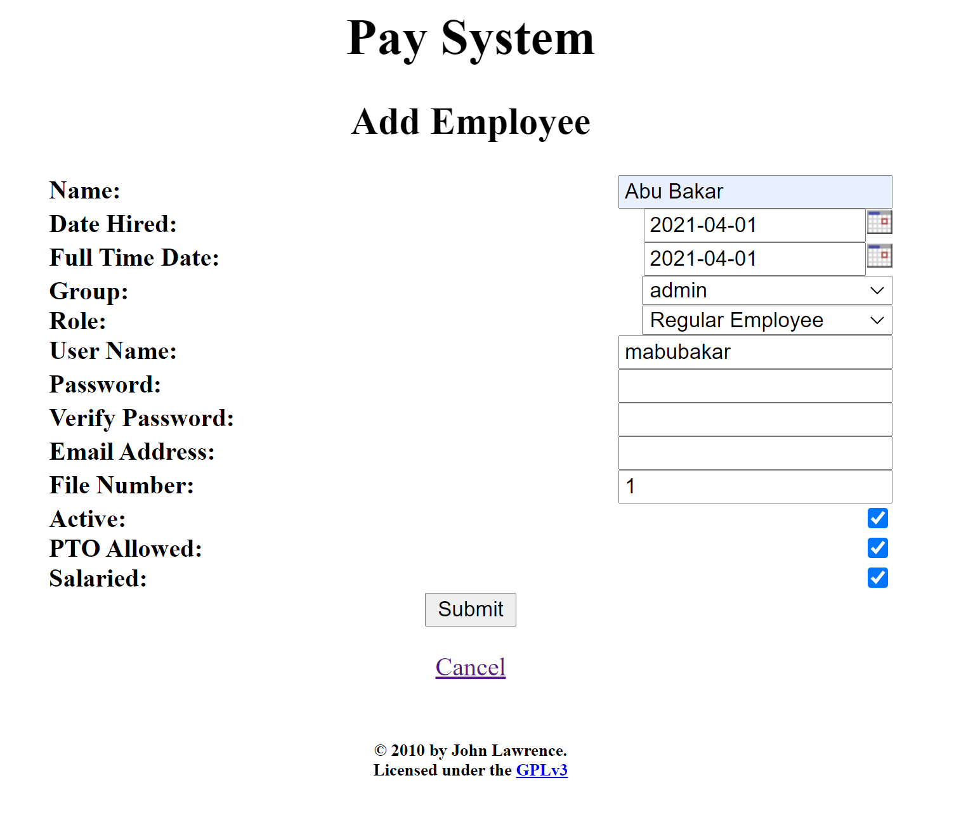

In the manage settings section, you can change the settings.

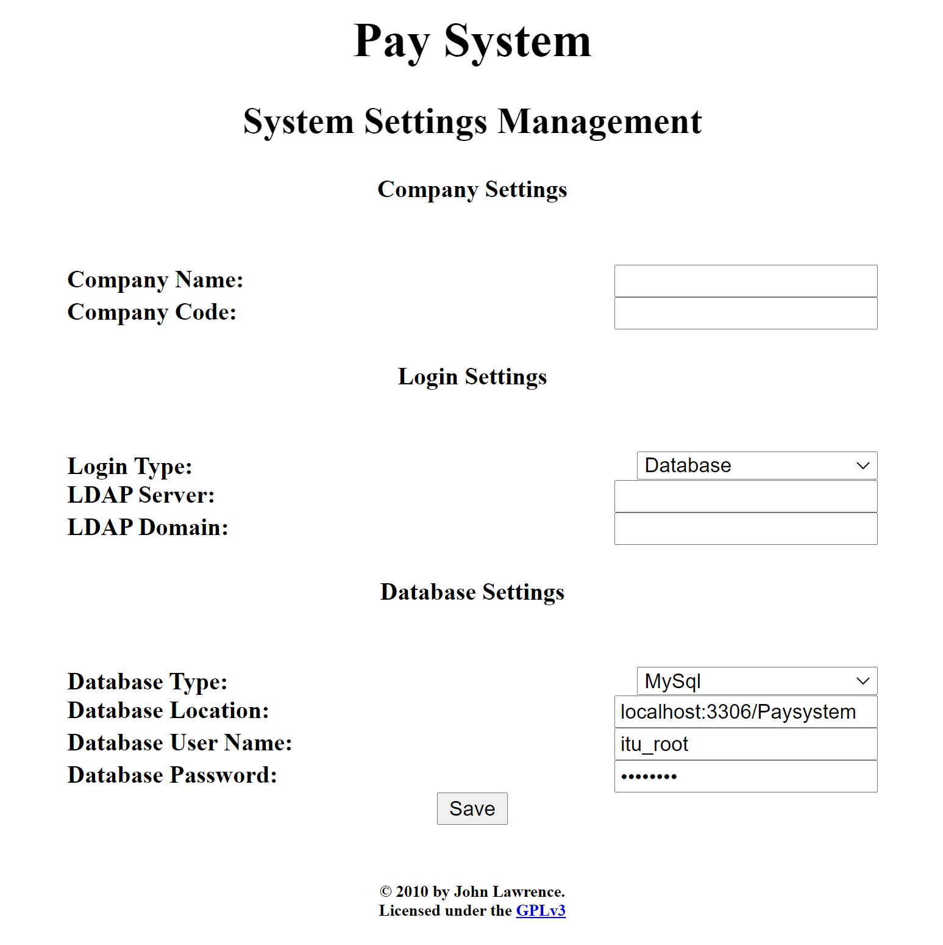

In the hour management section, you can add/delete/edit the hour types.

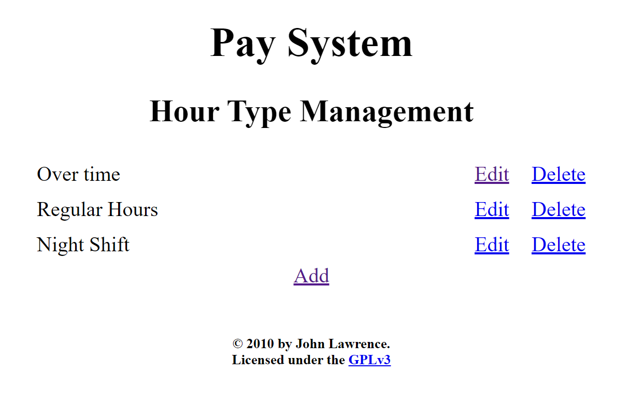

In the group management section, you can add/delete/edit the groups.

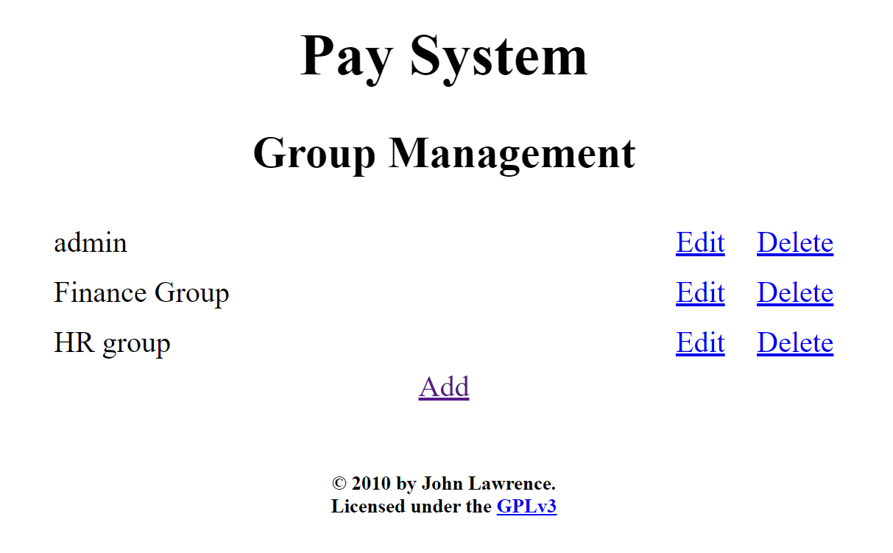

In the report section, you can generate the reports.

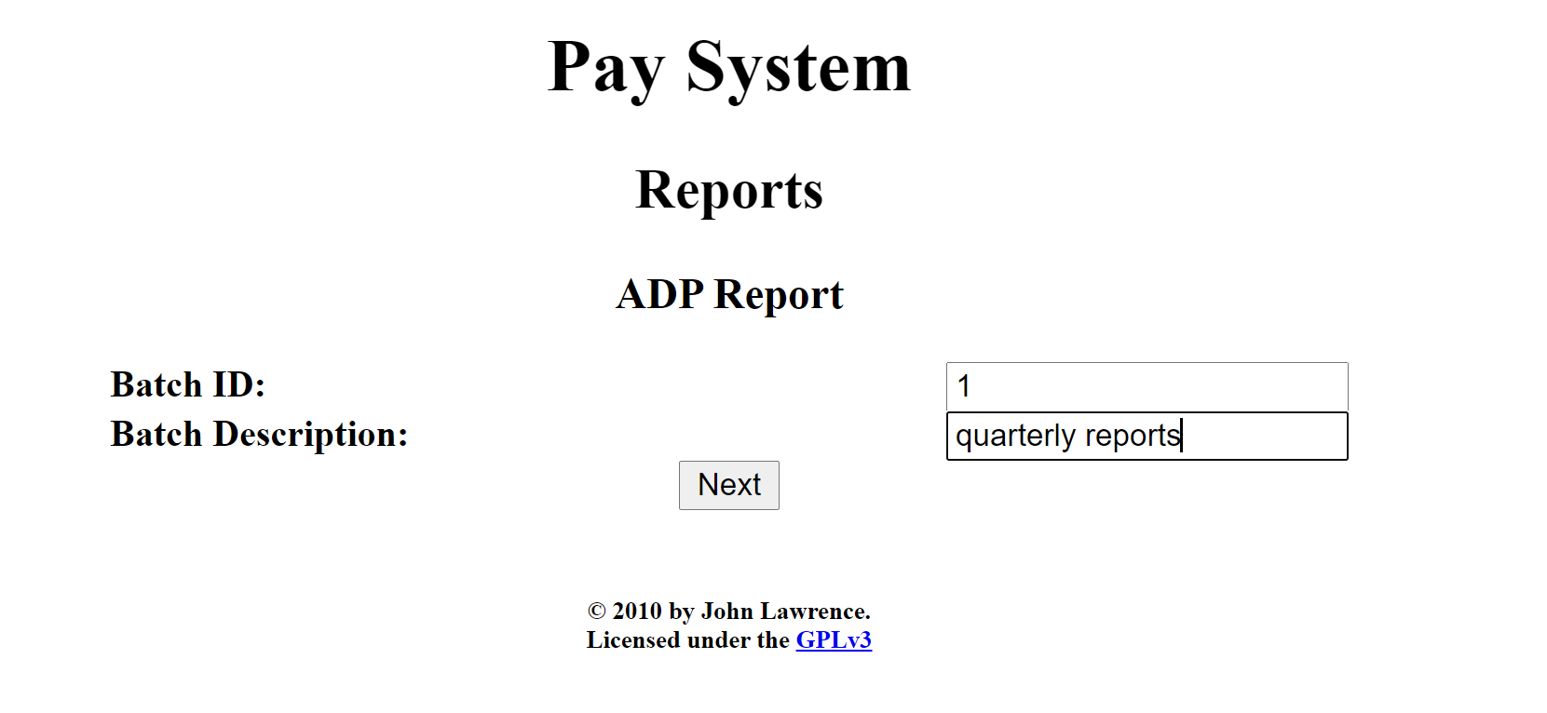

For the report generation, you can add the data for the employee.

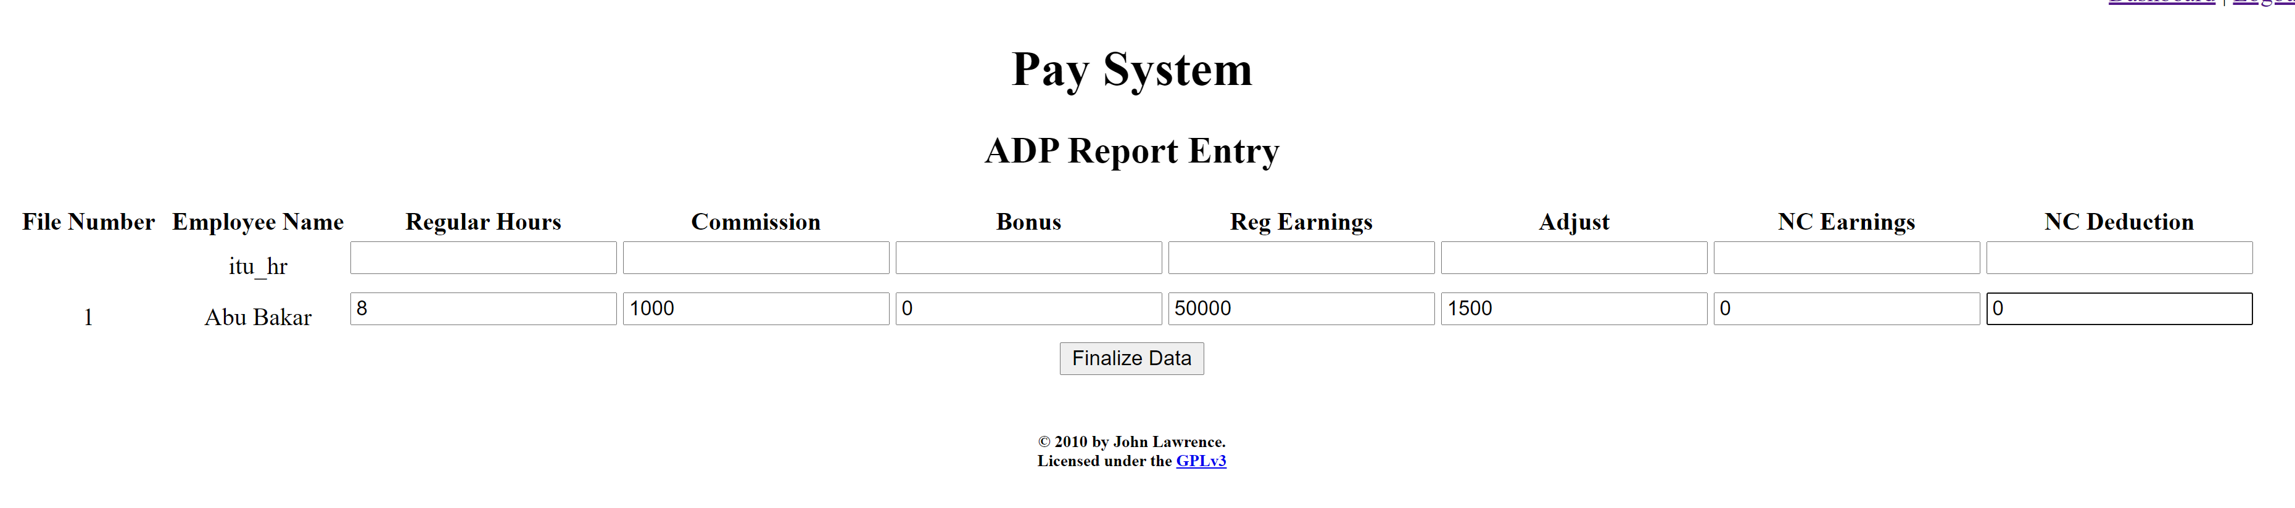

After clicking the finalize data, a csv file is downloaded.

## White-Box Testing

### **Function 1**:

Encodes a byte array into Base64 format.

Note: map[] table is populated in another constructor function.

**Source Code:**

timesheet-master\src\main\java\timeSheet\util\properties\Base64Coder.java

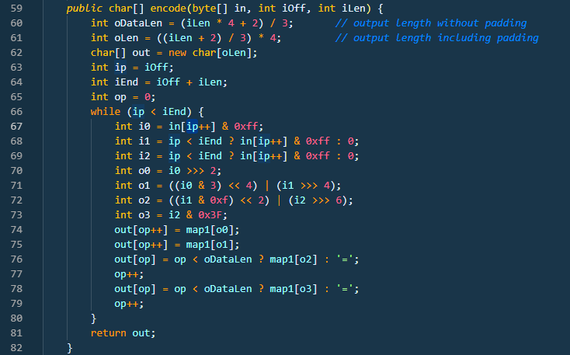

**CFG:**

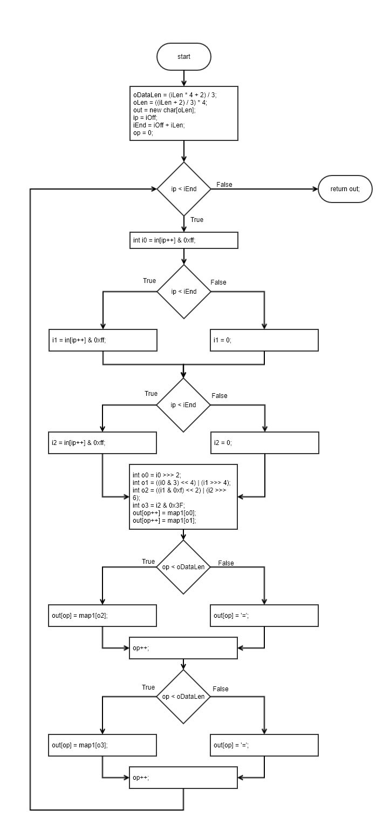

**Statement Coverage:**

|  |  |  |  |  |  |
| --- | --- | --- | --- | --- | --- |
| **Test case#** | **Input** | **Output** | **Expected Output** | **Pass/Fail** | **Comments/Remarks** |
| **1** | In[] = {‘A’, ‘B’, ‘C’};  iOff = 0;  iLen = 3; | QUJD | QUJD | Pass | Covers all statements |

**Branch Coverage:**

|  |  |  |  |  |  |
| --- | --- | --- | --- | --- | --- |
| **Test case#** | **Input** | **Output** | **Expected Output** | **Pass/Fail** | **Comments/Remarks** |
| **1** | In[] = {‘A’, ‘B’, ‘C’};  iOff = 0;  iLen = 3; | QUJD | QUJD | Pass | Covers 66TF, 68T, 69T, 76T, 78T |
| **2** | In[] = {‘A’, ‘B’, ‘C’};  iOff = 0;  iLen = 1; | QQ== | QQ== | Pass | Covers 66TF, 68F, 69F, 76F, 78F |

**Condition Coverage with Short Circuit Evaluation:**

|  |  |  |  |  |  |
| --- | --- | --- | --- | --- | --- |
| **Test case#** | **Input** | **Output** | **Expected Output** | **Pass/Fail** | **Comments/Remarks** |
| **1** | In[] = {‘A’, ‘B’, ‘C’};  iOff = 0;  iLen = 3; | QUJD | QUJD | Pass | Covers 66TF, 68T, 69T, 76T, 78T |
| **2** | In[] = {‘A’, ‘B’, ‘C’};  iOff = 0;  iLen = 1; | QQ== | QQ== | Pass | Covers 66TF, 68F, 69F, 76F, 78F |

**Boundary Interior:**

Possible logical paths

* 68T, 69T, 76T, 78T
* 68T, 69F, 76T, 78F
* 68F, 69F, 76F, 78F

|  |  |  |  |  |  |
| --- | --- | --- | --- | --- | --- |
| **Test case#** | **Input** | **Output** | **Expected Output** | **Pass/Fail** | **Comments/Remarks** |
| **1** | In[] = {‘A’, ‘B’, ‘C’};  iOff = 0;  iLen = 3; | QUJD | QUJD | Pass | Covers 68T, 69T, 76T, 78T |
| **2** | In[] = {‘A’, ‘B’, ‘C’};  iOff = 0;  iLen = 1; | QQ== | QQ== | Pass | Covers 68F, 69F, 76F, 78F |
| **3** | In[] = {‘A’, ‘B’, ‘C’};  iOff = 0;  iLen = 2; | QUI= | QUI= | Pass | Covers 68T, 69F, 76T, 78F |

**Loop Boundary:**

Consider N for loop boundary as 5

|  |  |  |  |  |  |
| --- | --- | --- | --- | --- | --- |
| **Test case#** | **Input** | **Output** | **Expected Output** | **Pass/Fail** | **Comments/Remarks** |
| **1** | In[] = {‘A’, ‘B’, ‘C’};  iOff = 0;  iLen = 0; | Empty string | Empty string | Pass | Covers 66F |
| **2** | In[] = {‘A’, ‘B’, ‘C’};  iOff = 0;  iLen = 3; | QUJD | QUJD | Pass | Covers 66T once |
| **3** | In[] = {‘A’, ‘B’, ‘C’, ‘D’};  iOff = 0;  iLen = 4; | QUJDRA== | QUJDRA== | Pass | Covers 66T at N-1 |
| **4** | In[] = {‘A’, ‘B’, ‘C’, ‘D’, ‘E’};  iOff = 0;  iLen = 5; | QUJDREU= | QUJDREU= | Pass | Covers 66T at N |
| **54** | In[] = {‘A’, ‘B’, ‘C’, ‘D’, ‘E’, ‘F’};  iOff = 0;  iLen = 6; | QUJDREVG | QUJDREVG | Pass | Covers 66T at N+1 |

**Basis Path:**

Path 1: 66F

Path 2: 66T, 68T, 69T, 76T, 78T

Path 3: 66T, 68T, 69F, 76T, 78F

Path 4: 66T, 68F, 69F, 76F, 78F

Note that no logical path is possible to cause 69T while 68F. Same is case with 76F and 78T. Similarly, conditions in 76 and 78 also depend upon same factor as 68, 69 so it is not possible for 68T but 76F and vice versa.

|  |  |  |  |  |  |
| --- | --- | --- | --- | --- | --- |
| **Test case#** | **Input** | **Output** | **Expected Output** | **Pass/Fail** | **Comments/Remarks** |
| **1** | In[] = {‘A’, ‘B’, ‘C’};  iOff = 0;  iLen = 3; | QUJD | QUJD | Pass | Covers Path2 |
| **2** | In[] = {‘A’, ‘B’, ‘C’};  iOff = 0;  iLen = 1; | QQ== | QQ== | Pass | Covers Path4 |
| **3** | In[] = {‘A’, ‘B’, ‘C’};  iOff = 0;  iLen = 0; | Empty String | Empty String | Pass | Covers Path1 |
| **4** | In[] = {‘A’, ‘B’, ‘C’};  iOff = 0;  iLen = 2; | QUI= | QUI= | Pass | Covers Path3 |

**Data Flow Testing:**

|  |  |  |  |
| --- | --- | --- | --- |
| **Variable #** | **Variable Name** | **Definitions** | **Uses** |
| 1 | iLen | 59 | 60, 61, 64 |
| 2 | oLen | 61 | 62 |
| 3 | op | 65, 74, 75, 77, 79 | 74, 75, 76, 77, 78, 79 |

|  |  |  |
| --- | --- | --- |
| **Variable #** | **Variable Name** | **DU pairs** |
| 1 | iLen | <59, 60>, <59, 61>, <59, 64> |
| 2 | oLen | <61, 62> |
| 3 | op | <65,74>, <74,75>, <75,76>, <75,77>, <77,78>, <77,79>, <79,74> |

|  |  |  |  |  |  |
| --- | --- | --- | --- | --- | --- |
| **Test case#** | **Input** | **Output** | **Expected Output** | **Pass/Fail** | **Comments/Remarks** |
| **1** | In[] = {‘A’, ‘B’, ‘C’, ‘D’, ‘E’, ‘F’};  iOff = 0;  iLen = 6; | QUJDREVG | QUJDREVG | Pass | iLen = Covers <59, 60>, <59, 61>, <59, 64>  oLen = Covers <61, 62>  op = Covers <65,74>, <74,75>, <75,76>, <75,77>, <77,78>, <77,79>, <79,74> |

### **Function 2:**

**Source Code:**

https://github.com/openjdk/jdk/tree/master/src/java.base/share/classes/java/time/Duration.java

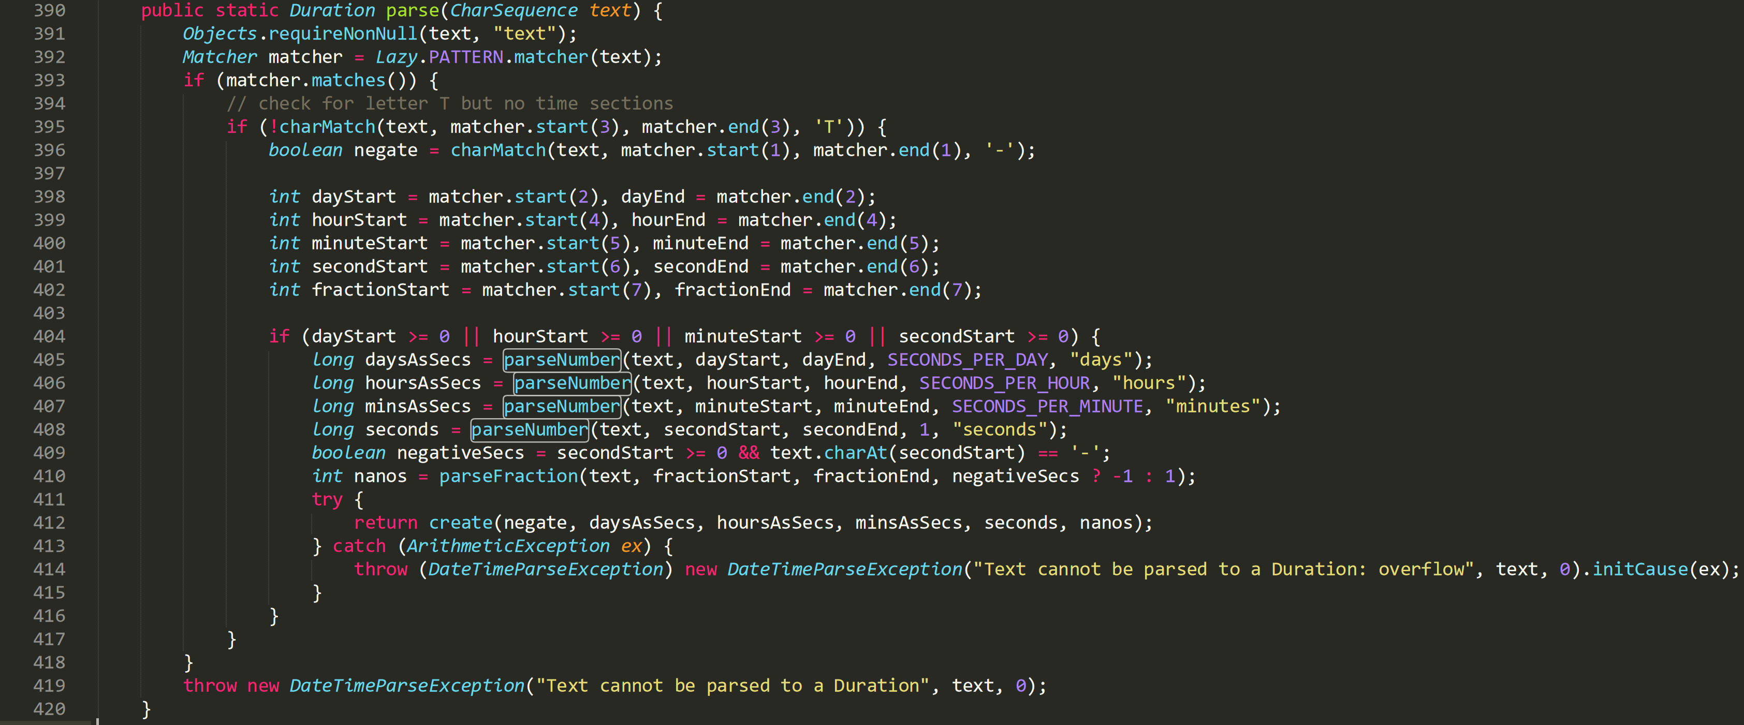**CFG:**

**Statement Coverage:**

Line 414 exception case is not covered under sir’s guidance.

|  |  |  |  |  |  |
| --- | --- | --- | --- | --- | --- |
| **Test case#** | **Input** | **Output** | **Expected Output** | **Pass/Fail** | **Comments/Remarks** |
| **1** | text = “PT6H” | “6 hours” | “6 hours” | Pass | Covers statements from 391 to 395, 398 to 412 |
| **2** | text = “G3D” | “Exception” | “Exception” | Pass | Covers statement 419 |
| **3** | text = “-P2D” | “-2 days” | “-2 days” | Pass | Covers statement 396 |

**Branch Coverage:**

|  |  |  |  |  |  |
| --- | --- | --- | --- | --- | --- |
| **Test case#** | **Input** | **Output** | **Expected Output** | **Pass/Fail** | **Comments/Remarks** |
| **1** | text = “PT6H” | “6 hours” | “6 hours” | Pass | Covers B393T, B395F, B404T |
| **2** | text = “G3D” | Exception | Exception | Pass | Covers B393F |
| **3** | text= “-PT6H3M” | “-6 Hours and -3 minutes” | “-6 Hours and -3 minutes” | Pass | Covers B393T, B395T |
| **4** | text= “PTDHM” | Exception | Exception | Pass | Covers B404F |

**Condition Coverage with Short Circuit Evaluation:**

|  |  |  |  |  |  |
| --- | --- | --- | --- | --- | --- |
| **Test case#** | **Input** | **Output** | **Expected Output** | **Pass/Fail** | **Comments/Remarks** |
| **1** | text = “PT6H” | “6 hours” | “6 hours” | Pass | Covers C393T, C395F,  C404-1T |
| **2** | text = “G3D” | Exception | Exception | Pass | Covers C393F |
| **3** | text= “PT-6D6H” | “-6 Days and 6 Hours” | “-6 Days and 6 Hours” | Pass | Covers C393T, C395T, C404-1F, C404-2T |
| **4** | text= “PT-6D-6H6M” | “-6 Days and -6 Hours and 6 minutes” | “-6 Days and -6 Hours and 6 minutes” | Pass | Covers C393T, C395T, C404-1F, C404-2F, C404-3T |
| **5** | text= “PT-6D-6H-6M6S” | “-6 Days and -6 Hours and -6 minutes and 6 seconds” | “-6 Days and -6 Hours and -6 minutes and 6 seconds” | Pass | Covers C393T, C395T, C404-1F, C404-2F, C404-3F, C404-4T |
| **6** | text= “PT-6D-6H-6M-6S” | Exception | Exception | Pass | Covers C393T, C395T, C404-1F, C404-2F, C404-3F, C404-4F |

**Boundary Interior:**

Boundary Interior Technique cannot be applied to this function because it does not contain any loop.

**Loop Boundary:**

Loop Boundary Technique cannot be applied to this function because it does not contain any loop.

**Basis Path:**

No. of Basis Paths = No. of decision points + 1

No. of Basis Paths = 3 + 1 = 4

Path 1: ABCDEFG

Path 2: ABH

Path 3: ABCEFG

Path 4: ABCEFH

|  |  |  |  |  |  |
| --- | --- | --- | --- | --- | --- |
| **Test case#** | **Input** | **Output** | **Expected Output** | **Pass/Fail** | **Comments/Remarks** |
| **1** | text  = “PT-6H3M” | “6 Hours and -3 minutes” | “6 Hours and -3 minutes” | Pass | Covers path ABCDEFG |
| **2** | text = “G3D” | “Exception” | “Exception” | Pass | Covers path ABH |
| **3** | text = “PT6H” | “6 hours” | “6 hours” | Pass | Covers ABCEFG |
| **4** | text= “PTDHM” | Exception | Exception | Pass | Covers ABCEFH |

**Data Flow Testing:**

|  |  |  |  |
| --- | --- | --- | --- |
| **Variable #** | **Variable Name** | **Definitions** | **Uses** |
| 1 | matcher | 392 | 393, 395, 396, 398, 399, 400, 401, 402 |
| 2 | dayStart | 398 | 404, 405 |
| 3 | hourStart | 399 | 404, 406 |

|  |  |  |
| --- | --- | --- |
| **Variable #** | **Variable Name** | **DU pairs** |
| 1 | Matcher | <392, 393> <392, 395> <392, 396>  <392, 398> <392, 399> <392, 400> <392, 401> <392, 402> |
| 2 | dayStart | <398, 404> <398,405> |
| 3 | hourStart | <399, 404> <399,406> |

|  |  |  |  |  |  |
| --- | --- | --- | --- | --- | --- |
| **Test case#** | **Input** | **Output** | **Expected Output** | **Pass/Fail** | **Comments/Remarks** |
| **1** | text  =“-PT2D6H4M20.345S” | “-2 days and -6 Hours and -4 minutes and -20.345 seconds” | “-2 days and -6 Hours and -4 minutes and -20.345 seconds” | Pass | For matcher : Covers  <392, 393>  <392, 395>  <392, 396>  <392, 398>  <392, 399>  <392, 400>  <392, 401>  <392, 402>  For dayStart: Covers  <398, 404> <398, 405>  For hourStar: Covers  <398, 404> <398, 406> |

### **Function 3:**

**Source Code:**

https://github.com/openjdk/jdk/tree/master/src/java.base/share/classes/java/math/ MutableBigInteger.java

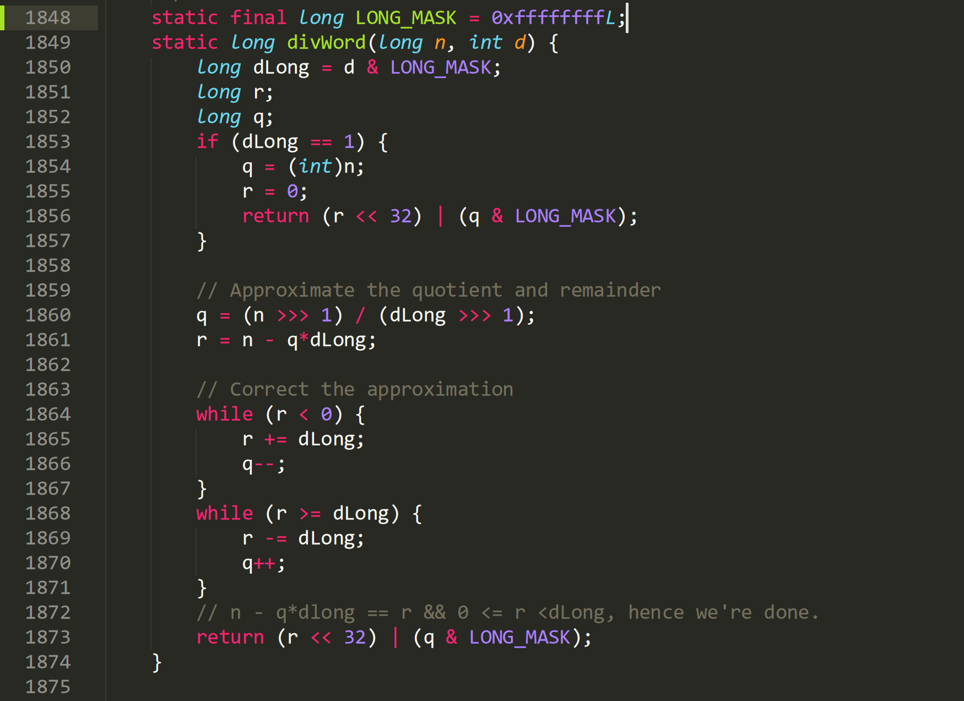

**CFG:**

**Statement Coverage:**

|  |  |  |  |  |  |
| --- | --- | --- | --- | --- | --- |
| **Test case#** | **Input** | **Output** | **Expected Output** | **Pass/Fail** | **Comments/Remarks** |
| **1** | n = 16  d = 1 | 16 | 16 | Pass | Covers Statement 1850-1857 |
| **2** | n = 10  d = 3 | 4294967299 | 4294967299 | Pass | Covers Statement 1850,1851,1852, 1860-1868, 1873 |
| **3** | - | - | - | - | Statement 1869- 1870 I think this is a dead code, I could not find any such case in which the condition at 1868 becomes True |

**Branch Coverage:**

|  |  |  |  |  |  |
| --- | --- | --- | --- | --- | --- |
| **Test case#** | **Input** | **Output** | **Expected Output** | **Pass/Fail** | **Comments/Remarks** |
| **1** | n = 16  d = 1 | 16 | 16 | Pass | Covers B1853T |
| **2** | n = 10  d = 3 | 4294967299 | 4294967299 | Pass | Covers B1853F , B1864TF, B1864F |
| **3** | - | - | - | - | Statement 1869- 1870 I think this is a dead code, I could not find any such case in which the condition at 1868 becomes True |

**Condition Coverage with Short Circuit Evaluation:**

|  |  |  |  |  |  |
| --- | --- | --- | --- | --- | --- |
| **Test case#** | **Input** | **Output** | **Expected Output** | **Pass/Fail** | **Comments/Remarks** |
| **1** | n = 16  d = 1 | 16 | 16 | Pass | Covers C1853T |
| **2** | n = 10  d = 3 | 4294967299 | 4294967299 | Pass | Covers C1853F , C1864TF, C1864F |
| **3** | - | - | - | - | Statement 1869- 1870 I think this is a dead code, I could not find any such case in which the condition at 1868 becomes True |

**Boundary Interior:**

|  |  |  |  |  |  |
| --- | --- | --- | --- | --- | --- |
| **Test case#** | **Input** | **Output** | **Expected Output** | **Pass/Fail** | **Comments/Remarks** |
| **1** | n = 10  d = 3 | 4294967299 | 4294967299 | Pass | Covers loop starting at Line 1864. This while loop has only one path. |
| **2** | - | - | - | - | Statement 1869- 1870 I think this is a dead code, I could not find any such case in which the condition at 1868 becomes True. |

**Loop Boundary:**

I think Loop at line 1868 is a dead code, I could not find any such case in which the condition at 1868 becomes True.

**Test cases are only for the loop at line 1864.**

I choose loop upper bound = 5

|  |  |  |  |  |  |
| --- | --- | --- | --- | --- | --- |
| **Test case#** | **Input** | **Output** | **Expected Output** | **Pass/Fail** | **Comments/Remarks** |
| **1** | n =10  d = 5 | 2 | 2 | Pass | Loop at line 1864 is skipped entirely. |
| **2** | n =5  d = 3 | 8589934593 | 8589934593 | Pass | Loop at line 1864 is run only once |
| **3** | n = 14  d = 6 | 8589934596 | 8589934596 | Pass | Loop at line 1864 is run 3 times. |
| **4** | n =20  d =3 | 8589934598 | 8589934598 | Pass | Loop at line 1864 is run 4 times |
| **5** | n = 28  d = 3 | 4294967305 | 4294967305 | Pass | Loop at line 1864 is run 5 times. |
| **6** | n = 32  d = 3 | 8589934602 | 8589934602 | Pass | Loop at line 1864 is run 6 times. |

**Basis Path:**

No. of Basis Paths = No. of decision points + 1

No. of Basis Paths = 3 + 1 = 4

Path 1: ABD

Path 2: ABCEFGHI

Path 3: ABCEFGI

Path 4: ABCEGI

|  |  |  |  |  |  |
| --- | --- | --- | --- | --- | --- |
| **Test case#** | **Input** | **Output** | **Expected Output** | **Pass/Fail** | **Comments/Remarks** |
| **1** | n = 16  d = 1 | 16 | 16 | Pass | Covers path ABD |
| **2** | - | - | - | - | Path ABCEFGHI cannot be covered since the condition in the G block is never True so H block cannot be executed. |
| **3** | n =5  d = 3 | 8589934593 | 8589934593 | Pass | Covers path ABCEFGI |
| **4** | n = 10  d = 2 | 5 | 5 | Pass | Covers path ABCEGI |

**Data Flow Testing:**

|  |  |  |  |
| --- | --- | --- | --- |
| **Variable #** | **Variable Name** | **Definitions** | **Uses** |
| 1 | dLong | 1850 | 1853, 1860, 1861, 1865, 1868, 1869 |
| 2 | n | 1849 | 1854, 1860, 1861 |
| 3 | q | 1854, 1860, 1866, 1870 | 1856, 1861, 1866, 1870, 1873 |

|  |  |  |
| --- | --- | --- |
| **Variable #** | **Variable Name** | **DU pairs** |
| 1 | dLong | <1850,1853> <1850,1860> <1850,1861> <1850,1865>  <1850,1868> <1850,1869> |
| 2 | n | <1849,1854> <1849,1860> <1850,1861> |
| 3 | q | <1854, 1856> <1860, 1861>  <1860, 1866> <1860, 1870>  <1860, 1873>  <1866, 1866> <1866, 1870>  <1866, 1873>  <1870, 1870> <1870, 1873> |

|  |  |  |  |  |  |
| --- | --- | --- | --- | --- | --- |
| **Test case#** | **Input** | **Output** | **Expected Output** | **Pass/Fail** | **Comments/Remarks** |
| **1** | n = 28  d = 3 | 4294967305 | 4294967305 | Pass | For dLong covers:  <1850,1853> <1850,1860> <1850,1861> <1850,1865>  <1850,1868>  For n covers:  <1849,1860> <1850,1861>  For q covers:  <1860, 1861>  <1860,1866>  <1866, 1866> <1866, 1873> |
| **2** | n = 10  d = 1 | 10 | 10 | Pass | For dLong covers:  <1850,1853> For n covers:  <1849,1854>  For q covers:  <1854,1856> |
| **3** | n = 10  d = 2 | 5 | 5 | Pass | For dLong covers:  <1850,1853>  <1850,1860>  <1850,1861> For n covers:  <1849,1860>  <1849,1861>  For q covers:  <1860, 1873> |
| **-** | - | - | - | - | For q these DU pairs cannot be covered: <1870, 1870>  <1870, 1873>  <1866, 1870>  <1866, 1873> |

### **Function 4:**

Decodes a byte array from Base64 format.

Note: map2[] table is populated in another constructor function.

**Source Code:**

timesheet-master\src\main\java\timeSheet\util\properties\Base64Coder.java

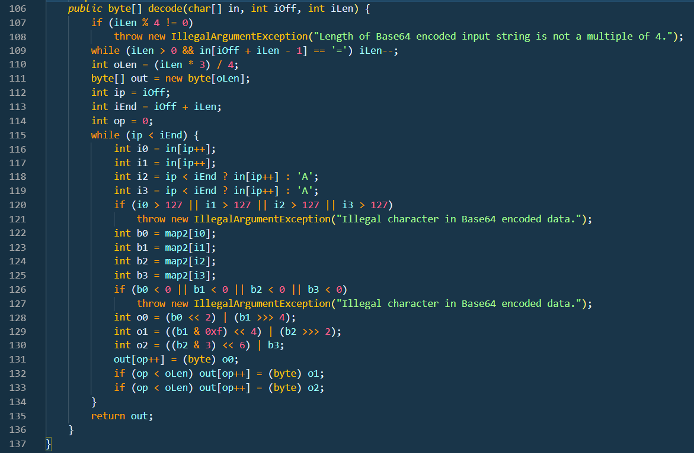

**CFG:**

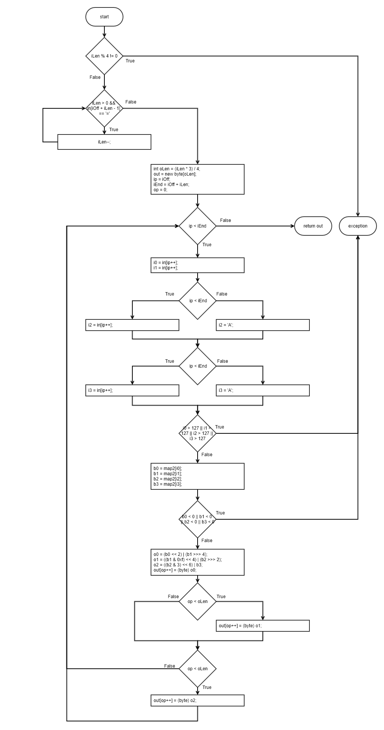

**Statement Coverage:**

Exception cases are not covered under sir’s guidance.

|  |  |  |  |  |  |
| --- | --- | --- | --- | --- | --- |
| **Test case#** | **Input** | **Output** | **Expected Output** | **Pass/Fail** | **Comments/Remarks** |
| **1** | In[] = ‘QUJD’  iOff = 0  iLen = 4 | ‘ABC’ | ‘ABC’ | Pass | No padding |
| **2** | In[] = ‘QQ==’  iOff = 0  iLen = 4 | ‘A’ | ‘A’ | Pass | Padded with == |

**Branch Coverage:**

Exception cases are not covered under sir’s guidance.

|  |  |  |  |  |  |
| --- | --- | --- | --- | --- | --- |
| **Test case#** | **Input** | **Output** | **Expected Output** | **Pass/Fail** | **Comments/Remarks** |
| **1** | In[] = ‘QUJD’  iOff = 0  iLen = 4 | ‘ABC’ | ‘ABC’ | Pass | 109F, 115TF, 118T, 119T, 132T, 133T |
| **2** | In[] = ‘QQ==’  iOff = 0  iLen = 4 | ‘A’ | ‘A’ | Pass | 109TF, 115TF, 118F, 119F, 132F, 133F |

**Condition Coverage with Short Circuit Evaluation:**

Exception cases are not covered under sir’s guidance.

|  |  |  |  |  |  |
| --- | --- | --- | --- | --- | --- |
| **Test case#** | **Input** | **Output** | **Expected Output** | **Pass/Fail** | **Comments/Remarks** |
| **1** | In[] = ‘QUJD’  iOff = 0  iLen = 0 | Empty String | Empty String | Pass | 109aF, 115F |
| **2** | In[] = ‘QUJD’  iOff = 0  iLen = 4 | ‘ABC’ | ‘ABC’ | Pass | 109aT, 109bF, 115TF, 118T, 119T, 132T, 133T |
| **3** | In[] = ‘QQ==’  iOff = 0  iLen = 4 | ‘A’ | ‘A’ | Pass | 109aT, 109bTF, 115TF, 118F, 119F, 132F, 133F |

**Boundary Interior:**

Exception cases are not covered under sir’s guidance.

Possible logical paths:

* 118T, 119T, 132T, 133T
* 118T, 119F, 132T, 133F
* 118F, 119F, 132T, 133F

|  |  |  |  |  |  |
| --- | --- | --- | --- | --- | --- |
| **Test case#** | **Input** | **Output** | **Expected Output** | **Pass/Fail** | **Comments/Remarks** |
| **1** | In[] = ‘QUJD’  iOff = 0  iLen = 4 | ‘ABC’ | ‘ABC’ | Pass | Covers 118T, 119T, 132T, 133T |
| **2** | In[] = ‘QQ==’  iOff = 0  iLen = 4 | ‘A’ | ‘A’ | Pass | Covers 118F, 119F, 132F, 133F |
| **3** | In[] = ‘QUI=’  iOff = 0  iLen = 4 | ‘AB’ | ‘AB’ | Pass | Covers 118T, 119F, 132T, 133F |

**Loop Boundary:**

Consider N=12 for loop. (Note that for valid input N-1 must be 8 and N+1 must be 16)

|  |  |  |  |  |  |
| --- | --- | --- | --- | --- | --- |
| **Test case#** | **Input** | **Output** | **Expected Output** | **Pass/Fail** | **Comments/Remarks** |
| **1** | In[] = ‘QUJD’  iOff = 0  iLen = 0 | Empty String | Empty String | Pass | Covers 115F |
| **2** | In[] = ‘QUJD’  iOff = 0  iLen = 4 | ‘ABC’ | ‘ABC’ | Pass | Covers 115F once |
| **3** | In[] = ‘QUJDREU=’  iOff = 0  iLen = 8 | ‘ABCDE’ | ‘ABCDE’ | Pass | Covers 115T for N-1 |
| **4** | In[] = ‘QUJDREVGRw==’  iOff = 0  iLen = 12 | ‘ABCDEFG’ | ‘ABCDEFG’ | Pass | Covers 115T for N |
| **5** | In[] = ‘QUJDREVGR0hJSg==’  iOff = 0  iLen = 16 | ‘ABCDEFGHIJ’ | ‘ABCDEFGHIJ’ | Pass | Covers 115T for N+1 |

**Basis Path:**

Path 1: 109F, 115F

Path 2: 109F, 115T, 118T, 119T, 132T, 133T

Path 3: 109T, 115F

Path 4: 109T, 115T, 118T, 119F, 132T, 133F

Path 5: 109T, 115T, 118F, 119F, 132F, 133F

Note that no logical path is possible to cause 119T while 118F. Same is case with 132F and 133T. Similarly, conditions in 132 and 133 also depend upon same factor as 118, 119 so it is not possible for 118T but 132F and vice versa. Furthermore, condition 109 also shares data dependency with 118, 119, 132, 133.

|  |  |  |  |  |  |
| --- | --- | --- | --- | --- | --- |
| **Test case#** | **Input** | **Output** | **Expected Output** | **Pass/Fail** | **Comments/Remarks** |
| **1** | In[] = ‘QUJD’  iOff = 0  iLen = 0 | Empty String | Empty String | Pass | Covers Path1 |
| **2** | In[] = ‘QUJD’  iOff = 0  iLen = 4 | ‘ABC’ | ‘ABC’ | Pass | Covers Path2 |
| **3** | In[] = ‘QQ==’  iOff = 2  iLen = 4 | Empty String | Empty String | Pass | Covers Path3 |
| **4** | In[] = ‘QQ==’  iOff = 0  iLen = 4 | ‘A’ | ‘A’ | Pass | Covers Path5 |
| **5** | In[] = ‘QUI=’  iOff = 0  iLen = 4 | ‘AB’ | ‘AB’ | Pass | Covers Path4 |

**Data Flow Testing:**

Exceptions cases not considered under sir’s guidance

|  |  |  |  |
| --- | --- | --- | --- |
| **Variable #** | **Variable Name** | **Definitions** | **Uses** |
| 1 | iLen | 106, 109 | 109, 110, 113 |
| 2 | oLen | 110 | 111, 132, 133 |
| 3 | op | 114, 131, 132, 133 | 131, 132, 133 |

|  |  |  |
| --- | --- | --- |
| **Variable #** | **Variable Name** | **DU pairs** |
| 1 | iLen | <106, 109>, <109, 109>, <106, 113>, <109, 113>, <106, 110>, <109, 110> |
| 2 | oLen | <110, 111>, <110, 132>, <110, 133> |
| 3 | op | <114, 131>, <131, 132>, <131, 133>, <132, 133> |

|  |  |  |  |  |  |
| --- | --- | --- | --- | --- | --- |
| **Test case#** | **Input** | **Output** | **Expected Output** | **Pass/Fail** | **Comments/Remarks** |
| **1** | In[] = ‘QUJD’  iOff = 0  iLen = 4 | ‘ABC’ | ‘ABC’ | Pass | iLen = Covers <106, 109>, <106, 110>, <106, 113>  oLen = Covers <110, 111>, <110, 132>, <110, 133>  op = Covers <114, 131>, <131, 132>, <132, 133> |
| **2** | In[] = ‘QQ==’  iOff = 0  iLen = 4 | ‘A’ | ‘A’ | Pass | iLen = Covers <106, 109>, <106, 110>, <106, 113>  oLen = Covers <110, 111>, <110, 132>, <110, 133>  op = Covers <114, 131>, <131, 132>, <131, 133> |

### **Function 5:**

**Source Code:**

https://github.com/openjdk/jdk/blob/master/src/java.base/share/classes/java/io/InputStream.

Java

checkFromIndexSize and read are external APIs. checkFromIndexSize can be implemented as dummy stub while read is implemented as needed by each test case.

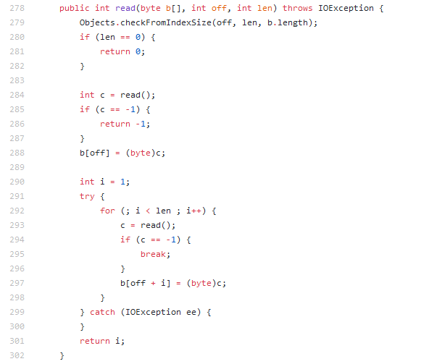

**CFG:**

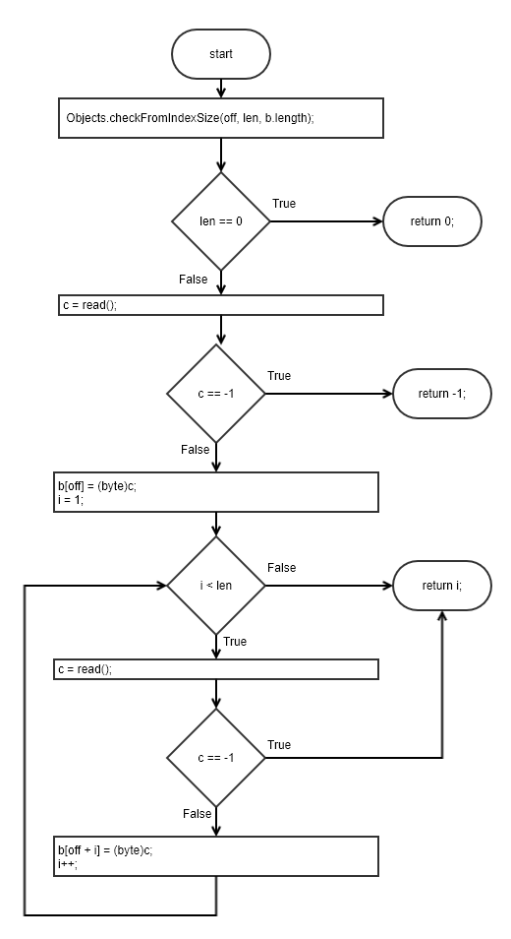

**Statement Coverage:**

|  |  |  |  |  |  |
| --- | --- | --- | --- | --- | --- |
| **Test case#** | **Input** | **Output** | **Expected Output** | **Pass/Fail** | **Comments/Remarks** |
| **1** | b[] = Empty Array  off = 0  len = 3 | 3,  b[] =‘ABC’ | 3,  b[] =‘ABC’ | Pass | External module API read() returns ‘A’, ‘B’, ‘C’ in consecutive calls. |
| **2** | b[] = Empty Array  off = 0  len = 0 | 0,  b[] = Empty Array | 0,  b[] = Empty Array | Pass | External module API read() is never called |
| **3** | b[] = Empty Array  off = 0  len = 3 | -1,  b[] = Empty Array | -1,  b[] = Empty Array | Pass | External module API read() returns -1 to notify an error at first call. |
| **4** | b[] = Empty Array  off = 0  len = 3 | 1,  b[] = ‘A’ | 1,  b[] = ‘A’ | Pass | External module API read() returns ‘A’, -1 in consecutive calls. |

**Branch Coverage:**

|  |  |  |  |  |  |
| --- | --- | --- | --- | --- | --- |
| **Test case#** | **Input** | **Output** | **Expected Output** | **Pass/Fail** | **Comments/Remarks** |
| **1** | b[] = Empty Array  off = 0  len = 3 | 3,  b[] =‘ABC’ | 3,  b[] =‘ABC’ | Pass | External module API read() returns ‘A’, ‘B’, ‘C’ in consecutive calls.  280F, 285F, 292TF, 294F |
| **2** | b[] = Empty Array  off = 0  len = 0 | 0,  b[] = Empty Array | 0,  b[] = Empty Array | Pass | External module API read() is never called.  280T |
| **3** | b[] = Empty Array  off = 0  len = 3 | -1,  b[] = Empty Array | -1,  b[] = Empty Array | Pass | External module API read() returns -1 to notify an error at first call.  280F, 285T |
| **4** | b[] = Empty Array  off = 0  len = 3 | 1,  b[] = ‘A’ | 1,  b[] = ‘A’ | Pass | External module API read() returns ‘A’, -1 in consecutive calls.  280F, 285F, 292T, 294T |

**Condition Coverage with Short Circuit Evaluation:**

|  |  |  |  |  |  |
| --- | --- | --- | --- | --- | --- |
| **Test case#** | **Input** | **Output** | **Expected Output** | **Pass/Fail** | **Comments/Remarks** |
| **1** | b[] = Empty Array  off = 0  len = 3 | 3,  b[] =‘ABC’ | 3,  b[] =‘ABC’ | Pass | External module API read() returns ‘A’, ‘B’, ‘C’ in consecutive calls.  280F, 285F, 292TF, 294F |
| **2** | b[] = Empty Array  off = 0  len = 0 | 0,  b[] = Empty Array | 0,  b[] = Empty Array | Pass | External module API read() is never called.  280T |
| **3** | b[] = Empty Array  off = 0  len = 3 | -1,  b[] = Empty Array | -1,  b[] = Empty Array | Pass | External module API read() returns -1 to notify an error at first call.  280F, 285T |
| **4** | b[] = Empty Array  off = 0  len = 3 | 1,  b[] = ‘A’ | 1,  b[] = ‘A’ | Pass | External module API read() returns ‘A’, -1 in consecutive calls.  280F, 285F, 292T, 294T |

**Boundary Interior:**

Possible logical paths (depends upon successful or unsuccessful read, returned from stub function. Input does not effectively dictate the decision):

* 294T
* 294F

|  |  |  |  |  |  |
| --- | --- | --- | --- | --- | --- |
| **Test case#** | **Input** | **Output** | **Expected Output** | **Pass/Fail** | **Comments/Remarks** |
| **1** | b[] = Empty Array  off = 0  len = 3 | 3,  b[] =‘ABC’ | 3,  b[] =‘ABC’ | Pass | External module API read() returns ‘A’, ‘B’, ‘C’ in consecutive calls.  294F |
| **2** | b[] = Empty Array  off = 0  len = 3 | 1,  b[] =‘A’ | 1,  b[] =‘A’ | Pass | External module API read() returns ‘A’, ‘-1’ in consecutive calls.  294T |

**Loop Boundary:**

Consider N=4 for loop boundary

|  |  |  |  |  |  |
| --- | --- | --- | --- | --- | --- |
| **Test case#** | **Input** | **Output** | **Expected Output** | **Pass/Fail** | **Comments/Remarks** |
| **1** | b[] = Empty Array  off = 0  len = 1 | 1,  b[] =‘A’ | 1,  b[] =‘A’ | Pass | External module API read() returns ‘A’ in consecutive calls.  Covers 292F |
| **2** | b[] = Empty Array  off = 0  len = 2 | 2,  b[] =‘AB’ | 2,  b[] =‘AB’ | Pass | External module API read() returns ‘A’, ‘B’ in consecutive calls.  Covers 292T once |
| **3** | b[] = Empty Array  off = 0  len = 4 | 4,  b[] =‘ABCD’ | 4,  b[] =‘ABCD’ | Pass | External module API read() returns ‘A’, ‘B’, ‘C’, ‘D’ in consecutive calls.  Covers 292T N-1 times |
| **4** | b[] = Empty Array  off = 0  len = 2 | 4,  b[] =‘ABCDE’ | 4,  b[] =‘ABCDE’ | Pass | External module API read() returns ‘A’, ‘B’, ‘C’, ‘D’, ‘E’ in consecutive calls.  Covers 292T N times |
| **5** | b[] = Empty Array  off = 0  len = 2 | 4,  b[] =‘ABCDEF’ | 4,  b[] =‘ABCDEF’ | Pass | External module API read() returns ‘A’, ‘B’, ‘C’, ‘D’, ‘E’, ‘F’ in consecutive calls.  Covers 292T N+1 times |

**Basis Path:**

Path 1: 280T

Path 2: 280F, 285T

Path 3: 280F, 285F, 292F

Path 4: 280F, 285F, 292TF, 294F

Path 5: 280F, 285F, 292T, 294T

|  |  |  |  |  |  |
| --- | --- | --- | --- | --- | --- |
| **Test case#** | **Input** | **Output** | **Expected Output** | **Pass/Fail** | **Comments/Remarks** |
| **1** | b[] = Empty Array  off = 0  len = 3 | 3,  b[] =‘ABC’ | 3,  b[] =‘ABC’ | Pass | External module API read() returns ‘A’, ‘B’, ‘C’ in consecutive calls.  Covers Path4 |
| **2** | b[] = Empty Array  off = 0  len = 0 | 0,  b[] = Empty Array | 0,  b[] = Empty Array | Pass | External module API read() is never called.  Covers Path1 |
| **3** | b[] = Empty Array  off = 0  len = 3 | -1,  b[] = Empty Array | -1,  b[] = Empty Array | Pass | External module API read() returns -1 to notify an error at first call.  Covers Path2 |
| **4** | b[] = Empty Array  off = 0  len = 3 | 1,  b[] = ‘A’ | 1,  b[] = ‘A’ | Pass | External module API read() returns ‘A’, -1 in consecutive calls.  Covers Path5 |
| **5** | b[] = Empty Array  off = 0  len = 1 | 1,  b[] = ‘A’ | 1,  b[] = ‘A’ | Pass | External module API read() returns ‘A’ in consecutive calls.  Covers Path3 |

**Data Flow Testing:**

|  |  |  |  |
| --- | --- | --- | --- |
| **Variable #** | **Variable Name** | **Definitions** | **Uses** |
| 1 | i | 290, 292 | 292, 297 |
| 2 | c | 284, 293 | 285, 288, 294, 297 |
| 3 | len | 278 | 279, 292 |

|  |  |  |
| --- | --- | --- |
| **Variable #** | **Variable Name** | **DU pairs** |
| 1 | i | <290,292>, <290,297>, <292, 292>, <292,297> |
| 2 | c | <284,285>, <284,288>, <293,294>, <293,297> |
| 3 | len | <278, 279>, <278,292> |

|  |  |  |  |  |  |
| --- | --- | --- | --- | --- | --- |
| **Test case#** | **Input** | **Output** | **Expected Output** | **Pass/Fail** | **Comments/Remarks** |
| **1** | b[] = Empty Array  off = 0  len = 3 | 3,  b[] =‘ABC’ | 3,  b[] =‘ABC’ | Pass | i = Covers <290,292>, <290,297>, <292, 292>, <292,297>  c = Covers <284,285>, <284,288>, <293,294>, <293,297>  len = Covers <278, 279>, <278,292> |

### **Function 6:**

**Source Code:**

https://github.com/openjdk/jdk/tree/master/src/java.base/share/classes/java/math/ MutableBigInteger.java

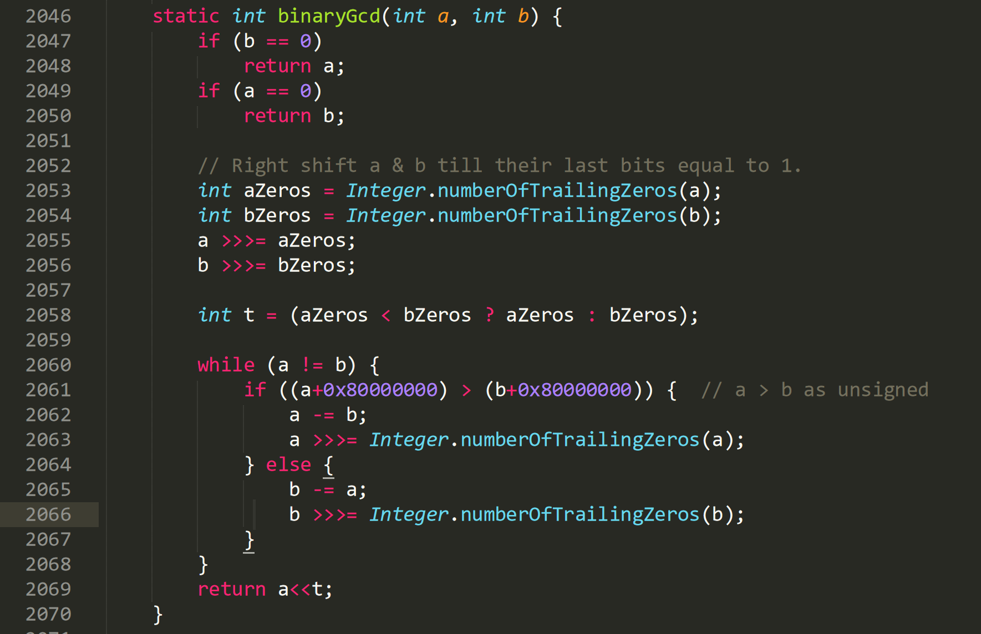

**CFG:**

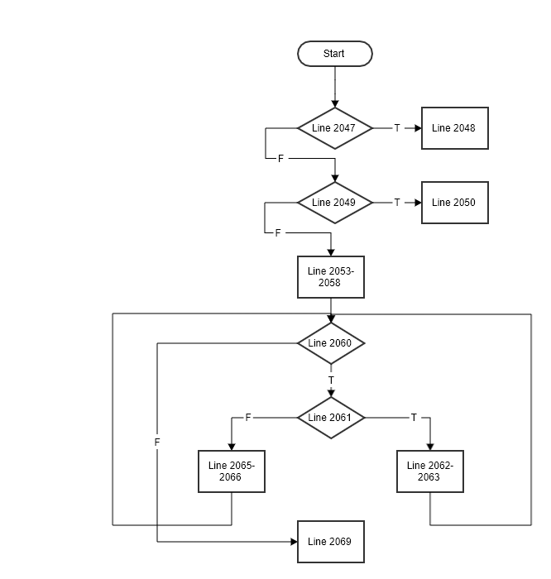.

**Statement Coverage:**

|  |  |  |  |  |  |
| --- | --- | --- | --- | --- | --- |
| **Test case#** | **Input** | **Output** | **Expected Output** | **Pass/Fail** | **Comments/Remarks** |
| **1** | a = 15 b = 0 | 15 | 15 | Pass | Covers statement 2047-2048 |
| **2** | a = 0  b =15 | 15 | 15 | Pass | Covers statement 2049-2050 |
| **3** | a = 98  b =56 | 14 | 14 | Pass | Covers statement 2047,2049, 2051-2069 |

**Branch Coverage:**

|  |  |  |  |  |  |
| --- | --- | --- | --- | --- | --- |
| **Test case#** | **Input** | **Output** | **Expected Output** | **Pass/Fail** | **Comments/Remarks** |
| **1** | a = 15 b = 0 | 15 | 15 | Pass | Covers B2047T |
| **2** | a = 0  b =15 | 15 | 15 | Pass | Covers B2049T, B2047F |
| **3** | a = 98  b =56 | 14 | 14 | Pass | Covers B2047F, B2049F, B2060TF, B2061T |
| **4** | a = 56  b =98 | 14 | 14 | Pass | Covers B2047F, B2049F, B2060TF, B2061F |

**Condition Coverage with Short Circuit Evaluation:**

|  |  |  |  |  |  |
| --- | --- | --- | --- | --- | --- |
| **Test case#** | **Input** | **Output** | **Expected Output** | **Pass/Fail** | **Comments/Remarks** |
| **1** | a = 15 b = 0 | 15 | 15 | Pass | Covers C2047T |
| **2** | a = 0  b =15 | 15 | 15 | Pass | Covers C2049T, C2047F |
| **3** | a = 98  b =56 | 14 | 14 | Pass | Covers C2047F, C2049F, C2060TF, C2061T |
| **4** | a = 56  b =98 | 14 | 14 | Pass | Covers C2047F, C2049F, C2060TF, C2061F |

**Data Flow Testing:**

|  |  |  |  |
| --- | --- | --- | --- |
| **Variable #** | **Variable Name** | **Definitions** | **Uses** |
| 1 |  |  |  |
| 2 |  |  |  |
| 3 |  |  |  |

|  |  |  |
| --- | --- | --- |
| **Variable #** | **Variable Name** | **DU pairs** |
| 1 |  |  |
| 2 |  |  |
| 3 |  |  |

|  |  |  |  |  |  |
| --- | --- | --- | --- | --- | --- |
| **Test case#** | **Input** | **Output** | **Expected Output** | **Pass/Fail** | **Comments/Remarks** |
| **1** |  |  |  |  |  |
| **2** |  |  |  |  |  |

### **Function 7:**

**Source Code:**

<https://github.com/openjdk/jdk/blob/master/src/java.base/share/classes/java/math/BitSieve.java>

bits are sieve bits where each bit represents a candidate odd integer. primeToCertainty is an external function which returns true if it is a prime with given probability.

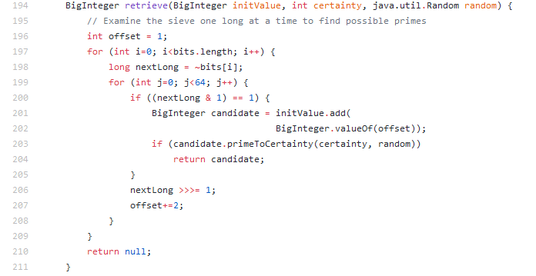

**CFG:**

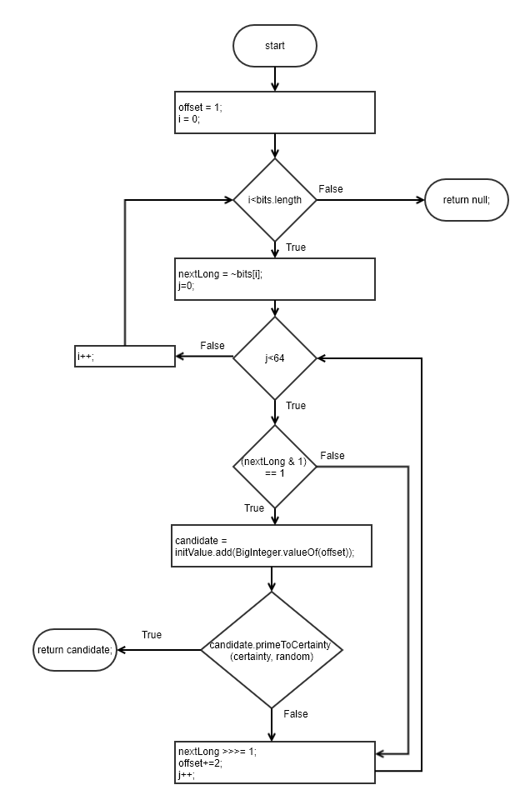

**Statement Coverage:**

|  |  |  |  |  |  |
| --- | --- | --- | --- | --- | --- |
| **Test case#** | **Input** | **Output** | **Expected Output** | **Pass/Fail** | **Comments/Remarks** |
| **1** | initValue = 0;  certainity = 100;  random = 10  bits[] = b’11111010’ | 257 | 257 | Pass | Stub primeToCertainty shall return ‘False, True’ in consecutive calls. |
| **2** | initValue = 0;  certainity = 100;  random = 10  bits[] = b’11111111’ | null | null | Pass | Stub primeToCertainty shall never be called. |

**Branch Coverage:**

|  |  |  |  |  |  |
| --- | --- | --- | --- | --- | --- |
| **Test case#** | **Input** | **Output** | **Expected Output** | **Pass/Fail** | **Comments/Remarks** |
| **1** | initValue = 0;  certainity = 100;  random = 10  bits[] = b’11111010’ | 257 | 257 | Pass | Stub primeToCertainty shall return ‘False, True’ in consecutive calls.  197T, 199TF, 200TF, 203TF |
| **2** | initValue = 0;  certainity = 100;  random = 10  bits[] = b’11111111’ | null | null | Pass | Stub primeToCertainty shall never be called.  197TF, 199TF, 200F |

**Condition Coverage with Short Circuit Evaluation:**

|  |  |  |  |  |  |
| --- | --- | --- | --- | --- | --- |
| **Test case#** | **Input** | **Output** | **Expected Output** | **Pass/Fail** | **Comments/Remarks** |
| **1** | initValue = 0;  certainity = 100;  random = 10  bits[] = b’11111010’ | 257 | 257 | Pass | Stub primeToCertainty shall return ‘False, True’ in consecutive calls.  197T, 199TF, 200TF, 203TF |
| **2** | initValue = 0;  certainity = 100;  random = 10  bits[] = b’11111111’ | null | null | Pass | Stub primeToCertainty shall never be called.  197TF, 199TF, 200F |

**Boundary Interior:**

|  |  |  |  |  |  |
| --- | --- | --- | --- | --- | --- |
| **Test case#** | **Input** | **Output** | **Expected Output** | **Pass/Fail** | **Comments/Remarks** |
| **1** |  |  |  |  |  |
| **2** |  |  |  |  |  |

**Loop Boundary:**

|  |  |  |  |  |  |
| --- | --- | --- | --- | --- | --- |
| **Test case#** | **Input** | **Output** | **Expected Output** | **Pass/Fail** | **Comments/Remarks** |
| **1** |  |  |  |  |  |
| **2** |  |  |  |  |  |

**Basis Path:**

|  |  |  |  |  |  |
| --- | --- | --- | --- | --- | --- |
| **Test case#** | **Input** | **Output** | **Expected Output** | **Pass/Fail** | **Comments/Remarks** |
| **1** |  |  |  |  |  |
| **2** |  |  |  |  |  |

**Data Flow Testing:**

|  |  |  |  |
| --- | --- | --- | --- |
| **Variable #** | **Variable Name** | **Definitions** | **Uses** |
| 1 |  |  |  |
| 2 |  |  |  |
| 3 |  |  |  |

|  |  |  |
| --- | --- | --- |
| **Variable #** | **Variable Name** | **DU pairs** |
| 1 |  |  |
| 2 |  |  |
| 3 |  |  |

|  |  |  |  |  |  |
| --- | --- | --- | --- | --- | --- |
| **Test case#** | **Input** | **Output** | **Expected Output** | **Pass/Fail** | **Comments/Remarks** |
| **1** |  |  |  |  |  |
| **2** |  |  |  |  |  |

### **Function 8:**

**Source Code:**

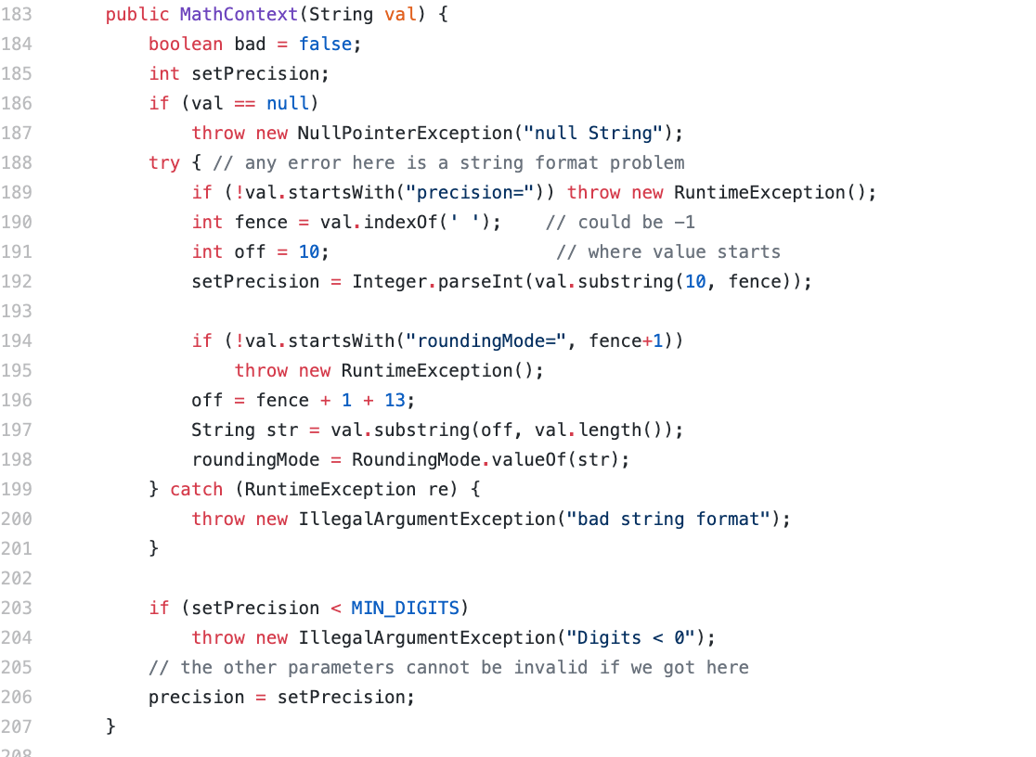

**CFG:**

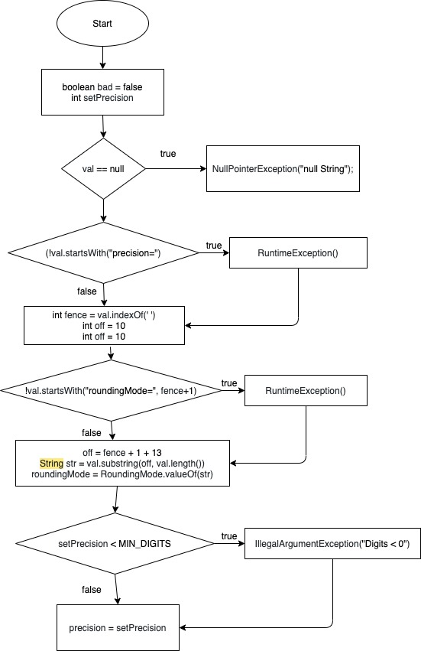

**Statement Coverage:**

|  |  |  |  |  |
| --- | --- | --- | --- | --- |
| **Test**  **case#** | **Input** | **Output** | **Expected**  **Output** | **Pass/Fail Comments/Remarks** |
| **1** | null | exception | exception | Pass Covered 184, 185, 186, 187 |
| **2** | ‘ThisString’ | exception | exception | Pass Covered 184, 185, 186, 188, 189 |
| **3** | ‘precision=12  12’ | exception | exception | Pass Covered 184, 185, 186, 188, 190, 191, 192, 194,  195 |
| **4** | roundingMode =12 12’ | exception | exception | Pass Covered 184, 185, 186, 188, 189 |

**Branch Coverage:**

|  |  |  |  |  |
| --- | --- | --- | --- | --- |
| **Test**  **case#** | **Input** | **Output** | **Expected**  **Output** | **Pass/Fail Comments/Remarks** |
| **1** | (null) | exception | exception | Pass Covered B186(True) |
| **2** | ‘ThisString’ | exception | exception | Pass Covered B186(False), B189(True) |
| **3** | ‘precision=12  12’ | exception | exception | Pass Covered B186(False), B189(False),  B194(True) |
| **4** | ‘roundingMode =12 12’ | exception | exception | Pass Covered B186(False), B189(True) |

**Condition Coverage with Short Circuit Evaluation:**

|  |  |  |  |  |
| --- | --- | --- | --- | --- |
| **Test**  **case#** | **Input** | **Output** | **Expected**  **Output** | **Pass/Fail Comments/Remarks** |
| **1** | (null) | exception | exception | Pass Covered C186(True) |

|  |  |  |  |  |
| --- | --- | --- | --- | --- |
| **2** | ‘ThisString’ | exception | exception | Pass Covered C186(False), C189(True) |
| **3** | ‘precision=12  12’ | exception | exception | Pass Covered C186(False), C189(False),  C194(True) |
| **4** | ‘roundingMode =12 12’ | exception | exception | Pass Covered C186(False), C189(True) |

### **Function 9**

**Source Code:**

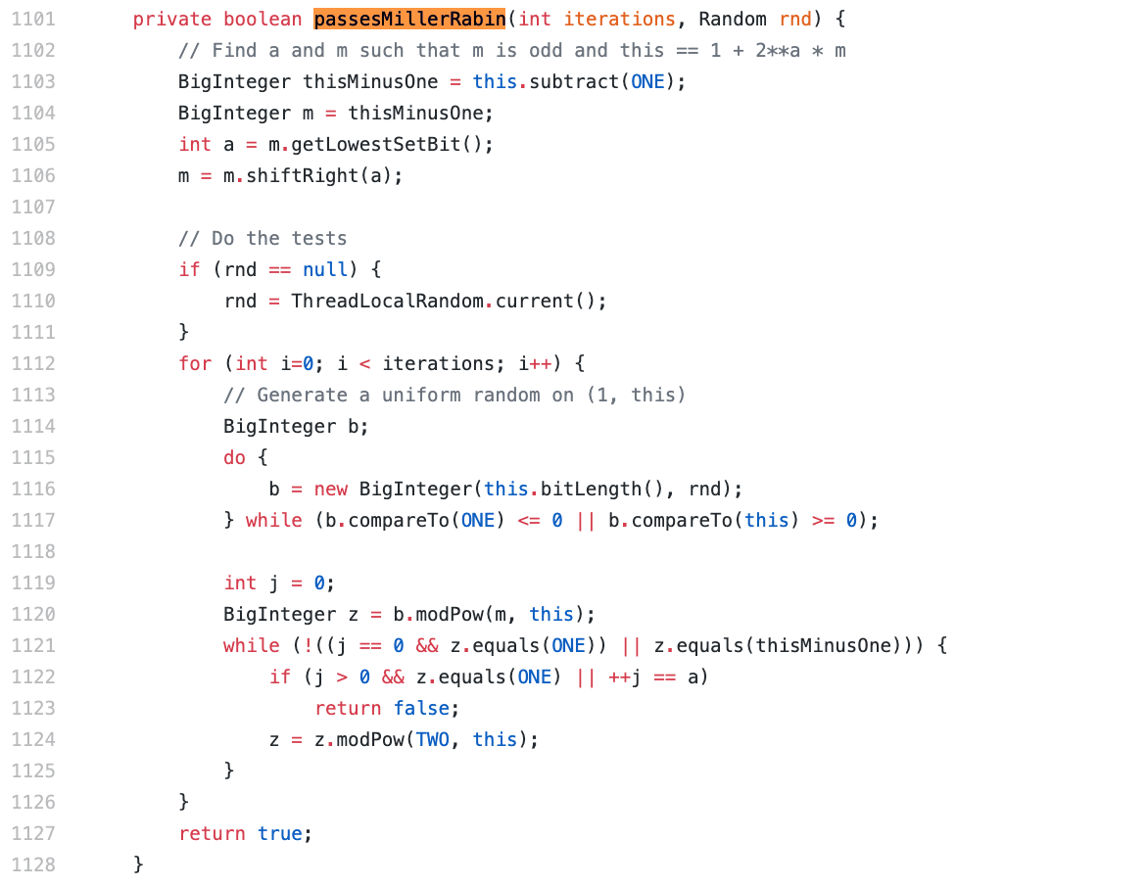

**CFG:**

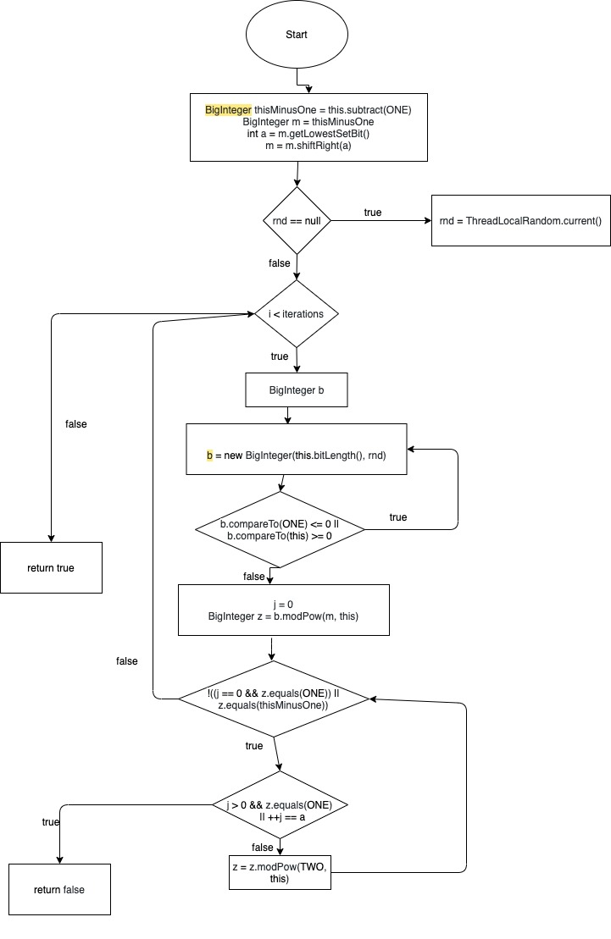

**Statement Coverage:**

|  |  |  |  |  |
| --- | --- | --- | --- | --- |
| **Test**  **case#** | **Input** | **Output** | **Expected**  **Output** | **Pass/Fail Comments/Remarks** |
| **1** | (4, null) | true | true | Pass covers 1103,  1104,1105,,1106,1109,1  110,1111,1112,1113,111  4-1128 |
| **2** | (0, 4) | true | true | Pass covers 1103,  1104,1105,,1106,1109,1  112,1127 |
| **3** | (null, null) | error: bad  operand  types for  binary  operator '<' | True | Fail covers 1103-1111,1112 |
| **4** | (7,9) | false | false | Pass covers 1103-1111,1112-1123 |

**Branch Coverage:**

|  |  |  |  |  |
| --- | --- | --- | --- | --- |
| **Test**  **case#** | **Input** | **Output** | **Expected**  **Output** | **Pass/Fail Comments/Remarks** |
| **1** | (4, null) | true | true | P covers B1109(T),  B1112(T), B1117(T),  B1121(T) |
| **2** | (0, 4) | true | true | P covers B1109(F),  B1112(F) |
| **3** | (null, null) | error: bad  operand  types for  binary  operator '<' | No output | F covers B1109(T), B1112(Crash) |

|  |  |  |  |  |
| --- | --- | --- | --- | --- |
| **4** | (7,9) | false | false | P covers B1109(T),  B1112(T), B1117(T),  B1121(T), B1122(T) |

**Condition Coverage with Short Circuit Evaluation:**

|  |  |  |  |  |
| --- | --- | --- | --- | --- |
| **Test**  **case#** | **Input** | **Output** | **Expected**  **Output** | **Pass/Fail Comments/Remarks** |
| **1** | (4, null) | true | true | P covers C1109(T),  C1112(T), C1117(T),  C1121(T) |
| **2** | (0, 4) | true | true | P covers C1109(F),  C1112(F) |
| **3**  **4** | (null, null)  (7,9) | error: bad  operand  types for  binary  operator '<' false | no output  false | F covers C1109(T),  C1112(Crash)  P covers C1109(T),  C1112(T), C1117(T),  C1121(T), C1122(T) |

### **Function 10:**

**Source Code:**

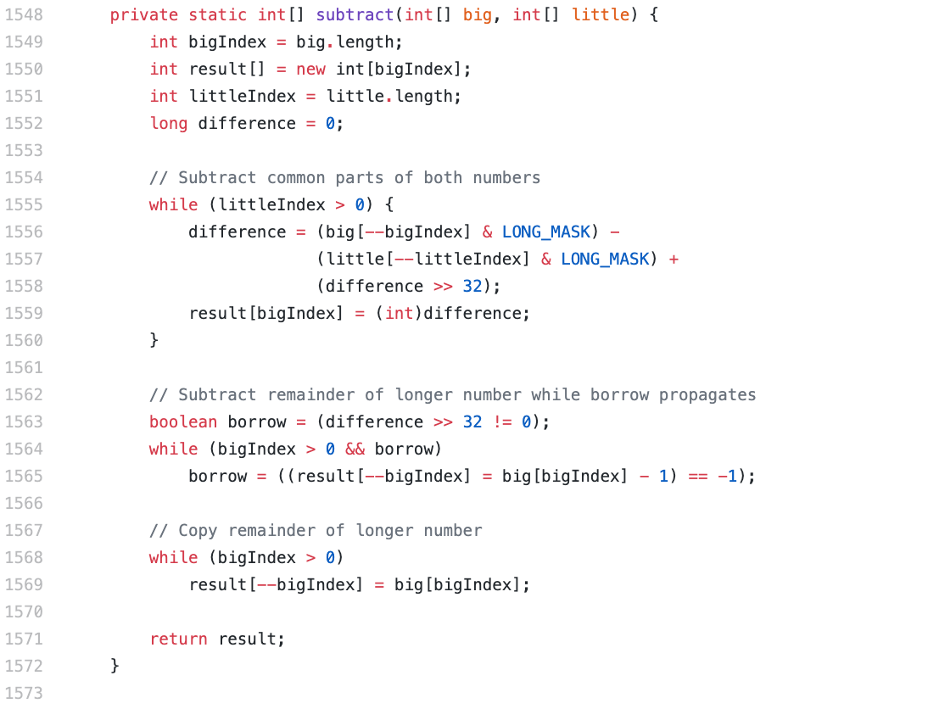

**CFG:**

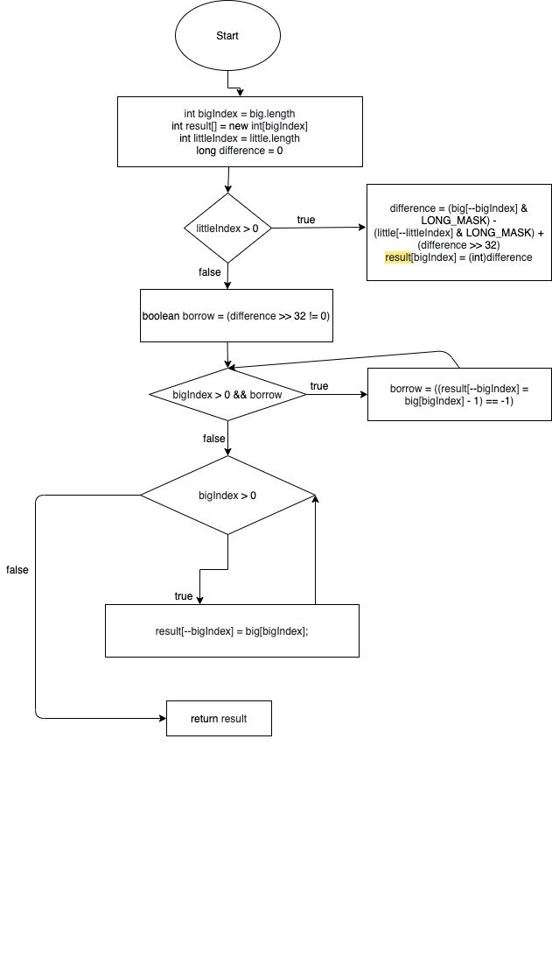

**Statement Coverage:**

|  |  |  |  |  |
| --- | --- | --- | --- | --- |
| **Test**  **case#** | **Input** | **Output** | **Expected**  **Output** | **Pass/Fail Comments/Remarks** |
| **1** | x = {10, 20};  y = {30, 40}; | [-21,20] | [-21,20] | Pass covers 1549, 1550, 1551, 1552, 1553, 1555,  1563,1564, 1565, 1568 |
| **2** | x = {10,20}  y = {} | [10,20] | [10,20] | Pass covers 1549, 1550, 1551, 1552, 1553, 1555,  1563,1564, 1565, 1568,  1569 |
| **3** | x = {} y = {30, 40} | [30, 40] | Index -1 out of  bounds for length 0 | fail 2nd empty array case is not handled |

**Branch Coverage:**

|  |  |  |  |  |
| --- | --- | --- | --- | --- |
| **Test**  **case#** | **Input** | **Output** | **Expected**  **Output** | **Pass/Fail Comments/Remarks** |
| **1** | x = {10, 20};  y = {30, 40}; | [-21,20] | [-21,20] | P covers B1555T,  B1564T, B1568T |
| **2** | x = {10,20}  y = {} | [10,20] | [10,20] | P covers B1555F, B1564T, B1568T |
| **3** | x = {} y = {30, 40} | [30, 40] | Index -1 out of  bounds for length 0 | F covers B1555F, B1564F, B1568F |

**Condition Coverage with Short Circuit Evaluation:**

|  |  |  |  |  |
| --- | --- | --- | --- | --- |
| **Test**  **case#** | **Input** | **Output** | **Expected**  **Output** | **Pass/Fail Comments/Remarks** |

|  |  |  |  |  |
| --- | --- | --- | --- | --- |
| **1** | x = {10, 20};  y = {30, 40}; | [-21,20] | [-21,20] | P covers C1555T,  C1564T, C1568T |
| **2** | x = {10,20}  y = {} | [10,20] | [10,20] | P covers C1555F,  C1564T, C1568T |
| **3** | x = {}  y = {30, 40} | Index -1  out of  bounds for length 0 | [30, 40] | F covers C1555F, C1564F, C1568F |

## Project Contribution

|  |  |  |  |
| --- | --- | --- | --- |
| **Member** | **Submission 1** | **Submission 2** | **Submission 3** |
| **Danish** | Setup and Run the web application, resolved all errors to run the project successfully | Chose func 1, 4, 5, 7  Wrote test cases for these functions |  |
| **Abu Bakar** | Documented the environment setup and prepared report for submission 1. | Chose func 2, 3, 6  Wrote test cases for these functions |  |
| **Awais** | No contribution | Chose func 8, 9, 10  Wrote test cases for these functions |  |
| **Musa** | No contribution | No contribution | No contribution |