Patterns in Kivy Framework

Group17 Members:

MSCS18002  
MSEE19001  
MSCS20001

# Strategy Pattern

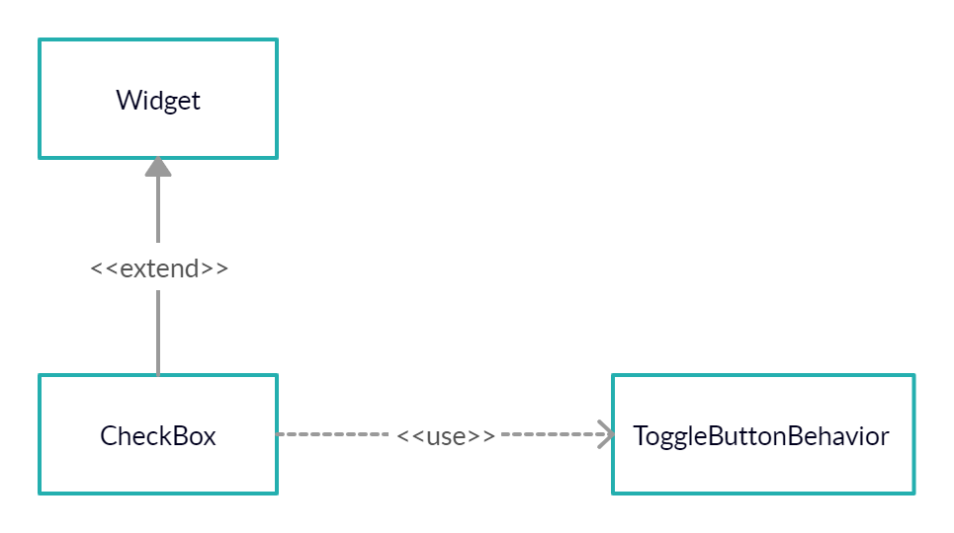

# Composite Pattern

# C:\Users\kferoz\Downloads\Untitled Document (1).png

# **Proxy Pattern (Not Exactly)** C:\Users\kferoz\Downloads\Untitled Document (2).png

Abstract Factory 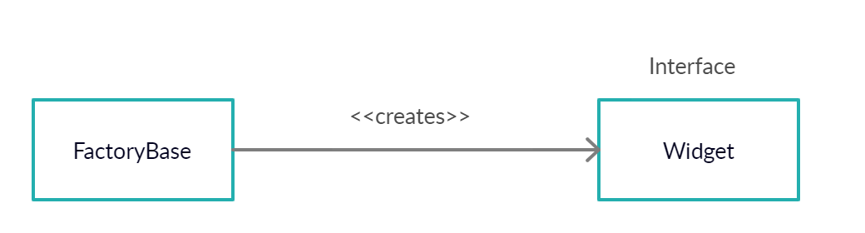

>>> widget = Factory.Widget(pos=(456,456))

**Besides, Observer Pattern and MVC Patterns also seem to exist but code base is very complex and we cannot make a class diagram.**

Observer PatternObserver pattern is used in Kivy's properties:

class MyClass(EventDispatcher):

numeric_var = NumericProperty(1)

To use them, **you have to declare them at class level**. That is, directly in the class, not in any method of the class. A property is a class attribute that will automatically create instance attributes. Each property by default provides an ``on_<propertyname>`` event that is called whenever the property's state/value changes.

Kivy provides the following properties:

* :mod:`~kivy.properties.NumericProperty`,
* :mod:`~kivy.properties.StringProperty`,
* :mod:`~kivy.properties.ListProperty`,
* :mod:`~kivy.properties.ObjectProperty`,
* :mod:`~kivy.properties.BooleanProperty`,
* :mod:`~kivy.properties.BoundedNumericProperty`,
* :mod:`~kivy.properties.OptionProperty`,
* :mod:`~kivy.properties.ReferenceListProperty`,
* :mod:`~kivy.properties.AliasProperty`,
* :mod:`~kivy.properties.DictProperty`,

MVC PatternThe adapter part of the RecycleView which together with the layout is the view part of the MVC pattern.

The view module handles converting the data to a view using the adapter class which is then displayed by the layout. A view can be any Widget based class.

However, inheriting from RecycleDataViewBehavior adds methods for converting the data to a view.