SimUDuck

Group17 Members:

MSCS18002  
MSEE19001  
MSCS20001

# Kivy Framework (kivy.org)

The framework that we use in **Kivy** framework to make the SimUDuck application.

Kivy is a free and open source Python framework for developing mobile apps and other applications with user interface. Kivy is python based.

# Strategy Pattern

The SimUDuck application is developed using the strategy pattern with the principle “program to interface, not to implementation”. This is achieved by having *FlyBehavior* and *QuackBehavior* interfaces. For *FlyBehavior* interface the implementation is present in *FlyWithWings*, *FlyNoWay* classes.

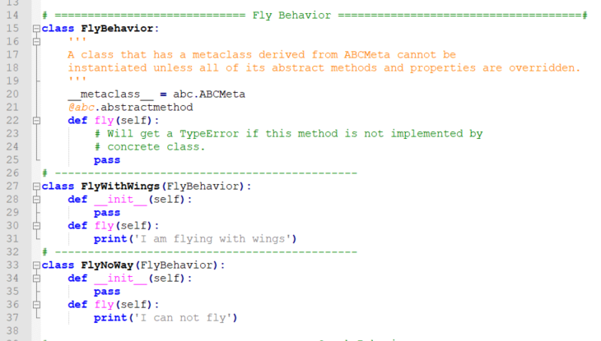

Similarly for *QuackBehavior*, the behaviors are implemented in *Quack*, *Squeak* classes.

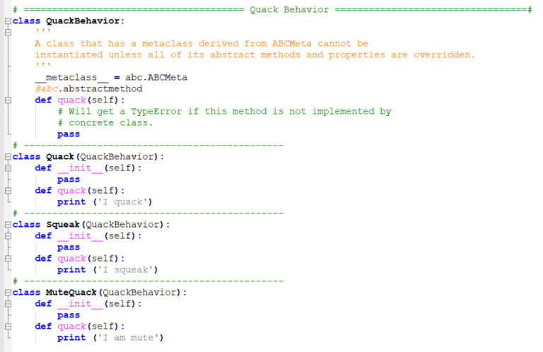

We have the parent DuckClass and all types of duck inherit from this parent class. The DuckClass has composition of *FlyBehavior* and *QuackBehavior* maintaining a HAS A relationship. This can be seen here:

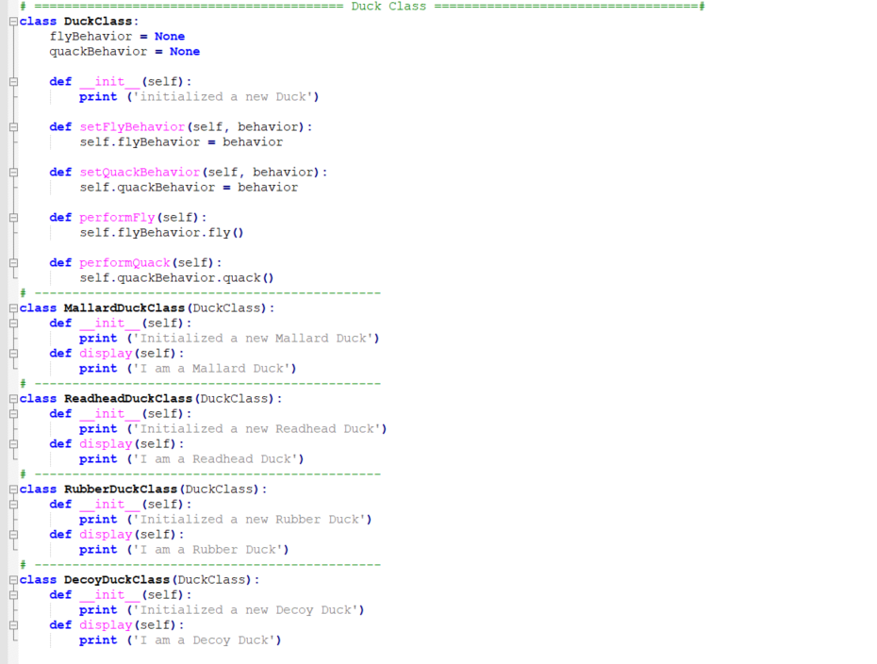

All new duck types inherit from the same parent DuckClass.

# Extending the application:

### Adding a new Duck type:

To add a new duck we need to inherit a new class from DuckClass and have the display implementation.

Class NewDuckClass(DuckClass)

def __init__(self):

print ('Initialized a new Duck')

def display(self):

print ('I am a new Duck')

### Adding a new FlyBehavior or QuackBehavior:

To add a new FlyBehavior or QuackBehavior, we add a new class that implements the interface class FlyBehavior and QuackBehavior respectively.

class NewFly(FlyBehavior):

def __init__(self):

pass

def fly(self):

print('I am a new flying’)

class NewQuack(QuackBehavior):

def __init__(self):

pass

def quack(self):

print ('I am a new quack’)

### Dynamically changing Behavior:

Because of strategy pattern, we can also change the behavior of the duck at runtime. That is by using SetFlyBehavior() and SetQuackBehavior() functions.

### Polymorphism

We have also achieved polymorphism because of using inheritance. No matter which type of duck it is, we can simply call the performFly() and performQuack() functions, and the specific behavior of flying and quacking will be displayed.

New_Mallard = MallardDuckClass()

New_Rubber = RubberDuckClass()

New_Mallard.performFly()

New_Mallard.performQuack()

New_Rubber.performFly()

New_Rubber.performQuack()

# Application Screenshots

