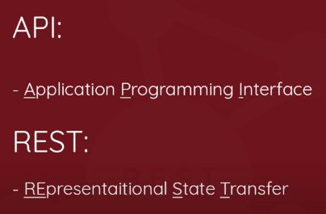

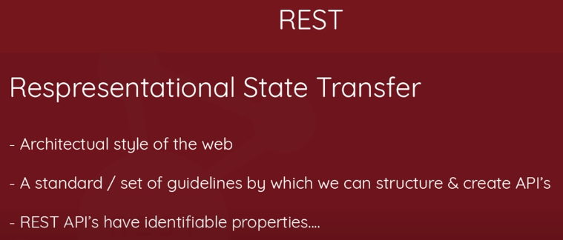

**REST Properties**

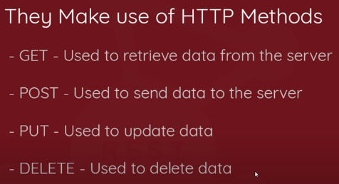

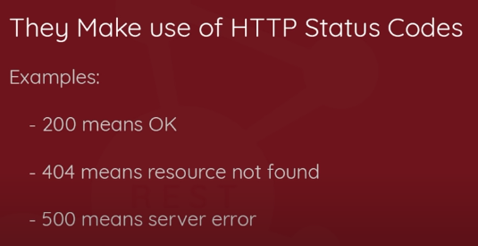

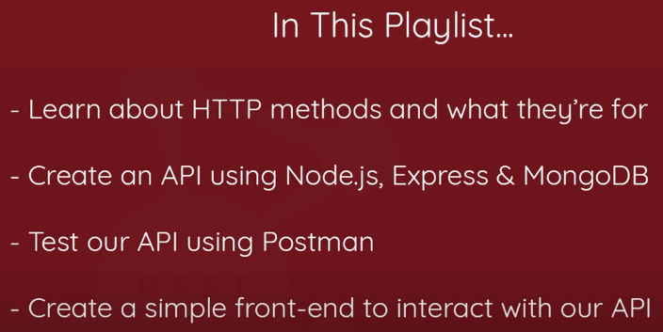

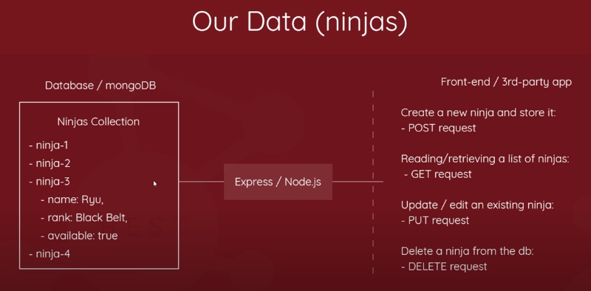

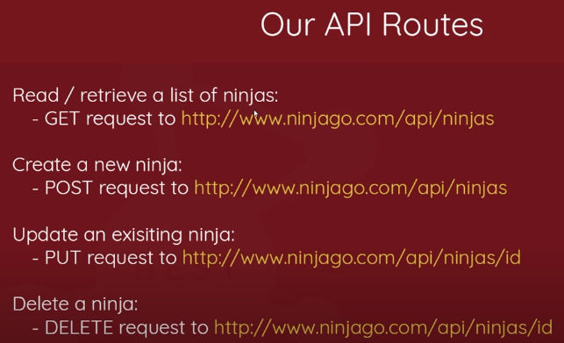

**Example using jQuery**

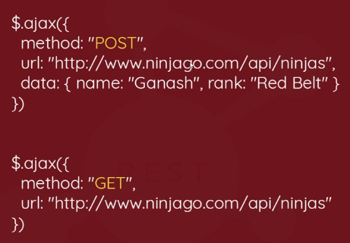

Every time we reload page, command prompt a “node index” lekha ta biroktikor!

To solve it, we’ll do as follow:

npm install nodemon --save-dev

dbjsd

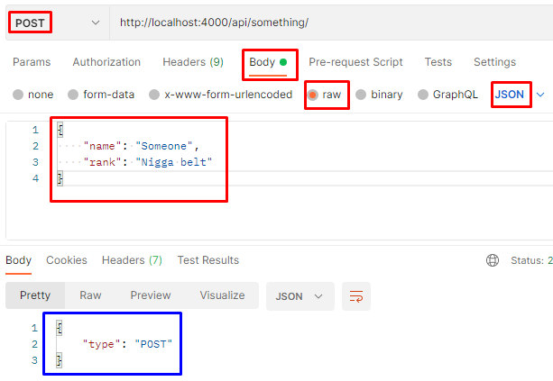

All the codes (blue marked) between request coming in & response going out is **Middleware**. Here, React Handlers is a middleware.

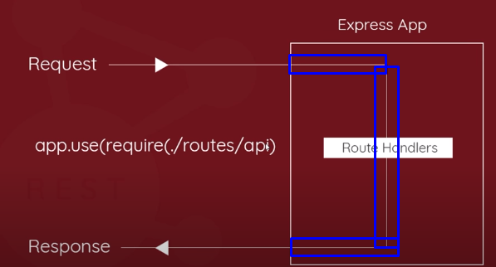

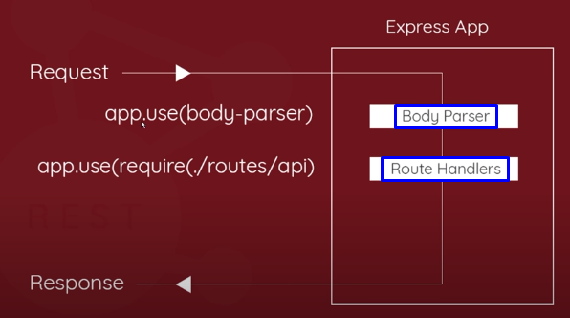

The blue marked portions are middleware

Body parser ki kore? Eita **request ney**, then this body parser **look at the body** of the request, **take this request**, pass it & attach it to the request object, and we get access of that particular request object in the **Route handlers,** tar mane, request object jokhn route handler er kase jay, already we’ve access to that data from the body because the body parser has attached **data** to the request object for us.

Hence, **Order** is very important here! cz agei route handler a chole gele, body parser thk **attached request object,** handler paaito e naa!

npm install body-parser --save (save into our dependencies)

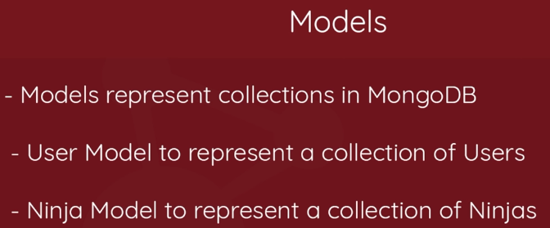

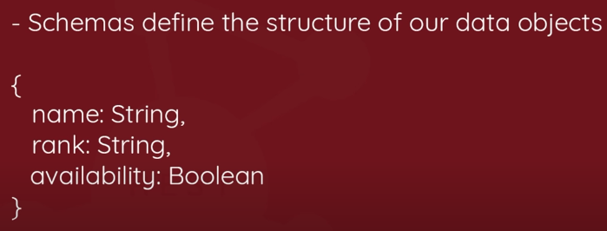



npm install mongoose --save