Slug or Friendly URL krte ei option select krte hbe (settings er permalink a giye)

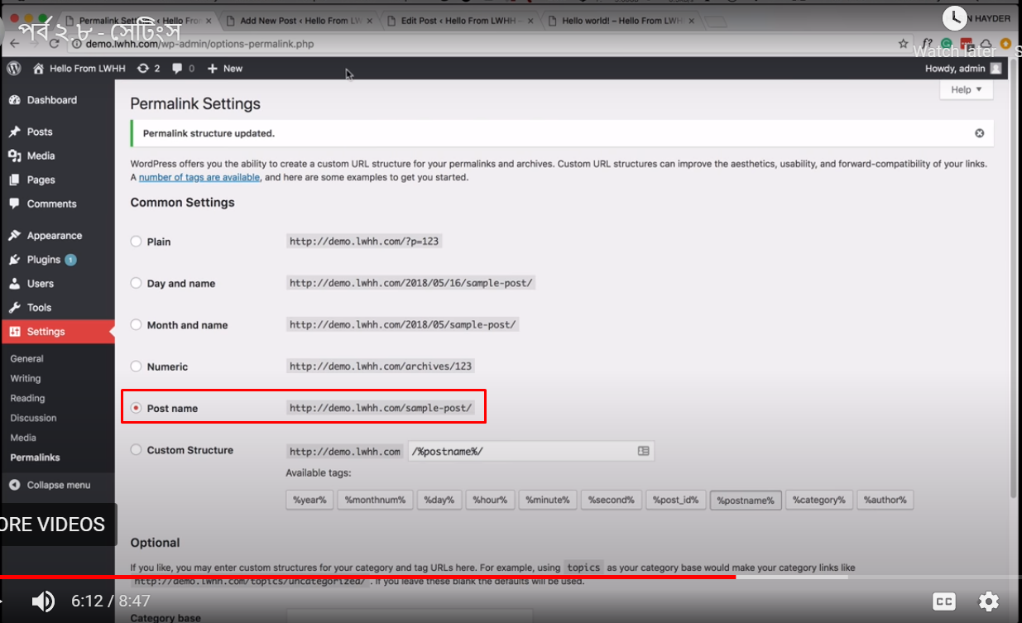

**V.V.I.** new post add krle, post edit krle ba site a j kono change krle, ei permalink a eshe akbr SAVE CHANGE dte hbe!