Directly theme er sathe incorporate kra jay na kisu plugin. akta companion plugin likhe tar mddhe oi code gulo rekhe sei shob plugin

<https://help.author.envato.com/hc/en-us/articles/360000510603-WordPress-Plugin-Requirements>

* deprecated function lekha jabe na
* admin code public facing code thk separate krte hbe
* sbkisu i.e., class, function, hook etc. **unique identifier** dia prefix krte hbe
* wp er built in function use krte hbe (except unavoidable situations)

validate & sanitize is for input & escape is for output

for details, go to WP theme development course → **security**

**JS Standards**

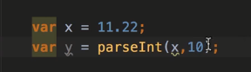

parseInt function a number er radix (eikhane 10 means decimal number) should be mentioned

function er vitore global variable create krle, use window.varName

function myFunc() {

window.myVar = ‘something’; // myVar is global variable

… … …

}

radix must be provided if parseInt is used

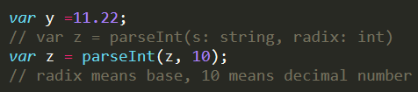

**CSS Standards**

Table of contents should be provided at the top of the stylesheet

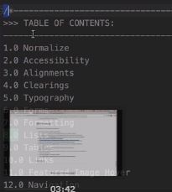

ei table of contents er seshe, media query te, bivinno types group wise comment our kore dte hbe easily bujhar jnno