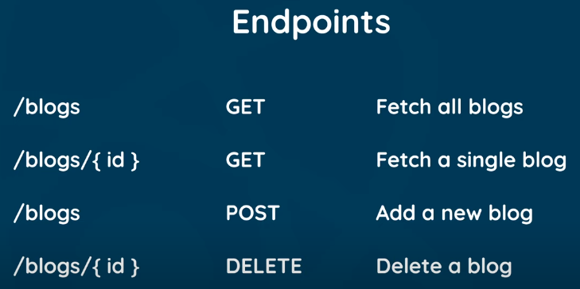

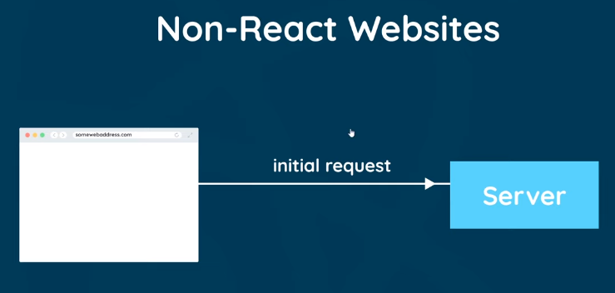

Jeikhane shob web app server a request handle kre, sheikhane react er websites shob dhrn er routing, page er content change soho sbkisu browser a e kre!

Other sites er moto server a request send krar pore, server html to pathay e, sathe extra **complied react JS files** pathay ja amdr react application **control** kre

So, initially, html file jehetu empty, browser o empty thake, but amdr create kra react components thk data **inject kre “react”**

Tar mane, amra jokhn about page a click krbo, react e amdr k about component a niye jabe, abr jokhn amra contact a click krbo, seita o react e krbe & all gonna happen in client side i.e. browser with react.

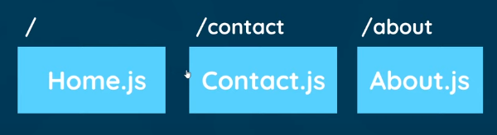

npm install react-router-dom