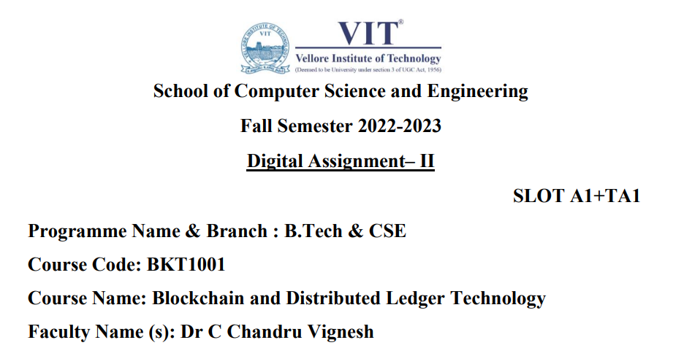

**Name : Rishabh Kumar Rai**

**Reg No. : 20BKT0076**

**--------------------------------------------------------------------------------------------------------------------------**

Q) Considerations for applying the Distributed Ledger Technology as a technical infrastructure for securities transactions settlement. Examine any one of the technologies to enhance the efficiency and facilitates the process of transaction settlement in private ledger with example

Distributed ledger technology (DLT), of which the blockchain technology[Footnote1](https://jfin-swufe.springeropen.com/articles/10.1186/s40854-019-0169-6#Fn1) is the best known example, has attracted significant interest from the financial industry and academia. DLT gained notoriety by being used for the trading of cryptocurrencies, such as Bitcoins, which are issued and validated by the system users rather than by a central authority. Since the deployment of virtual currencies, the financial industry has been investigating whether this technology can be applied to securities markets in order to create a more efficient market, compared to the usage of ledgers based on classical double-entry bookkeeping.

According to Goldman Sachs ([2016](https://jfin-swufe.springeropen.com/articles/10.1186/s40854-019-0169-6#ref-CR36)), DLT could reduce transaction costs of insurance underwritings by $2–4 billion in the USA alone and the costs related to securities clearing and settlement would decrease by $11–12 billion. An analysis of Banco Santander, Oliver Wyman, and Anthemis Group ([2015](https://jfin-swufe.springeropen.com/articles/10.1186/s40854-019-0169-6#ref-CR4)) suggests that DLT could reduce banks’ infrastructure costs attributable to cross-border payments and trading of securities by $15–$20 billion. The World Economic Forum ([2015](https://jfin-swufe.springeropen.com/articles/10.1186/s40854-019-0169-6#ref-CR77)) even estimates that by 2027, up to 10% of the value of the global GDP will be stored on blockchains.

Although financial institutions have yet to demonstrate that DLT is a viable and sustainable solution to cover the complete securities trade cycle (i.e. trading, clearing, and settlement), they developed several proofs of concept in particular niches[Footnote2](https://jfin-swufe.springeropen.com/articles/10.1186/s40854-019-0169-6#Fn2) of the trading and post-trading ecosystem. A non-exhaustive list of examples: the Australian Stock Exchange cooperated with Digital Assets to use DLT for the clearing and settlement of equity transactions (McDowell [2017](https://jfin-swufe.springeropen.com/articles/10.1186/s40854-019-0169-6#ref-CR51)); Nasdaq and SEB constructed a mutual fund trading platform based on the blockchain technology (Parsons [2017](https://jfin-swufe.springeropen.com/articles/10.1186/s40854-019-0169-6#ref-CR60)); Overstock.com launched a closed-system trading platform for the sale of its own proprietary blockchain (Ryan and Donohue, [2017](https://jfin-swufe.springeropen.com/articles/10.1186/s40854-019-0169-6#ref-CR71)), Nasdaq launched Linq to enable private securities issuance (Peter and Vishnia, [2016](https://jfin-swufe.springeropen.com/articles/10.1186/s40854-019-0169-6#ref-CR64)), the French central securities depository (CSD) ‘ID2S’ applies the blockchain technology to issue French commercial paper, and the Canadian Securities Exchange developed a DLT securities clearing and settlement platform to allow companies to issue equity and fixed income securities via security token offerings (McDowell [2018](https://jfin-swufe.springeropen.com/articles/10.1186/s40854-019-0169-6#ref-CR52)).

Settlement issues

An often-cited benefit of DLT is the ability to shorten the end-to-end processing of financial transactions (see Section 3.2.1 on speed of end-to-end processing). In addition to affecting the efficiency of payment, clearing and settlement, DLT also has the capacity to affect safety. In this respect, it is useful to consider key components of settlement: the settlement asset, how settlement is achieved operationally and how settlement finality is achieved for legal purposes.

**Settlement asset.** Some arrangements are based on updating balances in the ledger (that is, the ledger is recording positions through debits and credits). Some arrangements are based on transferring digital assets in the ledger (that is, the ledger is recording the transfer of ownership of a specific digital asset that exists only on the ledger). Yet other arrangements are based on transferring digital representations of a physical asset that is held in custody (ie the ledger is recording transfers of assets held elsewhere). In the context of a payment system, for example, an arrangement could be updating a balance, transferring digital currency or updating an account balance reflecting monies held at a custodian bank.

**Operational settlement.** In some DLT arrangements, it can take some time to update and synchronise state changes to a ledger. The first instance of an update, for example, may not represent operational settlement because it may take time for consensus to be achieved across the nodes in the synchronisation of ledgers. In arrangements that use a proof-of-work23 model, settlement is probabilistic. That is, the more times the transaction is confirmed in the ledger, the less likely it will be revoked. Operational settlement becomes more complex if it involves the delivery of one asset against another, for example, the exchange of securities against the corresponding cash amounts or exchange of one currency for another. In many arrangements involving an exchange of value, another financial market infrastructure is typically involved.

**Legal settlement finality.** Settlement finality is the legally defined moment at which the transfer of an asset or financial instrument, or the discharge of an obligation, is irrevocable and unconditional and not susceptible to being unwound following the bankruptcy or insolvency of a participant. In traditional systems, settlement finality is a clear and well-defined point in time, backed by a strong legal basis. For DLT arrangements, settlement finality may not be as clear. In arrangements that rely on a consensus algorithm to effect settlement finality, there may not necessarily be a single point of settlement finality. Further, the applicable legal framework may not expressly support finality in such cases.