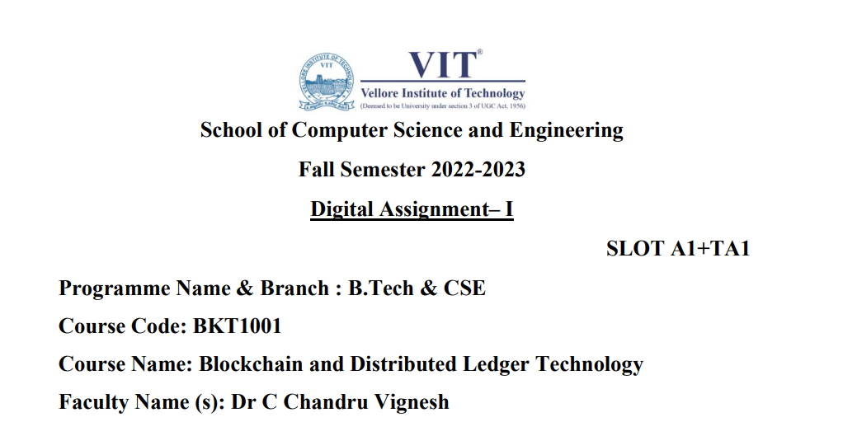

Rishabh Kumar Rai

20BKT0076

Q) Discuss the current challenges in healthcare and how the Blockchain helps the patient consent and health data exchanges, to improve revenue management in healthcare, combat fraud, track supply chain, simplify payment systems and medical claims processing in the system.

Need of blockchain in healthcare

As far as healthcare is concerned, the urgency of development increases to more incredible speeds. Today the need is for quality health facilities supported by advanced and newer technologies. Here, Blockchain would play a critical role in transforming the [healthcare sector](https://www.sciencedirect.com/topics/computer-science/healthcare-sector). In addition, the landscape of the health system is moving towards a patient-centred approach focusing on two main aspects: accessible services and appropriate healthcare resources at all times. The Blockchain enhances healthcare organisations to provide adequate patient care and high-quality health facilities. Health Information Exchange is another time-consuming and repetitive process that leads to high health industry costs, quickly sorted out using this technology. Using Blockchain technology, citizens may take part in health study programs. In addition, better research and shared data on public wellbeing will enhance treatment for different communities. A centralised database is used to manage the entire healthcare system and organisations .

Until now, the most significant problems faced are data protection, sharing, and interoperability in population health management. This particular problem is reliable by using Blockchain. This technology enhances security, data exchange, interoperability, integrity, and real-time updating and access when correctly implemented. There are also significant concerns about data protection, especially in the fields of personalised medicine and wearables. Patients and medical personnel require safe and straightforward means of recording, sending, and consulting data over networks without safety concerns; thus, Blockchain technology is implemented to resolve these issues .

Blockchain technology makes the transition to interoperability led by patients easier as it allows patients to make their medical data accessible and access laws. This gives a patient greater power over personal information and improves confidentiality and privacy. The measurement and implementation of quality management and enforcement are difficult. Any of these technical issues could be solved by Blockchain applications throughout the industry. Blockchain headlines will assist regulatory authorities in tracing legal drugs against falsified ones. This ensures that all approved parties exchange digital transactions containing the patient's details. Patients who move medical practitioners may merely update a single consent to exchange their complete records

Blockchain helps the patient consent and health data exchanges

Blockchain's ability makes for a sophisticated data storage framework that records a person's whole health history of diagnosis, test reports, prior regimes, and even measurements by intelligent sensors. A doctor can conveniently obtain all the details available to make correct diagnoses and recommendations using this method. Because all the data in a single Blockchain system is stored, it is safe from loss and shift. To avoid an organisation's internal networks, it can use Blockchain. A significant organisation of many separate players, with various control levels on an encrypted Blockchain database, can save organisations from external risks and assaults. If a healthcare organisation correctly implements a Blockchain network, this will eliminate such rescue attacks and other problems, such as computer corruption or hardware failure

The Blockchain makes the entire prescription process transparent, from manufacturing to pharmacy shelves. Congestion, freight direction, and speed may all be tracked using [IoT](https://www.sciencedirect.com/topics/computer-science/internet-of-things) and Blockchain. It offers the chance to schedule acquisitions efficiently to prevent disruptions and shortages in clinics, pharmacies, and other medical facilities with a given medication. The deployment of digital frameworks built on Blockchain would help ensure that the logistics data avoid uncontrolled adjustments. It increases trust and prevents the illicit handling of records, payments, and medication themselves by various people interested in purchasing drugs. The technology can effectively improve the condition of patients while at a competitive cost retaining the funds. It eliminates all obstacles and barriers in multi-level authentication. Because Blockchain can preserve an incorruptible, decentralised, and transparent log of all patient data, it is ripe for security applications. Furthermore, while Blockchain is visible, it is also private, hiding any individual's identity behind complicated and secure algorithms that can preserve the sensitivity of medical data. Thanks to the technology's decentralised structure, patients, doctors, and [healthcare providers](https://www.sciencedirect.com/topics/computer-science/healthcare-provider) can all share the same information swiftly and safely.

Blockchain can securely ease the transfer of patient records among health systems nationally and across borders, boost the coordination of member health management, lower transaction costs and risks, and even support medical tourism.A single entity doesn’t control medical data stored on blockchains. Therefore, it can be distributed among groups of individuals and organizations. Every transaction on the chain is time-stamped, becoming a permanent record of the entire whole that can’t be altered afterward.

To improve revenue management in healthcare

Blockchain networks minimise data transformation time and costs. Blockchain networks promise to solve the issue of fast and effective verification of medical credentials. Blockchain networks guarantee patient anonymity and protection. This will open up significant new ideas and findings that can change healthcare works in the world. Implementation of Blockchain will lead to valuable and privacy-respecting monetised data sharing networks. Blockchain is a distributed network computing technology that allows storing transaction history and documentation with time stamping. Each node in this network processes verifies and records each data input.

It is crucial to maintain an accurate record of the financial statements in the bookkeeping process. The clinical trials are suitable for smooth operation and assessment. Here, Blockchain companies have invented methods of streamlining the accounting and reporting process. Through this application, everyone can prepare to go to a health care provider and complete the paperwork in advance. It will save time by preventing them from waiting in line.

Blockchain reduces needless overhead expenses and thus enables the correct use of health records. This technology will also mitigate the need for multiple intermediaries to monitor critical health information sharing. The crucial task of healthcare providers is to provide efficient, timely, and adequate services for their people may therefore be simplified. With Blockchain healthcare technologies, the service providers will already have an overview of the medical record of any particular patient. Many problems that plague the healthcare system can be resolved, including interoperability, report completion, theft and even catastrophe data failure.

combat fraud

Blockchains can be used successfully in healthcare to make the right choices in the health ecosystem. The distributed Blockchain platform offers the health sector opportunities to trace fraud, reduce overhead costs, reliably manufacture jobs, eliminate duplication of labour, enforce openness in the health environment. Further, it is used to hold assets, such as immutability and confidence, and decentralisation. The clinical trials and the approval organisations for the subject are the areas where Blockchain has the opportunity to boost medical professionals' and researchers' reliability, auditability, and accountability. The benefit for patients is that their medical histories are protected more confidently and that their [diagnostic accuracy](https://www.sciencedirect.com/topics/computer-science/diagnostic-accuracy) improves chances of further care.

Blockchain increases overall safety in the health treatment of patients, addresses medication validity and drug traceability problems, and allows for safe interoperability. It is the only way to replace the existing supply chain management scheme and prevent counterfeit drug manufacturers from bringing their drugs into the market with better safety. Regardless of the medical centres and organisations. Blockchains would allow all data to be stored centralised location. The interoperability of Blockchain technology will enable doctors to conveniently view the detailed medical records to help diagnose their diagnosis and develop a better and more precise operation.

track supply chain

Blockchain in healthcare could improve traceability and transparency in the supply chain, providing both the big picture and minute details of every transaction of any pharmaceutical product. Blockchain technology is already being used to optimize supply chain integrity by companies such as [IBM](https://www.ibm.com/blockchain/industries/supply-chain), Walmart, and UPS.

With supply data stored in a blockchain, patients could potentially access real-time information about any drug from production to arrival at the retail pharmacy. Barcode labeling would enable other features to be woven into the system, such as:

* Monitoring the availability of medicines in polyclinics
* To whom the medicine was transferred
* The quantity of medication transferred

In this way, blockchains can transform the system from disconnected data segments owned by a single entity to the life history of any resource, whether it’s a patient’s health record or a drug moving through the supply chain.

The ledger technology helps healthcare researchers uncover genetic code by facilitating the secure transfer of patient medical records, managing the drug supply chain, and facilitating the safe transfer of patient medical records.

A Blockchain-driven supply chain system protects the protection, validity, and timeliness of the supply of medicinal products. It lets the producer maintain the right formulation blend according to medical requirements. Medical devices can charge patient data, verify the treatment with the intended patient, and exchange procedural data anonymously with the patients and the regulators.

In healthcare, clinical trials are being conducted to assess the effectiveness of such therapies to treat or provide a partial remedy to a particular disease. Scientists can record data on test outcomes, person numbers, patient records, and other variables. Data collected during clinical trials should be authenticated so that scientists, pharmaceutical firms, and policymakers can be confident in the quality of results. In clinical trials, Blockchain technology could provide greater transparency and accountability. The health care Blockchain has enormous record-keeping leverage, as the blocks are made available to clinicians and patients, while the processing of medical history is done with an awareness of patient issues. Blockchain in the supply chain is very popular, and it also fits well for medicines in the healthcare area

Simplify payment systems and medical claims processing in the system.

Blockchains could enable one accurate source of provider information. A Blockchain ledger could unify all stakeholders in the network: payers, providers, and patients, increasing the system’s efficiency by requiring only one update throughout the network. Smart contracts on the blockchain could transform the manual fashion in which member claims and disputes are currently processed.

Every insurance policy could be embedded in a smart contract or program, agreed upon, and accessible to all stakeholders. Bills could be automatically be validated, enhancing cycle time and reducing costs, and practically doing away with disputes.

Having a secure and centralized storehouse of clinical trials and patient outcomes for new treatments could vastly enhance patient care and results. The unchangeable time-stamped blockchain records of clinical trials and outcomes could help reduce result switching, data snooping, and unethical reporting, lowering fraud and error.

Blockchains could mobilize new and innovative research initiatives by sharing patient results more broadly (with patient consent). Moreover, fresh and innovative research initiatives would be catalyzed by sharing patient results more broadly (with patient consent), thus driving remarkable cooperation between participants and researchers.

Micropayments are yet another concept made possible by blockchain. Micropayments are distinctive value-based business models that compensate patients for adhering to the dietary and lifestyle recommendations made by their doctors. This micropayment approach, which only works with a certain blockchain, will keep track of every action the patient does in connection with the therapy re-examination.