**Tugas JST | Peramalan Jumlah Penjualan**

**Rischan Mafrur / 09650007**

Jumlah data : 50

epochs=100000;

goal=1e-6;

lr=0.5;

mc=0.8;

Training berlangsung selama 1 jam 9 menit 13 detik menggunakan intel Atom N570. Training Selesai sebelum goal tercapai yaitu setelah epochs terpenuhi 100000 epochs.

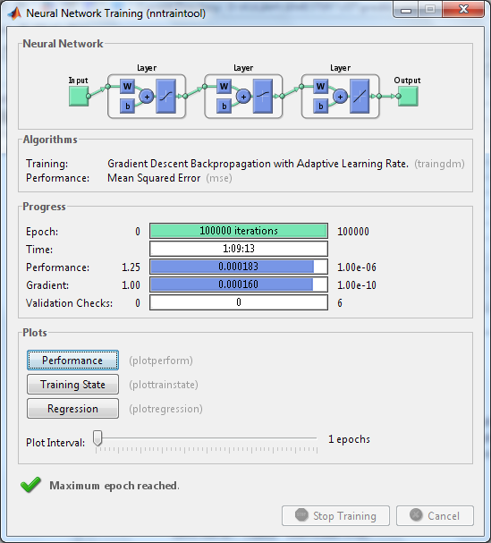

Testing menggunakan data training => semua data dikenali / 100 % data dikenali

Hasil testing menggunakan data testing ada x data yang dikenali dan y data yang tidak dikenali , bisa disimpulkan bahwa testing dapat mengenali z % data.

Lampiran

[pn,meanp,stdp,tn,meant,stdt]=prestd(p,t)

net=newff(minmax(pn),[10 5 1],{'tansig' 'logsig' 'purelin'},'traingdm');

net.IW{1,1}=[...

0.4500 0.0894 -0.8542 0.8416

0.9579 -0.1978 -0.5595 -0.6146

-0.6119 -0.9953 0.1435 -0.4015

-0.6320 -0.7867 -0.4583 0.5986

-0.0152 1.1257 0.4672 -0.1576

0.4021 -0.7500 -0.3316 -0.8762

0.5958 0.6346 0.6376 0.6659

-0.3116 0.9297 -0.7423 0.1878

-0.0043 0.7410 -0.8049 -0.6237

-0.7518 0.4902 0.5800 -0.6967];

net.b{1,1}=[...

-2.9086

-1.6140

2.9221

1.9021

-0.9166

1.5395

-1.2132

-1.4846

-1.4403

-2.2184];

net.LW{2,1}=[...

1.4500 1.0501 0.9679 -0.0225 0.0705 -1.7650 0.8302 1.1893 1.1413 0.3847

0.7305 1.4203 -0.3329 0.1057 -0.1429 -1.5011 -1.5074 1.0495 -1.1499 -1.0838

1.5362 -1.2236 -0.6011 0.0316 0.8532 0.4183 -1.4828 -0.9369 -0.9060 1.3406

1.4153 -1.2922 -0.1157 -1.2216 1.0480 1.6869 0.0372 0.9609 -0.1592 -0.8628

0.9604 1.1946 -1.2088 1.4801 0.3484 -0.2468 1.2570 -0.9697 -1.4478 -0.1297];

net.b{2,1}

net.LW{3,2}=[...

0.6595 -0.3997 0.4192 -0.8508 0.5004];

net.b{3,1}=[-0.0622];

net.trainParam.epochs=100000;

net.trainParam.goal=1e-6;

net.trainParam.lr=0.5;

net.trainParam.show=10000;

net.trainParam.mc=0.8;