**Final Assignment**

November 17, 2014

|  |  |  |
| --- | --- | --- |
| **Students** | **Topics** | **Data Requirements** |
| Rajashree | Location Prediction | GPS data |
| Abhijeet | Arm Flex & ear Shape | Arm Flex, Ear Images |
| Rischan | Gait | Accelerometer walking data |
| Fiqri | Activity Recognition | Walking, standing, running, up stairs, down stairs. |
| Gde | Keystroke and Gait | Keystroke, gait (walking) |
| Alvin | Activity Recognition | Walking, standing, running, up stairs, down stairs. |
| Fall | Fall Detection | Fall data |

Table 1. List students and research topics

List of Data that we have to collect:

1. Arm Flex
2. Ear Shape
3. Walking
4. Running
5. Standing
6. Up stairs
7. Down stairs
8. Fall

Please read this guidance carefully and we need your cooperation.

1. Accept my Dropbox invitation (this Dropbox folder is for collecting all of our data).
2. Install this application in your smartphone (<https://play.google.com/store/apps/details?id=com.fivasim.androsensor&hl=en> )
3. Please try to understand that application, I think I do not need to explain details about that application.

|  |  |
| --- | --- |
| D:\Dropbox\tmp\Screenshot_2014-11-17-18-52-48.png | D:\Dropbox\tmp\Screenshot_2014-11-17-18-52-56.png |
| D:\Dropbox\tmp\Screenshot_2014-11-17-18-53-15.png | D:\Dropbox\tmp\Screenshot_2014-11-17-18-55-52.png |

Press the menu in top right and then you will see list of menu in left side. Press button (red bullet) to start recording and stop recording. Your data will be stored in directory “AndroiSensor” inside your android sdcard.

1. Attach your phone with your thigh with phone’s position like in the Figure 1.

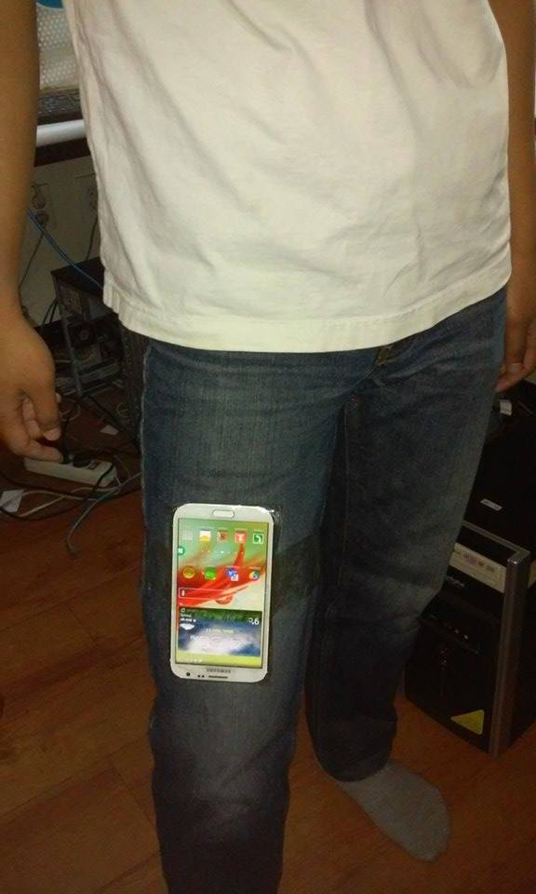

Figure 1. Phone positioning and attaching

1. Start to collect your data (please read carefully data collection methods in Table 2.).
2. Store your data to our drop box folder. Create new folder with your name and then store your data, follow “rischan” directory, see Figure 2. Don’t forget to put information about your device.

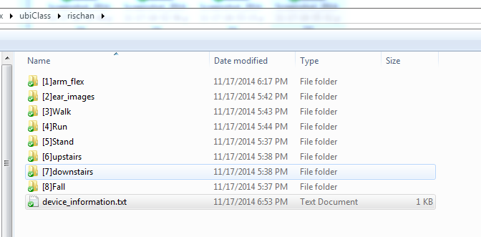

Figure 2. Format to store our data

1. The deadline for your file is **Friday, November 21, 2014.**

|  |  |
| --- | --- |
| **Arm Flex (10X)** | Put your phone on the table, press start recording and hold your phone and then pick up near to your ear like when you want to answer incoming call from someone then stop recording.  Doing this step for 10 times each person. |
| **Ear Shape (10)** | Open your camera application using your front camera and then take a picture of your ear shape. Total pics : 10 pictures |
| **Walking (10 A, 10 B)** | “10 A” means standing on “A” point and then walking 10 steps to “B” point. Do it for 10 times. “10 B” means standing on “B” point and then walking return back to “A” point. Do it for 10 times |
| **Running (10 A, 10 B)** | Same with walking but you are running not normal walking. |
| **Standing (2 minutes)** | Just stand for 2 minutes and record your data. |
| **Up stairs (8 steps, 10 X)** | In our building, we have stairs (8 steps). In this case, I tried to using that stairs. Normal walking up stairs, record it for 10 times. |
| **Down stairs (8 steps, 10 X)** | Normal walking down stairs, record it for 10 times. |
| **Fall (10X)** | Using mattress and record your forward fall for 10 times. (only forward fall) |

Table 2. Data Collection Methods

**Using ours dataset, apply the approaches in paper that already you read and present your result. I will send the presentation schedule as soon as possible.**