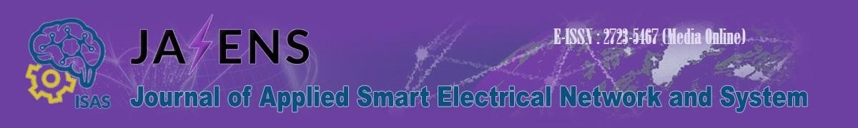

No : 04/IX/JASENS/2026

Subject : Letter of Acceptance for Manuscript Publication

To:
Nadia Putri
Department of Electrical Engineering, Example University

Dear Nadia Putri,

We are pleased to inform you that your manuscript entitled:

Adaptive Protection Coordination for Resilient Smart Distribution Networks

Nadia Putri, Ahmad Fauzan, Maria Lestari

has been accepted for publication in the Journal of Applied Smart Electrical Network and Systems (JASENS) after a comprehensive peer review process. Your paper will be scheduled for publication in Volume 7, No. 2 (September 2026).

JASENS is a peer-reviewed journal published by the Indonesia Society of Applied Science (ISAS) with the aim to provide a forum for academic researchers, industrial professionals, engineers, consultants, managers, educators, and practitioners to contribute and disseminate innovative new work on electrical engineering, smart electrical networks, and systems. Please note:

- The final version of your manuscript must strictly follow the JASENS template.
- Any required revisions must be addressed prior to publication.
- Proof of similarity check (plagiarism screening) and copyright agreement must be completed as part of the publication process.
- Should you have any questions or require further information, please do not hesitate to contact us at jasens@isas.or.id or through our online system.

We congratulate you on your achievement and look forward to your continued contribution to the advancement of applied electrical engineering.

Best regards,
Editor-in-Chief JASENS

Prof. Dr. Ratna Ika Putri, S.T., M.T

