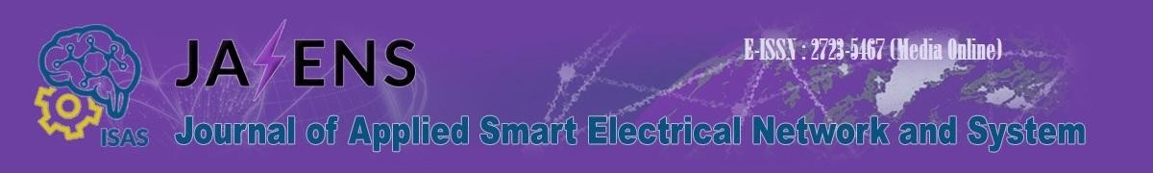

No : {{loa_number}}

Subject : Letter of Acceptance for Manuscript Publication

To:
{{recipient_name}}
{{recipient_affiliation}}

Dear {{recipient_name}},

We are pleased to inform you that your manuscript entitled:

{{article_title}}

{{authors}}

has been accepted for publication in the Journal of Applied Smart Electrical Network and Systems (JASENS) after a comprehensive peer review process. Your paper will be scheduled for publication in Volume {{volume}}, No. {{issue}} ({{publication_month}} {{publication_year}}).

JASENS is a peer-reviewed journal published by the Indonesia Society of Applied Science (ISAS) with the aim to provide a forum for academic researchers, industrial professionals, engineers, consultants, managers, educators, and practitioners to contribute and disseminate innovative new work on electrical engineering, smart electrical networks, and systems. Please note:

- The final version of your manuscript must strictly follow the JASENS template.
- Any required revisions must be addressed prior to publication.
- Proof of similarity check (plagiarism screening) and copyright agreement must be completed as part of the publication process.
- Should you have any questions or require further information, please do not hesitate to contact us at jasens@isas.or.id or through our online system.

We congratulate you on your achievement and look forward to your continued contribution to the advancement of applied electrical engineering.

Best regards,
Editor-in-Chief JASENS

Prof. Dr. Ratna Ika Putri, S.T., M.T

