GreenSense – Smart Environmental Monitoring System

1. Overview
GreenSense is an ESP32-based IoT prototype that monitors soil moisture, light, temperature and humidity. It classifies sensor readings, compares related parameters to identify normal or unusual conditions, generates an inference with a suggested solution, and publishes the result as JSON through MQTT. The prototype is tested in Wokwi.

2. Problem Statement
Environmental parameters should not always be interpreted independently. High humidity does not necessarily mean the soil is sufficiently moist, and high light does not necessarily mean the temperature is high. GreenSense uses cross-sensor reasoning to identify unusual relationships and provide an actionable interpretation.

3. My Approach
Pipeline: Sensor Inputs → ESP32 → Classification → Cross Sensor Logic → Inference/Anomaly → MQTT.
Normal rules: Low soil + low humidity → Dry; High soil + high humidity → Wet/Humid; High temperature + high light → Warm/Well lit; Low temperature + low light → Cool/Low light.

4. Observed Sensor Values & Threshold Reasoning
Thresholds were established by individually varying the Wokwi inputs and observing the resulting readings. I classified soil and light readings into 4 categories to get a more accurate reading of the environmental condition. The humidity (40% - 60%) and temperature (18 C – 27 C) thresholds were derived from research that suggested ideal ranges for plant growth.
Parameter | Range / Threshold | Level
Soil | <500 | LOW
Soil | 500–1599 | LOW-MID
Soil | 1600–2799 | HIGH-MID
Soil | ≥2800 | HIGH
Light | ≥2000 | LOW
Light | 500–1999 | LOW-MID
Light | 300–499 | HIGH-MID
Light | <300 | HIGH
Temperature | ≤25°C / >25°C | LOW / HIGH
Humidity | <50% / ≥50% | LOW / HIGH
LDR note: Wokwi's LDR has an inverse ADC response: lower simulated light produces a higher ADC value, so light classification is reversed accordingly.

5. My Custom Condition - Anomaly Detection
Condition | Inference | Suggested solution
Low soil + High humidity | Humid air but relatively dry soil. | Check irrigation / soil water retention.
High soil + Low humidity | Wet soil while surrounding air is dry. | Monitor evaporation; avoid unnecessary watering.
High temperature + Low light | High temperature despite low light. | Check ventilation / external heat sources.
Low temperature + High light | High light while temperature remains low. | Check artificial lighting / active cooling.

6. Components Used
Component | Purpose | Pin
ESP32 | Processing + WiFi/MQTT | —
Potentiometer | Soil moisture simulation | GPIO 34
LDR | Light measurement | GPIO 35
DHT22 | Temperature + humidity | GPIO 15
Software: Arduino C++, Wokwi, WiFi, MQTT/PubSubClient and DHT library. The potentiometer substitutes for a dedicated soil-moisture sensor in Wokwi.

7. Results
The prototype successfully reads all four parameters, classifies them, detects the defined cross-sensor anomalies, generates descriptions and solutions, connects to WiFi/MQTT, and publishes JSON.

8. Challenges Faced
1. No dedicated soil moisture component in Wokwi → potentiometer used as an analog simulator. 2. LDR response was inverse to simulated illumination → thresholds adjusted from observed readings. 3. Individual readings were insufficient for contextual interpretation → cross sensor rules added. 4. Sensor data had to be structured as JSON for MQTT publication.

9. Future Improvements
Replace the potentiometer with a real capacitive soil-moisture sensor; add a physical rain sensor and automated irrigation; support plant-specific thresholds and configurable anomaly rules.

10. Screenshots / Photos of the Build
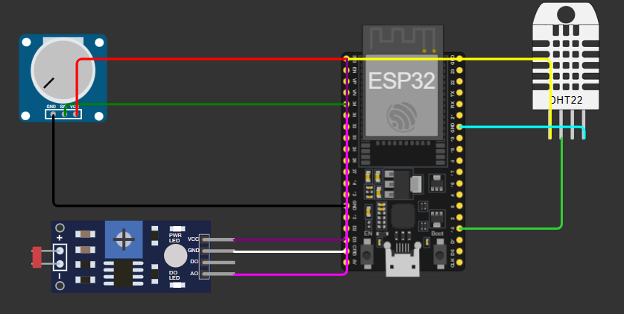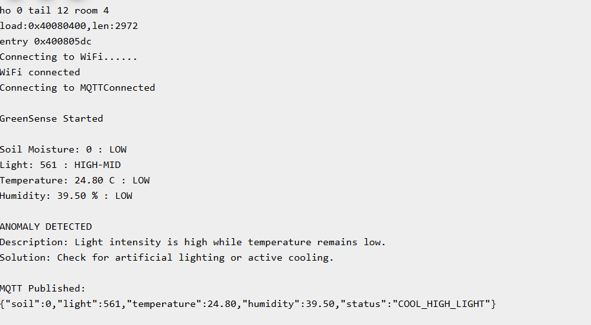

11. Links
Wokwi: Green Sense - Wokwi ESP32, STM32, Arduino Simulator
GitHub: https://github.com/risen-angel/GreenSense
Deployed Dashboard: https://green-sense-6mbwu4j9h-katyaini-s-projects.vercel.app/

