DAY-5

1.Write a c program to implement single shortest distance.

Program:

#include<stdio.h>

#include<conio.h>

#define INFINITY 9999

#define MAX 10

void dijkstra(int G[MAX][MAX],int n,int startnode);

int main()

{

int G[MAX][MAX],i,j,n,u;

printf("Enter no. of vertices:");

scanf("%d",&n);

printf("\nEnter the adjacency matrix:\n");

for(i=0;i<n;i++)

for(j=0;j<n;j++)

scanf("%d",&G[i][j]);

printf("\nEnter the starting node:");

scanf("%d",&u);

dijkstra(G,n,u);

return 0;

}

void dijkstra(int G[MAX][MAX],int n,int startnode)

{

int cost[MAX][MAX],distance[MAX],pred[MAX];

int visited[MAX],count,mindistance,nextnode,i,j;

for(i=0;i<n;i++)

for(j=0;j<n;j++)

if(G[i][j]==0)

cost[i][j]=INFINITY;

else

cost[i][j]=G[i][j];

for(i=0;i<n;i++)

{

distance[i]=cost[startnode][i];

pred[i]=startnode;

visited[i]=0;

}

distance[startnode]=0;

visited[startnode]=1;

count=1;

while(count<n-1)

{

mindistance=INFINITY;

for(i=0;i<n;i++)

if(distance[i]<mindistance&&!visited[i])

{

mindistance=distance[i];

nextnode=i;

}

visited[nextnode]=1;

for(i=0;i<n;i++)

if(!visited[i])

if(mindistance+cost[nextnode][i]<distance[i])

{

distance[i]=mindistance+cost[nextnode][i];

pred[i]=nextnode;

}

count++;

}

for(i=0;i<n;i++)

if(i!=startnode)

{

printf("\nDistance of node%d=%d",i,distance[i]);

printf("\nPath=%d",i);

j=i;

do

{

j=pred[j];

printf("<-%d",j);

}while(j!=startnode);

}

}

Output:

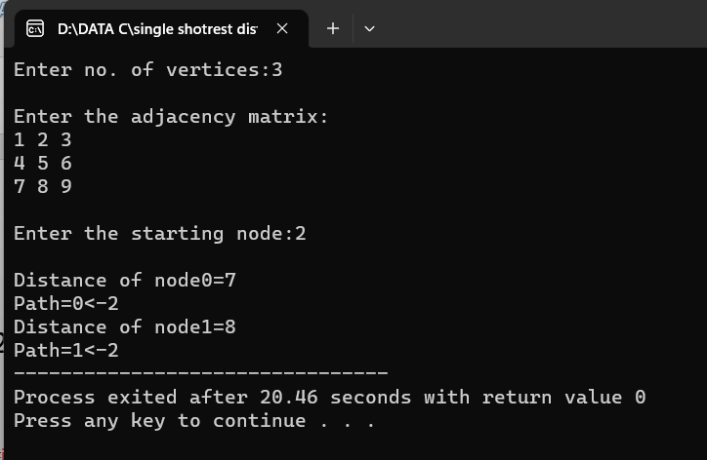

2.write a c program minimum spamming tree using prims method

Program:

#include <stdio.h>

#include <limits.h>

#define V 5

int minKey(int key[], int mstSet[]) {

int min = INT_MAX, min_index;

int v;

for (v = 0; v < V; v++)

if (mstSet[v] == 0 && key[v] < min)

min = key[v], min_index = v;

return min_index;

}

int printMST(int parent[], int n, int graph[V][V]) {

int i;

printf("Edge Weight\n");

for (i = 1; i < V; i++)

printf("%d - %d %d \n", parent[i], i, graph[i][parent[i]]);

} void primMST(int graph[V][V]) {

int parent[V];

int key[V], i, v, count;

int mstSet[V];

for (i = 0; i < V; i++)

key[i] = INT_MAX, mstSet[i] = 0;

key[0] = 0;

parent[0] = -1;

for (count = 0; count < V - 1; count++) {

int u = minKey(key, mstSet);

mstSet[u] = 1;

for (v = 0; v < V; v++)

if (graph[u][v] && mstSet[v] == 0 && graph[u][v] < key[v])

parent[v] = u, key[v] = graph[u][v];

} printMST(parent, V, graph);

} int main() {

int graph[V][V] = { { 0, 2, 0, 6, 0 }, { 2, 0, 3, 8, 5 },

{ 0, 3, 0, 0, 7 }, { 6, 8, 0, 0, 9 }, { 0, 5, 7, 9, 0 }, };

primMST(graph);

return 0;

}

Output:

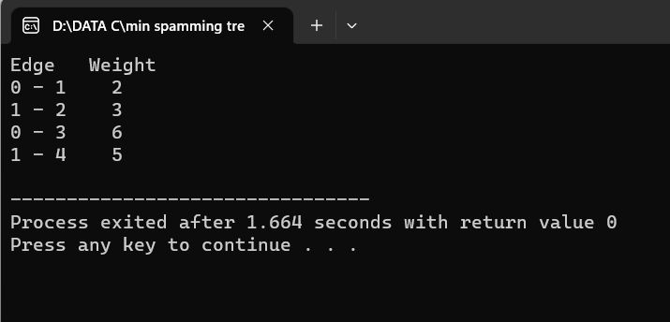

3.write a c program minimum spamming tree using Kruskal method

Program:

#include <stdio.h>

#define MAX 30

typedef struct edge {

int u, v, w;

} edge;

typedef struct edge_list {

edge data[MAX];

int n;

} edge_list;

edge_list elist;

int Graph[MAX][MAX], n;

edge_list spanlist;

void kruskalAlgo();

int find(int belongs[], int vertexno);

void applyUnion(int belongs[], int c1, int c2);

void sort();

void print();

void kruskalAlgo() {

int belongs[MAX], i, j, cno1, cno2;

elist.n = 0;

for (i = 1; i < n; i++)

for (j = 0; j < i; j++) {

if (Graph[i][j] != 0) {

elist.data[elist.n].u = i;

elist.data[elist.n].v = j;

elist.data[elist.n].w = Graph[i][j];

elist.n++;

}

}

sort();

for (i = 0; i < n; i++)

belongs[i] = i;

spanlist.n = 0;

for (i = 0; i < elist.n; i++) {

cno1 = find(belongs, elist.data[i].u);

cno2 = find(belongs, elist.data[i].v);

if (cno1 != cno2) {

spanlist.data[spanlist.n] = elist.data[i];

spanlist.n = spanlist.n + 1;

applyUnion(belongs, cno1, cno2);

}

}

}

int find(int belongs[], int vertexno) {

return (belongs[vertexno]);

}

void applyUnion(int belongs[], int c1, int c2) {

int i;

for (i = 0; i < n; i++)

if (belongs[i] == c2)

belongs[i] = c1;

}

void sort() {

int i, j;

edge temp;

for (i = 1; i < elist.n; i++)

for (j = 0; j < elist.n - 1; j++)

if (elist.data[j].w > elist.data[j + 1].w) {

temp = elist.data[j];

elist.data[j] = elist.data[j + 1];

elist.data[j + 1] = temp;

}

}

void print() {

int i, cost = 0;

for (i = 0; i < spanlist.n; i++) {

printf("\n%d - %d : %d", spanlist.data[i].u, spanlist.data[i].v, spanlist.data[i].w);

cost = cost + spanlist.data[i].w;

}

printf("\nSpanning tree cost: %d", cost);

}

int main() {

int i, j, total_cost;

n = 6;

Graph[0][0] = 0;

Graph[0][1] = 4;

Graph[0][2] = 4;

Graph[0][3] = 0;

Graph[0][4] = 0;

Graph[0][5] = 0;

Graph[0][6] = 0;

Graph[1][0] = 4;

Graph[1][1] = 0;

Graph[1][2] = 2;

Graph[1][3] = 0;

Graph[1][4] = 0;

Graph[1][5] = 0;

Graph[1][6] = 0;

Graph[2][0] = 4;

Graph[2][1] = 2;

Graph[2][2] = 0;

Graph[2][3] = 3;

Graph[2][4] = 4;

Graph[2][5] = 0;

Graph[2][6] = 0;

Graph[3][0] = 0;

Graph[3][1] = 0;

Graph[3][2] = 3;

Graph[3][3] = 0;

Graph[3][4] = 3;

Graph[3][5] = 0;

Graph[3][6] = 0;

Graph[4][0] = 0;

Graph[4][1] = 0;

Graph[4][2] = 4;

Graph[4][3] = 3;

Graph[4][4] = 0;

Graph[4][5] = 0;

Graph[4][6] = 0;

Graph[5][0] = 0;

Graph[5][1] = 0;

Graph[5][2] = 2;

Graph[5][3] = 0;

Graph[5][4] = 3;

Graph[5][5] = 0;

Graph[5][6] = 0;

kruskalAlgo();

print();

}

Output:

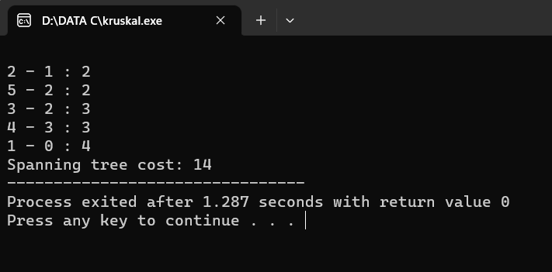

4.write a c program to implement depth first search graph traversal

Program:

#include <stdio.h>

#include <stdlib.h>

int vis[100];

struct Graph {

int V;

int E;

int** Adj;

};

struct Graph* adjMatrix()

{ struct Graph* G = (struct Graph*)

malloc(sizeof(struct Graph));

if (!G) {

printf("Memory Error\n");

return NULL;

} G->V = 7;

G->E = 7;

G->Adj = (int**)malloc((G->V) * sizeof(int*));

for (int k = 0; k < G->V; k++) {

G->Adj[k] = (int*)malloc((G->V) * sizeof(int));

}

for (int u = 0; u < G->V; u++) {

for (int v = 0; v < G->V; v++) {

G->Adj[u][v] = 0;

} }

G->Adj[0][1] = G->Adj[1][0] = 1;

G->Adj[0][2] = G->Adj[2][0] = 1;

G->Adj[1][3] = G->Adj[3][1] = 1;

G->Adj[1][4] = G->Adj[4][1] = 1;

G->Adj[1][5] = G->Adj[5][1] = 1;

G->Adj[1][6] = G->Adj[6][1] = 1;

G->Adj[6][2] = G->Adj[2][6] = 1;

return G;

}

void DFS(struct Graph* G, int u)

{ vis[u] = 1;

printf("%d ", u);

for (int v = 0; v < G->V; v++) {

if (!vis[v] && G->Adj[u][v]) {

DFS(G, v);

}

}

} void DFStraversal(struct Graph* G)

{ for (int i = 0; i < 100; i++) {

vis[i] = 0;

}

for (int i = 0; i < G->V; i++) {

if (!vis[i]) {

DFS(G, i);

}

}

}

int main()

{

struct Graph* G;

G = adjMatrix();

DFStraversal(G);

}

Output:

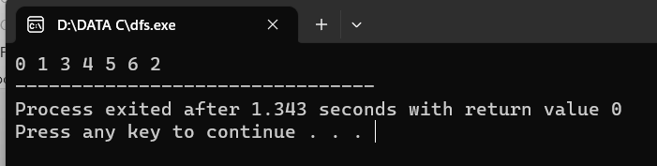

5.Write a c program to implement breadth first graph traversal

Program:

#include <stdio.h>

int n, i, j, visited[10], queue[10], front = -1, rear = -1;

int adj[10][10];

void bfs(int v)

{

for (i = 1; i <= n; i++)

if (adj[v][i] && !visited[i])

queue[++rear] = i;

if (front <= rear)

{

visited[queue[front]] = 1;

bfs(queue[front++]);

}

}

int main()

{

int v;

printf("Enter the number of vertices: ");

scanf("%d", &n);

for (i = 1; i <= n; i++)

{

queue[i] = 0;

visited[i] = 0;

}

printf("Enter graph data in matrix form: \n");

for (i = 1; i <= n; i++)

for (j = 1; j <= n; j++)

scanf("%d", &adj[i][j]);

printf("Enter the starting vertex: ");

scanf("%d", &v);

bfs(v);

printf("The node which are reachable are: \n");

for (i = 1; i <= n; i++)

if (visited[i])

printf("%d\t", i);

else

printf("BFS is not possible. Not all nodes are reachable");

return 0;

}

Output:

