Write a PL-SQL Program to create a trigger to backup a row which is delete from the one table and inserted in the another table

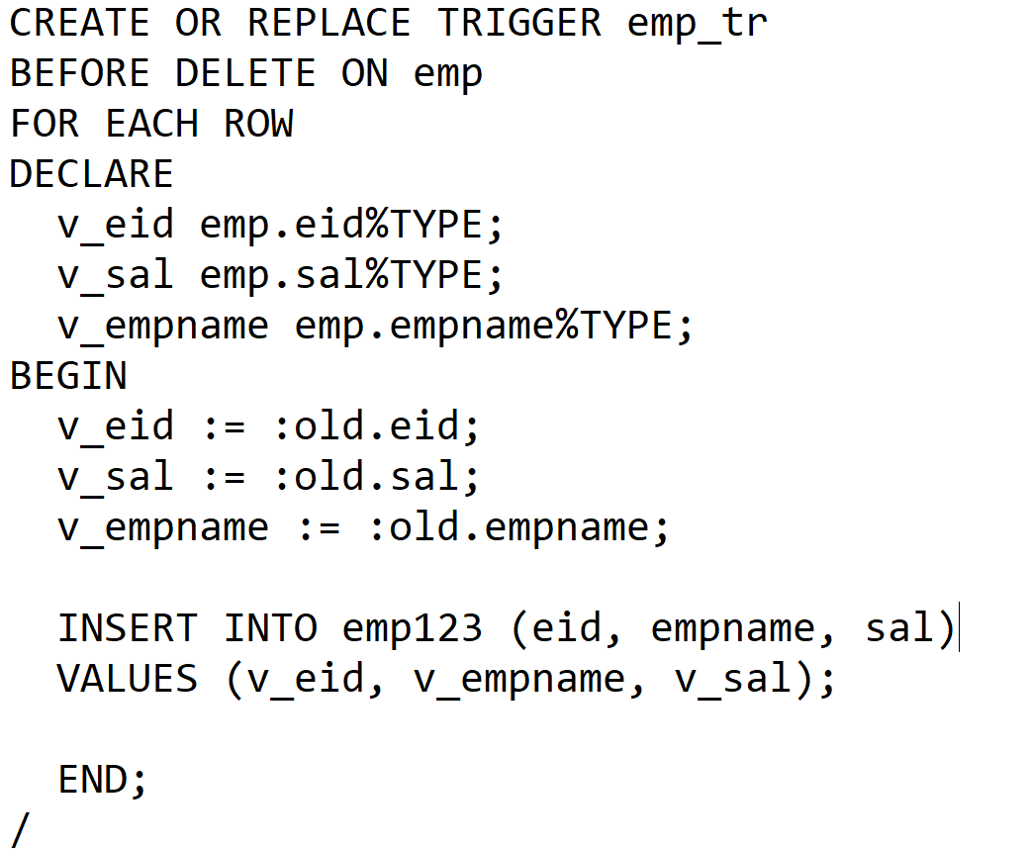

T2. Trigger to backup the deleted rows.

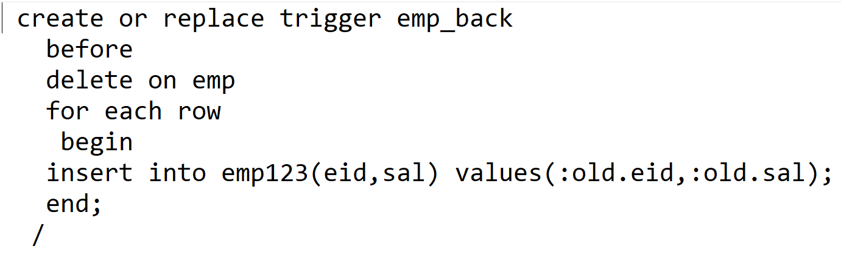

Above Trigger can also be written in the following way:

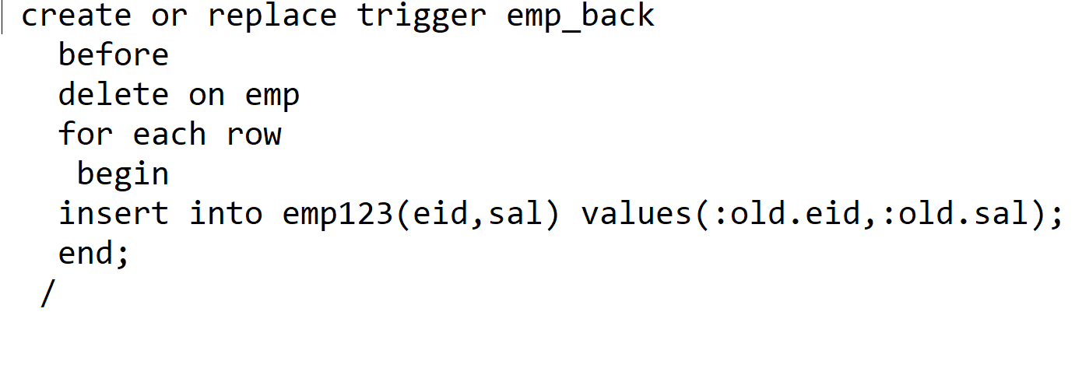

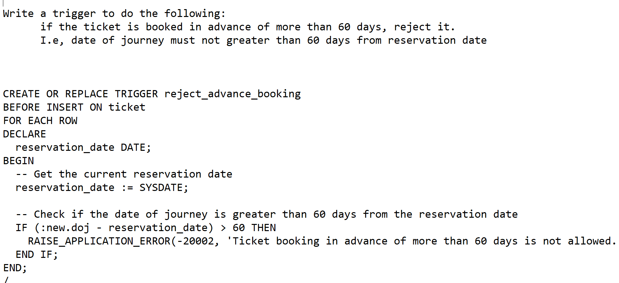

Write a trigger to restrict the operations on weekend:

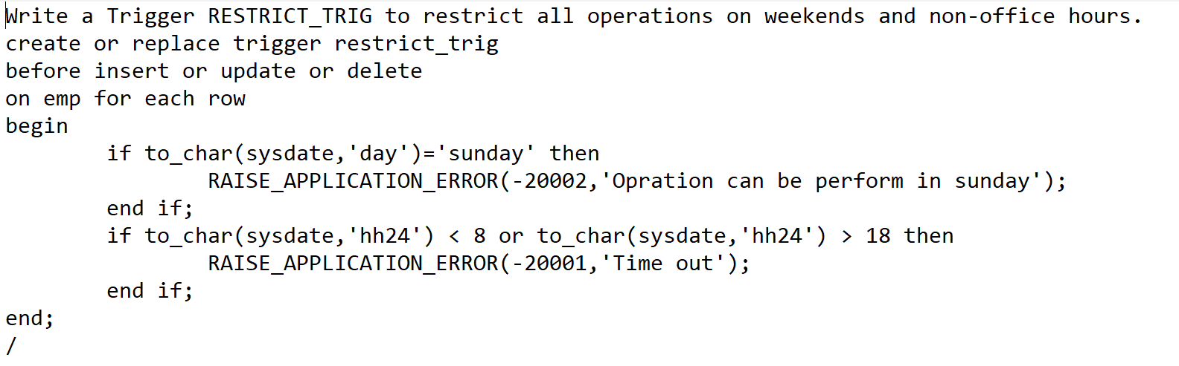

Write a trigger to restrict the entry of null values or duplicate values into the table:

