Inter processor arbitration

Computer systems need buses to facilitate the transfer of information between their various components. There is a dispute in the system bus that connects the CPU, Input-Output processor, and memory (main components of a computer). Only one between the CPU, Input-Output processor, and memory gets the grant to use the bus simultaneously. Hence, an appropriate priority resolving mechanism is required to decide which processor should get control of the bus. Therefore, a mechanism is needed to handle multiple requests for the bus, known as Inter processor Arbitration.

Arbitration Techniques
Following are the techniques of arbitration:

Static Arbitration Techniques
In this technique, the priority assigned is fixed. It has two types. They are serial arbitration procedures and parallel arbitration logic.

Serial Arbitration
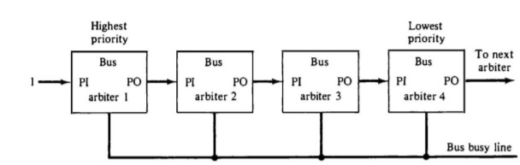

Fig: Serial (daisy-chain) arbitration

It is also known as Daisy chain Arbitration. It is obtained by the daisy-chain connection of bus arbitration circuits. The scheme got the term from the structure of the grant line, which chains through each device from the higher to lowest priority. The highest priority device will pass the grant line to the lower priority device only if it does not want it. Then the priority is forwarded to the next in the sequence. All devices use the same line for bus requests. If a busy bus line returns to its idle state, the most high-priority arbiter enables the busy line, and its corresponding processor can then run the required bus transfer.
Advantage
i) It is a simple design.
ii) Less number control lines are used.
Disadvantage
i) Priority depends on the physical location of the device
ii) Propagation delay due to serially granting of bus
iii) Failure of one of the devices may fail the entire system
iv) Cannot assure fairness- a low priority device may be locked out indefinitely

Parallel Arbitration
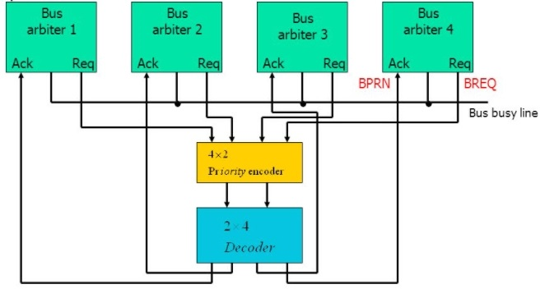

Fig: Parallel arbitration

It uses an external priority encoder and decoder. Each bus arbiter has a bus request output line and a bus acknowledge input line. Each arbiter enables request lines when its processor is requesting the system bus. The one with the highest priority determined by the output of the decoder gets access to the bus.

Dynamic Arbitration Techniques
Serial and Parallel bus arbitration are static since the priorities assigned are fixed. In dynamic arbitration, priorities of the system change while the system is in operation.
The various algorithms used are:-

Time Slice
It allocates a fixed-length time slice of bus time offered sequentially to each process in a round-robin fashion. The service provided by each system component and the system is independent of its location near the bus.

Polling
In polling, the controller generates the addresses for the devices. The number of address lines needed depends upon the number of connected devices to the system. The controller generates a sequence of device addresses in response to the bus request. When the requesting device recognizes its address, it activates the busy bus line and uses the bus. After several bus cycles, the polling process continues by choosing a different processor. The polling sequence usually is programmable, and as a result, the selection priority can be altered under program control.

Least Recently Used (LRU)
This algorithm provides the highest priority for a device, requesting that it has not used the bus for too long. The priorities are adjusted after several bus cycles according to the LRU algorithm.

FIFO (First IN First Out)
Requests are served in the order received in the FIFO scheme. The bus controller establishes a queue as per the request of the incoming bus to use this algorithm.
Each processor has to wait for its bus usage time as per first in and first-out (FIFO).

Rotating Daisy chain
It is a dynamic extension of the daisy chain algorithm. There is no central bus controller in this scheme, and the priority line is connected from the priority out of the last device back to the priority-in of the first device in a closed-loop.
Each arbiter priority for a given bus cycle is determined by its position along the bus priority line from the arbiter whose processor is currently controlling the bus. Once an arbiter releases the bus, it has the lowest priority.

Interprocessor Communication and Synchronization
In general, Interprocess Communication is a mechanism provided by the operating system (or OS). The various processors in a multiprocessor system should be provided with a facility for communicating with each other. The working of this mechanism is to provide communications between several processes.
In short, intercommunication allows a process to let another process know that some event has occurred or data is to be transferred from one process to another.
This article will help you understand Interprocessor Communication and Synchronization, methods to provide synchronization, approaches used for inter-process communication, and the importance of Inter-process communication.

What is Interprocessor Communication?
Interprocessor communication is used for interchanging useful information among various regions in one or more processes (or programs). This communication could involve letting another process know that some event has occurred or the transferring of data from one process to another.
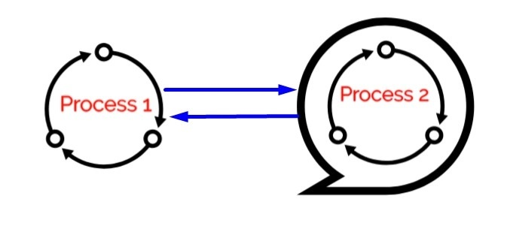
Fig: Interprocess communication illustration

Synchronization in Interprocessor Communication

Synchronization is an essential part of interprocess communication. It refers to a case where the data used to communicate between processors is control information. It is either given by the interprocess control mechanism or handled by the communicating processes.
It is required to maintain the correct sequence of processes and to make sure equal access to shared writable data.
Multiprocessor systems have various mechanisms for the synchronization of resources. Below are some methods to provide synchronization is as follows −
- Mutual Exclusion
- Semaphore
- Barrier
- Spinlock

Mutual Exclusion
Mutual Exclusion requires that only a single process thread can enter the critical section one at a time. This also helps synchronize and prevents the race condition by creating a stable state.
Semaphore
Semaphore is a type of variable that generally controls the access to the shared resources by several processes. Further, Semaphore is divided into two types as follows:
Binary Semaphore
A binary semaphore is limited to zero or one. It could be used to control access to one resource. In particular, it can be used to force the same release of an important category in the user code.
Counting Semaphore
Counting semaphore may take any integer value. It could be used to control access to resources having many instances.
Barrier
A barrier does not allow an individual process to proceed unless all the processes do not reach it. Many parallel languages use it, and collective routines impose barriers.

Spinlock
A spinlock is a type of lock that prevents processes from operating any function unless it is available. The processes which are trying to acquire the spinlock wait in a loop while checking if the lock is available or not. This is also known as busy waiting because the process is not doing any helpful operation even though it is active.

Cache Coherence
A cache coherence issue results from the concurrent operation of several processors and the possibility that various caches may hold different versions of the identical memory block. The practice of cache coherence makes sure that alterations in the contents of associated operands are quickly transmitted across the system.

Cache coherence has three different levels:
- Each writing operation seems to happen instantly.
- Each operand's value changes are seen in every processor in precisely the same order.
- Non-coherent behavior results from many processors interpreting the same action in various ways.
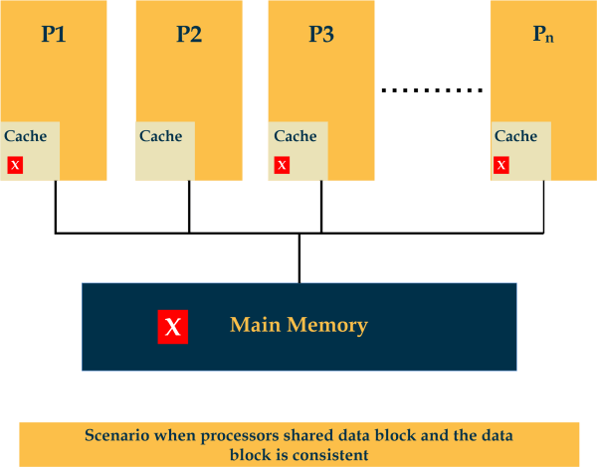

Methods to resolve Cache Coherence
The two methods listed below can be used to resolve the cache coherence issue:
- Write Through
- Write Back

Write Through
The easiest and most popular method is to write through. Every memory write operation updates the main memory. If the word is present in the cache memory at the requested address, the cache memory is also updated simultaneously with the main memory.
The benefit of this approach is that the RAM and cache always hold the same information. In systems with direct memory access transfer, this quality is crucial. It makes sure the information in the main memory is up-to-date at all times so that a device interacting over DNA can access the most recent information.
Advantage - It provides the highest level of consistency.
Disadvantage - It requires a greater number of memory accesses.

Write Back
Only the catch location is changed during a write operation in this approach. When the word is withdrawn from the cache, the place is flagged, so it is replicated in the main memory. The right-back approach was developed because words may be updated numerous times while they are in the cache. However, as long as they are still there, it doesn't matter whether the copy that is stored in the main memory is outdated because requests for words are fulfilled from the cache.
An accurate copy must only be transferred back to the main memory when the word is separated from the cache. According to the analytical findings, between 10% and 30% of all memory references in a normal program are written into memory.
Advantage - A very small number of memories accesses and write operations.
Disadvantage - Inconsistency may occur in this approach.
The important terms related to the data or information stored in the cache as well as in the main memory is as follows:
- Modified - The modified term signifies that the data stored in the cache and main memory are different. This means the data in the cache has been modified, and the changes need to be reflected in the main memory.
- Exclusive - The exclusive term signifies that the data is clean, i.e., the cache and the main memory hold identical data.
- Shared - Shared refers to the fact that the cache value contains the most current data copy, which is then shared across the whole cache as well as main memory.
- Owned - The owned term indicates that the block is currently held by the cache and that it has acquired ownership of it, i.e., complete privileges to that specific block.
- Invalid - When a cache block is marked as invalid, it means that it needs to be fetched from another cache or main memory.
Below is a list of the different Cache Coherence Protocols used in multiprocessor systems?
- MSI protocol (Modified, Shared, Invalid)
- MOSI protocol (Modified, Owned, Shared, Invalid)
- MESI protocol (Modified, Exclusive, Shared, Invalid)
- MOESI protocol (Modified, Owned, Exclusive, Shared, Invalid)

Types of Coherence:
There exist three varieties of coherence referred to the coherency mechanisms, which are listed below:
Directory Based - A directory-based system keeps the coherence amongst caches by storing shared data in a single directory. In order to load an entry from primary memory into its cache, the processor must request permission through the directory, which serves as a filter. The directory either upgrades or devalues the other caches that contain that record when a record is modified.
Snooping - Individual caches watch address lines during the snooping process to look for accesses to memory locations that they have cached. A write invalidate protocol is what it is known as. When a write activity is seen to a memory address for which a cache maintains a copy, the cache controller invalidates its own copy of the snooped memory location.
Snarfing - A cache controller uses this approach to try and update its own copy of a memory location when a second master alters a place in the main memory by keeping an eye on both the address and the contents. The cache controller updates its own copy of the underlying memory location with the new data when a write action is detected to a place of which a cache holds a copy.

