Example 6-1
Show how the flag register is affected by the following instructions.
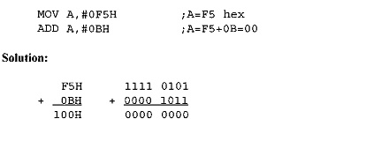
After the addition, register A (destination) contains 00 and the flags are as follows:
CY = 1 since there is a carry out from D7.
P = 0 because the number of Is is zero (an even number).
AC = 1 since there is a carry from D3 to D4.
ADDC and addition of 16-bit numbers
When adding two 16-bit data operands, we need to be concerned with the propagation of a carry from the lower byte to the higher byte. The instruction ADDC (add with carry) is used on such occasions. For example, look at the addition of 3CE7H + 3B8DH, as shown below.
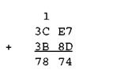
When the first byte is added (E7 + 8D = 74, CY = 1). The carry is propagated to the higher byte, which results in 3C + 3B + 1 = 78 (all in hex). Example 6-3 shows the above steps in an 8051 program.
Example 6-2
Write a program to add two 16-bit numbers. The numbers are 3CE7H and 3B8DH. Place the sum in R7 and R6; R6 should have the lower byte.
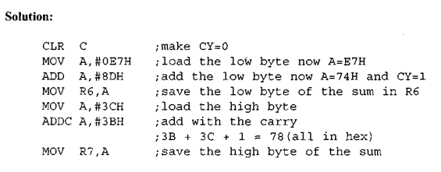
SUBB (subtract with borrow) when CY=0
Example 6-5
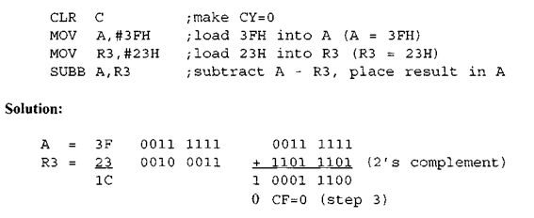
The flags would be set as follows: CY = 0, AC – 0, and the programmer must look at the carry flag to determine if the result is positive or negative.
Show the steps involved in the following.
If the C Y = 0 after the execution of SUBB, the result is positive; if C Y = 1, the result is negative and the destination has the 2′s complement of the result. Normally, the result is left in 2′s complement, but the CPL (complement) and INC instructions can be used to change it. The CPL instruction performs the 1 ‘s complement of the operand; then the operand is incremented (INC) to get the 2′s complement.
Multiplication of unsigned numbers
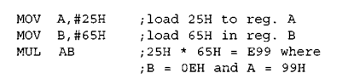

Division of unsigned numbers

