

**Manav Kendra Gyan Mandir School**

N.H.NO.8,

P.O.: KANDARI-391210,

TA.KARJAN, DIST.BARODA

A Project Report

on

**Library Management System**

For

AISSCE 2013-2014 Examination

As a part of the Informatics Practices Course (065)

SUBMITTED BY:

Aaditya Shah

1604173

Under the Guidance of:

Sanjay Parmar

PGT-Informatics Practices

**Declaration**

I declare that this project entitled “Library Management System” done at MKGM School is a record of project work submitted by me for the partial fulfillment of the AISSC exam of CBSE under the supervision and guidance of Mr Sanjay T Parmar (PGT-Computer Science).

The Project is genuine and not a reproduction of any project previously done or submitted.

-Aaditya Shah

1604173

**Acknowledgement**

I extend my sincere thanks to MKGM School which provided me with the opportunity to fulfill my wish and achieve my goal.

I would like to express deep debt to **Mr. Sanjay T Parmar (PGT-Computer Science)**, project guide for his vital suggestions, meticulous guidance and constant motivation which went a long way in the successful completion of this project.

I cannot move on without thank beloved **Principal Mr Mahendrasinh Vihol** for creating the required academic environment which made my task appreciable.

On a moral personal note, my deepest appreciation and gratitude to my beloved parents, who have been an inspiration and have provided me with unrelenting encouragement and support.

-    Aaditya Shah

**CERTIFICATE**

This is to certify that the Dissertation entitled, **Library Management** is a bonafide work done by *Master Aaditya Shah* of class XII Commerce during the academic session 2013-2014 is partial fulfillment of CBSE’s AISSCE Examination 2014 and has been carried out under my direct supervision and guidance. This report or a similar report on the topic has not been submitted for any other examination and does not form a part of any other course undergone by the candidate.

________________

**Signature of Teacher**

(Mr. Sanjay. T. Parmar)

_________________

**Signature of Principal**

(Mr. MahendraSinh Vihol)

**Seal of the school**

**INTRODUCTION**

The project titled **“Smart Library 1.0”** is Library management software for monitoring and controlling the transactions in a library. This project is designed & coded in **Netbeans 7.3.1** & database management is handled by **MySQL 5.0** . This software mainly focuses on basic operationsin a library like adding new member, new books, and updating new information,searching books and members and facility to borrow and return books.“Smart Library 1.0” is a java application written on 32-bit**,** Windows XP operating system, designed to help users maintain and organize library. Mysoftware is easy to use for both beginners and advanced users. It features a familiarand well thought-out, an attractive user interface, combined with strong searchinginsertion and reporting capabilities. The report generation facility of library systemhelps to get a good idea of which are the books borrowed or returned by the members.

**This software has four main modules:**

* Insertion to Database Module – User friendly input screen
* Extracting from Database module – Attractive Output Screen
* Report Generation module – Borrowed book list & Issued book list
* Search Facility system – Search for books

**system analysis**

**EXISTING SYSTEM:**

System Analysis is a detailed study of the various operations performed by a system and their relationships within and outside of the system. Here the key question is- what all problems exist in the present system? What must be done to solve the problem? Analysis begins when a user or manager begins a study of the program using existing system.

During analysis, data collected on the various files, decision points and transactions handled by the present system. Training, experience and common sense are required for collection of relevant information needed to develop the system. The success of the system depends largely on how clearly the problem is defined, thoroughly investigated and properly carried out through the choice of solution.

A good analysis model should provide not only the mechanisms of problem understanding but also the frame work of the solution. Thus, it should be studied thoroughly by collecting data about the system. Then the proposed system should be analyzed thoroughly in accordance with the needs.

**System analysis can be categorized into four parts:**

* System planning and initial investigation
* Information Gathering
* Applying analysis tools for structured analysis
* Feasibility study
* Cost/ Benefit analysis.

In our existing system, all the transaction of books are done manually, so taking more time for a transaction like borrowing a book or returning a book and also for searching of members and books. Another major disadvantage is that preparing the list of books borrowed and the available books in the library will take more time, currently a one day process for verifying all records. So after conducting the feasibility study we decided to make a computerized library management system.

**PROPOSED SYSTEM**

Proposed system is an automated Library Management System. Through our software user can add members, add books, search members, search books, update information, edit information, borrow and return books in quick time. Our proposed system has the following advantages.

* User friendly interface
* Fast access to database
* Less error
* More Storage Capacity
* Search facility
* Look and Feel Environment
* Quick transaction

All the manual difficulties in managing the Library have been rectified by implementing computerization.

**Feasibility analysis**

Whatever we think need not be feasible .It is wise to think about the feasibility of any problem we undertake. Feasibility is the study of impact, which happens in the organization by the development of a system. The impact can be either positive or negative. When the positives nominate the negatives, then the system is considered feasible. Here the feasibility study can be performed in two ways such as technical feasibility and Economical Feasibility.

* **Technical Feasibility:**

We can strongly says that it is technically feasible, since there will not be much difficulty in getting required resources for the development and maintaining the system as well. All the resources needed for the development of the software as well as the maintenance of the same is available in the organization here we are utilizing the resources which are available already.

* **Economical Feasibility:**

Development of this application is highly economically feasible .The organization needed not spend much m one for the development of t he system already available. The only thing is to be done is making an environment for the development with an effective supervision. If we are doing so, we can attain the maximum usability of the corresponding resources .Even after the development, the organization will not be in a condition to invest more in the organization .Therefore, the system is economically feasible.

**minimum hardware requirements**

* Processor : Pentium IV or better
* RAM : 128 MB or more
* Hard Disk : 20GB
* Monitor : Any
* Key Board : 122 Keys

**minimum software requirements**

* Operating System : Windows 98, Windows XP, Windows 7 or better
* Language : Java 7 Runtime Environment or better
* Front End : Netbeans 7.3.1
* Back End : MySQL server 5.0

**software interface**

* **Splash Screen**

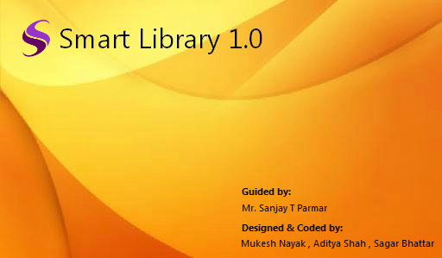

* **Login Form**

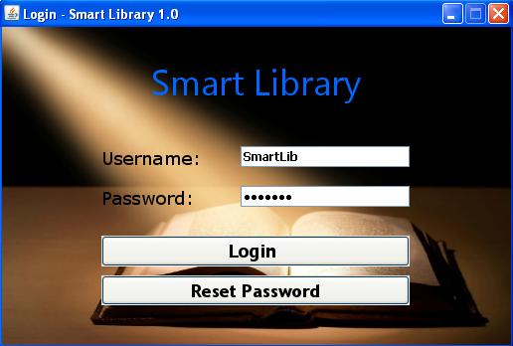

* **Change Password**

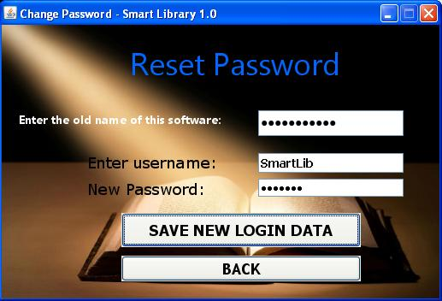

* **Main Window**

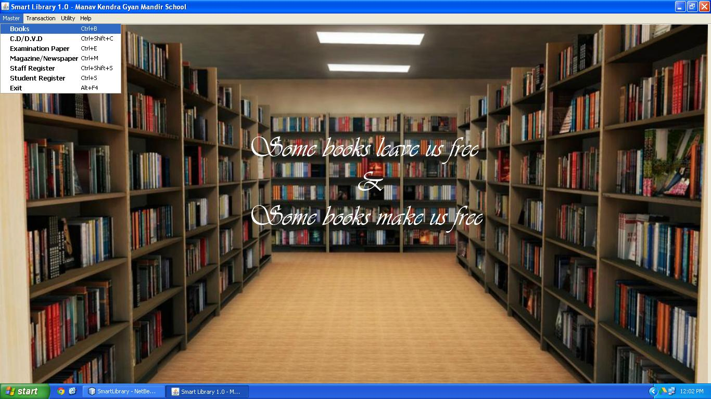

* **Books**

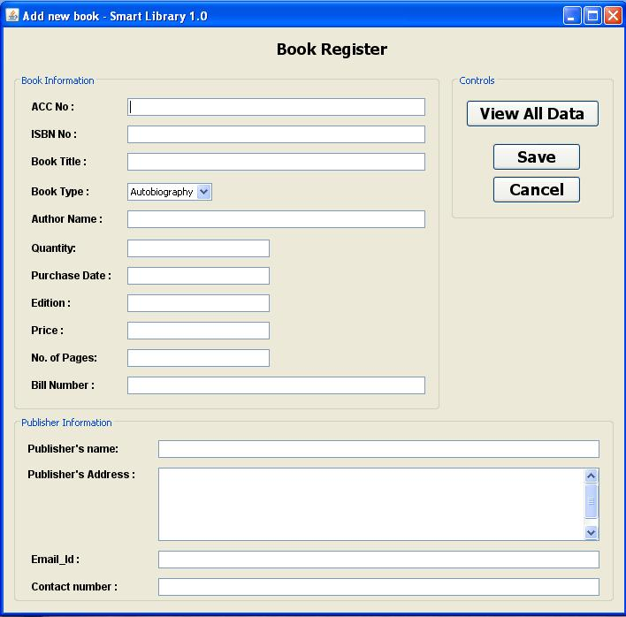

* **CD / DVD**

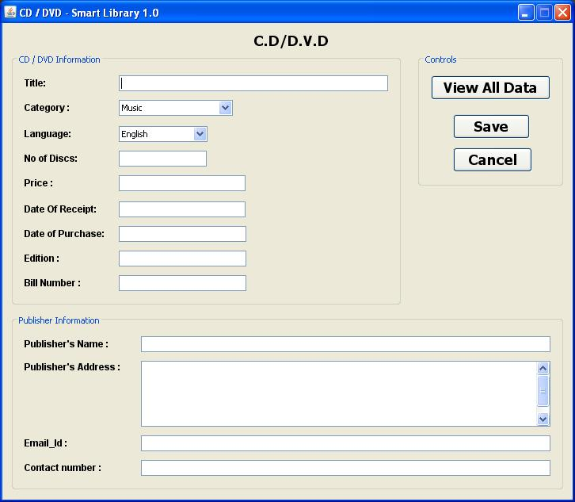

* **Examination Paper**

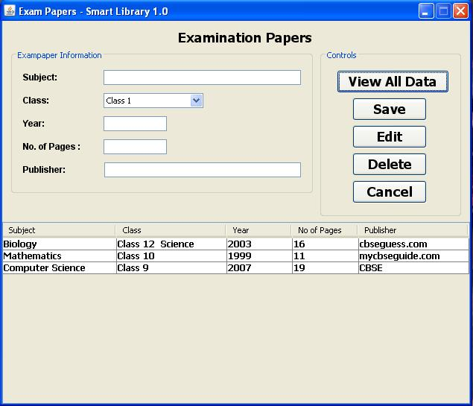

**\***

* **Magazine / Newspaper**

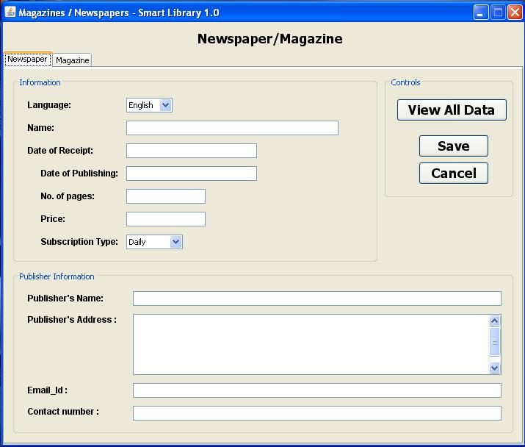

* **Staff Register**

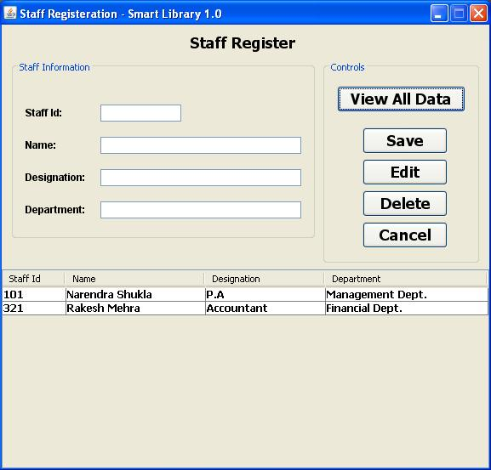

* **Student Register**

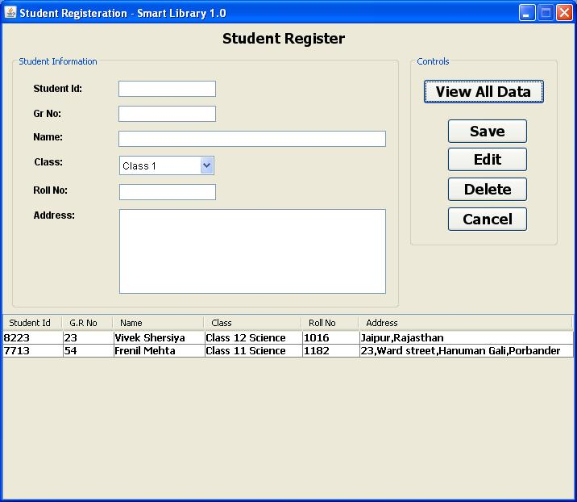

* **Issue**

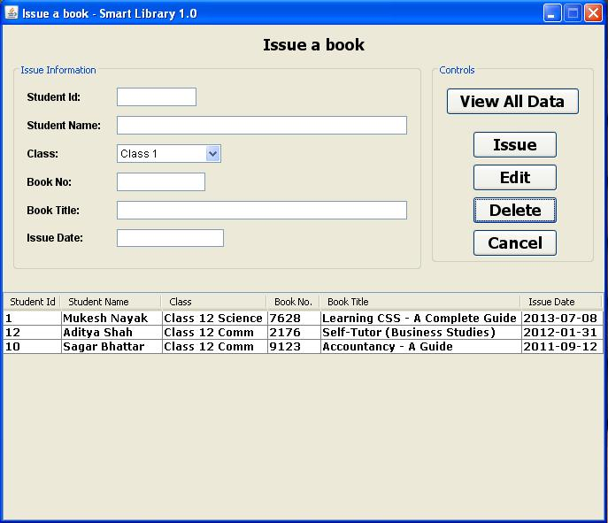

* **Return**

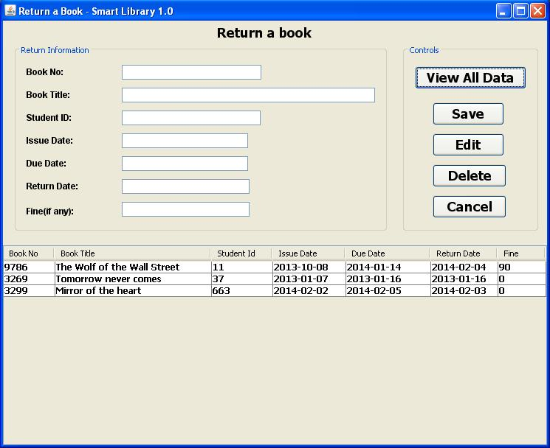

* **Search Books**

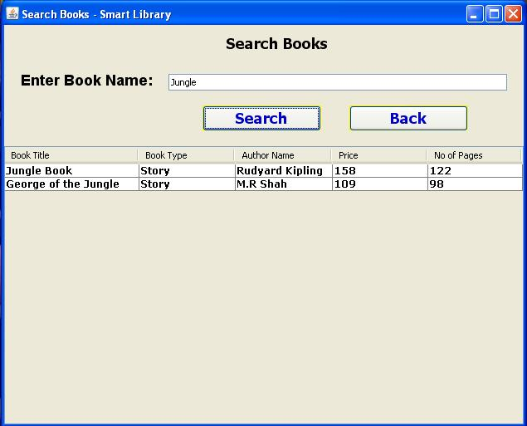

* **Calculator**

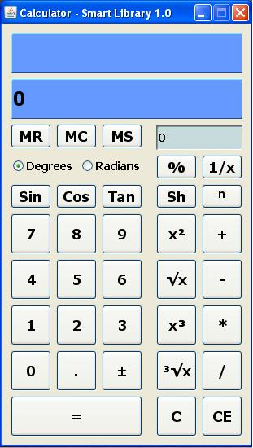

* **Calendar**

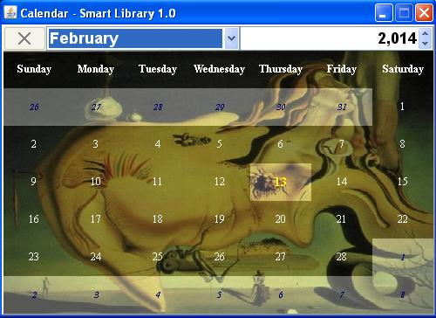

* **Shortcuts**

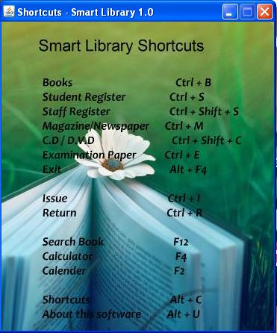

* **About this software**

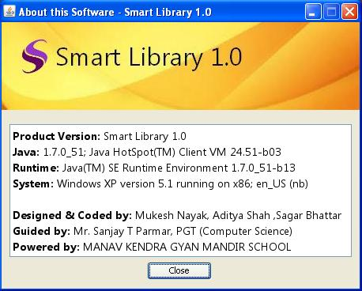

**system design**

* **Input Design:**

Input design is the process of converting user-oriented input to a computer based format. Input design is a part of overall system design, which requires very careful attention .Often the collection of input data is the most expensive part of the system.

**The main objectives of the input design are:**

1. Produce cost effective method of input

2. Achieve highest possible level of accuracy

3. Ensure that the input is acceptable to and understood by the staff.

**Input Data:** The goal of designing input data is to make enter easy, logical and free from errors as possible. The entering data entry operators need to know the allocated space for each field; field sequence and which must match with that in the source document. The format in which the data fields are entered should be given in the input form .Here data entry is online; it makes use of processor that accepts commands and data from the operator through a key board. The input required is analyzed by the processor. It is then accepted or rejected. Input stages include the following processes:

* Data Recording
* Data Transcription
* Data Conversion
* Data Verification
* Data Control
* Data Transmission
* Data Correction

One of the aims of the system analyst must be to select data capture method and devices, which reduce the number of stages so as to reduce both the changes of errors and the cost .Input types, can be characterized as.

* External
* Internal
* Operational
* Computerized
* Interactive

Input files can exist in document form before being input to the computer. Input design is rather complex since it involves procedures for capturing data as well as inputting it to the computer.

* **Output Design:**

Outputs from computer systems are required primarily to communicate the results of processing to users. They are also used to provide a permanent copy of these result for latter consultation .Computer output is the most important and direct source of information to the users. Designing computer output should proceed in an organized well throughout the manner. The right output must be available for the people who find the system easy to use. The outputs have been defined during the logical design stage. If not, they should defined at the beginning of the output designing terms of types of output connect, format, response etc.

**Various types of outputs are:**

• External outputs

• Internal outputs

• Operational outputs

• Interactive outputs

• Turn around outputs

All screens are informative and interactive in such a way that the user can full fill his requirements through asking queries.

**database design**

The general theme behind a database is to handle information as an integrated whole. A database is a collection of interrelated data stored with minimum redundancy to serve many users quickly and effectively. After designing input and output, the analyst must concentrate on database design or how data should be organized around user requirements. The general objective is to make information access, easy quick, inexpensive and flexible for other users. During database design the following objectives are concerned:-

* Controlled Redundancy
* Data independence
* Accurate and integrating
* More information at low cost
* Recovery from failure
* Privacy and security
* Performance
* Ease of learning and use

**tables used**

* **Table Name: loginform**

|  |  |  |
| --- | --- | --- |
| **NAME** | **TYPE** | **ATTRIBUTES** |
| Uname | Varchar(25) | Unique |
| Pwd | Varchar(22) | Unique |

* **Table Name: password_change**

|  |  |  |
| --- | --- | --- |
| **NAME** | **TYPE** | **ATTRIBUTES** |
| Uname | Varchar(25) | Unique |

* **Table Name: book_register**

|  |  |  |
| --- | --- | --- |
| **NAME** | **TYPE** | **ATTRIBUTES** |
| ACC_NO | Varchar(30) |  |
| ISBN_NO | Varchar(20) | Primary Key |
| BOOK_TITLE | Varchar(50) |  |
| BOOK_TYPE | Varchar(20) |  |
| AUTHOR_NAME | Varchar(50) | Not Null |
| QUANTITY | Int(11) | Not Null |
| PUR_DATE | Date | Not Null |
| EDITION | Varchar(10) | Not Null |
| PRICE | Int(11) | Not Null |
| NO_PAGES | Int(11) |  |
| BILL_NUMBER | Varchar(25) | Not Null |
| PUB_NAME | Varchar(35) | Not Null |
| PUB_ADRESS | Varchar(65) |  |
| EMAIL_ID | Varchar(25) |  |
| CONTACT | Float |  |

* **Table Name: cd_form**

|  |  |  |
| --- | --- | --- |
| **NAME** | **TYPE** | **ATTRIBUTES** |
| TITLE | Varchar(50) | Not Null |
| CATEGORY | Varchar(20) | Not Null |
| LANGUAGE | Varchar(25) | Not Null |
| NO_DISC | Int(11) | Not Null |
| PRICE | Int(11) |  |
| DATE_OF_RECEIPT | Date | Not Null |
| PUR_DATE | Date |  |
| EDITION | Varchar(10) |  |
| BILL_NO | Varchar(50) | Not Null |
| PUB_NAME | Varchar(50) | Not Null |
| PUB_ADRESS | Varchar(65) |  |
| EMAIL_ID | Varchar(25) |  |
| CONTACT_NO | Float |  |

* **Table Name: exam_paper**

|  |  |  |
| --- | --- | --- |
| **NAME** | **TYPE** | **ATTRIBUTES** |
| SUBJECT | Varchar(20) | Not Null |
| CLASS | Varchar(20) | Not Null |
| YEAR | Int(11) | Not Null |
| NO_PAGES | Int(11) |  |
| PUBLISHERS | Varchar(65) | Not Null |

* **Table Name: magazine**

|  |  |  |
| --- | --- | --- |
| **NAME** | **TYPE** | **ATTRIBUTES** |
| TYPE | Varchar(34) | Not Null |
| NAME | Varchar | Not Null |
| DATE_OF_RECEIPT | Date | Not Null |
| DATE_OF_PUB | Date | Not Null |
| NO_PAGES | Int(11) |  |
| PRICE | Int(11) |  |
| SUB_TYPE | Varchar | Not Null |
| PUB_NAME | Varchar | Not Null |
| PUB_ADRESS | Varchar |  |
| EMAIL | Varchar |  |
| CONTACT_NO | Int(11) |  |

* **Table Name: newspaper**

|  |  |  |
| --- | --- | --- |
| **NAME** | **TYPE** | **ATTRIBUTES** |
| LANGUAGE | Varchar(34) | Not Null |
| NAME | Varchar | Not Null |
| DATE_OF_RECEIPT | Date | Not Null |
| DATE_OF_PUBLISH | Date | Not Null |
| NO_PAGES | Int(11) |  |
| PRICE | Int(11) |  |
| SUB_TYPE | Varchar | Not Null |
| PUB_NAME | Varchar | Not Null |
| PUB_ADRESS | Varchar |  |
| EMAIL | Varchar |  |
| CONTACT_NO | Int(11) |  |

* **Table Name: staff_register**

|  |  |  |
| --- | --- | --- |
| **NAME** | **TYPE** | **ATTRIBUTES** |
| STAFF_ID | Varchar(35) | Not Null |
| NAME | Varchar(50) | Not Null |
| DESIGNATION | Varchar(35) | Not Null |
| DEPARTMENT | Varchar(50) | Not Null |

* **Table Name: student_register**

|  |  |  |
| --- | --- | --- |
| **NAME** | **TYPE** | **ATTRIBUTES** |
| STUDENT_ID | Varchar(35) | Not Null |
| GR_NO | Tinyint(4) |  |
| NAME | Varchar(50) | Not Null |
| CLASS | Varchar(25) | Not Null |
| ROLL NO | Varchar(25) | Not Null |
| ADDRESS | Varchar(56) |  |

* **Table Name: issue_master**

|  |  |  |
| --- | --- | --- |
| **NAME** | **TYPE** | **ATTRIBUTES** |
| STUDENT_ID | Int(11) | Not Null |
| STUDENT_NAME | Varchar(50) | Not Null |
| CLASS | Varchar(25) | Not Null |
| BOOK_NO | Varchar(15) | Not Null |
| BOOK_TITLE | Varchar(50) | Not Null |
| ISSUE_DATE | Date | Not Null |

* **Table Name: return_master**

|  |  |  |
| --- | --- | --- |
| **NAME** | **TYPE** | **ATTRIBUTES** |
| BOOK_NO | Int(11) | Not Null |
| BOOK_TITLE | Varchar(50) | Not Null |
| STUDENT_ID | Varchar(25) | Not Null |
| ISSUE_DATE | Date | Not Null |
| DUE_DATE | Date | Not Null |
| RETURN_DATE | Date | Not Null |
| FINE | Int(11) | Not Null |

**conclusion**

This was an effort to develop a simple Library Management System which may be useful in a Library to insert, store, handle and retrieve information about books, magazines, cd/dvd, newspapers etc. I hope you will like it.

**bibliography**

* Informatics Practices, Class XII - By Sumita Arora
* Netbeans Forums
* [Google](http://www.google.com).com
* Stackoverflow.com
* Sourcecode.in

