National Institute 0f Technology, Hamirpur

Department Of Computer Science and Engineering
July-Dec 2020



Subject Name:  Advanced O.S Lab | Subject Code:  CSD – 416
Course:  Advanced O.S | Semester:  4th Year, 7th Semester
Submitted By:  Student Name: Rishabh Katna  Roll No: 17MI552 | Submitted To:  Dr. Siddhartha Chauhan
Faculty Signature:

Experiment 1
Aim : To simulate various job scheduling algorithms.

Theory :

Job Scheduling algorithms:
These are the algorithms used by the CPU to schedule various job in efficient ways to achieve maximum performance and CPU utilization.

The Purpose of a Scheduling algorithm
- Maximum CPU utilization
- Fare allocation of CPU
- Maximum throughput
- Minimum turnaround time
- Minimum waiting time
- Minimum response time
Various job scheduling algorithms are used to achieve this purpose. Some of them are :
a. fcfs scheduling ( First-Come-First-Serve Algorithm ).
b. sjf scheduling ( Shortest Job First Scheduling )
c. round robin scheduling
d. priority scheduling

The main initializer code used to setup the program is given below.
Initializer Code:
#include <iostream>
#include <queue>
#include <vector>
#include <algorithm>
#include <iomanip>

using namespace std;

vector<string> namesOfProcesses = {"P1", "P2", "P3", "P4", "P5"};
vector<int> arrivalTimes = {};
vector<int> burstTimes = {};
vector<int> priorities = {2, 3, 4, 5, 5};

const int INFINITY = 100;
const int TIME_QUANTUM = 2;

class Job {
public:
string name;
bool isServed = false, isPresentInReadyQueue = false;
int arrivalTime, burstTime, waitingTime, completionTime, turnAroundTime, originalBurstTime, priority;

Job(string name, int arrivalTime, int burstTime, int priority){
this->name = name;
this->arrivalTime = arrivalTime;
this->burstTime = burstTime;
this->waitingTime = 0;
this->completionTime = 0;
this->turnAroundTime = 0;
this->isServed = false;
this->originalBurstTime = this->burstTime;
this->priority = priority;
}

void printStats(){
cout
<< setw(20) << this->name
<< setw(5) << this->arrivalTime
<< setw(5) << this->originalBurstTime
<< setw(5) << this->waitingTime
<< setw(5) << this->completionTime
<< setw(5) << this->turnAroundTime
<< endl;
}
};
void insertJobsInJobQueue(vector<Job> &jobQueue)
{
int numberOfJobs = namesOfProcesses.size();

generateRandomArrivalTimes();

generateRandomBurstTimes();

for(int i=0; i<numberOfJobs; i++){
string nameOfCurJob = namesOfProcesses[i];
int arrivalTimeOfCurJob = arrivalTimes[i];
int burstTimeOfCurJob = burstTimes[i];
int priorityOfCurJob = priorities[i];

Job newJob(nameOfCurJob, arrivalTimeOfCurJob, burstTimeOfCurJob, priorityOfCurJob);

jobQueue.push_back(newJob);
}

}

void insertJobsInReadyQueue(queue<Job*> &readyQueue, vector<Job> &jobQueue, int timer){

// check for all the jobs which are arrived before timer
// passed in original jobQueue
for(auto &job : jobQueue){
// check if job has arrived and has not been isisServed yed
if(job.arrivalTime <= timer && job.isServed == false && job.isPresentInReadyQueue == false){
Job* jobptr = &job;
// push address of job in the ready queue
jobptr->isPresentInReadyQueue = true;
readyQueue.push(jobptr);
}
}

}

void printFinalInformation(vector<Job> &finishedJobs, int totalWaitingTime, int totalTurnAroundTime){

int totalNumberOfJobs = namesOfProcesses.size();
double averageWaitingTime = (1.0 * totalWaitingTime) / (totalNumberOfJobs);
double averageTurnAroundTime = (1.0 * totalTurnAroundTime) / (totalNumberOfJobs);
cout
<< setw(20) << "Name"
<< setw(5) << "A.T"
<< setw(5) << "B.T"
<< setw(5) << "W.T"
<< setw(5) << "C.T"
<< setw(5) << "T.A.T"
<< endl;

for(auto job : finishedJobs) job.printStats();
printf("Average turn around time in the system = %.2lf\n", averageTurnAroundTime);
printf("Average waiting time in the system = %.2lf\n", averageWaitingTime);
cout << "........................................................................." << endl;

}

////////////////// generate random arrival times /////////////////////
void generateRandomArrivalTimes()
{
// change the arrival times
int numberOfProcesses = namesOfProcesses.size();

arrivalTimes.resize(numberOfProcesses);

for(int i=0; i < numberOfProcesses; i++){
int randomArrivalTime = 0;

// generate random arrival time
randomArrivalTime = (rand() % 19);

arrivalTimes[i] = randomArrivalTime;
}

}

///////////////// generate random burst times ///////////////////////////
void generateRandomBurstTimes()
{
// change the arrival times
int numberOfProcesses = namesOfProcesses.size();

burstTimes.resize(numberOfProcesses);

for(int i=0; i < numberOfProcesses; i++){
int randomBurstTime = 0;

// generate random burst time
randomBurstTime = (rand() % 10);

burstTimes[i] = randomBurstTime;
}

}

a. F.C.F.S algorithm :
It is the simplest algorithm to implement. The process with the minimal arrival time will get the CPU first. The lesser the arrival time, the sooner will the process gets the CPU. It is the non-preemptive type of scheduling.

Code :
class FcfsScheduler{
void serveJob(Job &jobToServe, int timer){

jobToServe.waitingTime = (jobToServe.arrivalTime > timer) ? 0 : (timer - jobToServe.arrivalTime);

jobToServe.completionTime = jobToServe.arrivalTime + jobToServe.waitingTime + jobToServe.burstTime;

jobToServe.turnAroundTime = jobToServe.completionTime - jobToServe.arrivalTime;

}
public:
void scheduleJobs(vector<Job> jobQueue){
int timer = 0;

// stores the finished jobs
vector<Job> finishedJobs;

// calculate the total waiting time of the processes
int totalWaitingTime = 0, totalTurnAroundTime = 0;

// process jobs while there are jobs available in ready queue
// delay of counter time
while(!jobQueue.empty()){
// get the first job from the readyQueue
Job jobToServe = jobQueue[0]; jobQueue.erase(jobQueue.begin());

// get the time at which job will leave the system
serveJob(jobToServe, timer);

totalTurnAroundTime += jobToServe.turnAroundTime;

totalWaitingTime += jobToServe.waitingTime;

// book a new time slot for the new job
timer = jobToServe.completionTime;

// since the job is completed, hence we can add the job in the finishedJobs array
finishedJobs.push_back(jobToServe);
}

printFinalInformation(finishedJobs, totalWaitingTime, totalTurnAroundTime);
}

};

b. SJF scheduling

The job with the shortest burst time will get the CPU first. The lesser the burst time, the sooner will the process get the CPU. It is the non-preemptive type of scheduling.
class SjfScheduler {
protected:
const int inf = 100;
vector<Job> finishedJobs = {};
int totalWaitingTime = 0, totalTurnAroundTime = 0;
void insertJobsInReadyQueue(vector<Job*> &readyQueue, vector<Job> &jobQueue, int timer){
for(auto &job : jobQueue){
// check if job has arrived and has not been served yed
if(job.arrivalTime <= timer && job.isServed == false){
Job* jobptr = &job;
// push address of job in the ready queue
readyQueue.push_back(jobptr);
}
}

}

static bool onBurstTime(Job* j1, Job* j2){
return j1->burstTime <= j2->burstTime;
}
};

i. SJF Preemptive scheduling
It is the preemptive form of SJF. In this algorithm, the OS schedules the Job according to the remaining time of the execution.

class SjfPreemptiveScheduler : public SjfScheduler{
void serveJob(Job* jobToServe, int timer){
jobToServe->isServed = true;
jobToServe->completionTime = timer + 1;
jobToServe->turnAroundTime = jobToServe->completionTime - jobToServe->arrivalTime;
jobToServe->waitingTime = jobToServe->turnAroundTime - jobToServe->originalBurstTime;
// jobToServe->responseTime = jobToServe->waitingTime;
}
public:
void scheduleJobs(vector<Job> jobQueue){
int timer = 0;
while(timer < inf){
// address of all job objects
vector<Job*> readyQueue;

// this code is wrong
insertJobsInReadyQueue(readyQueue, jobQueue, timer);

if(readyQueue.empty()){
timer++;
continue;
}

sort(readyQueue.begin(), readyQueue.end(), onBurstTime);

Job* jobToServe = readyQueue[0]; // address of the job to serve

jobToServe->burstTime -= 1;

if(jobToServe->burstTime == 0) {
serveJob(jobToServe, timer);
totalWaitingTime += jobToServe->waitingTime;
totalTurnAroundTime += jobToServe->turnAroundTime;

finishedJobs.push_back(*jobToServe);
}

timer ++;
}
printFinalInformation(finishedJobs, totalWaitingTime, totalTurnAroundTime);
}
};

ii. SJF Non-Preemptive scheduling
he job with the shortest burst time will get the CPU first. The lesser the burst time, the sooner will the process get the CPU. It is the non-preemptive type of scheduling.

class SjfNonPreemptiveScheduler : public SjfScheduler{
void serveJob(Job* jobToServe, int timer)
{
jobToServe->isServed = true;

jobToServe->waitingTime = timer - jobToServe->arrivalTime;

jobToServe->completionTime = timer + jobToServe->burstTime;

jobToServe->turnAroundTime = jobToServe->completionTime - jobToServe->arrivalTime;
}
public:
void scheduleJobs(vector<Job> jobQueue){
int timer = 0;
while(timer < inf){
// address of all job objects
vector<Job*> readyQueue;

insertJobsInReadyQueue(readyQueue, jobQueue, timer);

// if no job has arrived, then don't do anything
if(readyQueue.empty()){
timer++;
continue;
}

sort(readyQueue.begin(), readyQueue.end(), onBurstTime);

Job* jobToServe = readyQueue[0]; // address of the job to serve

serveJob(jobToServe, timer);

timer = jobToServe->completionTime;

totalWaitingTime += jobToServe->waitingTime;

totalTurnAroundTime += jobToServe->turnAroundTime;

finishedJobs.push_back(*jobToServe);

}

printFinalInformation(finishedJobs, totalWaitingTime, totalTurnAroundTime);
}

};

c. Prioriy Scheduler
In this algorithm, the priority will be assigned to each of the processes. The higher the priority, the sooner will the process get the CPU. If the priority of the two processes is same then they will be scheduled according to their arrival time.
class ComparyPriorities
{
/* data */
public:
bool operator () (Job* j1, Job* j2){
return j1->priority < j2->priority;
}
};

class PriorityScheduler {
vector<Job> finishedJobs = {};

void insertJobsInReadyQueue(priority_queue<Job*, vector<Job*>, ComparyPriorities> &readyQueue, vector<Job> &jobQueue, int timer){

// check for all the jobs which are arrived before timer
// passed in original jobQueue
for(auto &job : jobQueue){
// check if job has arrived and has not been isisServed yed
if(job.arrivalTime <= timer && job.isServed == false && job.isPresentInReadyQueue == false){
Job* jobptr = &job;
// push address of job in the ready queue
jobptr->isPresentInReadyQueue = true;
readyQueue.push(jobptr);
}
}

}

void serveJob(Job* jobToServe, int timer){

jobToServe->isServed = true;

jobToServe->completionTime = timer;

jobToServe->turnAroundTime = jobToServe->completionTime - jobToServe->arrivalTime;

jobToServe->waitingTime = jobToServe->turnAroundTime - jobToServe->originalBurstTime;
}

public:

void scheduleJobs(vector<Job> jobQueue){

int timer = 0;

priority_queue<Job*, vector<Job*>, ComparyPriorities> readyQueue; // when something is entered, it gets to its appr location

int totalWaitingTime = 0, totalTurnAroundTime = 0;

while(timer < INFINITY){

// insert jobs in ready queue
insertJobsInReadyQueue(readyQueue, jobQueue, timer);

if(readyQueue.empty()) {
timer++;
continue;
}

// get the best job
Job* jobToServe = readyQueue.top();

jobToServe->burstTime--;

timer++;

if(jobToServe->burstTime == 0){
// done processing .... no need for more cpu allocation
// out of our readyQueue
readyQueue.pop();

serveJob(jobToServe, timer);

totalWaitingTime += jobToServe->waitingTime;

totalTurnAroundTime += jobToServe->turnAroundTime;

finishedJobs.push_back(*jobToServe);
}

}

printFinalInformation(finishedJobs, totalWaitingTime, totalTurnAroundTime);
}

};

d. Round-Robin Scheduler :
In the Round Robin scheduling algorithm, the OS defines a time quantum (slice). All the processes will get executed in the cyclic way. Each of the process will get the CPU for a small amount of time (called time quantum) and then get back to the ready queue to wait for its next turn. It is a preemptive type of scheduling.
class RoundRobinScheduler {
static bool onArrivalTime(Job j1, Job j2){
return j1.arrivalTime < j2.arrivalTime;
}

void serveJob(Job* jobToServe, int timer){
jobToServe->isServed = true;
// mark isisServed as true
// these are calculated accurately
jobToServe->completionTime = timer;
// calculate waiting time, execution time and tat
jobToServe->turnAroundTime = jobToServe->completionTime - jobToServe->arrivalTime;

jobToServe->waitingTime = jobToServe->turnAroundTime - jobToServe->originalBurstTime;
}
public:

void scheduleJobs(vector<Job> jobQueue) {

sort(jobQueue.begin(), jobQueue.end(), onArrivalTime);

vector<Job> finishedJobs = {};
int timer = 0;

// stores the addresses of the jobs

queue<Job*> readyQueue;

// store the job processes in previous step
Job* prevJobProcessed = NULL;

int totalWaitingTime = 0;
int totalTurnAroundTime = 0;

while(timer < INFINITY){

insertJobsInReadyQueue(readyQueue, jobQueue, timer);

// insert the prevJobProcesses
if(prevJobProcessed != NULL) readyQueue.push(prevJobProcessed);

prevJobProcessed = NULL;

if(readyQueue.empty()){
timer += 1;
continue;
}

/// if some jobs have arrived

// take first job of the queue
Job* jobToServe = readyQueue.front(); readyQueue.pop();
// process the job for interval

int processingInterval = min(TIME_QUANTUM, jobToServe->burstTime);

jobToServe->burstTime -= processingInterval;

timer += processingInterval;

// check if job has done its processing

// job will not be pushed in ready queue again
if(jobToServe->burstTime != 0){
prevJobProcessed = jobToServe;
continue;
}

// burstTime == 0
serveJob(jobToServe, timer);

// cout << jobToServe->name << ' ' << jobToServe->burstTime << endl;
totalWaitingTime += jobToServe->waitingTime;

totalTurnAroundTime += jobToServe->turnAroundTime;

finishedJobs.push_back(*jobToServe);

}

printFinalInformation(finishedJobs, totalWaitingTime, totalTurnAroundTime);

}

};

Output :

driver Code :
int main()
{
vector<Job> jobQueue = {};

insertJobsInJobQueue(jobQueue);

// start the processing

cout << "Round Robin Scheduler ..................................................." << endl;
RoundRobinScheduler roundRobinScheduler;
roundRobinScheduler.scheduleJobs(jobQueue);
cout << "........................................................................." << endl;

cout << "Sjf Preemptive Scheduler ................................................" << endl;
SjfPreemptiveScheduler sjfPreemptiveScheduler;
sjfPreemptiveScheduler.scheduleJobs(jobQueue);
cout << "........................................................................." << endl;

cout << "Sjf NonPreemptive Scheduler ............................................." << endl;
SjfNonPreemptiveScheduler sjfNonPreemptiveScheduler;
sjfNonPreemptiveScheduler.scheduleJobs(jobQueue);

cout << "fcfs scheduler .........................................................." << endl;
FcfsScheduler fcfsScheduler;
fcfsScheduler.scheduleJobs(jobQueue);
cout << "........................................................................." << endl;

cout << "Priority Scheduler ......................................................" << endl;
PriorityScheduler priorityScheduler;
priorityScheduler.scheduleJobs(jobQueue);

}

Output :

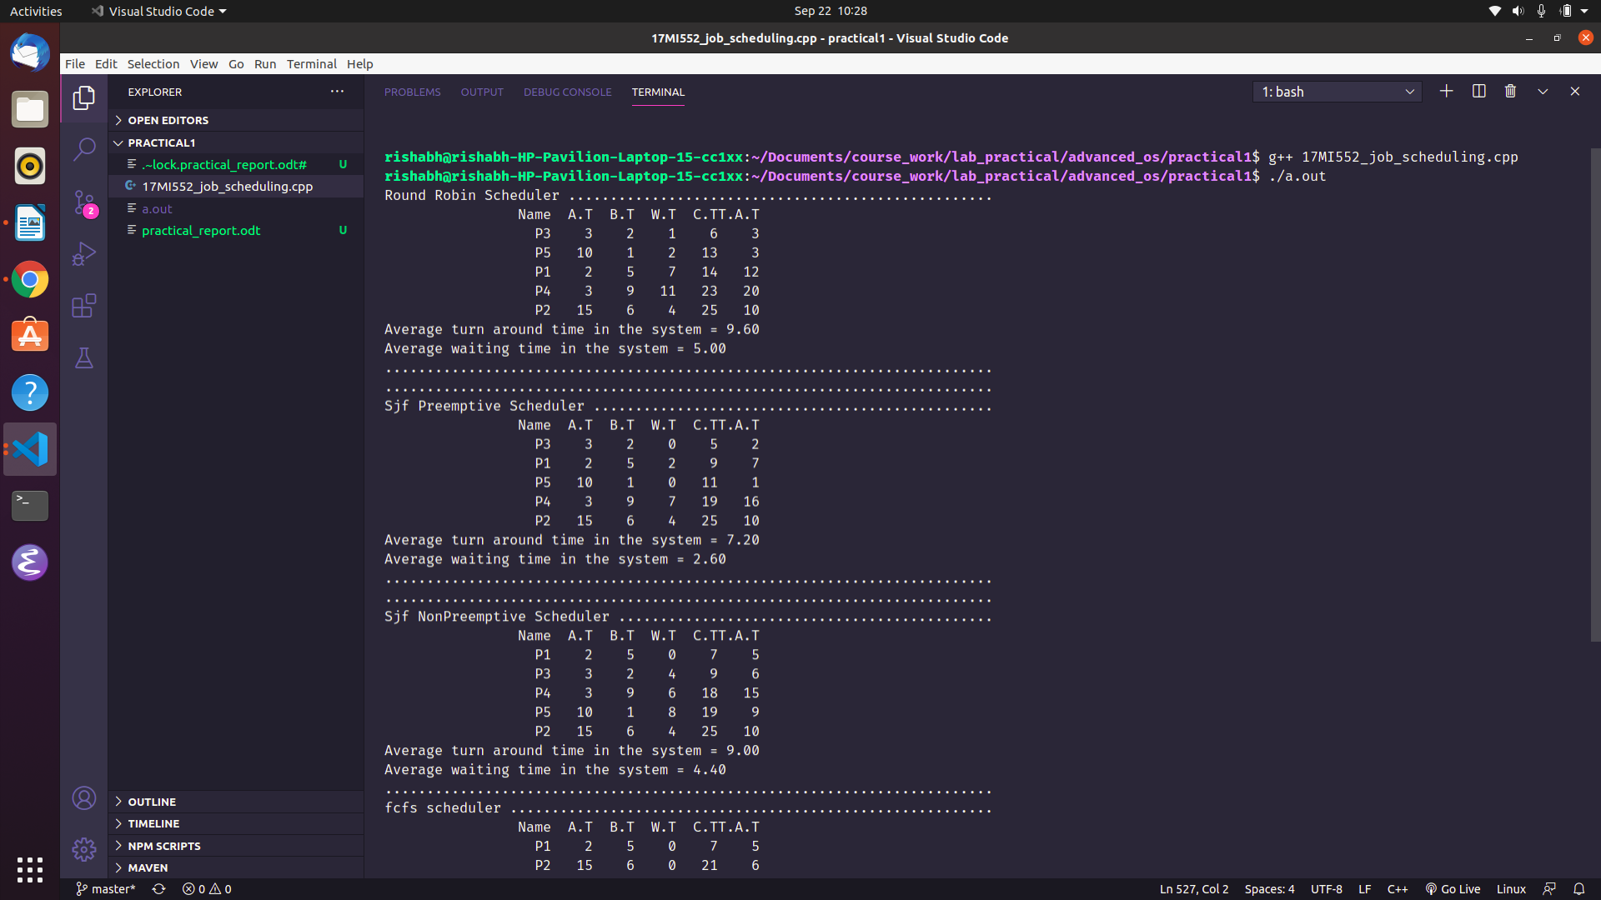

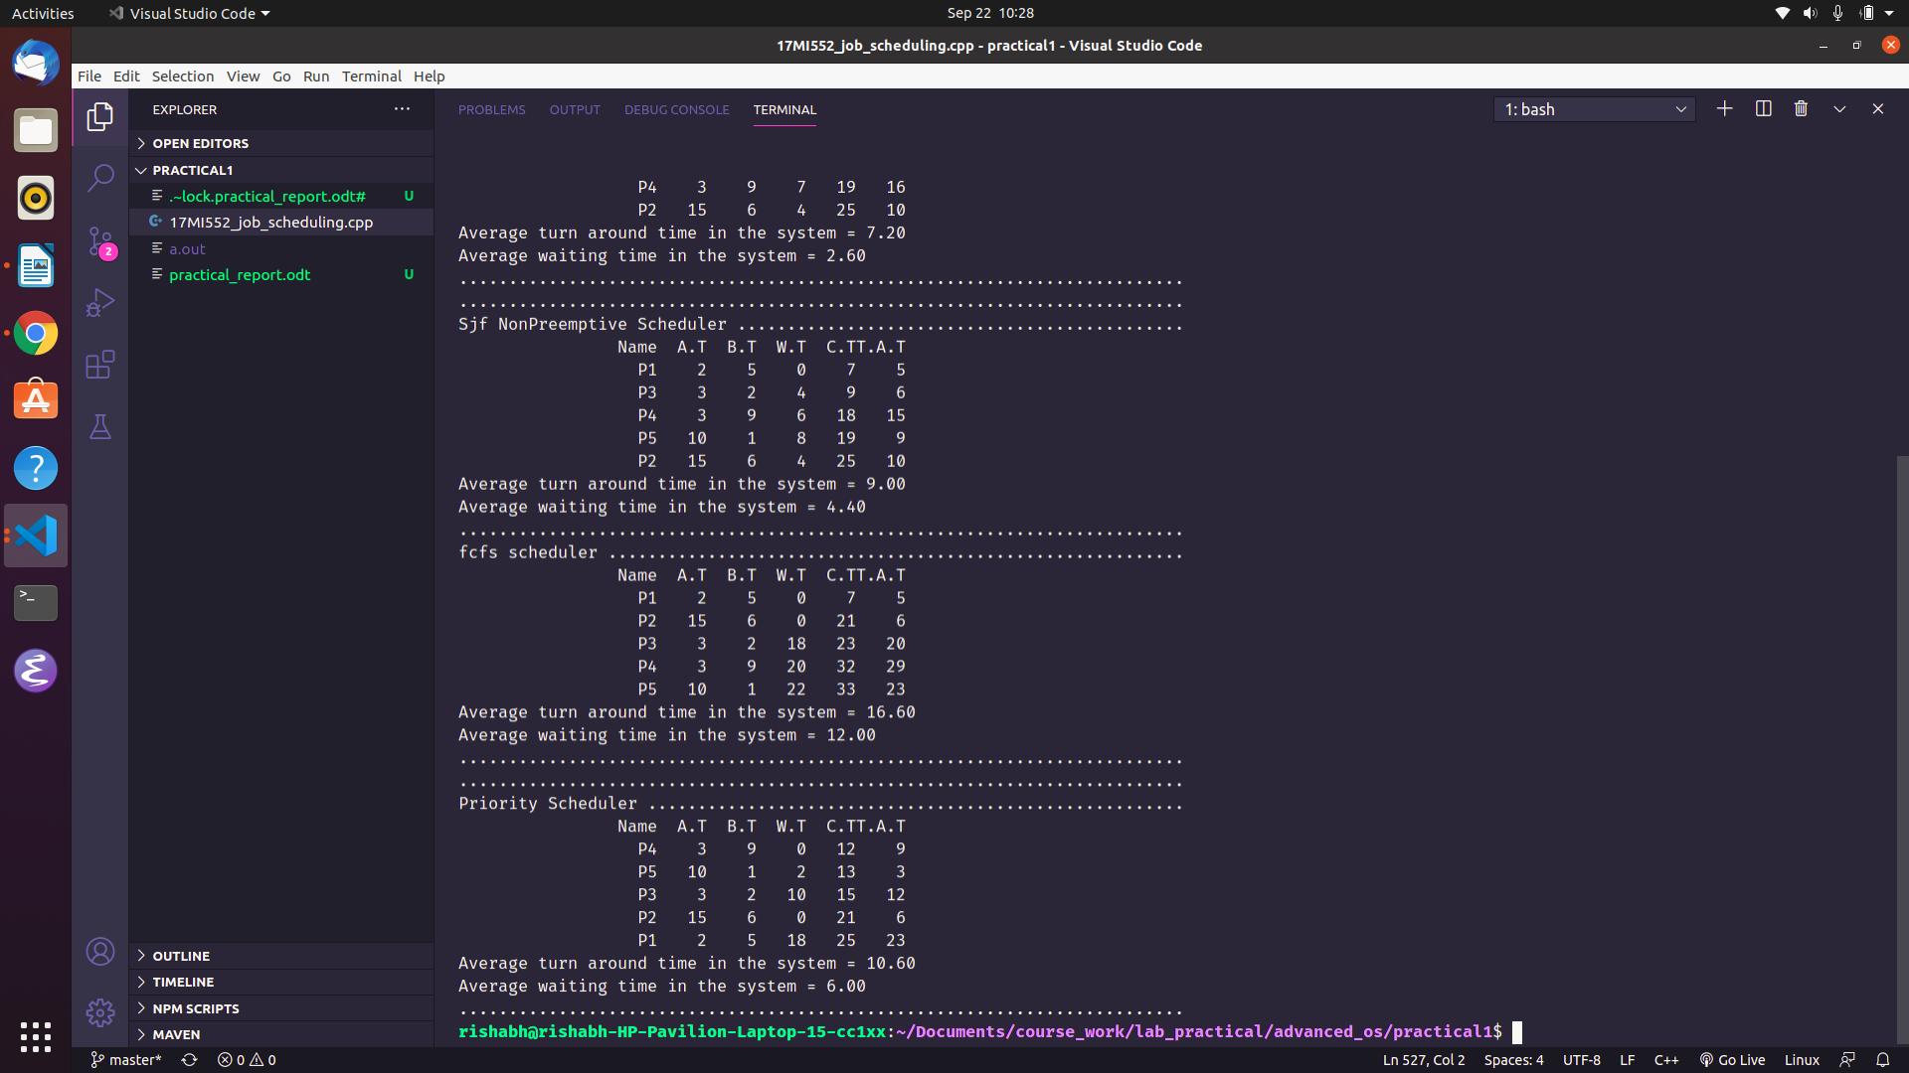

Experiment 2
Aim : To simulate FIFO and LRU page replacement algorithm.

Theory:
Page Replacement algorithms:
In an operating system that uses paging for memory management, a page replacement algorithm is needed to decide which page needs to be replaced when new page comes in.
Page Fault – A page fault happens when a running program accesses a memory page that is mapped into the virtual address space, but not loaded in physical memory.
Since actual physical memory is much smaller than virtual memory, page faults happen. In case of page fault, Operating System might have to replace one of the existing pages with the newly needed page. Different page replacement algorithms suggest different ways to decide which page to replace. The target for all algorithms is to reduce the number of page faults.

a. FIFO (First-In First-Out Algorithm):
This is the simplest page replacement algorithm. In this algorithm, the operating system keeps track of all pages in the memory in a queue, the oldest page is in the front of the queue. When a page needs to be replaced page in the front of the queue is selected for removal.
b. LRU(Least Recently Used Algorithm):
In this algorithm the new page will be replaced which is least recently used.

Code:
nitializer code:
#include <iostream>
#include <vector>
#include <string>
#include <algorithm>
#include <iomanip>
#include <unordered_map>
#include <climits>

using namespace std;

void printFrameStats(vector<int> frame){

for(auto fr : frame){

cout << setw(5) << fr << ' ';

}

cout << endl;
}

void printFinalStats(int numMisses, vector<int> referenceString, string nameScheduler){

int numHits = referenceString.size() - numMisses;

string twentyDots(20, '.');

cout << twentyDots << nameScheduler <<" Scheduler " << twentyDots << endl;

cout <<"Total misses in cache \t = \t" << numMisses << endl;

cout <<"Total hits in cache \t = \t" << numHits << endl;

cout <<"Hit ratio of the system = \t" << (1.0 * numHits /

referenceString.size()) << endl;

cout << endl;

cout << endl;

}

FIFO

class FIFO {

unordered_map<int, bool> isPresentInCache;

int numMisses = 0, numFrames;

vector<int> frame;

public :
int pageReplacement(vector<int> referenceString, int numFrames){

frame.resize(numFrames, -1);

int insertIndex = 0;

for(int page : referenceString){
// print current situation of frames
printFrameStats(frame);

if(!isPresentInCache[page]){

if(frame[insertIndex] != -1){
// replace the existing from cache
isPresentInCache[frame[insertIndex]] = false;
}

// insert into cache
frame[insertIndex] = page;

isPresentInCache[page] = true;

// remove the entry from cache

insertIndex = (insertIndex + 1) % numFrames;

numMisses++;

}

}

return numMisses;

}

};

LRU
class LRU {

unordered_map<int, int> indexOf, lastOccurenceOf;

vector<int> frame;

int numFrames = 0, numMisses = 0;

int getAppropriateIndex(){

for(int i=0; i<numFrames; i++){

if(frame[i] == -1) return i;

}

// replace the frame
int locationLeastUsedPage = INT_MAX;

int leastUsedPage;

for(auto occurence : lastOccurenceOf){

if(occurence.second < locationLeastUsedPage) {

leastUsedPage = occurence.first;

locationLeastUsedPage = occurence.second;

}

}

return indexOf[leastUsedPage] - 1;

}

public:

int pageReplacement(vector<int> referenceString, int numFrames){
this->numFrames = numFrames;

frame.resize(numFrames, -1);

for(int i = 0; i < referenceString.size(); i++){

int currPage = referenceString[i];

printFrameStats(frame);

if(indexOf[currPage] > 0){ // currentPage is present in cache
lastOccurenceOf[currPage] = i;
continue;
}

// cout << "This part of code running ..." << endl;
// 2 =>

// replacement needs to carry out
int insertIndex = getAppropriateIndex();
// cout << insertIndex << endl;
//

// galat ho ra hai
indexOf[frame[insertIndex]] = -1;
lastOccurenceOf[frame[insertIndex]] = INT_MAX;

// insert new page
frame[insertIndex] = currPage;
// insertIndex ==> 0
indexOf[currPage] = (insertIndex + 1);
lastOccurenceOf[currPage] = i;
numMisses++;
}

return numMisses;
}

};

DRIVER Program
int main()
{
vector<int> referenceString = {7, 0, 1, 2, 0, 3, 0, 4, 2, 3, 0, 3, 2, 3};

int numFrames = 4;

vector<int> frame(numFrames, -1);

FIFO fifo;
LRU lru;

int numMissesFIFO = fifo.pageReplacement(referenceString, numFrames);

int numMissesLRU = lru.pageReplacement(referenceString, numFrames);

printFinalStats(numMissesFIFO, referenceString, "FIFO");

printFinalStats(numMissesLRU, referenceString, "LRU");

return 0;
}

Output:
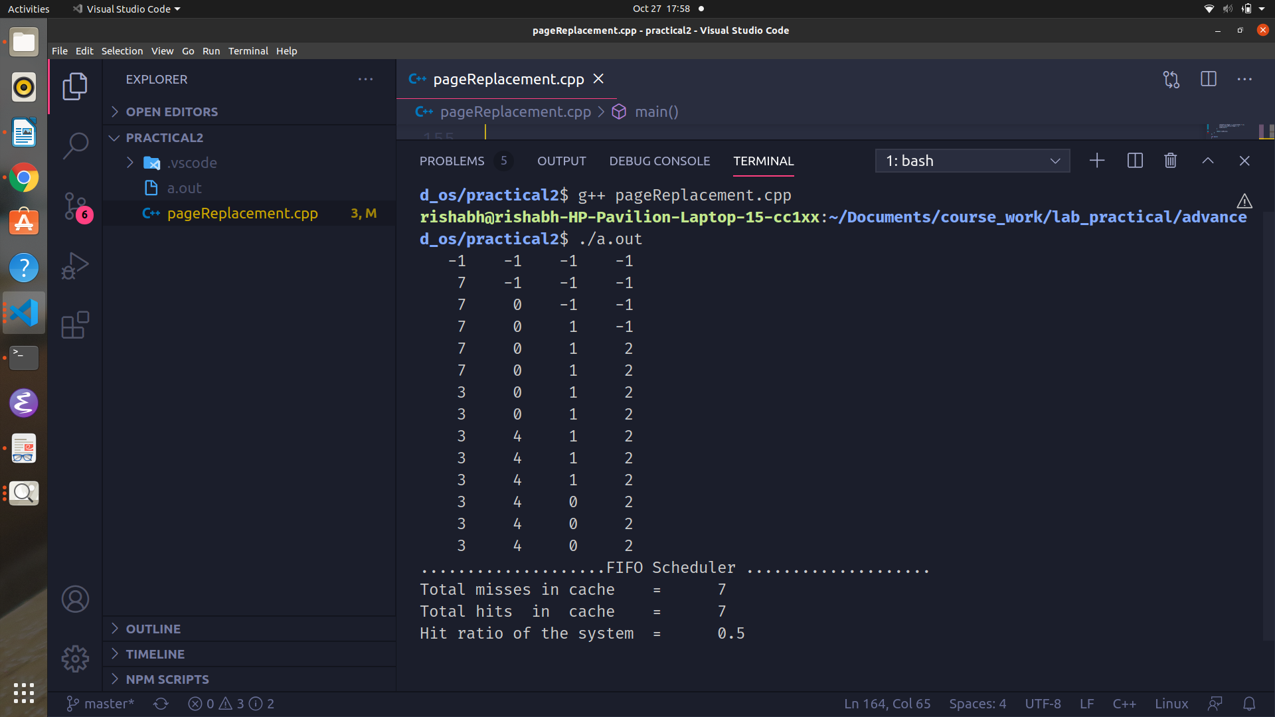
FIFO Scheduler:

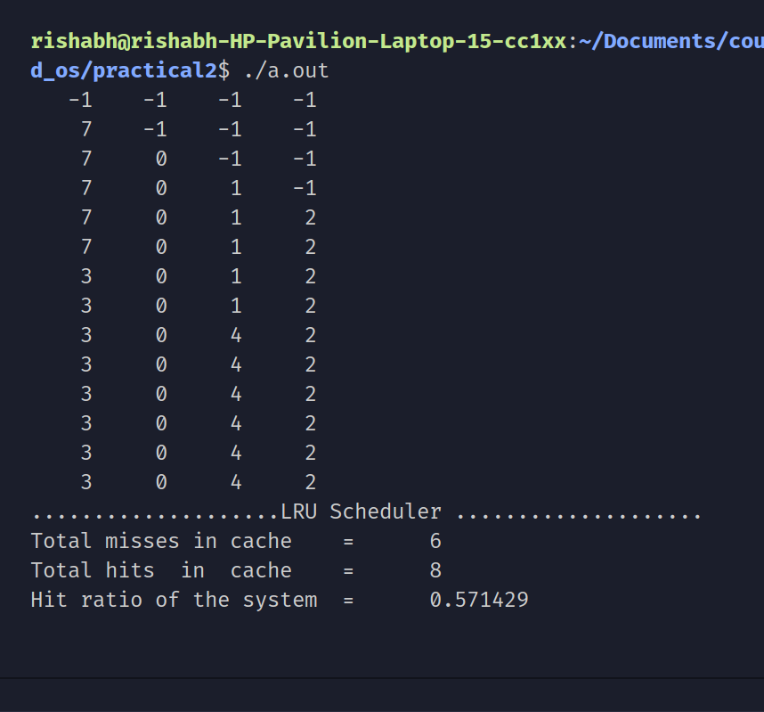
LRU Scheduler:

Experiment 3
Aim : To Implement a distributed file server.
Theory:
DFS:
A Distributed File System (DFS) as the name suggests, is a file system that is distributed on multiple file servers or multiple locations. It allows programs to access or store isolated files as they do with the local ones, allowing programmers to access files from any network or computer.
The main purpose of the Distributed File System (DFS) is to allows users of physically distributed systems to share their data and resources by using a Common File System. A collection of workstations and mainframes connected by a Local Area Network (LAN) is a configuration on Distributed File System. A DFS is executed as a part of the operating system. In DFS, a namespace is created and this process is transparent for the clients.
DFS has two components:
- Location Transparency: Location Transparency achieves through the namespace component.
- Redundancy: Redundancy is done through a file replication component.

Our DFS is divided into two modules:
a. Client module
b. Server module
a. Client module:
Client module runs on the client machine. It is responsible for the communication between client and the server. Our client module is divided into following components.
i. Cache: Cache module is further divided into two parts:
.File storage:
This is the location where the cached files are stored in our system.
.Cache record:
This is a file which keeps record of the files currently stored in the cache and the timestamps of storage.
Ii. Client side code :
The program which sends the request to the server and caches the recieved file from the server.
b. Server module:
Server module is further divided into two parts :
i. File storage:
This module contains all the files of the server.
ii. Directory:
This file is used to keep track of the last update timestamps of the files stored in the server storage. This is used to prevent the problem of cache coherence.
Iii. Server side code :
The program which automates the communication between client and the server. It accepts a filename from the server and return the conntents of the file to the client. The client caches the file and then stores it in its own cache.

DIAGRAM:

File Storage
File Storage
filename
1
Cache Record
Directory file
File length

Client Side program
Server side program
File content

CLIENT MODULE
Code:
#include <fstream>
#include <iostream>
#include <string>
#include <algorithm>
#include <sstream>

#include <sys/stat.h>
#include <sys/socket.h>
#include <sys/types.h>
#include <time.h>

#include <netinet/in.h>
#include <unistd.h>

using namespace std;
#define MOD_GET_FILE 0
#define MOD_UPDATE_FILE 1

const int PORT = 5400;

/*
@name --> print_str
@params --> string str
@return --> void
@desc --> prints the string str on the console
*/
void print_str(string str)
{
for (char ch : str)
printf("%c", ch);
printf("\n");
}

/*
@name --> is_in_cache
@params --> string file_name
@return --> true/false
@desc --> looks in the cache_record.txt file to check whether the file is in the cache
*/
bool is_in_cache(char *file_name)
{
// ifstream fin("./cache/cache_record.txt", "r");
ifstream fin("./cache/cache_record.txt");

string content((std::istreambuf_iterator<char>(fin)),
(std::istreambuf_iterator<char>()));

string filename_str(file_name);

istringstream iss(content);

string cur_filename;

// check each filename in cache and check if it already exits
while (iss >> cur_filename)
{
if (cur_filename == filename_str)
{
cout << "---------------------------------------" << endl;
cout << "file " << filename_str << " found in cache" << endl;
cout << "---------------------------------------" << endl;

return true;
}
}

return false;

// return false;
}
/*
@name --> extract_dirname
@params --> string path
@return --> string dirname
@desc --> extracts the name of the dir from the given path
*/
string extract_dirname(const string &path)
{
string dirname = path;

int loc_last_slash = dirname.size() - 1;

while (dirname[loc_last_slash] != '/')
loc_last_slash--;

return dirname.substr(0, loc_last_slash);
}
/*
@name --> is_path_exits
@params --> string dirname
@return --> true/false
@desc --> Checks whether the path exists.. if it does, return true else false
*/
bool is_path_exits(string path)
{
struct stat buffer;
return (stat(path.c_str(), &buffer) == 0);
}

/*
@name -> cache file
@params -> string filename, string filecontent
@return -> void
@desc -> create a new file and writes the filecontent in the file in cache folder
*/
void cache_file(string filename, const string &filecontent, int mode = MOD_GET_FILE)
{
// extract dir name
string dirname = extract_dirname(filename);

string dirname_cache = "./cache" + dirname.substr(1, dirname.size());

if (!is_path_exits(dirname_cache))
{
// if not then create the folder
int status = mkdir(dirname_cache.c_str(), 0777);
if (status != -1)
{
cout << "---------------------------------------" << endl;
cout << "Successfully Created a directory" << endl;
cout << "---------------------------------------" << endl;
}

else
{
cout << "---------------------------------------" << endl;
printf("Couldn't create a new directory.. please try again\n");
cout << "---------------------------------------" << endl;
exit(-1);
}
}

string filename_cache = "./cache" + filename.substr(1, filename.size());
// create a new file

ofstream main_file(filename_cache, ios::out);

// open the filename in the cache
if (!main_file.is_open())
{
cout << "---------------------------------------" << endl;
printf("Couldn't open the file... Error occured");
cout << "---------------------------------------" << endl;

exit(-1);
}

// start writing filecontent to file
main_file << filecontent << endl;

// create an entry in cache
ofstream cache_record_file("./cache/cache_record.txt", ios::app);

if (mode == MOD_GET_FILE)
{
time_t cache_timestamp = time(NULL);

cache_record_file << filename << ' ' << cache_timestamp << endl;

cache_record_file.close();
}

main_file.close();

}

/*
@name --> send_filename_datagram
@params --> int client_socket, string filename
@return --> void
@desc --> takes the filename, adds a header('0') and send the datagram to the server
*/
void send_datagram(int client_socket, char header, string filename)
{
int filename_len = filename.size();

int datagram_len = filename_len + 1;
// send the whole header

// construct header
string datagram = header + string(filename);

const char *filename_datagram = datagram.c_str();

printf("%s\n", filename_datagram);

send(client_socket, filename_datagram, datagram_len, 0);

cout << "-----------------------------------------" << endl;
cout << "Filename datagram sent to the server \t:\t" << string(filename_datagram) << endl;
cout << "---------------------------------------" << endl;
}
/*
@name --> recieve_timestamp_from_server
@params --> int client_socket, string filename
@return --> timestamp when the file was last updated on the server
@desc --> gets the last update time stamp of a file and returns it to the main program
*/
time_t recieve_timestamp_from_server(int client_socket, const char *filename)
{
time_t last_update_timestamp = time(NULL);

send_datagram(client_socket, '1', string(filename));

recv(client_socket, &last_update_timestamp, sizeof(last_update_timestamp), 0);

return last_update_timestamp;
}

/*
@name --> get_file_cache_ts
@params --> string filename
@return --> timestamp when the file was cached on our client module
@desc --> searches for filename in client record, notes the last record timestamp and returns it
*/
time_t get_file_cache_ts(const char *filename)
{
ifstream fin_cache("./cache/cache_record.txt");

string filename_str(filename), cur_filename;

time_t cache_file_ts = 0, cur_ts;

while (!fin_cache.eof())
{
fin_cache >> cur_filename >> cur_ts;

if (cur_filename.empty())
continue;

if (cur_filename == filename_str)
return cur_ts;
}

return cache_file_ts;
}
/*
@name --> update_cache
@params --> string filename, int new_ts, int old_ts
@return --> void
@desc --> updates the timestamp of the filename in the cache record (replaces old_ts with new_ts)
*/
void update_cache(const char *filename, time_t new_ts, time_t old_ts)
{
// udate the cache so its holds the latest ts of updation
ifstream fin("./cache/cache_record.txt");

string content = "";

// read content of file in better way
while (!fin.eof())
{
string fn, ts;

fin >> fn >> ts;

content += fn + ' ' + ts;
}

// find old
string to_remove = string(filename) + ' ' + to_string(old_ts);

string to_insert = string(filename) + ' ' + to_string(new_ts);

// remove string from content
size_t pos = content.find(to_remove);

if (pos != string::npos)
{
content.erase(pos, to_remove.size());

content += to_insert;
}
fin.close();
ofstream fout("./cache/cache_record.txt");

cout << " <<<<<<<<< FINAL CONTENT OF THE CACHE >>>>>>>>>>>>>>>>>>>>" << endl;
cout << content << endl;
cout << endl;
cout << "<<<<<<<<<<<<<<<<<<<<<<<<<<<<>>>>>>>>>>>>>>>>>>>>>>>>>>>>>>>>>>" << endl;

fout << content << endl;
fout.close();
}
/*
@name --> recieve_file
@params --> int client_socket, int file_size, int num_blocks
@return --> string file_content
@desc --> recieves num_blocks from server and store the blocks in a string...
*/
string recieve_file(int client_socket, int file_size, int num_blocks)
{
string file_content;
int max_block_size = 1024;
for (int i = 0; i < num_blocks; i++)
{
// get size of current block to be recieved
int cur_block_size = min(max_block_size, (file_size - (i * max_block_size)));

char buffer[cur_block_size];

// recieve block and store it in buffer
recv(client_socket, &buffer, sizeof(buffer), 0);

file_content += string(buffer);
}

return file_content;
}
/*
@name --> get_file_from_server
@params --> int client_socket, string filename
@return --> string filecontent
@desc --> sends the filename to the server, recieves the filecontent. Then it returns the filecontent
*/
string get_file_from_server(int client_socket, char filename[])
{
printf("Filename sending to the server = %s\n", filename);
// send filename datagram
send_datagram(client_socket, '0', string(filename));
int file_size;
recv(client_socket, &file_size, sizeof(file_size), 0);

// // // revieve file from server
cout << "SIZE OF FILE : " << file_size << endl;

int num_blocks;

recv(client_socket, &num_blocks, sizeof(num_blocks), 0);

cout << "---------------------------------------" << endl;
printf("Num blocks to recieve = %d\n", num_blocks);
cout << "---------------------------------------" << endl;

// // // send acknowledgement
bool is_reached = true;
send(client_socket, &is_reached, sizeof(is_reached), 0);

// // recieve blocks
string file_content = recieve_file(client_socket, file_size, num_blocks);
// cache file after recieving

return file_content;
}
/*
Driver Program
*/

int main()
{
// ifstream fin("./cache/cache_record.txt", "r");
char filename[] = "./folder1/file_to_recieve.txt";

// server object
sockaddr_in server_address;
server_address.sin_family = AF_INET;
server_address.sin_port = htons(PORT);
server_address.sin_addr.s_addr = INADDR_ANY;

if (!is_in_cache(filename))
{
int client_socket = socket(AF_INET, SOCK_STREAM, 0);

// connect to the client
connect(client_socket, (sockaddr *)&server_address, sizeof(server_address));

// send name of file to server
string file_content = get_file_from_server(client_socket, filename);

cache_file(string(filename), file_content);

fflush(stdout);

close(client_socket);
}
else
{
int client_socket = socket(AF_INET, SOCK_STREAM, 0);

connect(client_socket, (sockaddr *)&server_address, sizeof(server_address));

cout << "Require timestamp" << endl;

time_t last_update_ts = recieve_timestamp_from_server(client_socket, filename);

time_t client_cache_ts = get_file_cache_ts(filename);

close(client_socket);

/* Check if File was updated at the server after it was cached on this computer */
if (difftime(last_update_ts, client_cache_ts) <= 0)
{

cout << "---------------------------------------" << endl;

cout << "File up to date" << endl;

cout << "---------------------------------------" << endl;
}
else
{
int client_socket = socket(AF_INET, SOCK_STREAM, 0);

connect(client_socket, (sockaddr *)&server_address, sizeof(server_address));

cout << "---------------------------------------" << endl;
cout << "File updated at server " << endl;
cout << "---------------------------------------" << endl;

string file_content = get_file_from_server(client_socket, filename);

cache_file(string(filename), file_content, MOD_UPDATE_FILE);
// update the cache with the new file content
update_cache(filename, last_update_ts, client_cache_ts);

close(client_socket);

// update_cache(filename, )
}
}
return 0;
}

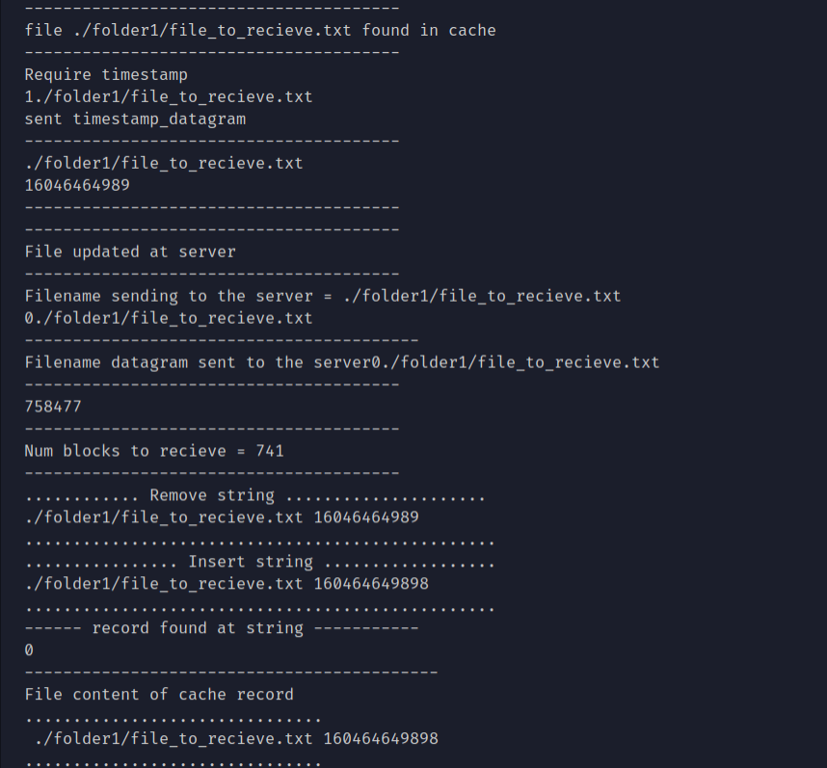
OUTPUT:

Server module:
#include <string>
#include <fstream>
#include <iostream>
#include <string.h>

#include <math.h>

#include <sys/socket.h>
#include <sys/types.h>

#include <netinet/in.h>
#include <unistd.h>

using namespace std;

#define PORT 5400

/*
@name --> filesize
@params --> string filename
@return --> size of the file having name filename
@desc --> gets the size of the file and returns the size of the file
*/
ifstream::pos_type filesize(const char *filename)
{
std::ifstream in(filename, std::ifstream::ate | std::ifstream::binary);
return in.tellg();
}
/*
@name --> get_length
@params --> string filename
@return --> length of filename
@desc --> uses filesize() func to get the size of the file and return to the user
*/
int get_length(const char *filename)
{

ifstream fin(filename);

if (!fin.is_open())
{
return -1;
}

return filesize(filename);
}
/*
@name --> send_blocks
@params --> int client_socket, string filename, int filesize
@return --> void
@desc --> breaks the file into blocks and sends them to the server
*/

void send_blocks(int client_socket, string content, int filesize, int num_blocks)
{

int max_block_size = 1024;

for (int i = 0; i < num_blocks; i++)
{

int start_ptr = i * max_block_size;
int end_ptr = min((i + 1) * max_block_size, filesize);

int cur_block_size = (end_ptr - start_ptr);

// create a buffer to send
char buffer[cur_block_size];

// copy file content to buffer.
for (int i = start_ptr; i < end_ptr; i++)
{
buffer[i - start_ptr] = content[i];
}
// send buffer
send(client_socket, &buffer, sizeof(buffer), 0);

// cout << "Block " << i << " sent to the client" << endl;
}
}
/*
@name --> send_file
@params --> int client_socket, string filename, int filesize
@return --> void
@desc --> breaks the file into blocks and sends each block to the client connected via client socket
*/
void send_file(int client_socket, const char *filename, int filesize)
{
int max_block_size = 1024;

int num_blocks = ceil(1.0 * filesize / max_block_size);

bool is_recieved = false;

// send num_blocks to client
while (!is_recieved)
{

send(client_socket, &num_blocks, sizeof(num_blocks), 0);

recv(client_socket, &is_recieved, sizeof(is_recieved), 0);
}
cout << "---------------------------------------" << endl;
printf("Acknowledgement recieved... sending file..\n");
cout << "---------------------------------------" << endl;

ifstream ifs(filename);
string content((std::istreambuf_iterator<char>(ifs)),
(std::istreambuf_iterator<char>()));

// send file to client in blocks
send_blocks(client_socket, content, filesize, num_blocks);
cout << "---------------------------------------" << endl;

cout << ".........file send to client ..... " << endl;
cout << ".........Closing connection ...... " << endl;
cout << "---------------------------------------" << endl
<< endl
<< endl;
}
/*
@name --> get_file_ts
@params --> char *filename
@return --> last update timestamp of filename
@desc --> looks up for the last update timestamp of the filename and returns it
*/
time_t get_file_ts(const char *filename)
{
string filename_str = string(filename);

// open directory.txt
ifstream fin_dir("./directory.txt");

time_t final_update_ts = 0;
while (!fin_dir.eof())
{

string cur_filename;
time_t cur_ts;

fin_dir >> cur_filename >> cur_ts;

if (cur_filename == filename_str)
{
final_update_ts = cur_ts;
break;
}
}

return final_update_ts;
}

/*
@name --> serve_client
@params --> int client_socket
@return --> void
@desc --> recieves the client socket and serves the requests of the client
*/
void serve_client(int client_socket)
{
char datagram[1024];

recv(client_socket, &datagram, sizeof(datagram), 0);

printf("DATAGRAM HEADER : %s\n", datagram);
// extract filename and header from datagram
char header = datagram[0];

string payload = string(datagram).substr(1, string(datagram).size());

const char *filename = payload.c_str();

// if operation is 0, then send file
if (header == '0')
{
int file_length = get_length(filename);

cout << "---------------------------------------" << endl;
cout << "GOT FILE LENGTH = " << file_length << endl;
cout << "---------------------------------------" << endl;

send(client_socket, &file_length, sizeof(file_length), 0);

cout << file_length << endl;

send_file(client_socket, filename, file_length);
}
// else send the timestamp details of the file
else if (header == '1')
{
cout << "---------------------------------------" << endl;
cout << "Recieved request for timestamp" << endl;
// get timestamp of filename
time_t file_write_ts = get_file_ts(filename);

// send timestamp of filename
send(client_socket, &file_write_ts, sizeof(file_write_ts), 0);
}

}

/*
Driver program
*/
int main()
{
int server_socket = socket(AF_INET, SOCK_STREAM, 0);

sockaddr_in server_address;

server_address.sin_port = htons(PORT);
server_address.sin_family = AF_INET;
server_address.sin_addr.s_addr = INADDR_ANY;

// bind
bind(server_socket, (sockaddr *)&server_address, sizeof(server_address));

// listern
listen(server_socket, 5);

// recieve connection

while (true)
{
int client_socket = accept(server_socket, NULL, NULL);

if (client_socket != -1)
{
cout << "Client connected to the server... " << endl;

serve_client(client_socket);

close(client_socket);
}
}

fflush(stdout);

close(server_socket);

// socket struct
}

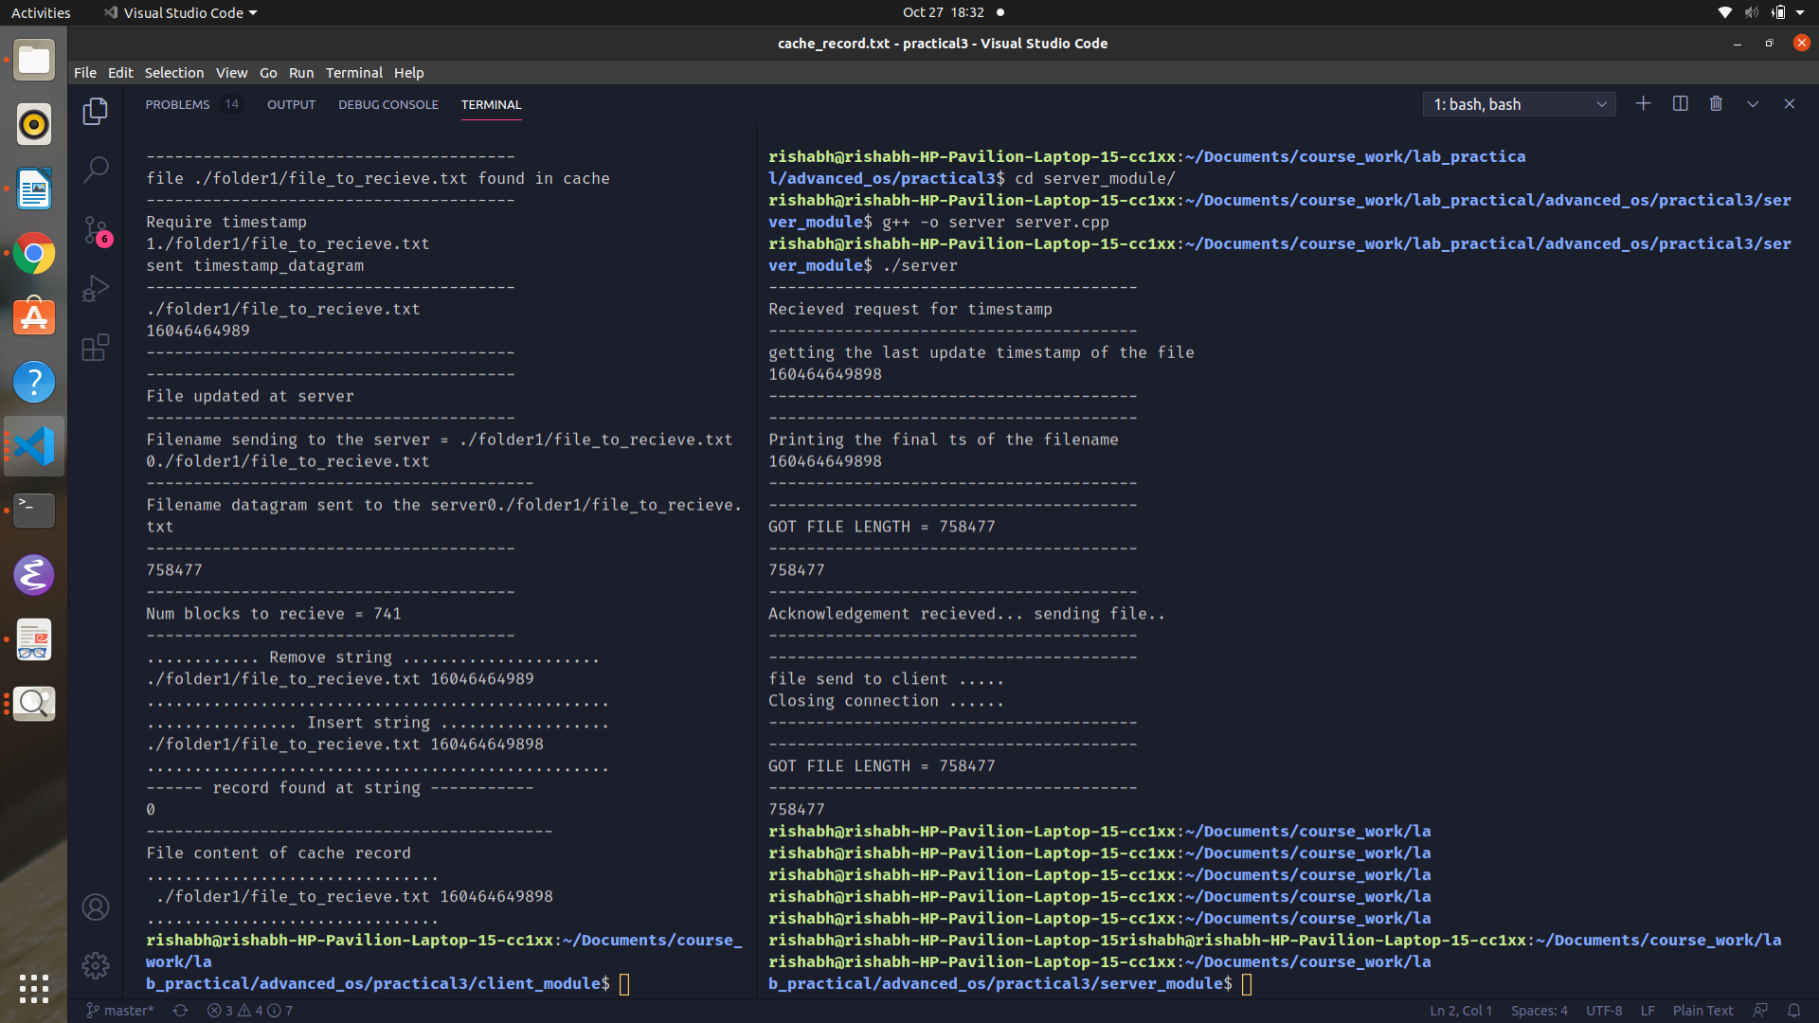
Output:

Experiment 4
Aim : To implement a TCP client and server model in C.
Theory:
TCP( Transfer control protocol):
This is a connection oriented protocol which is used in the transport layer of a tcp-ip networking model. It uses sockets as an end point of communication between a client and a server. (Sockets is just IP address and port number combined.)
Client-Server model:
A Client-Server model distinguishes between the different nodes in the internet as either a client or a server.
Client: A computer requesting a service is called a client.
Server: A computer serving the client is called a server.

DIAGRAM:
CLIENT COMPUTER
SERVER COMPUTER
username

Client Module
response

Client Server

CODE:
Client Code:
In our application, the client and server communicate through sockets. We are going to use C sys/socket.h library to initialize a socket.
The working of the client is as follows:
- Connect to the server using sockets.
- print the initial response recieved from the server.
- Takes input from the console and sends the name to the server.
- Recieves the response from the server.
- Print the response on the console.

Code:
#include <iostream>
#include <string>
#include <sys/stat.h>
#include <sys/socket.h>
#include <sys/types.h>
#include <time.h>
#include <netinet/in.h>
#include <unistd.h>
using namespace std;

const int PORT = 5400;

int main()
{
int client_socket = socket(AF_INET, SOCK_STREAM, 0);

// server object
sockaddr_in server_address;
server_address.sin_family = AF_INET;
server_address.sin_port = htons(PORT);
server_address.sin_addr.s_addr = INADDR_ANY;

// connect to server
connect(client_socket, (sockaddr *)&server_address, sizeof(server_address));
// print("response")

/* Recieve a responce from server after connecting */
char server_response[2048];

recv(client_socket, &server_response, sizeof(server_response), 0);

printf("%s\n", server_response);
// send string

/* Send your name to the server */
char name[1024];
printf("Enter your name : ");
fgets(name, sizeof(name), stdin);

send(client_socket, name, sizeof(name), 0);

// input name

/* Recieve a response from the server */
char final_server_response[2048];
recv(client_socket, final_server_response, sizeof(final_server_response), 0);
printf("Server sent a response : \n\t%s\n", final_server_response);

fflush(stdout);

close(client_socket);

return 0;
}

Server Code:
The job of a server includes:
- It accepts a client connection
- It responds to the client connection with a response to let the client know the he is connected to the server.
- It recieves the name of the client from the client module.
- It appends a string to the end of the client response.
- It sends the string back to the client as a response.
Code:
#include <iostream>
#include <string>

#include <sys/stat.h>
#include <sys/socket.h>
#include <sys/types.h>
#include <string.h>

#include <netinet/in.h>
#include <unistd.h>

using namespace std;

const int PORT = 5400;

void serve_client(int client_socket)
{
/* Recieving initial response from the client */
///////////////////////////////////////////////////////
char server_response[] = "Congrats.. You've reached the server";

// send server response to the client
send(client_socket, server_response, sizeof(server_response), 0);

// recieve a string
char client_response[2048];
recv(client_socket, &client_response, sizeof(client_response), 0);

printf("Client sent a message : %s\n", client_response);
////////////////////////////////////////////////////////////////

/* Sending a response back to the client */

///////////////////////////////////////////////////////////////////
char append_server_response[] = "... You have reached the server";

int final_response_size = strlen(client_response) + strlen(server_response) + 1;
char *final_server_response = (char *)malloc(final_response_size); // +1 for the null-terminator
// in real code you would check for errors in malloc here
strcpy(final_server_response, client_response);
strcat(final_server_response, append_server_response);

send(client_socket, final_server_response, final_response_size, 0);

printf("Final repsonse to the client : \n\t%s\n", final_server_response);
//////////////////////////////////////////////////////////////////////////

printf("One more client served\n\n");
}

int main()
{
sockaddr_in server_address;
server_address.sin_family = AF_INET;
server_address.sin_port = htons(PORT);
server_address.sin_addr.s_addr = INADDR_ANY;

// bind
bind(server_socket, (sockaddr *)&server_address, sizeof(server_address));

// accept
listen(server_socket, 5);

printf("Listening at port %d\n", PORT);
// recieve connection
while (true)
{
int client_socket = accept(server_socket, NULL, NULL);
serve_client(client_socket);
close(client_socket);
}
return 0;
}

Output:
Commands for running the client:
- g++ -o client cl.cpp

- ./client

Commands for running the server:
- g++ -o server server.cpp

- ./server

Server:
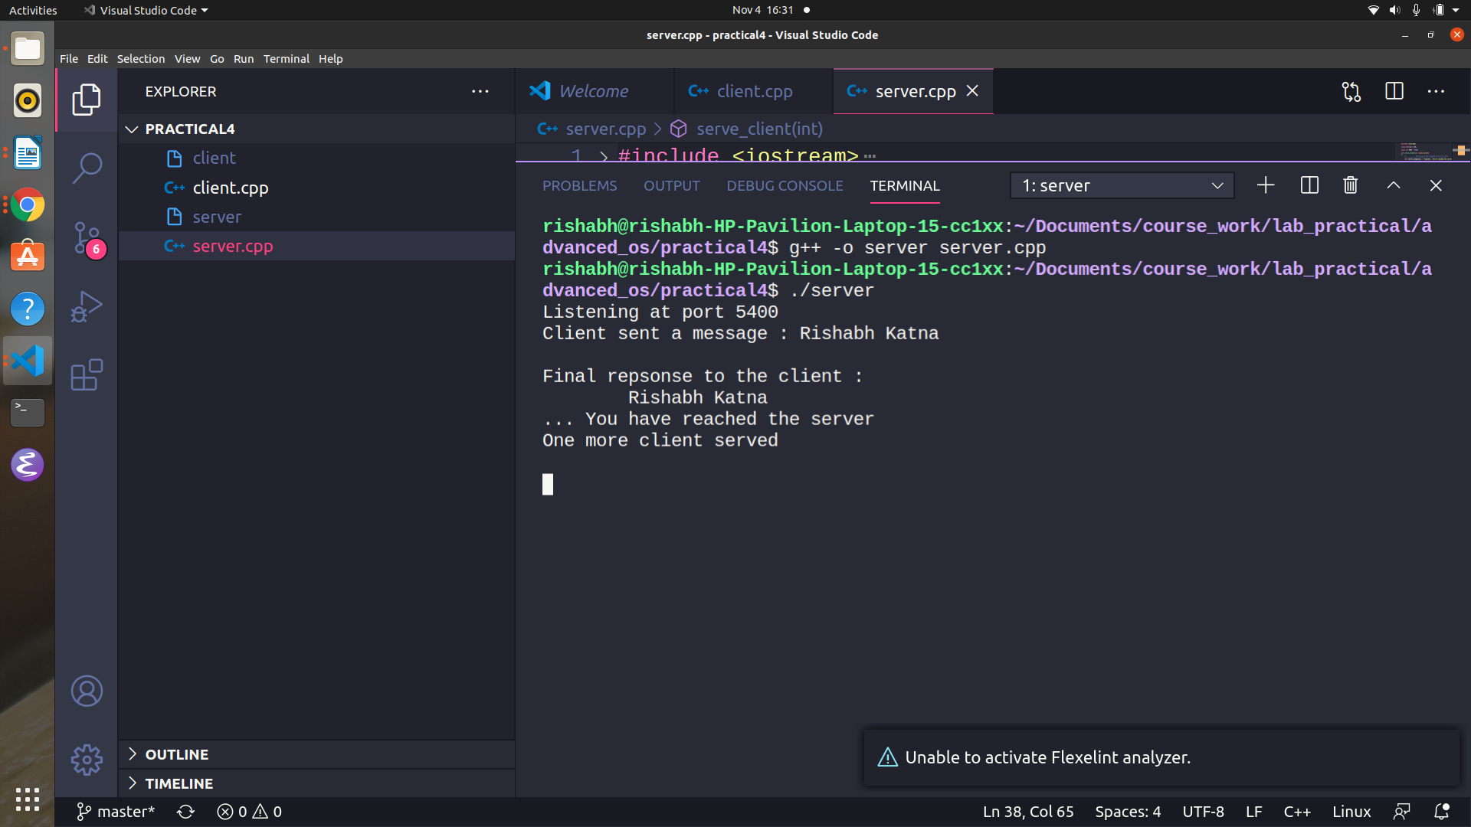

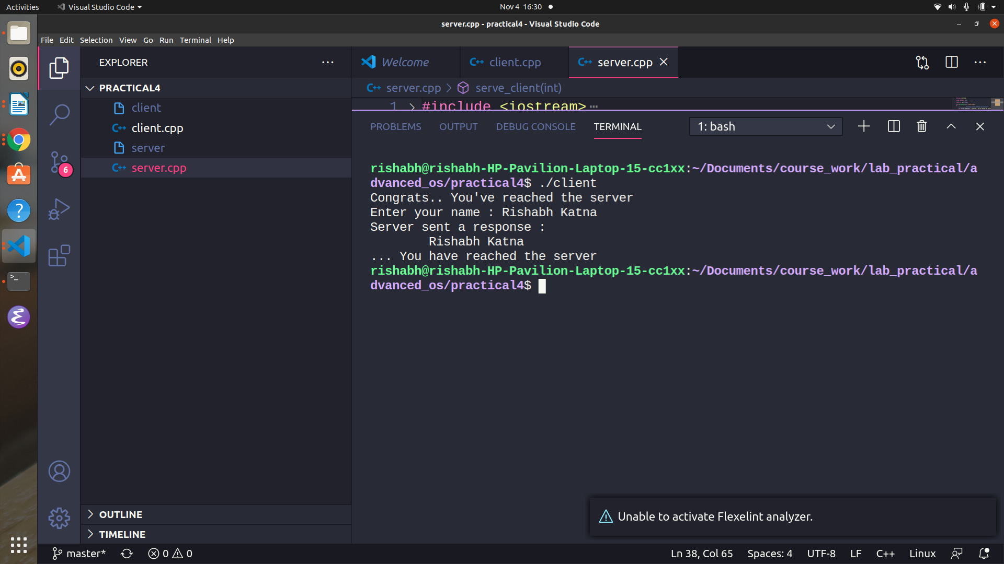
Client:
Experiment 5
Aim : To implement Christian’s algorithm.
Theory:
Christian’s algorithm:
Cristian’s Algorithm is a clock synchronization algorithm is used to synchronize time with a time server by client processes. This algorithm works well with low-latency networks where Round Trip Time is short as compared to accuracy while redundancy prone distributed systems/applications do not go hand in hand with this algorithm. Here Round Trip Time refers to the time duration between start of a Request and end of corresponding Response.
Algorithm:
1) The process on the client machine sends the request for fetching clock time(time at server) to the Clock Server at time .
2) The Clock Server listens to the request made by the client process and returns the response in form of clock server time.
3) The client process fetches the response from the Clock Server at time and calculates the synchronised client clock time using the formula given below.

CODE:
Server.cpp
#include <iostream>
#include <chrono>
#include <ctime>
#include <sys/socket.h>
#include <netinet/in.h>
#include <unistd.h>
using namespace std;
#define SEND_CORRECT_TIME 0

const int PORT = 5400;

int start_server(int PORT, in_addr_t IP)
{
int server_socket = socket(AF_INET, SOCK_STREAM, 0);

// struct
sockaddr_in server_address{};
server_address.sin_family = AF_INET;
server_address.sin_port = htons(PORT);
server_address.sin_addr.s_addr = IP;

// bind
bind(server_socket, (sockaddr *)&server_address, sizeof(server_address));

// accept
listen(server_socket, 5);

printf("Listening at port %d\n", PORT);

return server_socket;
}

time_t get_utc_time(time_t T)
{
tm *utc_time{};
// Ts has cur time
time(&T);

utc_time = gmtime(&T);

return mktime(utc_time);
}

void server_client(int client_socket)
{

int request_code;

recv(client_socket, &request_code, sizeof(int), 0);

cout << "Request Code : " << request_code << endl;

if (request_code == SEND_CORRECT_TIME)
{
// change this to get utc time
time_t Ts = 0;

Ts = get_utc_time(Ts);

cout << Ts << endl;

// To introduct some round trip time
sleep(Ts % 3);

send(client_socket, &Ts, sizeof(Ts), 0);
}
}

int main()
{
// bind
int server_socket = start_server(PORT, INADDR_ANY);
// recieve connection
while (true)
{
int client_socket = accept(server_socket, nullptr, nullptr);
server_client(client_socket);
close(client_socket);

}
}

Client.cpp
//
// Created by rishabh on 05/11/20.
//
#include <iostream>
#include <chrono>
#include <ctime>
#include <sys/socket.h>
#include <netinet/in.h>
#include <unistd.h>
using namespace std;
#define SEND_CORRECT_TIME 0

const int PORT = 5400;

int connect_to_server(int PORT, in_addr_t IP)
{
int client_socket = socket(AF_INET, SOCK_STREAM, 0);

sockaddr_in server_address{};
server_address.sin_port = htons(PORT);
server_address.sin_family = AF_INET;
server_address.sin_addr.s_addr = IP;

// connect
if (connect(client_socket, (sockaddr *)&server_address, sizeof(server_address)) == -1)
{
cerr << "Couldn't connect to server" << endl;
}

return client_socket;
}

time_t get_correct_time(int client_socket, time_t T0)
{
int message_code = SEND_CORRECT_TIME;

// send this message code to server
send(client_socket, &message_code, sizeof(message_code), 0);

// recv Ts timestamp from server
int Ts;
recv(client_socket, &Ts, sizeof(Ts), 0);
cout << "Server Time = " << Ts << endl;
// compute T1

auto T1 = chrono::system_clock::to_time_t(chrono::system_clock::now());

auto round_trip_time = (T1 - T0);

time_t Tp = ((double)round_trip_time / 2) + Ts;

cout << "Round trip time of the message :\t" << round_trip_time << endl;

return Tp;
}

int main()
{
// calculate time now
time_t T0 = chrono::system_clock::to_time_t(chrono::system_clock::now());
cout << "Original time of the client clock : " << ctime(&T0) << endl;

// initialize socket
int client_socket = connect_to_server(PORT, INADDR_ANY);

time_t Tp = get_correct_time(client_socket, T0);

cout << "Correct time of the clock :\t" << ctime(&Tp) << endl;

fflush(stdout);
close(client_socket);
}

Output:
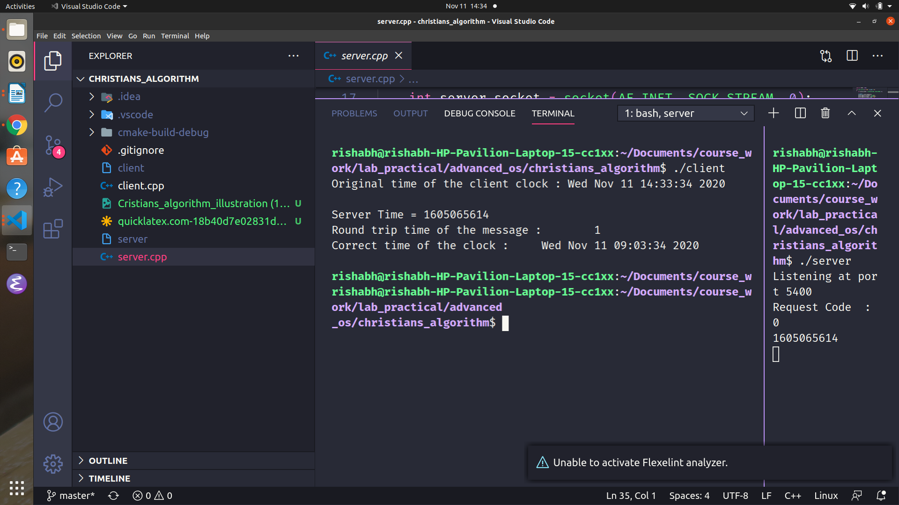

Experiment 6
Aim: To simulate the working of lamport logical clock.
Theory:
Lamport logical clock:
The Lamport timestamp algorithm is a simple logical clock algorithm used to determine the order of events in a distributed computer system. As different nodes or processes will typically not be perfectly synchronized, this algorithm is used to provide a partial ordering of events with minimal overhead, and conceptually provide a starting point for the more advanced vector clock method. The algorithm is named after its creator, Leslie Lamport.

Code:
##include <iostream>
#include <vector>
#include <algorithm>
#include <iomanip>

using namespace std;

class event
{
public:
int process_id, sequence_number, timer;

event(int p_id, int s_no, int t) : process_id(p_id), sequence_number(s_no), timer(t) {}

void print_stats()
{
cout << "e" << process_id << sequence_number << "(" << timer << ") --> ";
}
};

class Process
{
public:
int timer = 1, id, seq_number = 1;

/* Each process maintains its local history */
vector<event> local_history;

Process(int _id) : id(_id) {}

void new_event()
{
event e(this->id, this->seq_number, this->timer);

local_history.push_back(e);

this->timer++;

this->seq_number++;
}

// send a message to another process
void send_message(Process &p)
{
cout << "Message sent: P" << this->id << "(" << this->timer << ")"
<< " --> P" << p.id << "(" << p.timer << ")" << endl;

this->new_event();

p.timer = max(this->timer, p.timer);

p.new_event();
}
};

bool on_timer_or_id(const event &e1, const event &e2)
{
if (e1.timer < e2.timer)
return true;

if (e1.timer == e2.timer)
return (e1.process_id < e2.process_id);

return false;
}

void print_vector(const vector<event> &v)
{
for (event e : v)
{
e.print_stats();
}
cout << endl
<< endl;
}
int main()
{

Process p1(1), p2(2);
/* Event happening in P1 */
p2.new_event();
p1.new_event();
p1.new_event();

/* Event happening in P2 */
p2.new_event();
p2.new_event();

// /* Message sent by process p2 to process p1 */
p2.send_message(p1);

p1.send_message(p2);

/* construct the global history from the local histories */
vector<event> global_history;

/* global history = p1's local history U p2's local history */
global_history.insert(global_history.end(), p1.local_history.begin(), p1.local_history.end());
global_history.insert(global_history.end(), p2.local_history.begin(), p2.local_history.end());

/* Sort all events on the basis of timer */
cout << "Order of events in process P1" << endl;
print_vector(p1.local_history);

cout << "Order of events in process P2" << endl;
print_vector(p2.local_history);

cout << "Order of events in the whole system : " << endl;
sort(global_history.begin(), global_history.end(), on_timer_or_id);
print_vector(global_history);
}

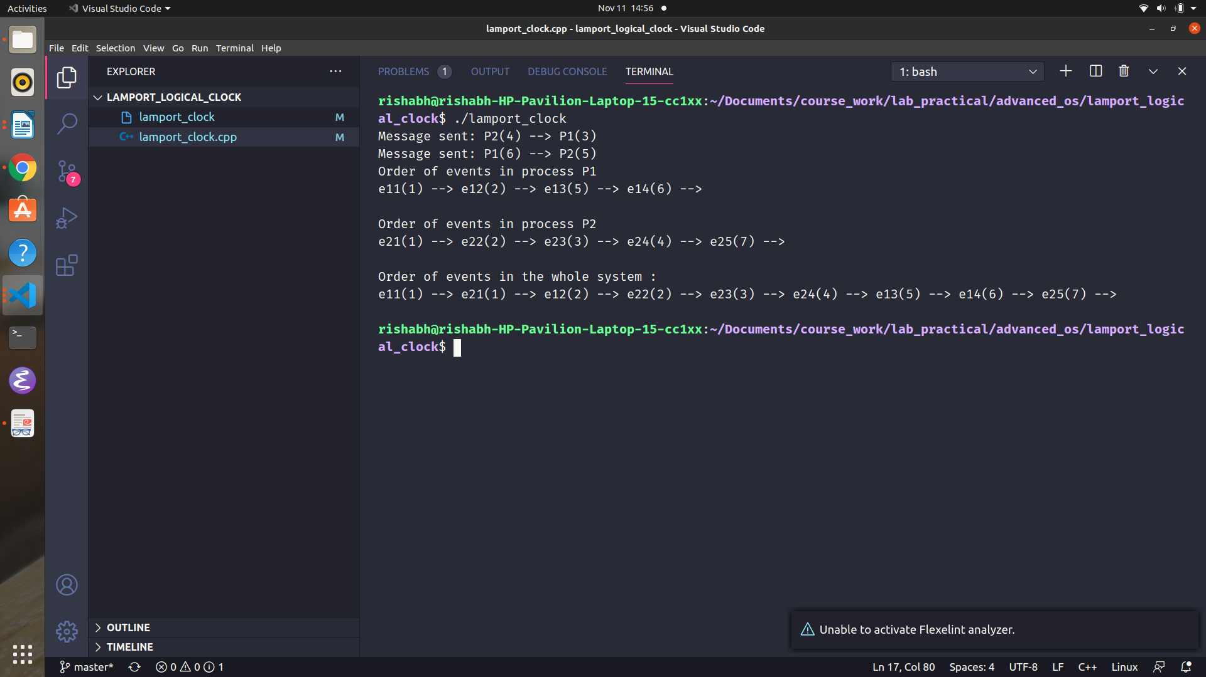
Output:

