**Experiment 6**

**Aim: To implement K-means and K-medoids algorithm on the Iris dataset.**

**Code:**

1. **K-means**

|  |
| --- |
| **import** **pandas** **as** **pd**  **import** **numpy** **as** **np**  **import** **matplotlib.pyplot** **as** **plt**  **import** **random**  iris_data_path = "./iris.data"  iris_dataset = pd.read_csv(iris_data_path, header=**None**)  iris_dataset.pop(**4**)  K = **3**  # lets generate k random indices and then apply this algo  k_random_indices = [**0**, **51**, **101**]  centroids = [iris_dataset.loc[i] **for** i **in** k_random_indices]  max_iterations = **1000**  tol = **0.000001**  clusters = [[] **for** _ **in** range(K)]  **for** i_iter **in** range(max_iterations):  clusters = [[] **for** _ **in** range(K)]  **for** i **in** range(iris_dataset.shape[**0**]):    # find dists from all the centroids  dists_from_centroid = [np.linalg.norm(iris_dataset.loc[i] - centroids[j]) **for** j **in** range(**0**, K)]  # get the min dist from centroid  min_dist_idx = dists_from_centroid.index(min(dists_from_centroid))  clusters[min_dist_idx].append(iris_dataset.loc[i])  prev_centroids = centroids  centroids = [np.average(cluster, axis=**0**) **for** cluster **in** clusters]  # if optimized, then break else go for another round  is_optimized = **True**  **for** i **in** range(K):  original_centroid = prev_centroids[i]  curr_centroid = centroids[i]  diff = np.sum((curr_centroid - original_centroid) / original_centroid * **100.0**)  print(diff)  **if** diff > tol:  is_optimized = **False**  **if** is_optimized:  print(f'{i_iter} iterations to find the optimal solutions')  **break**  colors = ["r", "g", "b"]  ######### mark the centroids  **for** i **in** range(len(centroids)):  plt.scatter(centroids[i][**2**], centroids[i][**3**], color= "k", marker="o")  i = **0**  **for** cluster **in** clusters:  color_for_this_cluster = colors[i]  i += **1**  **for** point **in** cluster:  plt.scatter(point[**2**], point[**3**], color = color_for_this_cluster, marker="x")  plt.title("K-Means on iris dataset")  plt.xlabel("Petal Width")  plt.xlabel("Petal Length")  plt.show() |

**Output:**

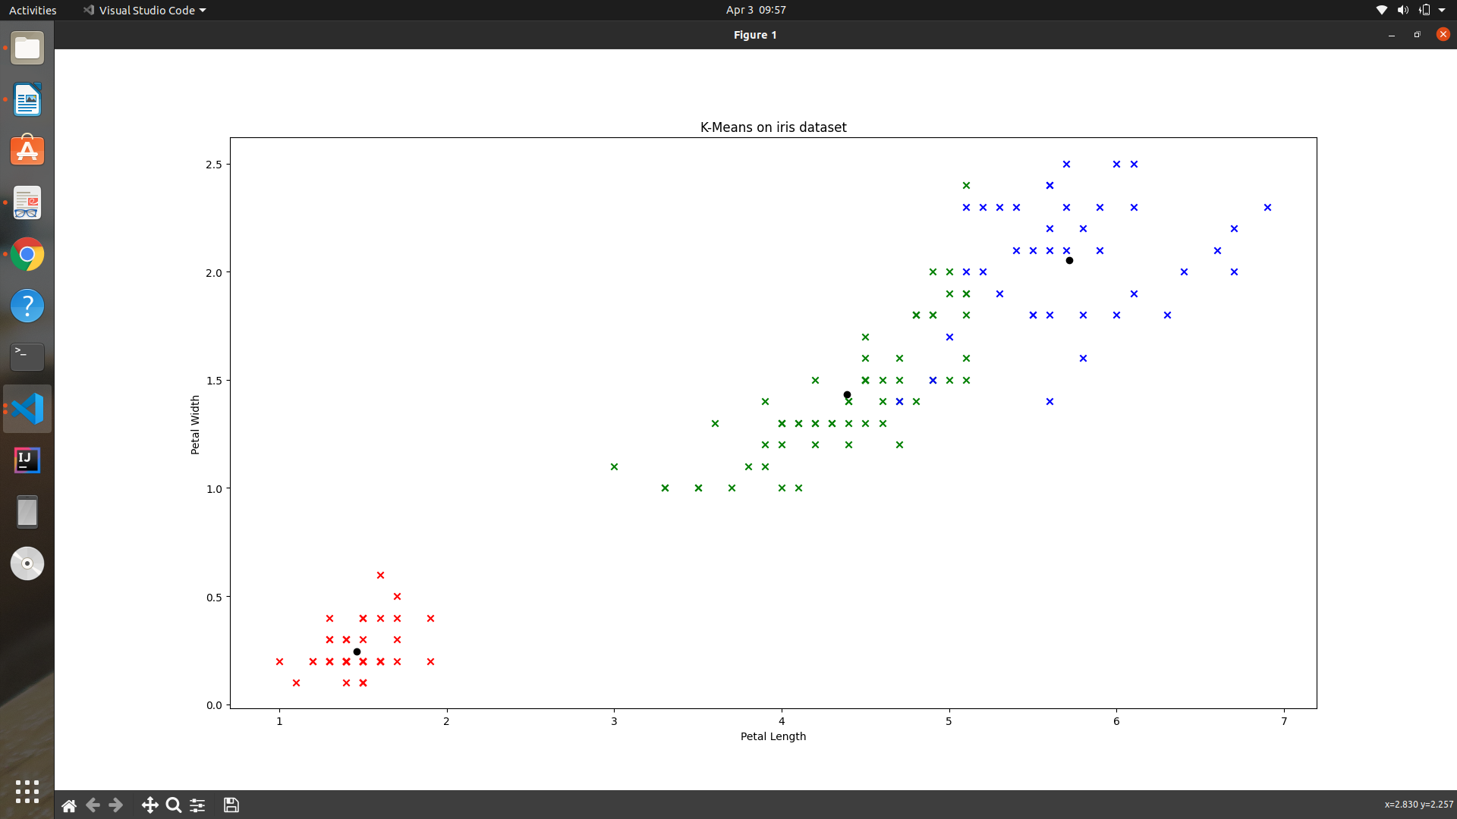

**2. K-medoids:**

|  |
| --- |
| **import** **pandas** **as** **pd**  **import** **numpy** **as** **np**  **import** **random**  **import** **matplotlib.pyplot** **as** **plt**  iris_dataset = pd.read_csv('iris.data', header=**None**)  iris_dataset.pop(**4**)  # get initial KMediods  K = **3**  max_iter = **1000**  initial_medoids_indices = {random.choice(range(**0**, **150**)) **for** _ **in** range(K)}  initial_medoids = [iris_dataset.loc[idx] **for** idx **in** initial_medoids_indices]  non_mediods_data = []  **for** i **in** range(**150**):  **if** i **not** **in** initial_medoids_indices:  non_mediods_data.append(iris_dataset.loc[i])  **def** **swap**(medoids, non_medoids, med_idx, non_med_idx):  temp = non_medoids[non_med_idx]  non_medoids[non_med_idx] = medoids[med_idx]  medoids[med_idx] = temp  **def** **compute_cost**(medoids, non_medoids):  clusters = [[] **for** _ **in** range(len(medoids))]  cost = **0**  **for** non_med **in** non_medoids:  dists = [np.linalg.norm(non_med - medoid) **for** medoid **in** medoids]  min_dist_idx = dists.index(min(dists))  cost += dists[min_dist_idx]  clusters[min_dist_idx].append(non_med)  **return** cost, clusters  init_cost, init_clusters = compute_cost(initial_medoids, non_mediods_data)  i_iters = **0**  **while** **True**:  i_iters += **1**  # print(f'Non Medoids = {non_mediods_data}')  med_copy = initial_medoids.copy()  non_med_copy = non_mediods_data.copy()  med_swap_idx = random.randint(**0**, K-**1**)  non_med_swap_idx = random.randint(**0**, len(non_med_copy) - **1**)  swap(initial_medoids, non_mediods_data, med_swap_idx, non_med_swap_idx)  new_cost, new_clusters = compute_cost(initial_medoids, non_mediods_data)  **if**(new_cost > init_cost):  initial_medoids = med_copy  non_mediods_data = non_med_copy  **break**  init_clusters = new_clusters  init_cost = new_cost  colors = ["r", "g", "b"]  ######### mark the centroids  **for** i **in** range(len(initial_medoids)):  plt.scatter(initial_medoids[i][**0**], initial_medoids[i][**1**], color= "k", marker="o")  i = **0**  **for** cluster **in** init_clusters:  color_for_this_cluster = colors[i]  i += **1**  **for** point **in** cluster:  plt.scatter(point[**0**], point[**1**], color = color_for_this_cluster, marker="x")  print(f'Number of iterations = {i_iters}')  plt.title("K-Medoids on iris dataset")  plt.xlabel("Sepal Length")  plt.xlabel("Sepal Width")  plt.show() |

