National Institute 0f Technology, Hamirpur Department Of Computer Science and Engineering
Sept-November 2020



Subject Name:  Information Security Lab | Subject Code:  CSD – 415
Course:  Information Security | Semester:  4th Year, 7th semester
Submitted By:  Student Name: Rishabh Katna  Roll No: 17MI552 | Submitted To:  Dr. Narottam Chand
Faculty Signature:

PRACTICAL #1
AIM : Introduction to Wireshark and implement Capture packets and Display packets in Wireshark.

Theory:
Wireshark, formerly known as Ethereal, can be used to examine the details of traffic at a variety of levels ranging from connection-level information to the bits that make up a single packet. Packet capture can provide a network administrator with information about individual packets such as transmit time, source, destination, protocol type and header data. This information can be useful for evaluating security events and troubleshooting network security device issues.

Images:

a. Interface of Wireshark:

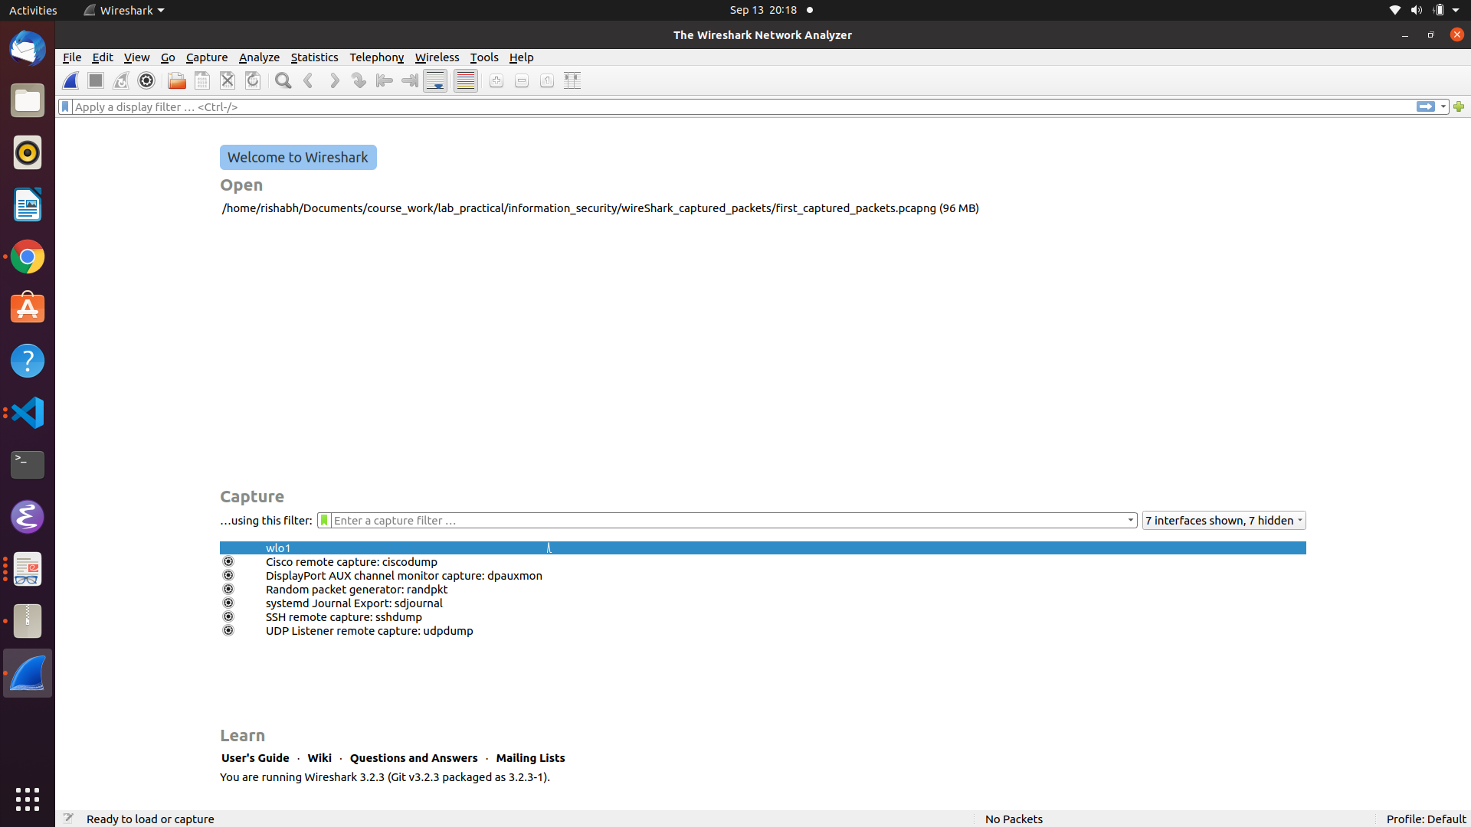
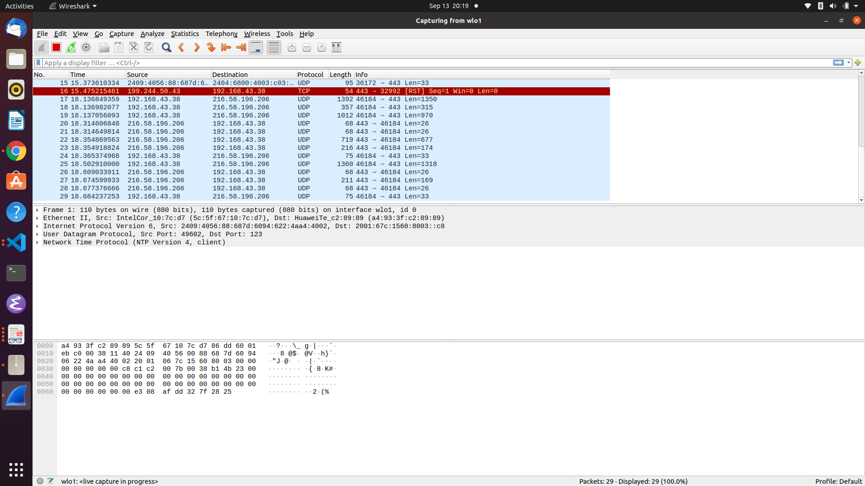

Capture packets filters in Wireshark:

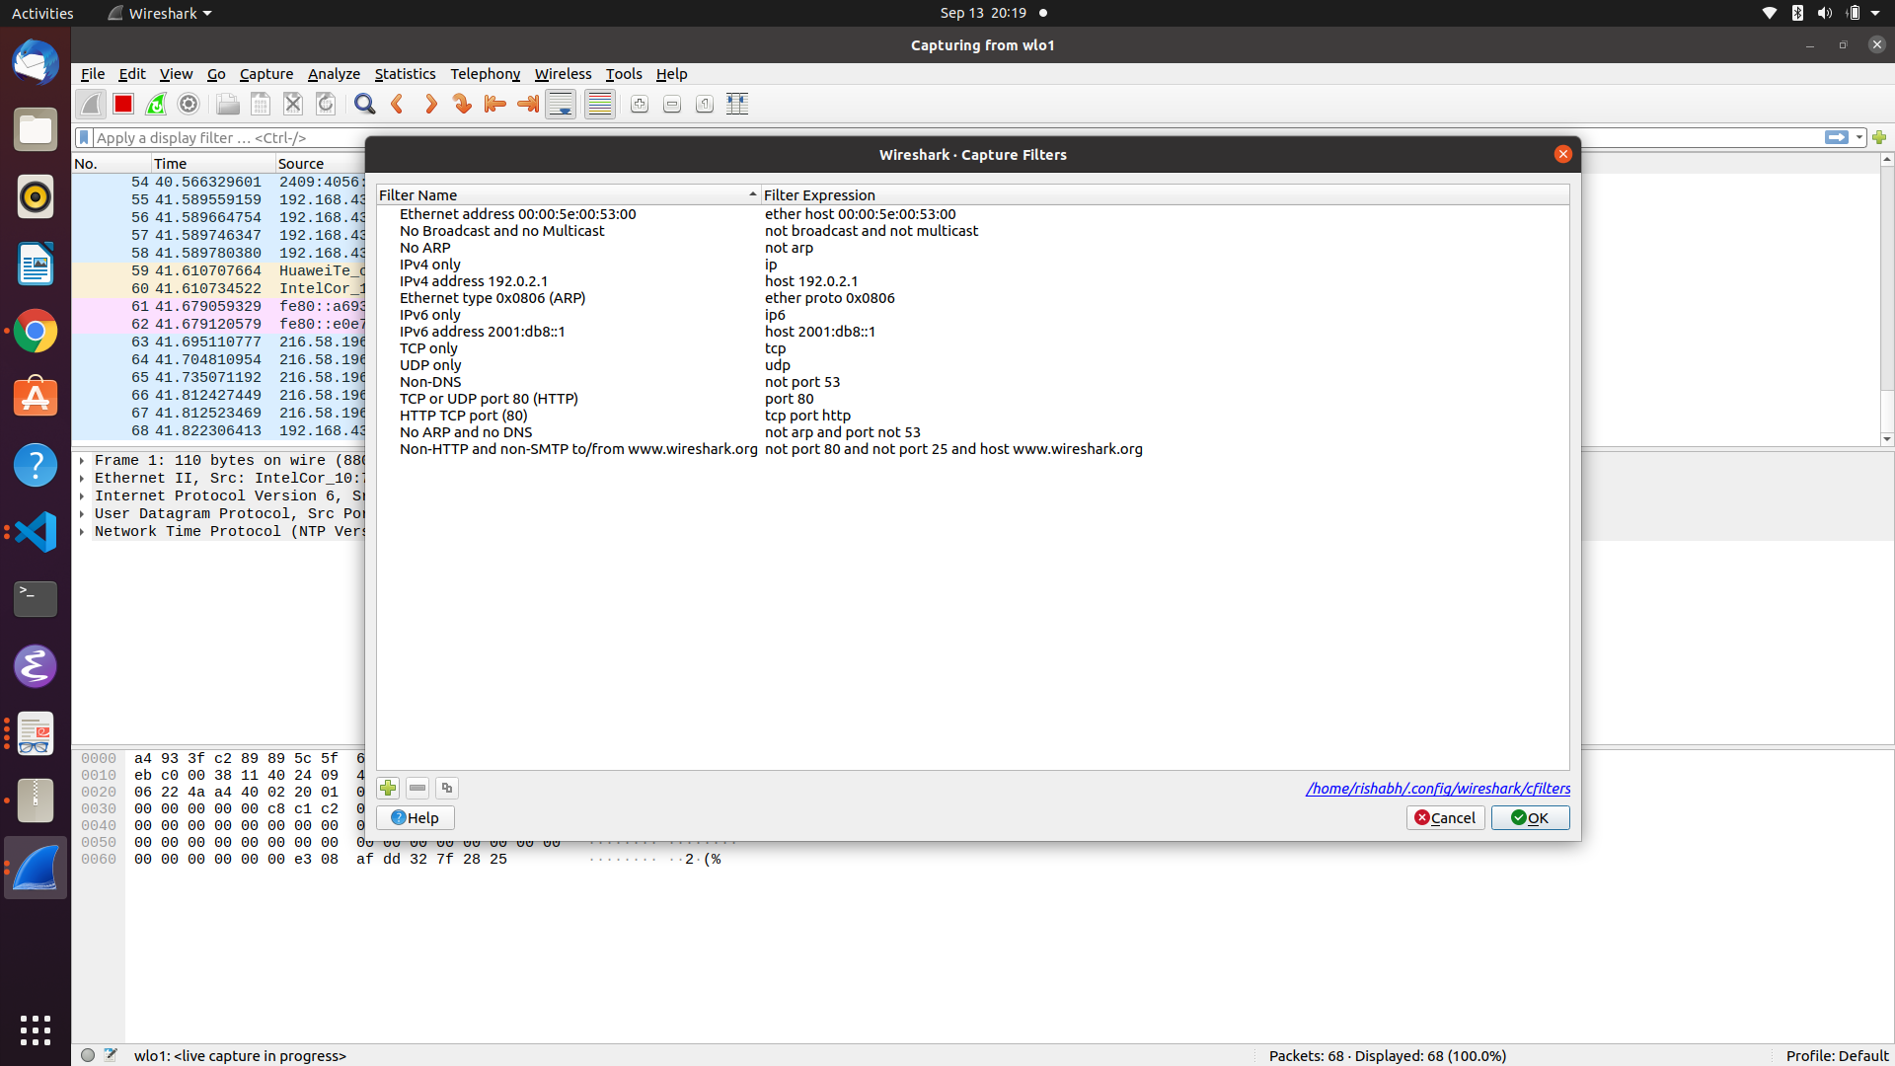

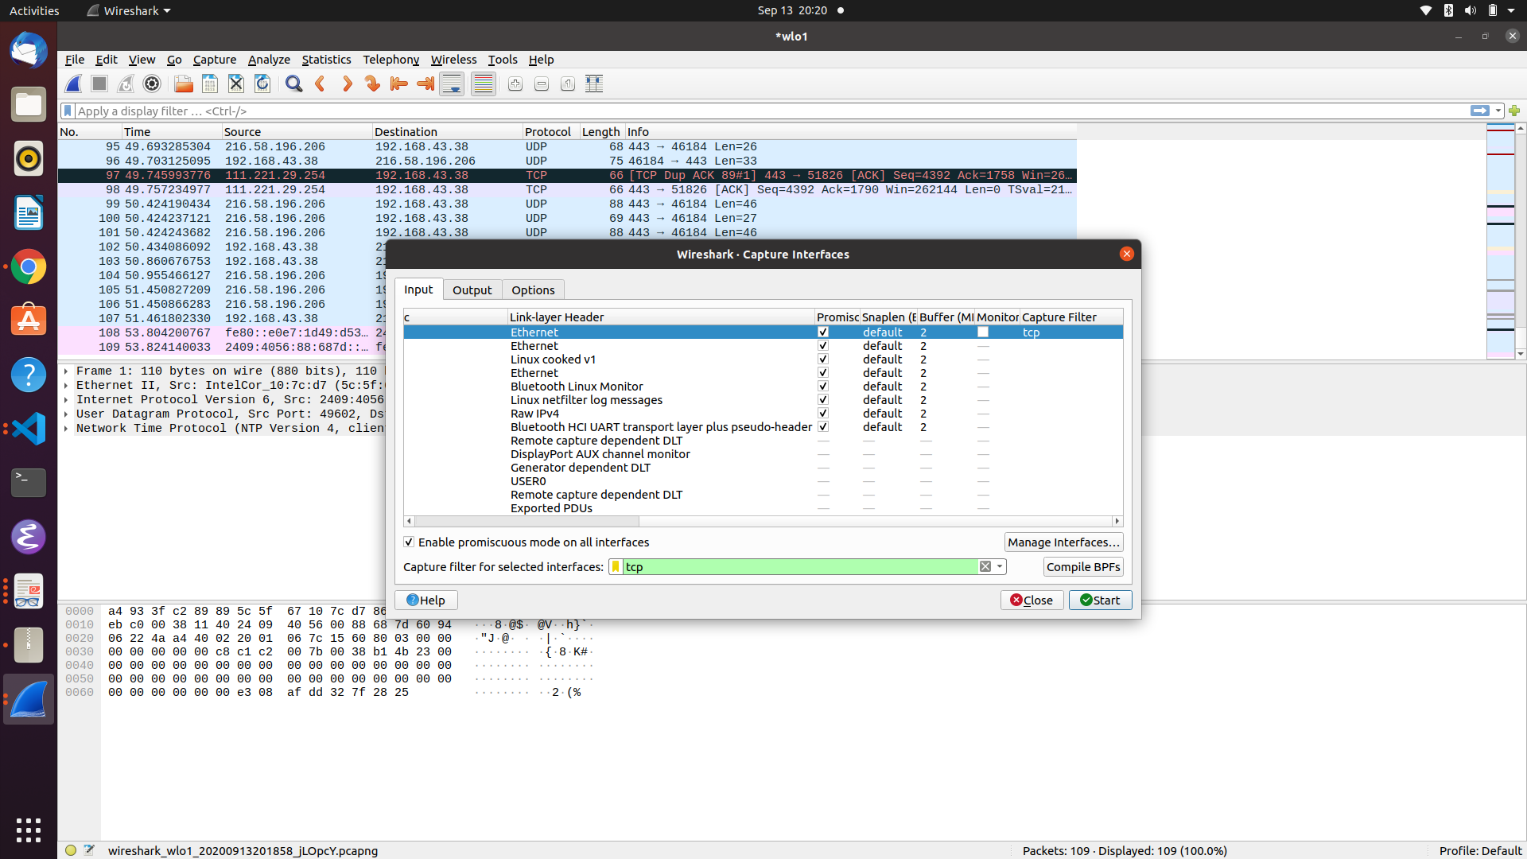

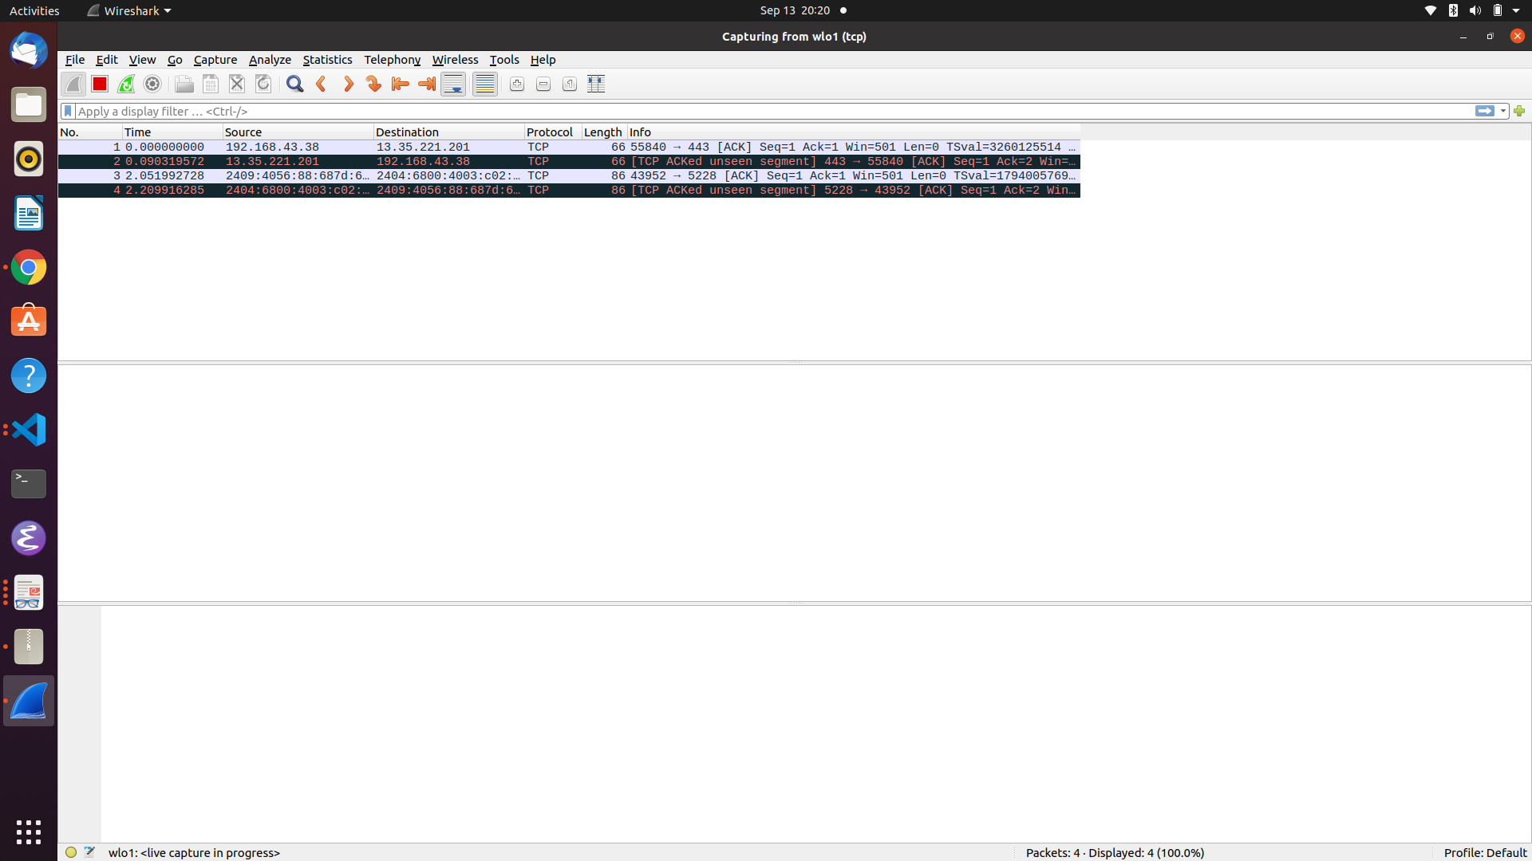

Display Filter :
