**PROTOBUF**

PROTOBUF “Protocol Buffers” is a protocol developed by Google, It was used by google internally until 2008 then was made public

It’s a method of serializing structured data and to develop programs to make communication with different programs through IDL (Interface Definition Language)

It is optimized to be faster than **JSON** and **XML** by removing many responsibilities usually done by **data formats** and making it focus only on the ability to serialize and deserialize data as fast as possible.

**Setup**

**Link : https://github.com/protocolbuffers/protobuf/releases**

* **ProtoC compiler** for protobuf

It compiles the proto file to generate language specific code corresponding to structure defined

Other schema compilers are available from other sources to create language-dependent output for over 20 other languages

**Java Proto Command:**

protoc --java_out=src/main/java src/main/resources/guest.proto

**Javascript proto command:**

protoc --js_out=import_style=commonjs,binary:build/gen guest.proto

* **Proto file** with extension .proto

Data structures (called *messages*) are defined in proto file

**message** PhoneNumber {  
 **required string** number = 1;  
 **optional** PhoneType type = 2 [**default** = ***HOME***];  
}

**enum** PhoneType {  
 ***MOBILE*** = 0;  
 ***HOME*** = 1;  
 ***WORK*** = 2;  
}

* **Java(Any language) protocol buffer API** to write and read message

Eg add node modules for node js

Add pom/Gradle dependencies for Java

<dependency>

<groupId>com.google.protobuf</groupId>

<artifactId>protobuf-java</artifactId>

<version>3.11.0</version>

</dependency>

version number of the runtime matches (or is newer than) the version number of the protoc.

**Proto2 vs Proto3**

1. By default optional in v3
2. Enum count start from 0
3. Method to check value is initialized to fields (obj.hasValue())

**USECASE**

Used in producer/ consumer scenarios like

• Data blobs storage

• Networks

• PC to embedded devices

• Multi-processor/ controller/Microservices

**DRAWBACK**

•No encryption/ decryption features

•No compression beyond encoding

**Protobuf data types**

| **Encoding** | **Sample types** | **Length** |
| --- | --- | --- |
| varint | int32, uint32, int64 | Variable length |
| fixed | fixed32, float, double | Fixed 32-bit or 64-bit length |
| byte sequence | string, bytes | Sequence length |

**COMPARISON**

JSON, XML, Raw Text

⎫ Highly portable

⎫ Human readable (kind of)

X Not cheap to parse

X Not cheap to encode

X Not cheap to store

X Not cheap to send

**SUMMMARY**

Overview and integration IDL

• Interface definition language specified by Google • Two versions Proto2/ Proto3 • Proto files have .proto suffix • Google compiler converts IDL to boilerplate • Runtime libraries decode and encode streams • Simple to read and write

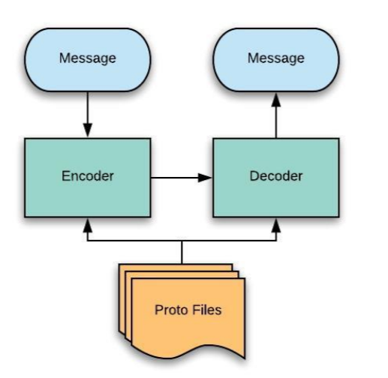

Proto Buffer Flow

Reference:

<https://medium.com/better-programming/understanding-protocol-buffers-43c5bced0d47>

https://auth0.com/blog/beating-json-performance-with-protobuf/

https://opensource.com/article/19/10/protobuf-data-interchange

<https://blog.usejournal.com/what-the-hell-is-protobuf-4aff084c5db4>

<https://github.com/rish93/protobufsession-30102020>