PROJECT REPORT

Data Structure and Algorithms

(UCS 406)

**SHIPPING RECOMMENDER**

By

Ravi Gupta (101603273)

Ravi Singla (101603274)

Rishab (101603276)

Rishabh Gupta (101603278)

Submitted to:

Ms. Maninder Kaur

Computer Science & Engineering Department

Thapar Institute of Engineering and Technology, Patiala

May 2018

**Table of Content**

|  |  |  |
| --- | --- | --- |
| **Sr No.** | **Title** | **Page No.** |
| 1 | Problem Formulation | 3 |
| 2 | Problem Analysis | 4 |
| 3 | Methodology Used (pseudocode/algorithm) | 4 |
| 4 | Result and Conclusion | 5-6 |
| 5 | References | 7 |

* **Problem Formulation**

In this project we are dealing with the real-world scenario of order booking of the electronics items like mobile phones, TVs, Laptops, etc. In this case the if a person has to order an electronic product or has to pre-book a certain product then the shopkeeper has to look into the stocks available for pre-order and the stock of item available with him. Pre-order products are dispatched on the basis of the priority’s assigned by the shopkeeper while the normally available products are dispatched on first come first serve basis.

Priorities are assigned as follows:

**Card Priority**

Platinum Card 1

Gold Card 2

Silver Card 3

New Customer 4

On the basis of these priorities the order must be dispatched and in case there is a case where there is the same order of same product by the two customers having same priority cards so, the product will be shipped on the basis of first come first serve basis between the two customers. So, the main purpose of this project is to manage the shipping of the orders placed and setting the priority of the pre-booked orders.

* **Problem Analysis**

In this project we are implementing linked lists, priority queue, file handling of csv files, converting the string into integer data type. Whenever an order is placed the data gets stored into the linked lists after checking the available quantity from the csv file. After the order is placed, in case of pre booking the order is shipped according to priorities on the basis of card allotted to the customer and in case of normal orders, shipping is on fist come first basis.

* **Methodology Used**
* **Pseudocode for connecting .csv file to c++**
* Declare the ifstream object
* Open the desired csv file
* Repeat while end of file is reached
* Retrieve (pdata,var,',') //separated by comma values
* **Pseudocode for giving priority to customers**
  + Make a new node of pre-booking type structure
  + If the pre-booking queue is empty insert the new node at the first position
  + Else iterate through the list while the priority of the current node is greater than or equal to the priority of the new node
    - Priority is checked considering the 3rd digit (from right) of the card number of a customer.
  + If the resultant node is first node then insert the new node at the first position
  + Else insert the new node at the position just before the resultant node.
* **Pseudocode for showing the pre-booking list**
* Take a pointer pointing to the first node of the pre-booking queue
* Iterate through the queue while the pointer doesn’t become NULL
  + Print all the variables stored in the structure of the pre-booking queue
  + Go to the next node

**Result and Conclusions**

* **Time complexity of the Program**

Time complexity when data is stored in linked lists is Big-O $\left(n^{2}\right)$

Time complexity in rest of the program is Big-O(n)

* **Outputs of the Program**

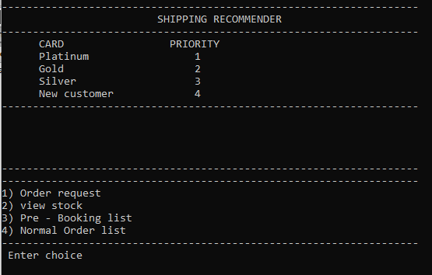

Fig. 1 Main Page

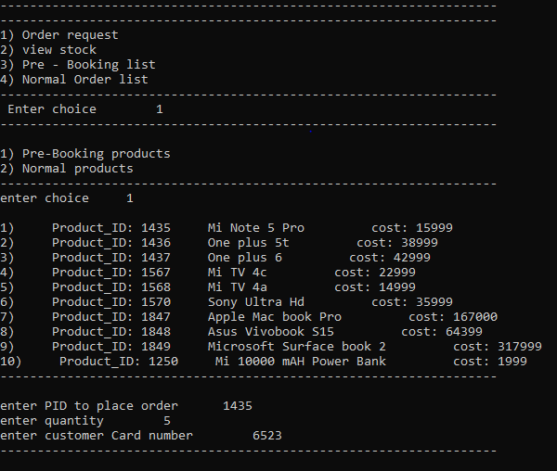

Fig. 2 Order Request

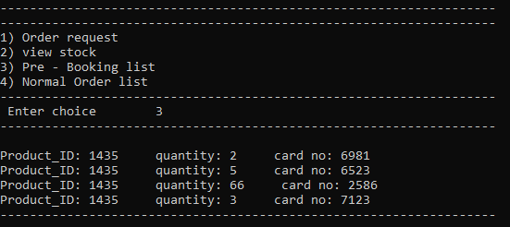

Fig. 3 pre booking list

**References**

* <https://www.geeksforgeeks.org/linked-list-set-2-inserting-a-node/>
* <https://www.geeksforgeeks.org/priority-queue-set-1-introduction/>
* <http://www.cplusplus.com/forum/general/13087/>
* <https://www.youtube.com/watch?v=wRj9PZ2wyZI>
* <https://www.geeksforgeeks.org/converting-strings-numbers-cc/>