**GHOST**

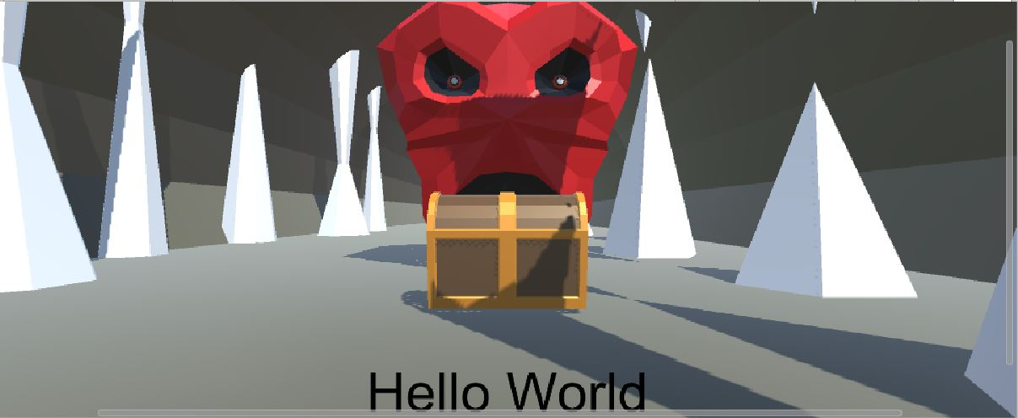

SCENE IN UNITY

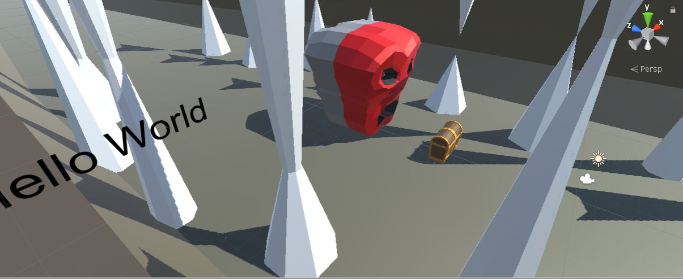

**GHOST** IS A VIRTUAL REALITY GAME IN WHICH THE PLAYER MOVE TOWARDS A TREASURE. THE TREASURE IS GUARDED BY A GHOST. THE GHOST DETECT THE MOTION OF PLAYERS. THE PLAYER HAS TO LOOK AROUND TO STOP MOVING.

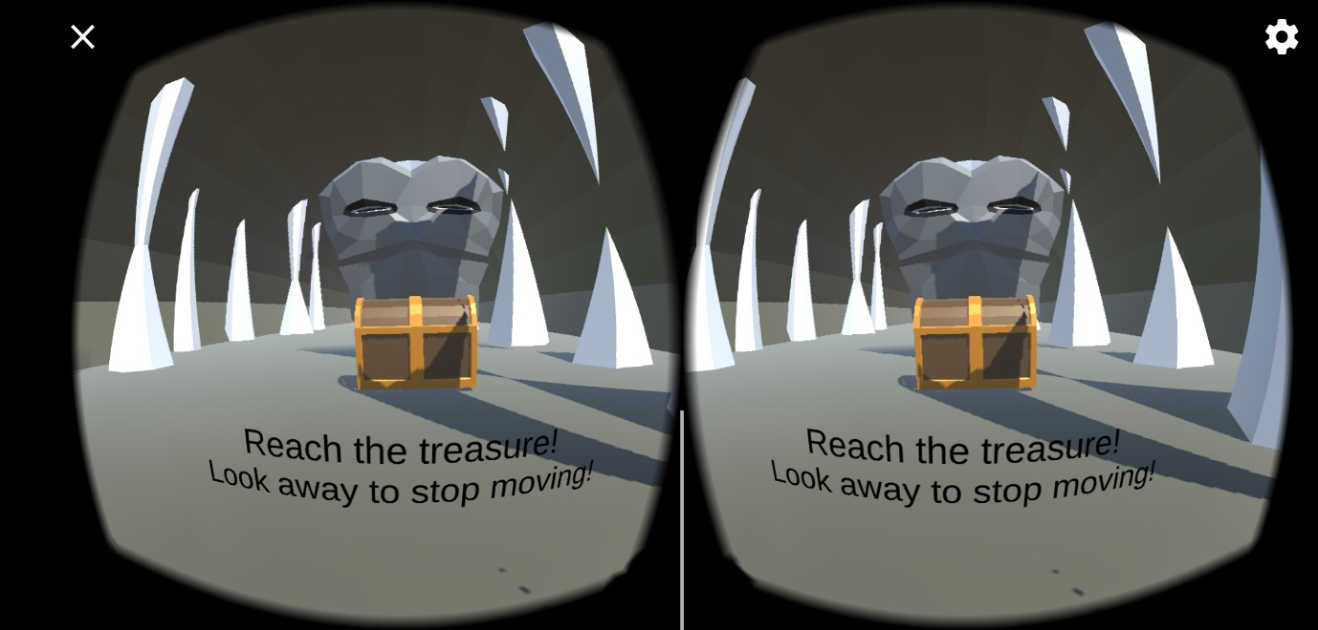

THE PLAYER IS MOVING TOWARDS THE TREASURE

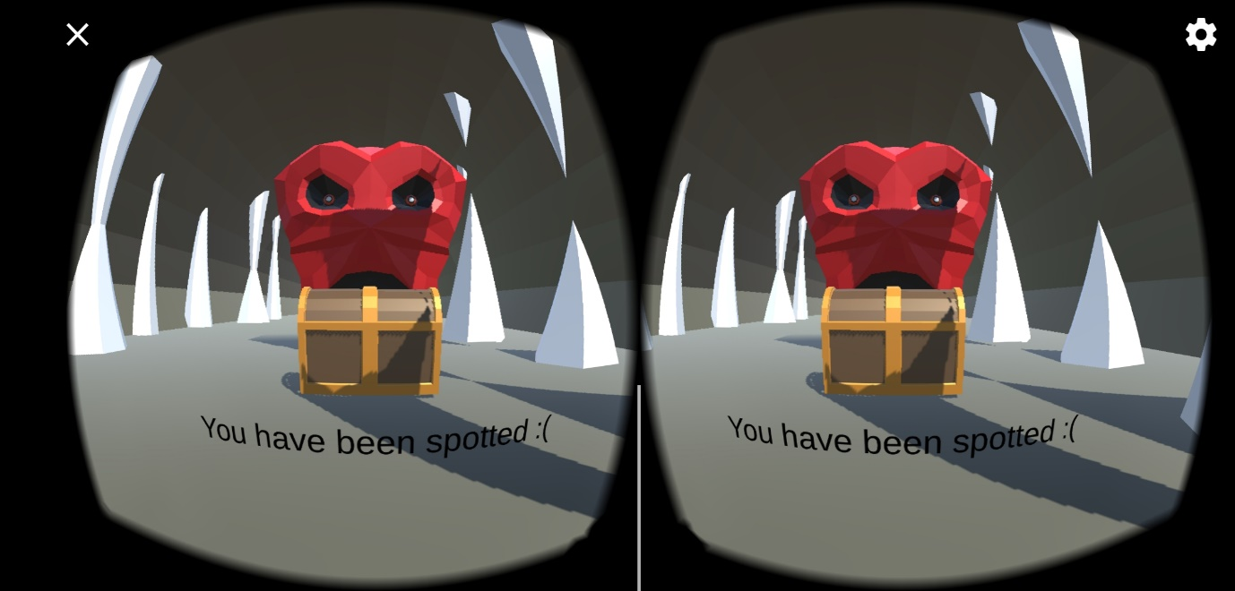

THE GHOST DETECT THE MOVEMENT OF PLAYER

‘

* Models are created using Blender.
* Unity is used for VR. (Google VR SDK)