Exercise
1. Create a page which displays page visits on the home page like this
You have visited this page ‘n’ times.
(Where n is the number of times a user has visited the home page).
check what happens when you do this exercise from
- an incognito mode.
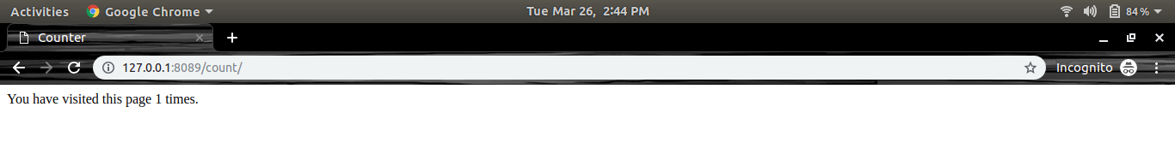
- a different browser.
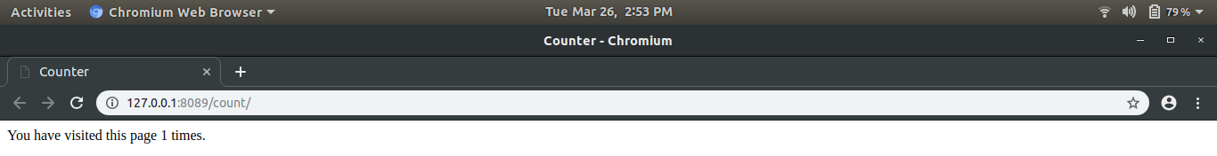
- on clearing the browsing history.
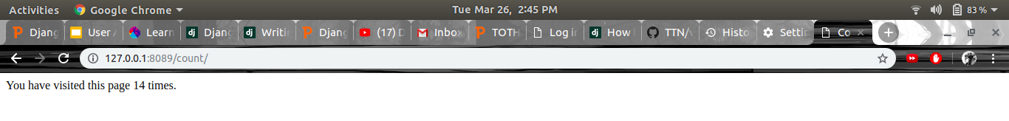
- on clearing the browsing history and cookies.
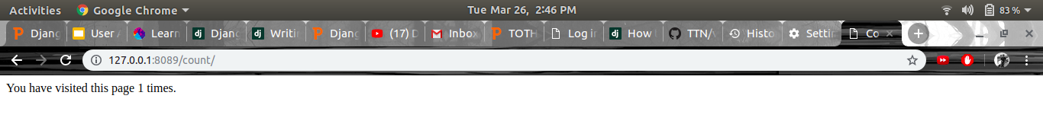

2. Set the custom expiry of 5 min to your session
Done in code.
