**Problem Statement: There can be multiple customers, who can place multiple orders on the site. Now a sales person can handle these orders will distribute into multiple sales persons (One order will be assign to one salesperson only). So a sales person can have multiple orders of multiple customers**

1. **Create Database**

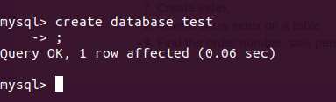

1. **Design Schema**

Customer : customerID (PK) int ,name varchar(20)

salesPerson : salesId (PK) int , name varchar(20)

Orders : orderId (PK) ,customerId (FK->Customer) , salesPersonId (FK->salesPerson)

Product : productId (PK), name varchar(20) , amount int , stock int

orderProduct : opID (pk) , productId (FK->product),orderId (FK->orders),quantity int

RELATIONSHIP : order-product : many to many

Customer -order : one to many

Salesperson -order: one to many

1. **Create tables**

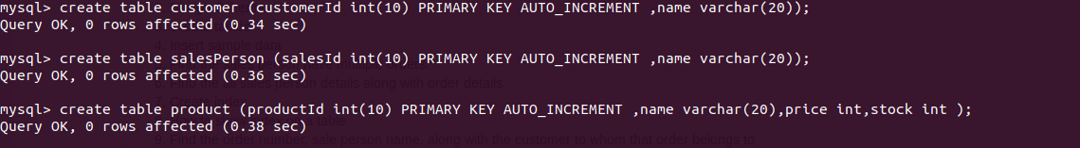





1. **Insert sample data**

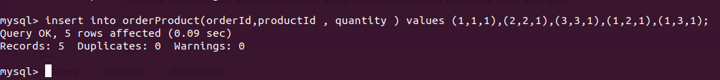

1. **Find the sales person have multiple orders.**

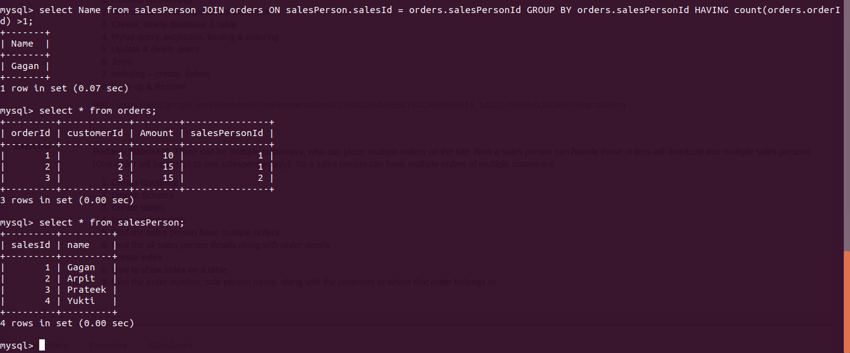

1. **Find the all sales person details along with order details**

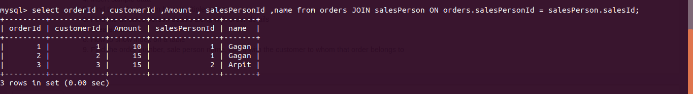

1. **Create index**

**7 & 8 in same screeshot.**

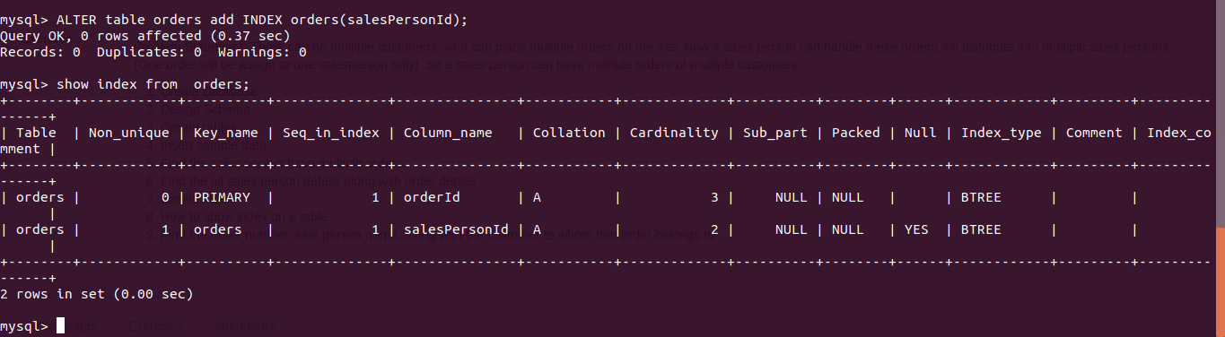

1. **How to show index on a tableFind the order number, sale person name, along with the customer to whom that order belongs to**

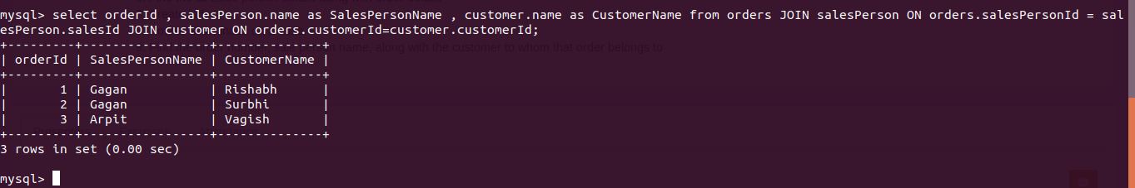

**TABLE DATA IN NEXT PAGE:**

**DATA:**

