**Q1. Write a program to replace a substring inside a string with the other string ?**

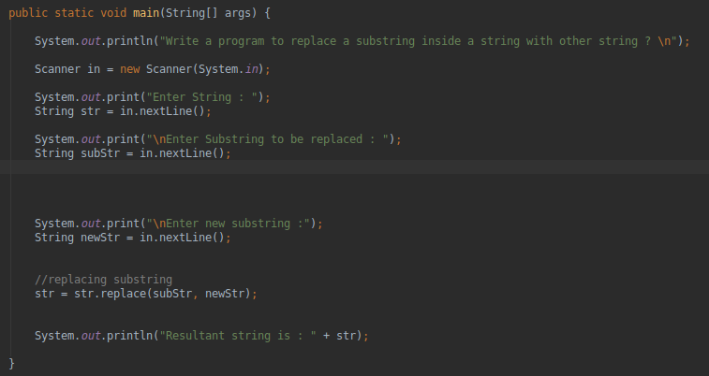

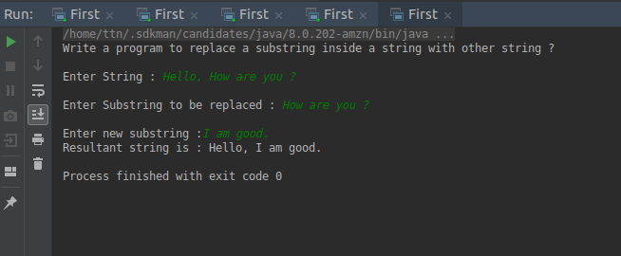

---------------------------------------------------------------------------------------------------

**Q2. Write a program to find the number of occurrences of the duplicate words in a string and print them.**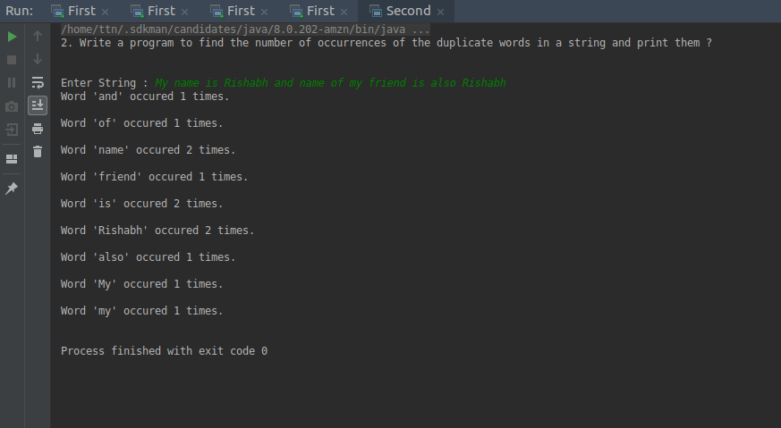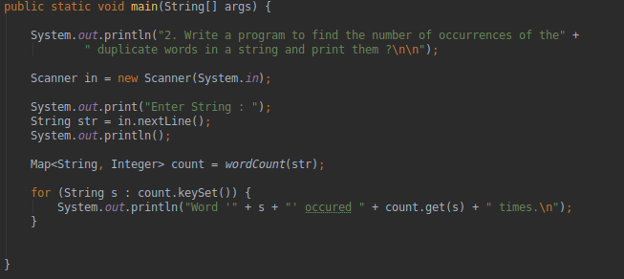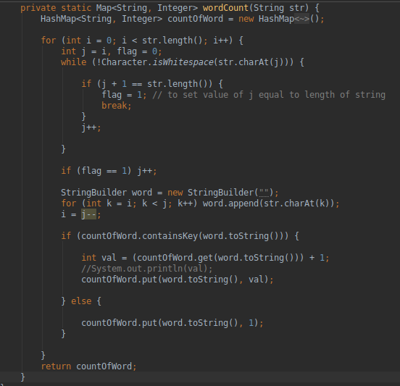

**Q3. Write a program to find the number of occurrences of a character in a string without using loop?**

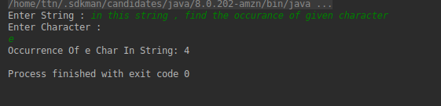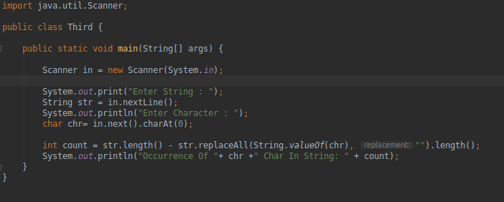

--------------------------------------------------------------------------------------------------

**Q4. Calculate the number & Percentage Of Lowercase Letters,Uppercase Letters, Digits And Other Special Characters In A String.**

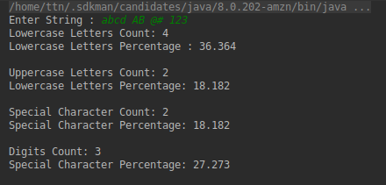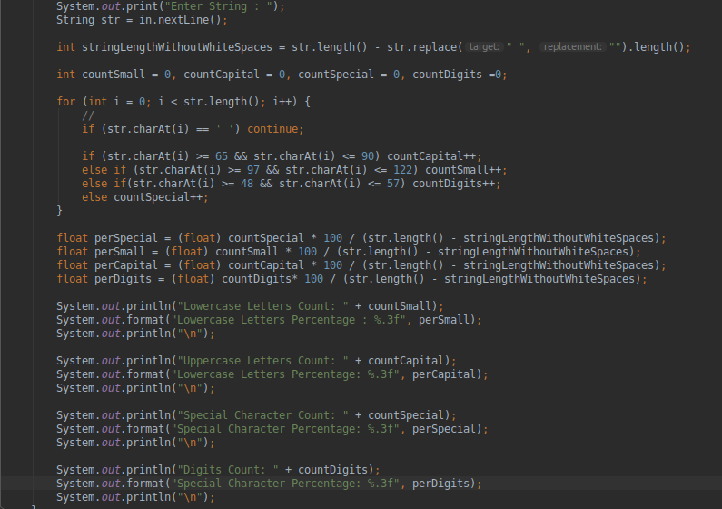

**---------------------------------------------------------------------------------------------------**

**Q5. Find common elements between two arrays.**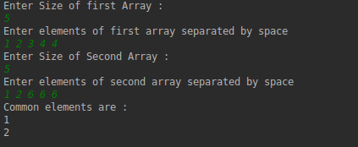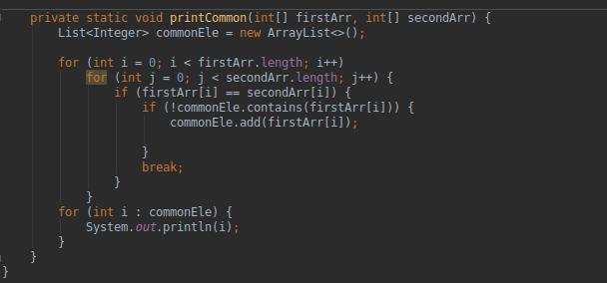

**-------------------------------------------------------------------------------------------------**

**Q6. There is an array with every element repeated twice except one. Find that element.**

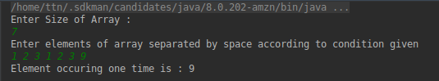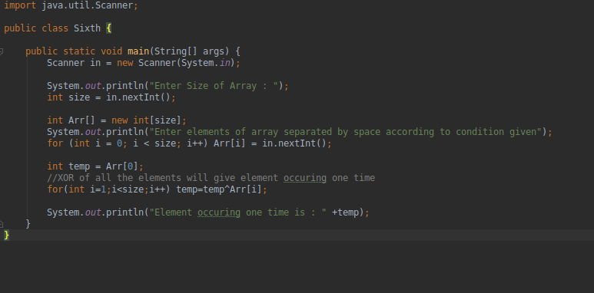

**---------------------------------------------------------------------------------------------------**

**Q7. Write a program to print your Firstname,LastName & age using static block,static method & static variable respectively**

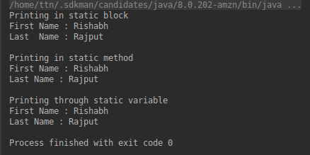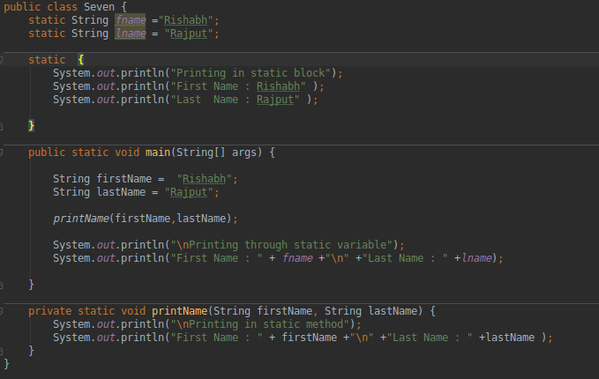

**---------------------------------------------------------------------------------------------------**

**Q8. Write a program to reverse a string and remove character from index 4 to index 9 from the reversed string using String Buffer**

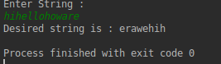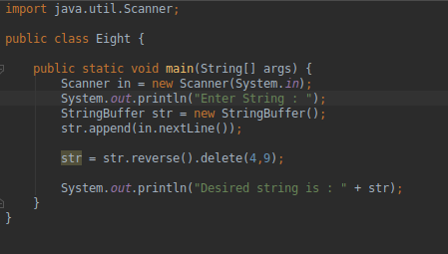

**---------------------------------------------------------------------------------------------------**

**Q9.Write a program to display values of enums using a constructor & getPrice() method (Example display house & their prices)**

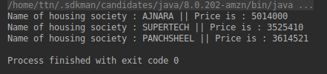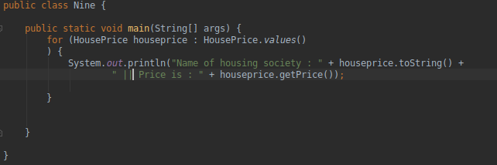

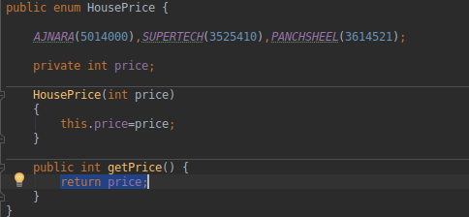

**---------------------------------------------------------------------------------------------------**

**Q10.Write a single program for following operation using overloading**

**A) Adding 2 integer number**

**B) Adding 2 double**

**C) multiplying 2 float**

**D) multiplying 2 int**

**E) concate 2 string**

**F) Concate 3 String**

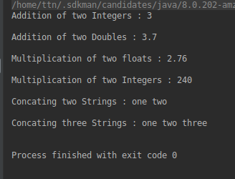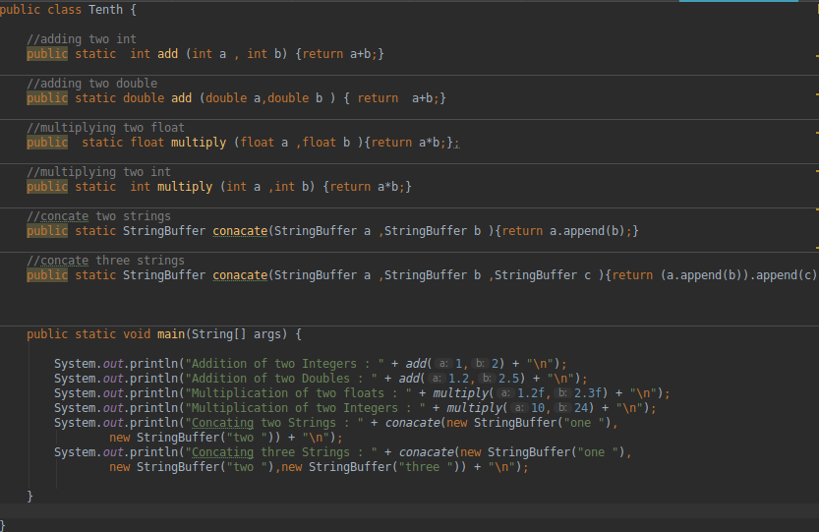

**Q11.Create 3 subclass of bank SBI,BOI,ICICI all 4 should have method called getDetails which provide there specific details like rate of interest etc,print details of every banks**