1. Program can be found here:

2. Output for Sequential Matrix Multiplication:

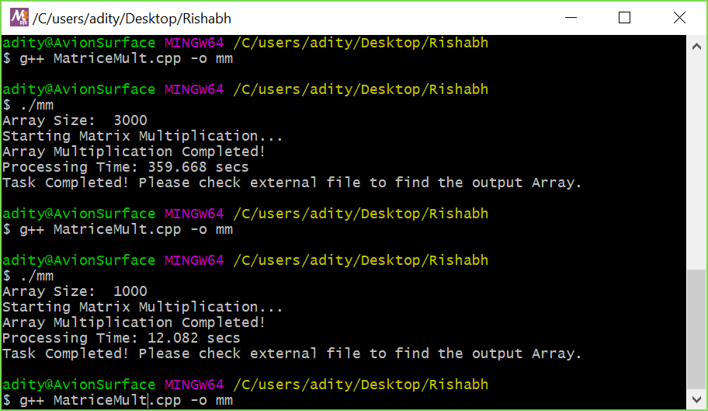

3. Roadmap to modify current program:

After thorough research and analysis, the most common method to implement Multi-threading in Matrice multiplication is by Dividing the multiplication steps across the threads. This is because all the other functions are dependent on the input from the user or output from the matrix except multiplication which is complex task and each row and column can be multiplied separately and this wouldn’t impact the result.

So, I divided the steps in multiplication of the matrices such that all the threads would have equal or close to equal number of elements to operate using a for loop. When all threads are run simultaneously, the speed of the program improves significantly.

4. Threading program can be found on the link posted below. Pthread library couldn’t be used due to system issue so I used thread library.

5. Evaluation of the program: The program was significantly faster than sequential program and completed the process successfully. However, the speed didn’t really had any improvements as the number of threads were increased after 2 to 4.

6. Program for OpenMP Version can be found here:

7. Using OpenMP didn’t improve any time efficiency. Ultimately using Pthread was the fastest.

8. Task Submitted.

**Note: Evaluations can be found on excel document supplied.**