import java.util.ArrayList;

import java.util.Collections;

import java.util.Scanner;

public class Prac8A {

public static void main(String[] args) {

ArrayList list = new ArrayList<>();

Scanner sc = new Scanner(System.in);

boolean runMenu = true;

while (runMenu) {

System.out.println("1. Add element");

System.out.println("2. Add element at index");

System.out.println("3. Set element at index");

System.out.println("4. Delete element at index");

System.out.println("5. Size of arraylist");

System.out.println("6. Loop through list");

System.out.println("7. Sort the list");

System.out.print("Response : ");

int response = sc.nextInt();

switch (response) {

case 1: // add element

{

boolean run = true;

while (run) {

System.out.print("element to add : ");

String ele = sc.next();

list.add(ele);

System.out.println("Continue adding? (true/false)");

run = sc.nextBoolean();

}

break;

}

case 2: // add element at index

{

boolean run = true;

while (run) {

System.out.print("element to add : ");

String ele = sc.next();

System.out.println();

System.out.print("at index : ");

int index = sc.nextInt();

list.add(index, ele);

System.out.println("Continue adding? (true/false)");

run = sc.nextBoolean();

}

}

break;

case 3: // set element at index

{

boolean run = true;

while (run) {

System.out.print("element to add : ");

String ele = sc.next();

System.out.println();

System.out.print("at index : ");

int index = sc.nextInt();

list.set(index, ele);

System.out.println("Continue setting? (true/false)");

run = sc.nextBoolean();

}

}

break;

case 4: // delete element at index

{

boolean run = true;

while (run) {

System.out.print("delete element at index : ");

int index = sc.nextInt();

list.remove(index);

System.out.println("Continue deleting? (true/false)");

run = sc.nextBoolean();

}

}

break;

case 5: // size

System.out.println("Size of arraylist : " + list.size());

break;

case 6:

System.out.print("[");

for (Object o : list) {

System.out.print(o + " ");

}

System.out.println("]");

System.out.println();

break;

case 7: // sort

Collections.sort(list);

System.out.println("arraylist was sorted");

break;

default:

System.out.println("Enter valid response");

}

System.out.println("Back to menu? (true/false)");

runMenu = sc.nextBoolean();

}

}

}

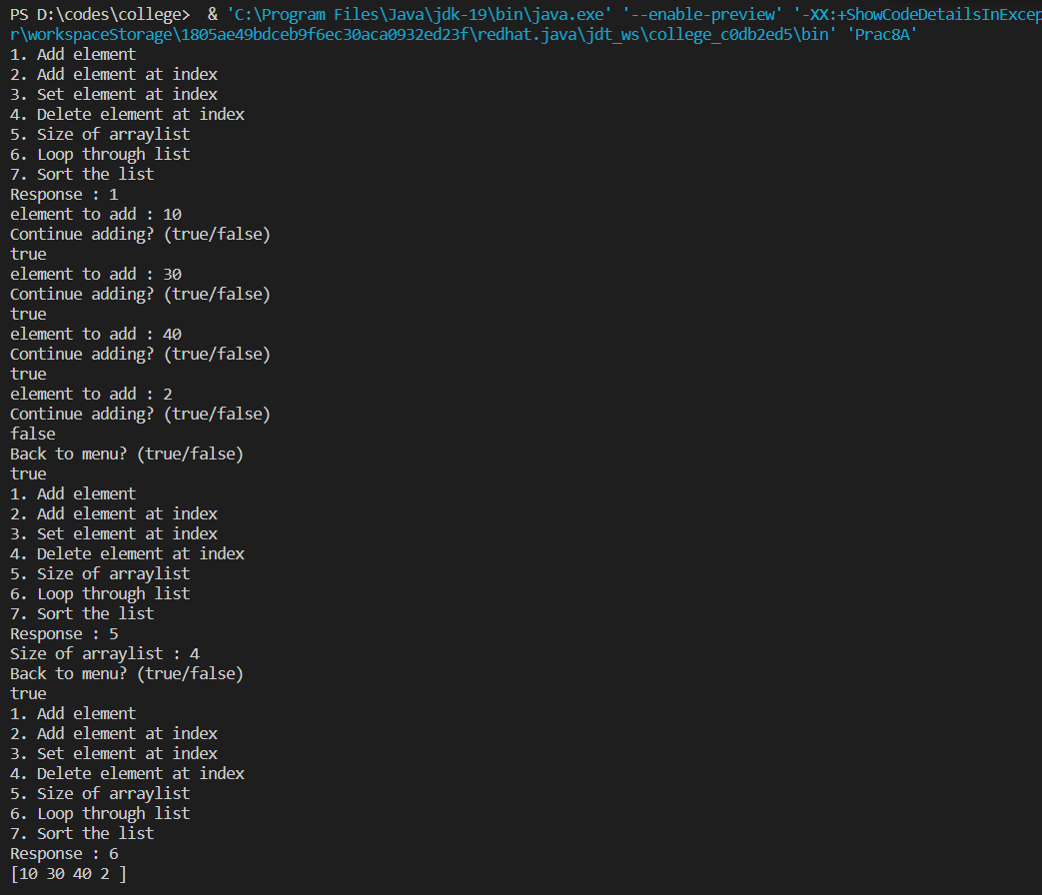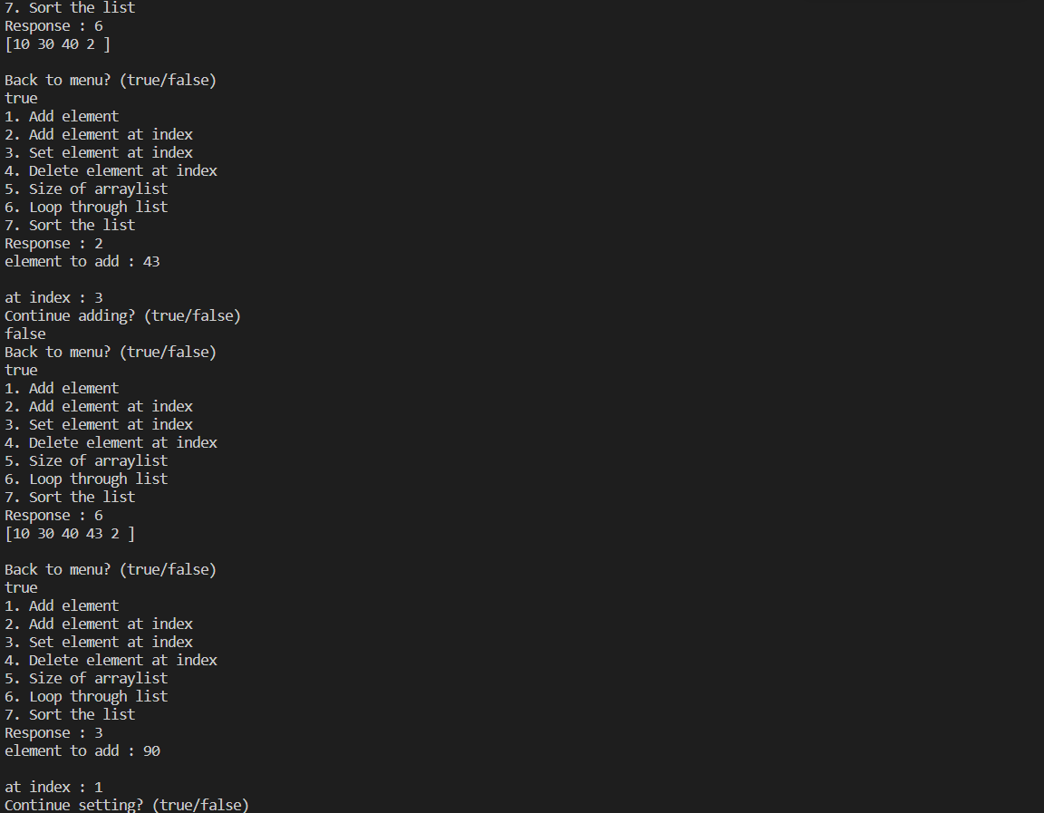

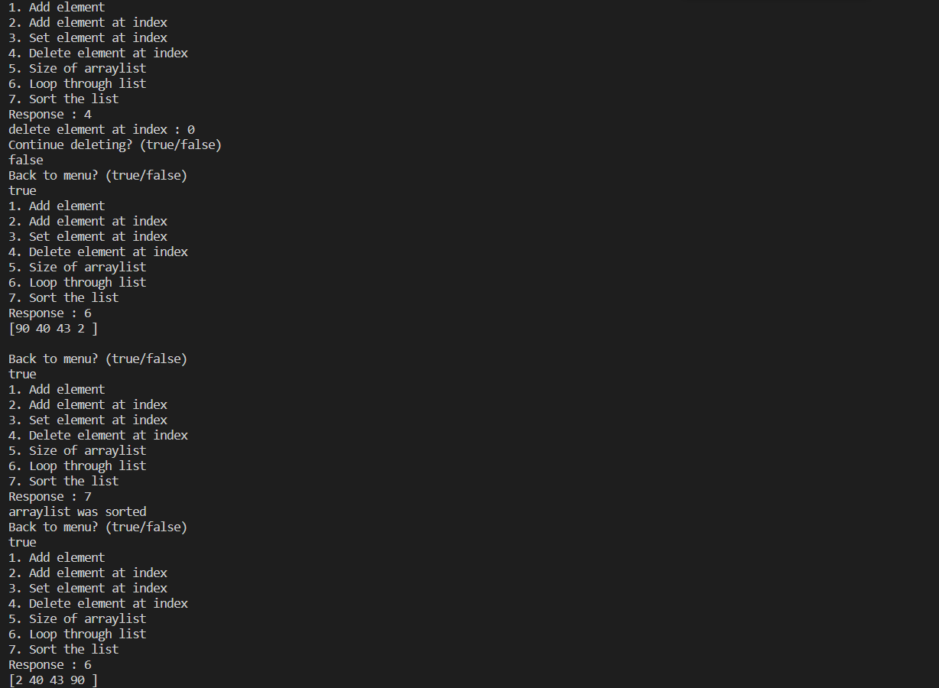

import java.util.Vector;

public class Prac8B {

public static void main(String[] args) {

Vector v = new Vector<>();

//{100, 200, 300, 200, 400, 500, 600, 700};

v.add(100);

v.add(200);

v.add(300);

v.add(200);

v.add(400);

v.add(500);

v.add(600);

v.add(700);

System.out.println("Vector : " + v);

v.remove((Object)200);

System.out.println("Vector after removing repitative occurance : " + v);

v.remove(4);

System.out.println("Vector after removing element at index 4 : " + v);

System.out.println("Element at index 1 : " + v.get(1));

}

}

