package add;

public class AddFrame extends javax.swing.JFrame {

public AddFrame() {

initComponents();

}

@SuppressWarnings("unchecked")

// <editor-fold defaultstate="collapsed" desc="Generated Code">

private void initComponents() {

jLabel1 = new javax.swing.JLabel();

num1 = new javax.swing.JTextField();

num2 = new javax.swing.JTextField();

jButton1 = new javax.swing.JButton();

resTf = new javax.swing.JTextField();

setDefaultCloseOperation(javax.swing.WindowConstants.EXIT_ON_CLOSE);

jLabel1.setText("Additon of two numbers");

num1.addActionListener(new java.awt.event.ActionListener() {

public void actionPerformed(java.awt.event.ActionEvent evt) {

num1ActionPerformed(evt);

}

});

jButton1.setText("Add");

jButton1.addActionListener(new java.awt.event.ActionListener() {

public void actionPerformed(java.awt.event.ActionEvent evt) {

jButton1ActionPerformed(evt);

}

});

javax.swing.GroupLayout layout = new javax.swing.GroupLayout(getContentPane());

getContentPane().setLayout(layout);

layout.setHorizontalGroup(

layout.createParallelGroup(javax.swing.GroupLayout.Alignment.LEADING)

.addGroup(layout.createSequentialGroup()

.addGroup(layout.createParallelGroup(javax.swing.GroupLayout.Alignment.LEADING)

.addGroup(layout.createSequentialGroup()

.addGap(201, 201, 201)

.addComponent(jLabel1, javax.swing.GroupLayout.PREFERRED_SIZE, 223, javax.swing.GroupLayout.PREFERRED_SIZE))

.addGroup(layout.createSequentialGroup()

.addGap(175, 175, 175)

.addComponent(num1, javax.swing.GroupLayout.PREFERRED_SIZE, 71, javax.swing.GroupLayout.PREFERRED_SIZE)

.addGap(39, 39, 39)

.addComponent(num2, javax.swing.GroupLayout.PREFERRED_SIZE, 71, javax.swing.GroupLayout.PREFERRED_SIZE))

.addGroup(layout.createSequentialGroup()

.addGap(219, 219, 219)

.addGroup(layout.createParallelGroup(javax.swing.GroupLayout.Alignment.LEADING)

.addComponent(resTf, javax.swing.GroupLayout.PREFERRED_SIZE, 71, javax.swing.GroupLayout.PREFERRED_SIZE)

.addComponent(jButton1))))

.addContainerGap(176, Short.MAX_VALUE))

);

layout.setVerticalGroup(

layout.createParallelGroup(javax.swing.GroupLayout.Alignment.LEADING)

.addGroup(layout.createSequentialGroup()

.addGap(28, 28, 28)

.addComponent(jLabel1, javax.swing.GroupLayout.PREFERRED_SIZE, 50, javax.swing.GroupLayout.PREFERRED_SIZE)

.addGap(37, 37, 37)

.addGroup(layout.createParallelGroup(javax.swing.GroupLayout.Alignment.BASELINE)

.addComponent(num1, javax.swing.GroupLayout.PREFERRED_SIZE, javax.swing.GroupLayout.DEFAULT_SIZE, javax.swing.GroupLayout.PREFERRED_SIZE)

.addComponent(num2, javax.swing.GroupLayout.PREFERRED_SIZE, javax.swing.GroupLayout.DEFAULT_SIZE, javax.swing.GroupLayout.PREFERRED_SIZE))

.addGap(50, 50, 50)

.addComponent(jButton1)

.addGap(66, 66, 66)

.addComponent(resTf, javax.swing.GroupLayout.PREFERRED_SIZE, javax.swing.GroupLayout.DEFAULT_SIZE, javax.swing.GroupLayout.PREFERRED_SIZE)

.addContainerGap(111, Short.MAX_VALUE))

);

pack();

}// </editor-fold>

private void num1ActionPerformed(java.awt.event.ActionEvent evt) {

// TODO add your handling code here:

}

private void jButton1ActionPerformed(java.awt.event.ActionEvent evt) {

// TODO add your handling code here:

int a = Integer.parseInt(num1.getText());

int b = Integer.parseInt(num2.getText());

resTf.setText(Integer.toString(a+b));

}

/**

* @param args the command line arguments

*/

public static void main(String args[]) {

//<editor-fold defaultstate="collapsed" desc=" Look and feel setting code (optional) ">

try {

for (javax.swing.UIManager.LookAndFeelInfo info : javax.swing.UIManager.getInstalledLookAndFeels()) {

if ("Nimbus".equals(info.getName())) {

javax.swing.UIManager.setLookAndFeel(info.getClassName());

break;

}

}

} catch (ClassNotFoundException ex) {

java.util.logging.Logger.getLogger(AddFrame.class.getName()).log(java.util.logging.Level.SEVERE, null, ex);

} catch (InstantiationException ex) {

java.util.logging.Logger.getLogger(AddFrame.class.getName()).log(java.util.logging.Level.SEVERE, null, ex);

} catch (IllegalAccessException ex) {

java.util.logging.Logger.getLogger(AddFrame.class.getName()).log(java.util.logging.Level.SEVERE, null, ex);

} catch (javax.swing.UnsupportedLookAndFeelException ex) {

java.util.logging.Logger.getLogger(AddFrame.class.getName()).log(java.util.logging.Level.SEVERE, null, ex);

}

java.awt.EventQueue.invokeLater(new Runnable() {

public void run() {

new AddFrame().setVisible(true);

}

});

}

private javax.swing.JButton jButton1;

private javax.swing.JLabel jLabel1;

private javax.swing.JTextField num1;

private javax.swing.JTextField num2;

private javax.swing.JTextField resTf;

}

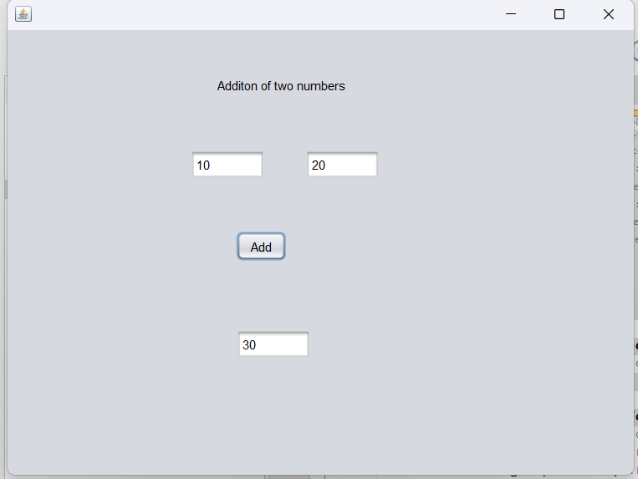

import java.io.File;

import java.io.FileWriter;

import java.io.IOException;

public class Prac9 {

public static void main(String[] args) {

File f = new File("src/filehandling/prac9.txt");

try {

if(f.createNewFile()){

System.out.println(f.toPath());

} else {

System.out.println("file already exists");

}

System.out.println(f.getAbsolutePath());

System.out.println(f.getName());

System.out.println(f.getTotalSpace());

System.out.println(f.getUsableSpace());

} catch (IOException e) {

e.printStackTrace();

}

}

}

