abstract class Shape { //prac5

    abstract void draw();

    abstract void colour();

    abstract void area();

}

class Circle extends Shape {

    int radius;

    Circle(int rad) {

        radius = rad;

    }

    void circumference() {

        System.out.println("Circumference of Circle is");

        System.out.println(2 \* 3.14 \* radius);

    }

    void area() {

        System.out.println("area of Circle is");

        System.out.println(3.14 \* radius \* radius);

    }

    void draw() {

        System.out.println("Circle");

    }

    void colour() {

        System.out.println("Red");

    }

}

class Square extends Shape {

    int side1;

    Square(int side) {

        side1 = side;

    }

    void perimeter() {

        System.out.println("perimeter of Square is");

        System.out.println(4 \* side1);

    }

    void area() {

        System.out.println("area of Square is");

        System.out.println(side1 \* side1);

    }

    void draw() {

        System.out.println("Square");

    }

    void colour() {

        System.out.println("blue");

    }

}

public class Prac4 {

    public static void main(String[] args) {

        Circle cir = new Circle(10);

        Square sq = new Square(10);

        cir.draw();

        cir.colour();

        cir.area();

        cir.circumference();

        sq.draw();

        sq.colour();

        sq.area();

        sq.perimeter();

    }

}

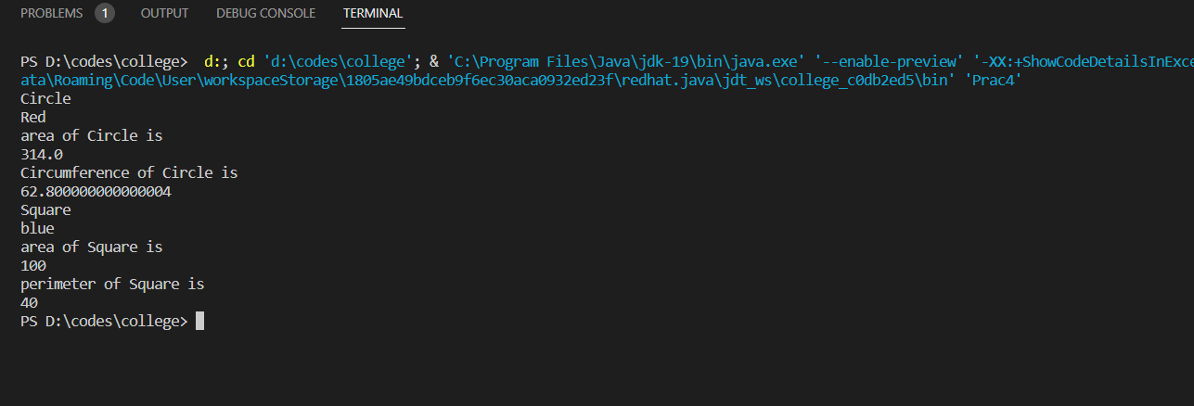

class Shape { //prac4

int a;

void draw() {

}

void display() {

System.out.println("hello");

}

}

class Circle extends Shape {

void draw() {

System.out.println("Circle.....");

}

void display() {

System.out.println("This is circle");

}

}

class Square extends Shape {

void draw() {

System.out.println("Square.....");

}

void display() {

System.out.println("This is square");

}

}

public class Prac5 {

public static void main(String[] args) {

Circle cis = new Circle();

Square sq = new Square();

sq.draw();

sq.display();

cis.draw();

cis.display();

}

}

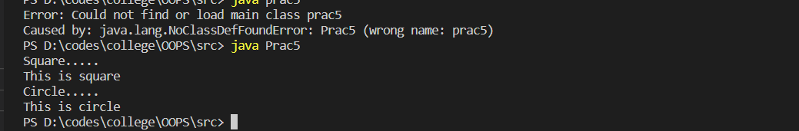

class Bank { //prac6

double getRateOfInterest() {

return 0.00;

}

}

class Sbi extends Bank {

@Override

double getRateOfInterest() {

return 0.07;

}

}

class Icici extends Bank {

@Override

double getRateOfInterest() {

return 0.06;

}

}

class Axis extends Bank {

@Override

double getRateOfInterest() {

return 0.08;

}

}

public class Prac6 {

public static void main(String[] args) {

Sbi sbi = new Sbi();

System.out.println("Rate of interest of sbi : " + sbi.getRateOfInterest());

Icici icici = new Icici();

System.out.println("Rate of interest of icici : " + icici.getRateOfInterest());

Axis axis = new Axis();

System.out.println("Rate of interest of axis : " + axis.getRateOfInterest());

}

}

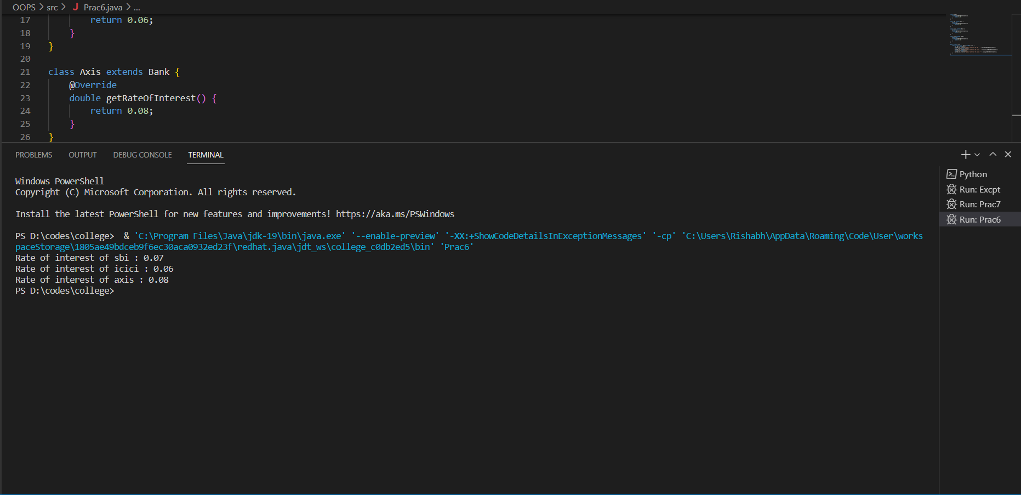

class Prac7 {

public static void main(String[] args) {

int a = 10, b = 0;

double c;

try {

System.out.printf("a = %d \nb = %d\n", a, b);

System.out.print("a / b = ");

c = a / b;

System.out.println(c);

} catch (Exception e) {

System.out.println("Exception found");

}

}

}