package prac7;

class Prac7 {

public static void main(String[] args) {

try {

int a = 9, b = 0, c;

c = a / b;

} catch (Exception e) {

e.printStackTrace();

}

System.out.println("program executed succesfully");

}

}

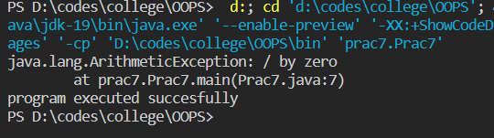

public class exception {

public static void main(String[] args) {

try {

int a = 9, b = 0, c;

c = a / b;

} catch (Exception e) {

e.printStackTrace();

}

try {

int[] a = { 2, 6, 8, 1, 3, 1, 7, 9 };

System.out.println(a[9]);

} catch (Exception e) {

e.printStackTrace();

}

System.out.println("program executed succesfully");

}

}

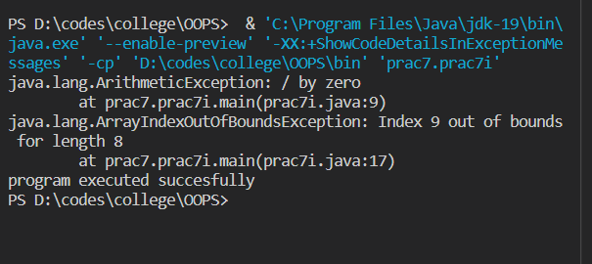

package prac7;

class Prac7iii {

public static void main(String[] args) {

try {

int a = 8, b = 4, c;

c = a / b;

System.out.println(c);

int[] arr = { 2, 5, 6, 7, 7 };

System.out.println(arr[9]);

String str = null;

System.out.println(str.toLowerCase());

} catch (ArithmeticException e) {

System.out.println(e);

} catch (NullPointerException e) {

System.out.println(e);

} catch (ArrayIndexOutOfBoundsException e) {

System.out.println(e);

}

System.out.println("program executed succesfully");

}

}

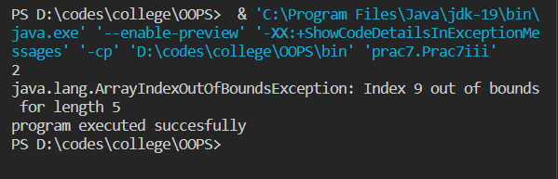

package prac7;

import java.io.FileInputStream;

import java.io.FileNotFoundException;

class file {

void read() throws FileNotFoundException {

FileInputStream a = new FileInputStream("d:/abc.txt");

}

}

public class Prac7iv {

public static void main(String[] args) {

file f = new file();

try {

f.read();

} catch (Exception e) {

System.out.println(e);

}

}

}

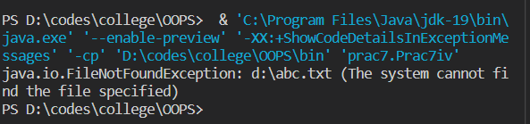

package prac7;

import java.util.Scanner;

class youngerage extends RuntimeException {

youngerage(String msg) {

super(msg);

}

}

class Prac7v {

public static void main(String[] args) {

Scanner sc = new Scanner(System.in);

int age = sc.nextInt();

try {

if (age < 18) {

throw new youngerage("not eligible");

} else {

System.out.println("eligible");

}

}

catch (Exception e) {

e.printStackTrace();

}

System.out.println("hello");

}

}

