nterms = int(input("How many terms? "))

n1, n2 = 0, 1

count = 0

if nterms <= 0:

print("Please enter a positive integer")

elif nterms == 1:

print("Fibonacci sequence upto",nterms,":")

print(n1)

else:

print("Fibonacci sequence:")

while count < nterms:

print(n1, end = " ")

nth = n1 + n2

n1 = n2

n2 = nth

count += 1

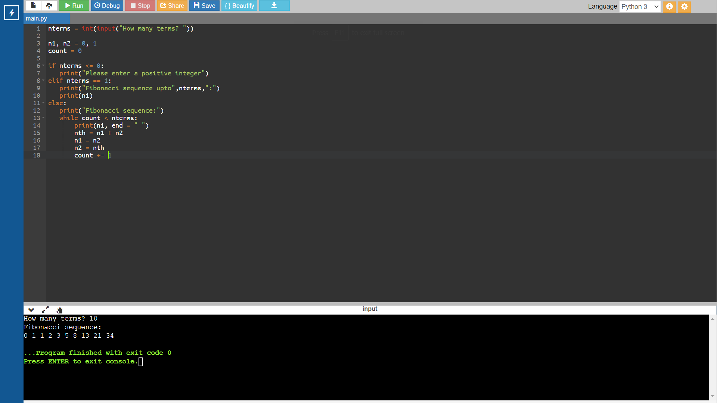

n = 5

fact = 1

for i in range(1,n+1):

fact = fact \* i

print(f"The factorial of {n} is : ",end="")

print(fact)

