print("prac 4(i)")

list = [1123,243,5,4231,35,56,74,5,45]

print(list)

print("type : ",type(list))

print("list item at index 3 : ", list[3])

list.append(6437)

print("after appending 6437 : ", list)

list.remove(243)

print("after removing 243 : ", list)

print("length of list : ", len(list))

print()

print("prac 4(ii)")

tuple = (5,31,8,56,34,1,3,5,6,9,1)

print(tuple)

print("type : ", type(tuple))

print("length of tuple : ", len(tuple))

print()

print("prac 4(iii)")

m1 = [[1,2,3], [3,4,5], [5,6,7]]

m2 = [[10,20,30], [30,40,50], [50,60,70]]

row = []

res = []

for i in range(len(m1)):

    for j in range(len(m2)):

        row.append(m1[i][j] + m2[i][j])

    res.append(row)

    row = []

print("Matrix 1 : ", m1)

print("Matrix 2 : ", m2)

print("addition of two matrix : ", res)

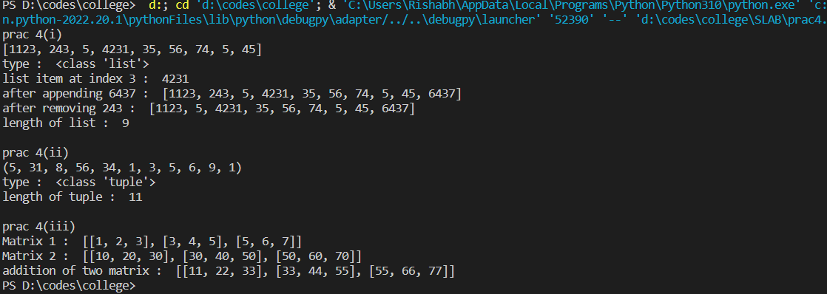

print("prac 5(i)")

set = {12,3,12,4,34,45,56,47,34,123,123}

print(set)

print("type : ", type(set))

print("length of set : ", len(set))

set.add(80)

print("after adding 80 : ", set)

set.remove(34)

print("after removing 34 : ",set)

set2 = {12,4,8,5,467,6,45,34,45,7}

print(set | set2)

print(set & set2)

print()

print("prac 5(ii)")

dict = {56: "Rishabh", 57: "Joe", 58: "Chandler", 59: "Monica"}

print(dict)

print("type : ", type(dict))

print("name of roll no 58 : ", dict.get(58))

dict.pop(57)

print("after removing : ", dict)

print("length : ", len(dict))

dict[58] = "Jason"

print("after updating : ", dict)

