from sympy import *

a = Rational(5, 8)

print("value of a is :" + str(a))

b = Integer(3.579)

print("value of b is :" + str(b))

# you can't get any numerical value

p = pi**3

print("value of p is :" + str(p))

# evalf method evaluates the expression to

# a floating-point number

q = pi.evalf()

print("value of q is :" + str(q))

# equivalent to e ^ 1 or e ** 1

r = exp(1).evalf()

print("value of r is :" + str(r))

s = (pi + exp(1)).evalf()

print("value of s is :" + str(s))

rslt = oo + 10000

print("value of rslt is :" +

str(rslt))

if oo > 9999999 :

print("True")

else:

print("False")

# import everything from sympy module

from sympy import *

x = Symbol('x')

y = Symbol('y')

z = (x + y) + (x-y)

print("value of z is :" + str(z))

# import everything from sympy module

from sympy import *

# make a symbol

x = Symbol('x')

# make the derivative of sin(x)*e ^ x

ans1 = diff(sin(x)*exp(x), x)

print("derivative of sin(x)*e ^ x :", ans1)

# Compute (e ^ x * sin(x)+ e ^ x *cos(x))dx

ans2 = integrate(exp(x)*sin(x) +exp(x)*cos(x), x)

print("indefinite integration is :", ans2)

# Compute definite integral of sin(x ^ 2)dx

# in b / w interval of ? and ?? .

ans3 = integrate(sin(x**2), (x, -oo, oo))

print("definite integration is :", ans3)

# Find the limit of sin(x) / x given x tends to 0

ans4 = limit(sin(x)/x, x, 0)

print("limit is : ", ans4)

# Solve quadratic equation like, example :x ^ 2?2 = 0

ans5 = solve(x**2 - 2, x)

print("roots are : ", ans5)

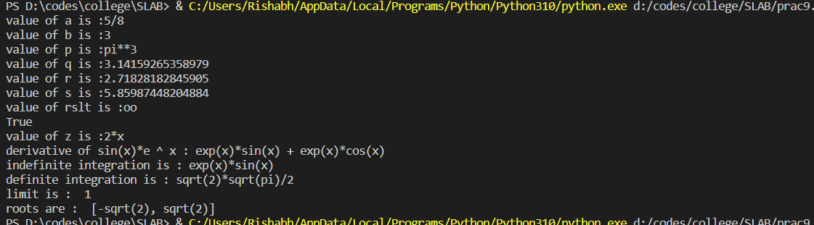

class Employee:

count = 0

def __init__(self, name, desig, salary):

self.name = name

self.desig = desig

self.salary = salary

Employee.count += 1

def displayCount(self):

print("There are %d employees" % Employee.count)

def displayDetails(self):

print("Name:", self.name, ", Designation:", self.desig, ", Salary:", self.salary)

e1 = Employee("John", "Manager", 80000)

e2 = Employee("Mike", "Team Leader", 50000)

e3 = Employee("Derek", "Programmer", 30000)

e4 = Employee("Raj", "Assistant", 25000)

e4.displayCount()

print("Details of all employee:")

e1.displayDetails()

e2.displayDetails()

e3.displayDetails()

e4.displayDetails()

