x = int(input("Number 1 : "))

y = int(input("Number 2 : "))

z = x + y

print("Sum : ",x + y)

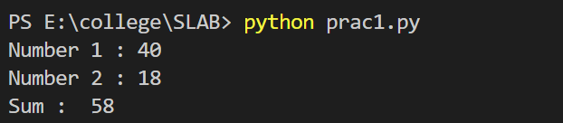

#x and y values taken from previously code

if x > y:

    print(f"{x} is greater")

else:

    print(f"{y} is greater")

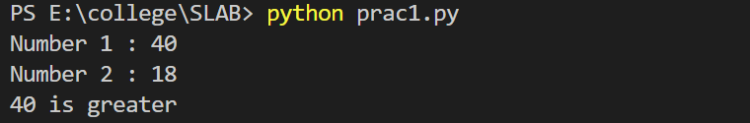

num = z

if num % 2 == 0:

    print(f"{num} is Even")

else:

    print(f"{num} is odd")

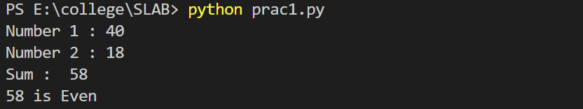

print("Before Swap : ",x, y)

temp = x

x = y

y = temp

print("After Swap : ",x, y)

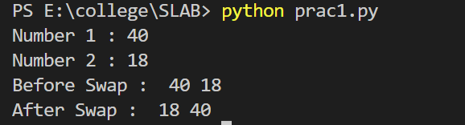

year = int(input("Enter a year: "))

if (year % 400 == 0) and (year % 100 == 0):

    print("{0} is a leap year".format(year))

elif (year % 4 ==0) and (year % 100 != 0):

    print("{0} is a leap year".format(year))

else:

    print("{0} is not a leap year".format(year))

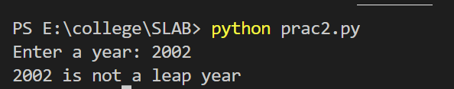

x = int(input("Number 1 : "))

y = int(input("Number 2 : "))

z = int(input("Number 3 : "))

if x > y  and x > z:

    print(f"{x} is greatest of three")

elif y > z:

    print(f"{y} is greatest of three")

else:

    print(f"{z} is greatest of three")

