**MATRICES:**

1. 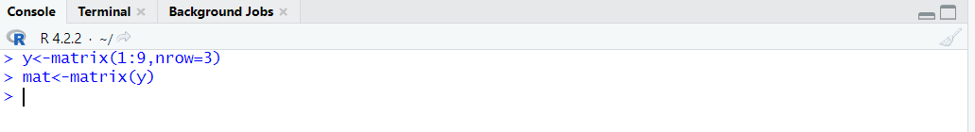

**OUTPUTS:**

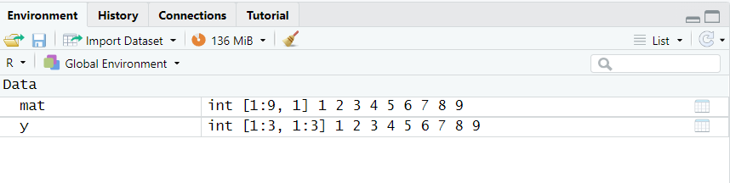

**COMMANDS:** 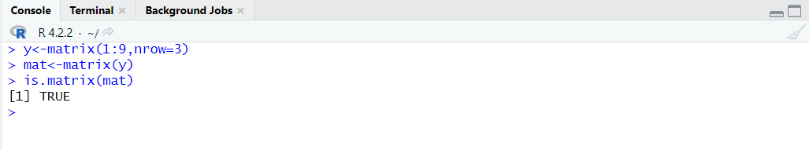

**OUTPUT/ENVIRONMENT:**

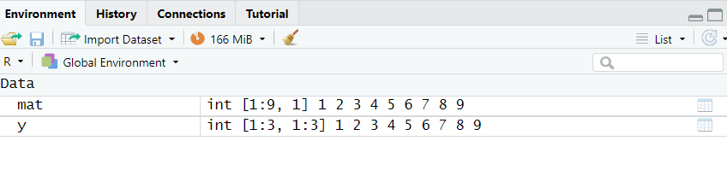

**COMMANDS:**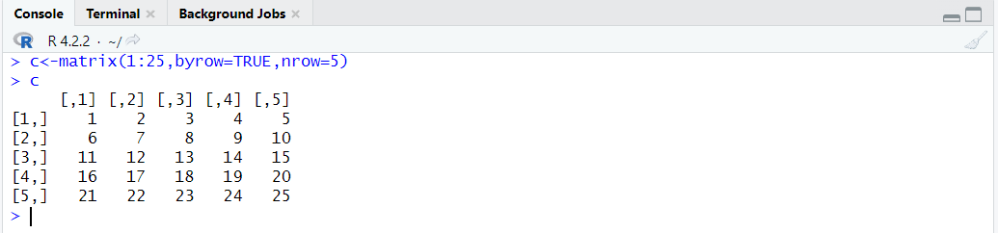

**OUTPUTS/ENVIRONMENT:**

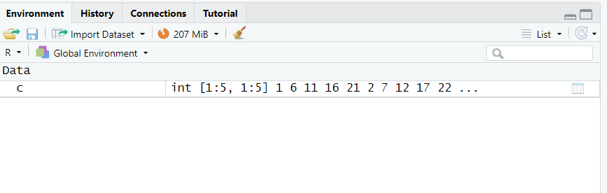

**COMMANDS:**

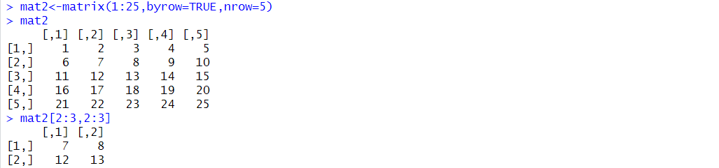

**OUTPUT/ENVIRONMENT:**

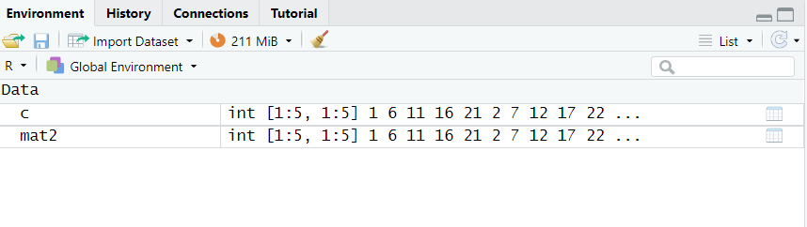

**COMMANDS/ OUTPUT:**

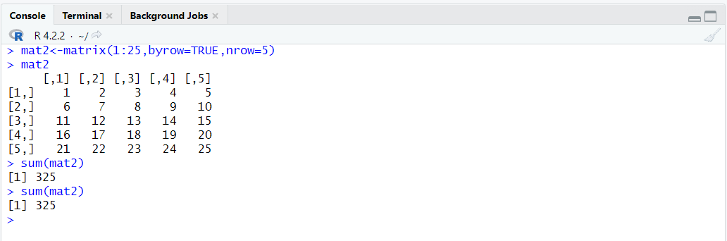

**COMMAND:**

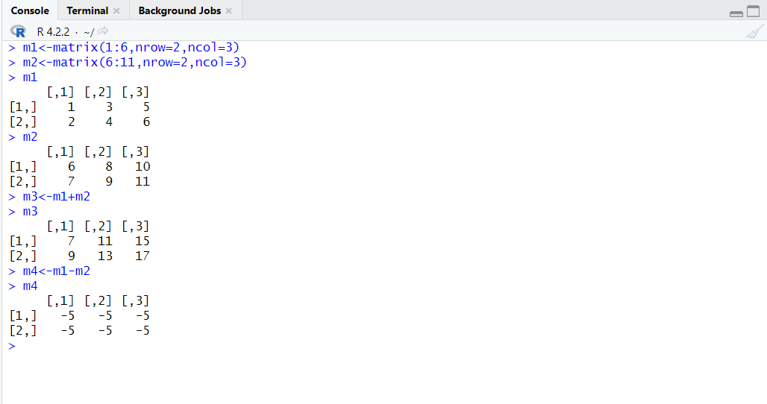

**OUTPUT/ENVIRONMENT:**

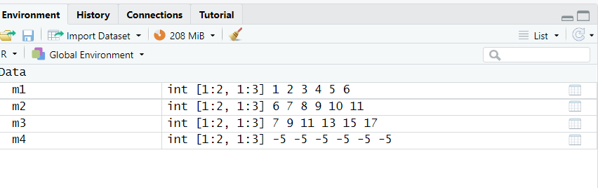

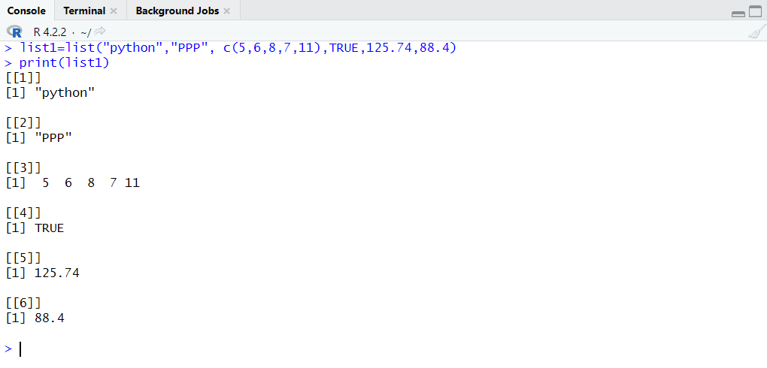

**OUTPUT/ENVIRONMENT:**

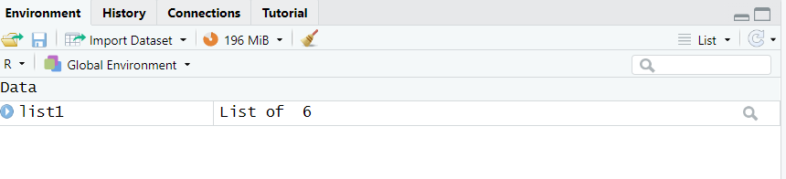

**COMMANDS:**

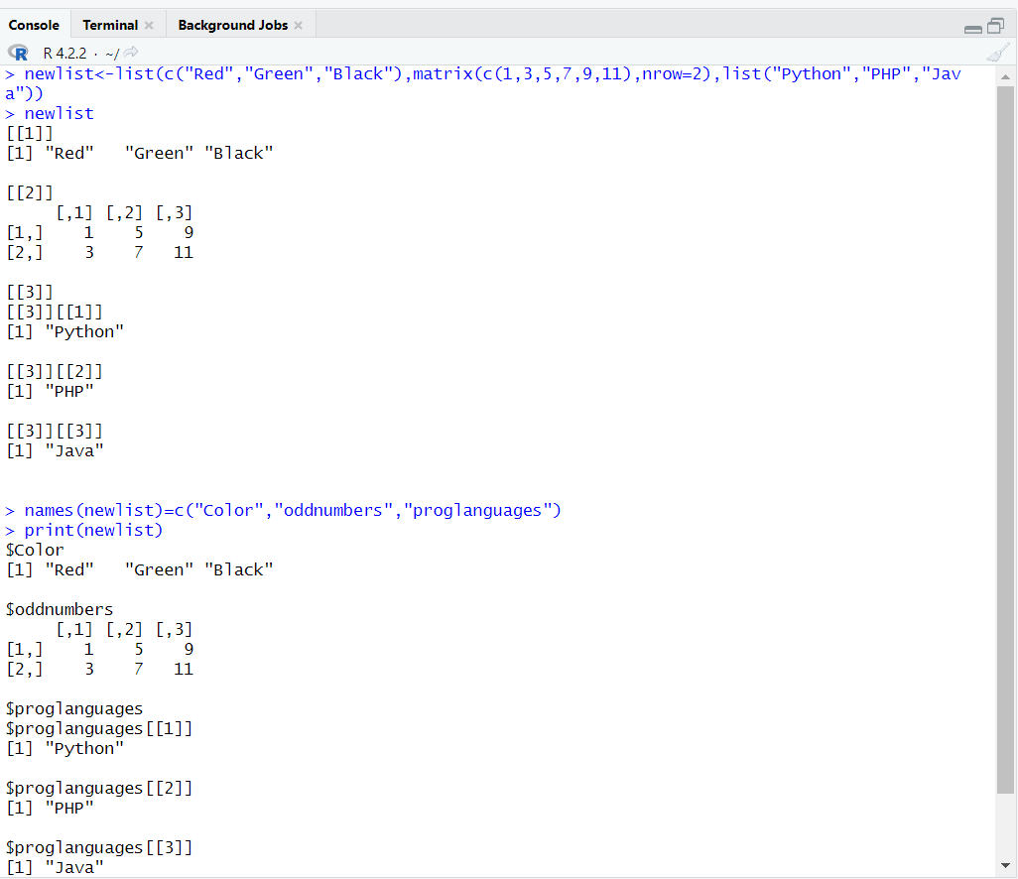

**OUTPUT/ENVIRONMENT:**

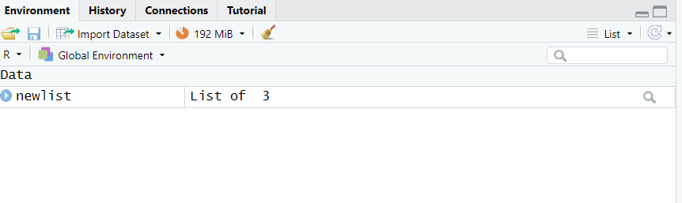

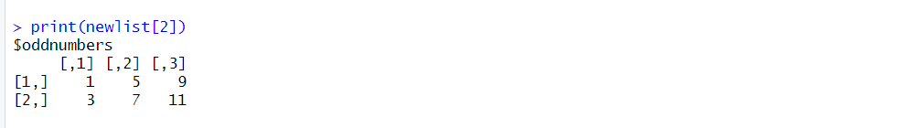

**DATA FRAMES:**

**COMMANDS:**

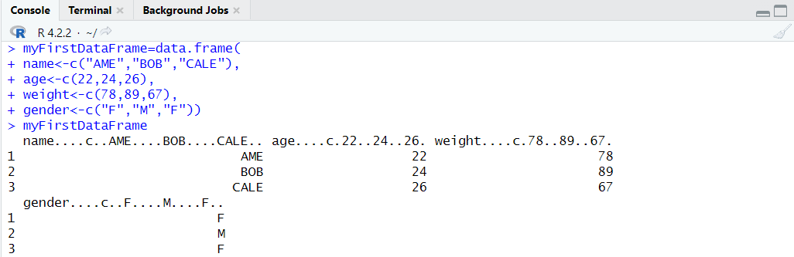

**OUTPUTS/ENVIRONMENT:**

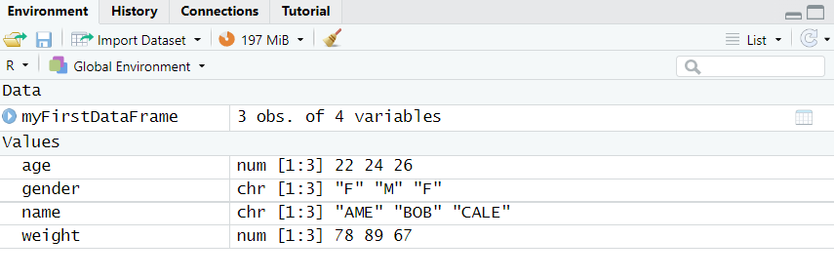

**COMMANDS :**

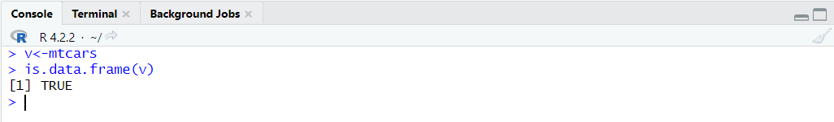

**OUTPUT/ENVIRONMENTS:**

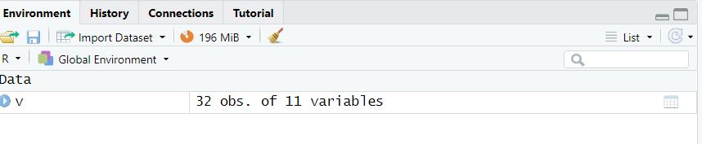

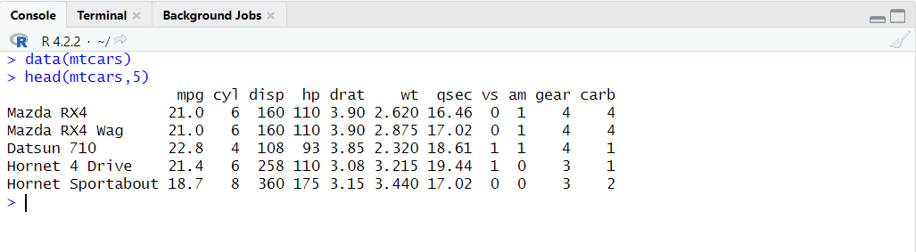

**OUTPUT/ENVIRONMENT:**

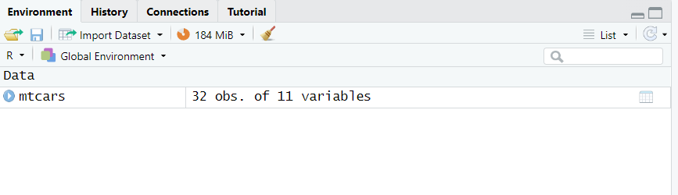

**COMMANDS/ OUTPUT:** 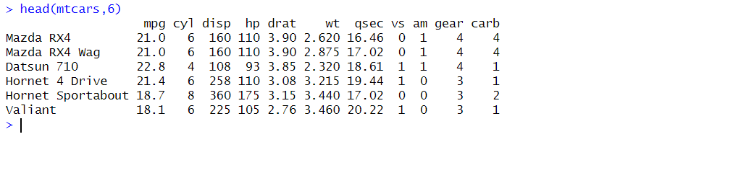

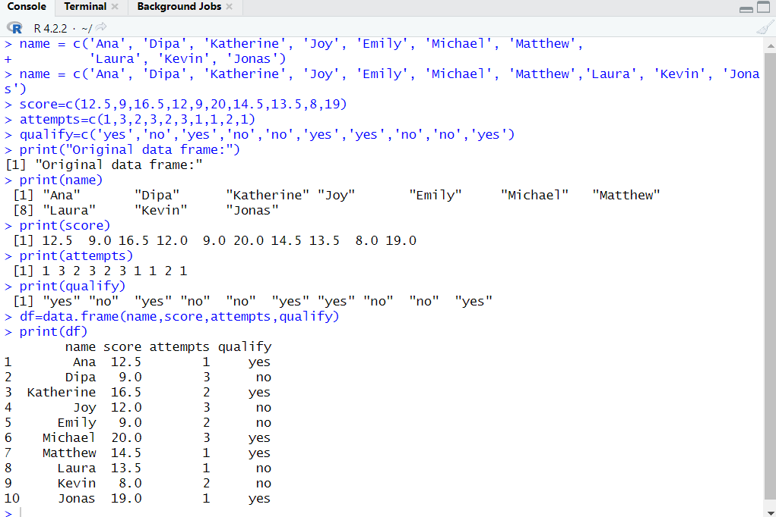

**OUTPUT/ENVIRONMENT:**

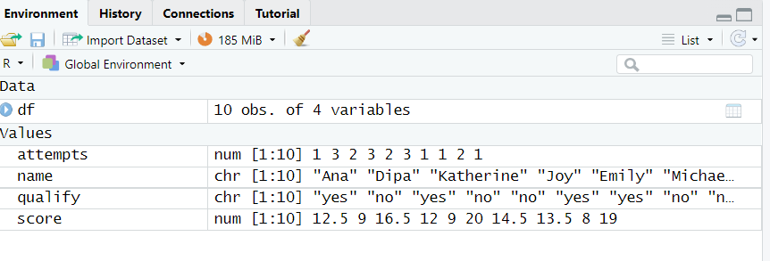

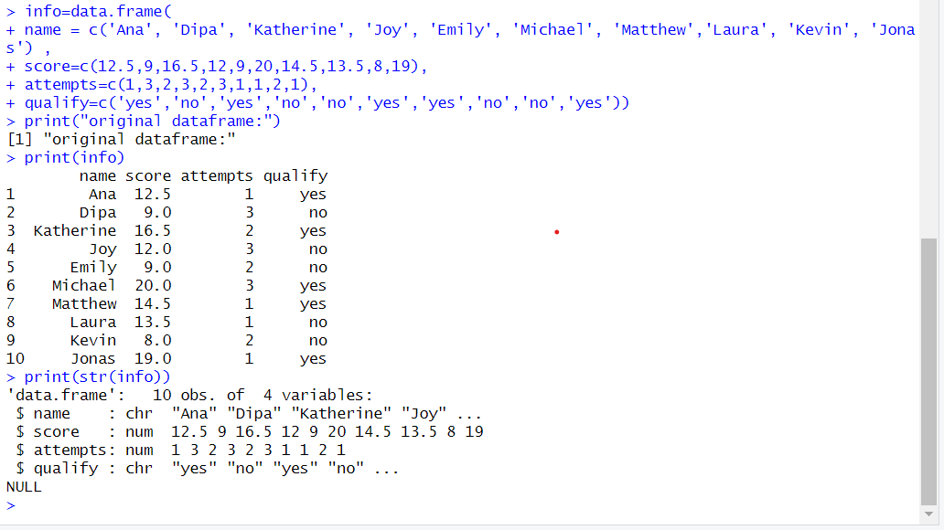

**OUTPUT/ENVIRONMENT:**

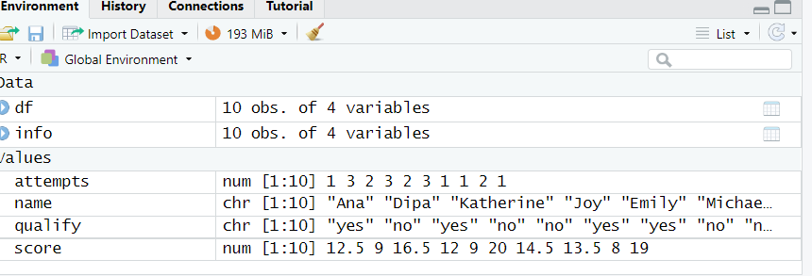

**COMMANDS and OUTPUT:**

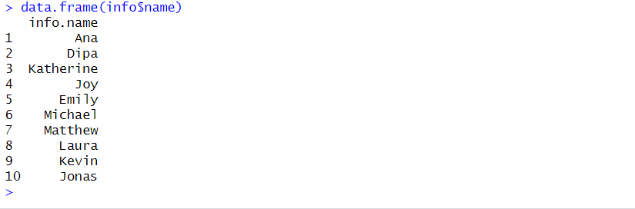

**COMMANDS:**

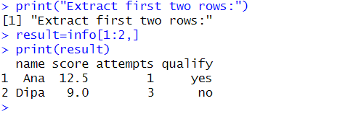

**OUTPUT/ENVIRONMENT:**

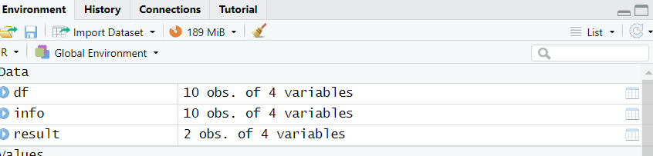

**COMMAND and OUTPUT:**

