Name: Hemanshu Anil Waghmare

Photo:

Email: : hemanshu.waghmare@gmail.com
Enrollment Number: 21071350
Contact Number: 9284133409
Semester: VIII
Section: A
Group Id: 28
Guide: Prof. Chanchla Tripathi
Project Title: Speak2Summarise: Daily Task Recap
Abstract:
The hardware-software integrated system called Speak2Summarise combines speech-to-text (STT) and text summarization. It captures spoken words and generates context-aware summaries with relatively high accuracy. Recall and content retention pertaining to memory transcription pose significant challenges. This is of particular importance to people suffering from memory-related disorders. The invention includes a hardware component consisting of a MAX9814 microphone for speech capturing, Arduino Nano (ATmega328P) for processing audio signals and saving the .wav file in sdcard, a DS1302 Real Time Clock (RTC) for time stamping the time of audio capture start time, and an SD card module for retaining the recorded audio. The provided power management subsystem operates successfully for portable and embedded applications. The system incorporates advanced features like WhisperX for ASR which ensure high accuracy speech to text conversion over the cloud. The system provides adaptations for English and extends its reach beyond assistive technologies and virtual assistance, such as business transcriptions and education. Abstract summarization methods using BERT are used to attain relevant summaries which are devoid of redundancy and provide clarity.

Keywords — Speech-to-Text, WhisperX, Noise Reduction, Audio Segmentation, Diarization, Text Summarization

Certificate of Publication/Competition:
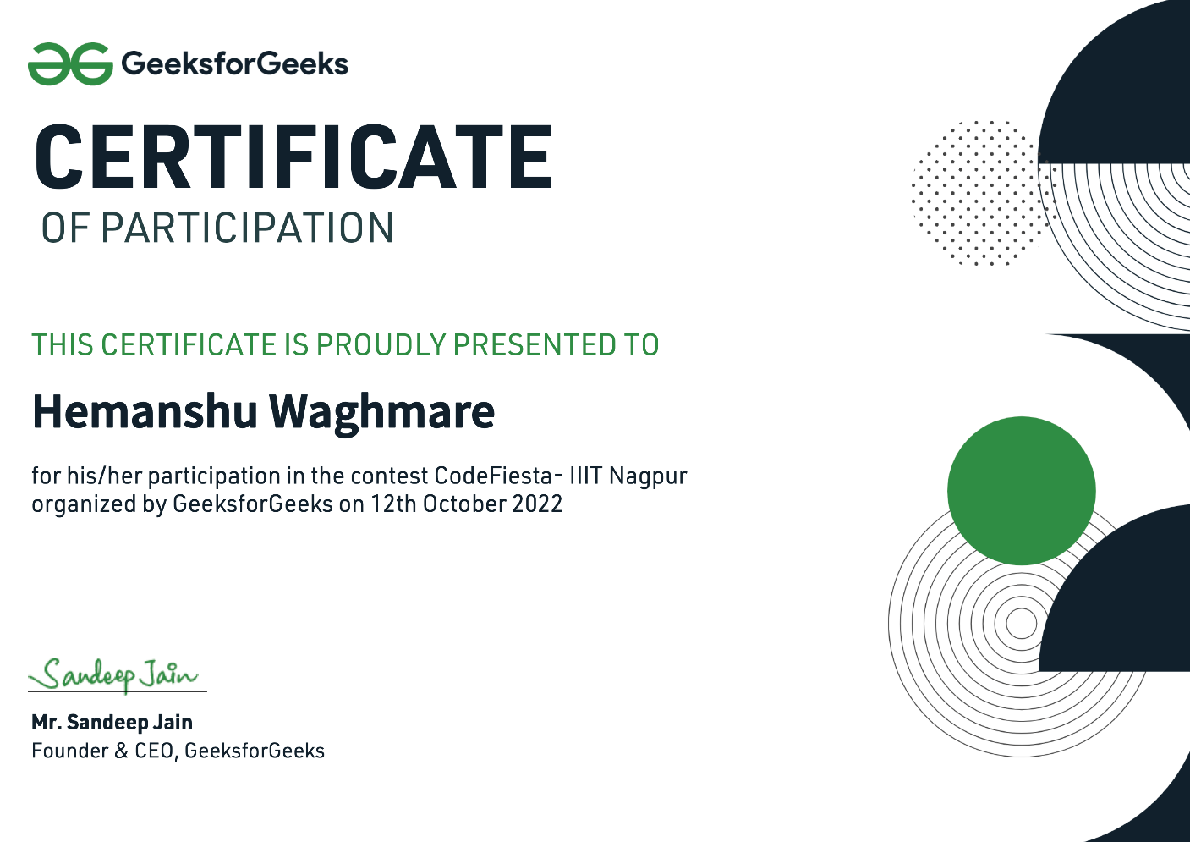

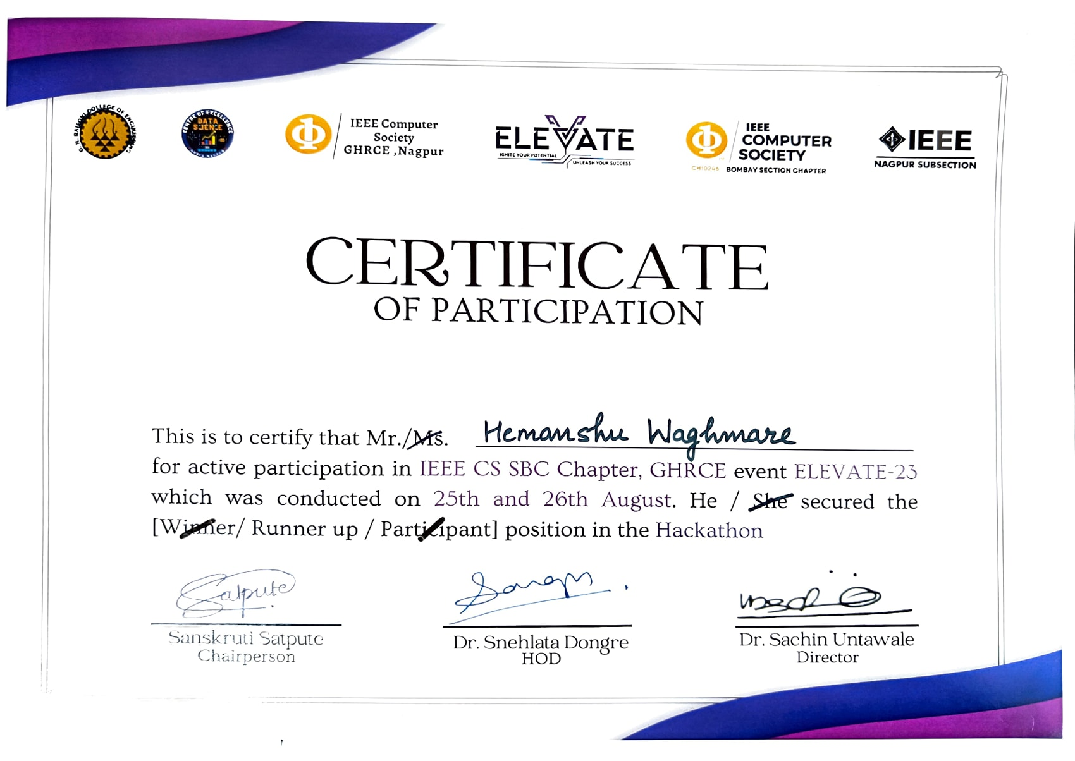
Name: Dhruv Rajiv Dalvi
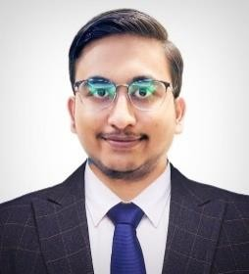
Photo:

Email: dhruvdalvi786@gmail.com
Enrollment Number: 21070282
Contact Number: 7378749332
Semester: VIII
Section: A
Group Id: 28
Guide: Prof. Chanchla Tripathi
Project Title: Speak2Summarise: Daily Task Recap
Abstract:
The hardware-software integrated system called Speak2Summarise combines speech-to-text (STT) and text summarization. It captures spoken words and generates context-aware summaries with relatively high accuracy. Recall and content retention pertaining to memory transcription pose significant challenges. This is of particular importance to people suffering from memory-related disorders. The invention includes a hardware component consisting of a MAX9814 microphone for speech capturing, Arduino Nano (ATmega328P) for processing audio signals and saving the .wav file in sdcard, a DS1302 Real Time Clock (RTC) for time stamping the time of audio capture start time, and an SD card module for retaining the recorded audio. The provided power management subsystem operates successfully for portable and embedded applications. The system incorporates advanced features like WhisperX for ASR which ensure high accuracy speech to text conversion over the cloud. The system provides adaptations for English and extends its reach beyond assistive technologies and virtual assistance, such as business transcriptions and education. Abstract summarization methods using BERT are used to attain relevant summaries which are devoid of redundancy and provide clarity.

Keywords — Speech-to-Text, WhisperX, Noise Reduction, Audio Segmentation, Diarization, Text Summarization

Certificate of Publication/Competition:

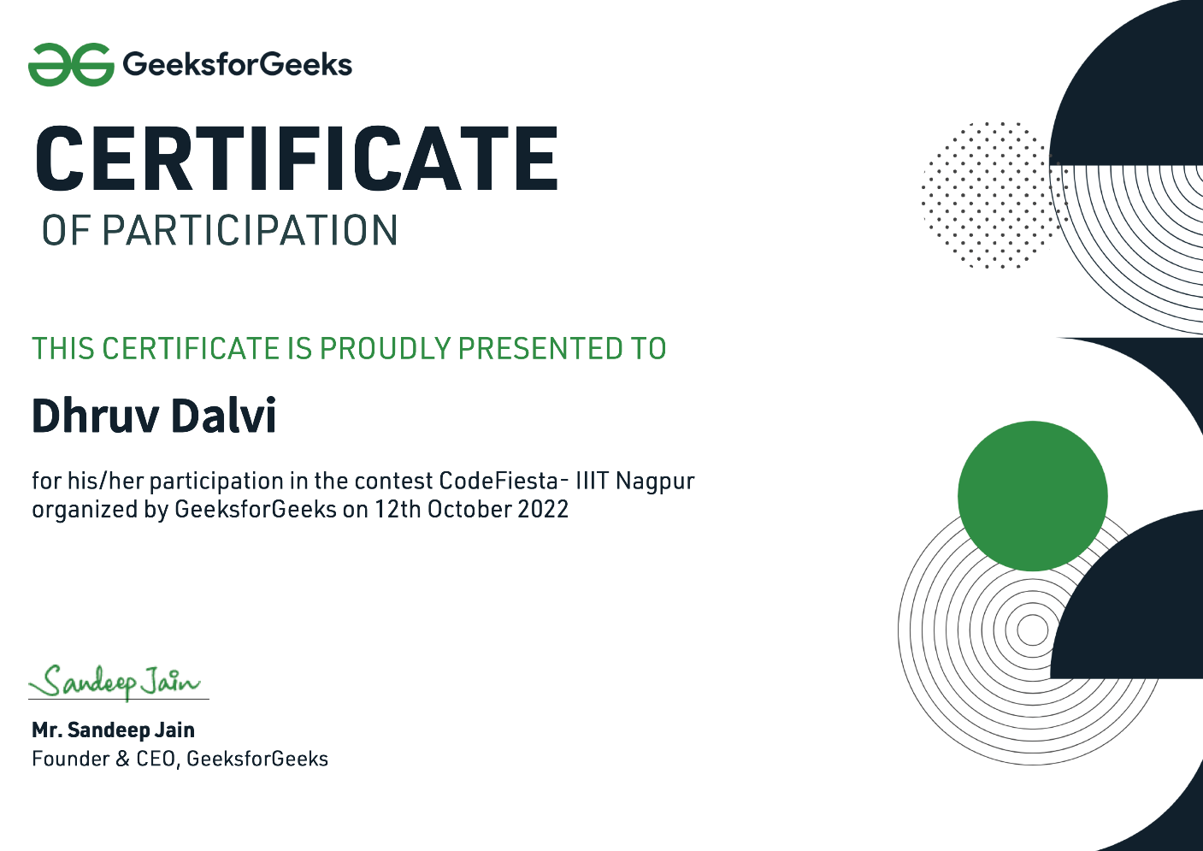

Name: Rishabh Devendra Jain
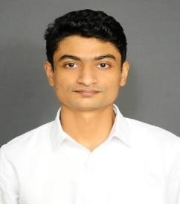
Photo:

Email: rishabhjain231102@gmail.com
Enrollment Number: 21070055
Contact Number: 9322192806
Semester: VIII
Section: A
Group Id: 28
Guide: Prof. Chanchla Tripathi
Project Title: Speak2Summarise: Daily Task Recap
Abstract:
The hardware-software integrated system called Speak2Summarise combines speech-to-text (STT) and text summarization. It captures spoken words and generates context-aware summaries with relatively high accuracy. Recall and content retention pertaining to memory transcription pose significant challenges. This is of particular importance to people suffering from memory-related disorders. The invention includes a hardware component consisting of a MAX9814 microphone for speech capturing, Arduino Nano (ATmega328P) for processing audio signals and saving the .wav file in sdcard, a DS1302 Real Time Clock (RTC) for time stamping the time of audio capture start time, and an SD card module for retaining the recorded audio. The provided power management subsystem operates successfully for portable and embedded applications. The system incorporates advanced features like WhisperX for ASR which ensure high accuracy speech to text conversion over the cloud. The system provides adaptations for English and extends its reach beyond assistive technologies and virtual assistance, such as business transcriptions and education. Abstract summarization methods using BERT are used to attain relevant summaries which are devoid of redundancy and provide clarity.

Keywords — Speech-to-Text, WhisperX, Noise Reduction, Audio Segmentation, Diarization, Text Summarization
Name: Sanket Sharad Asole
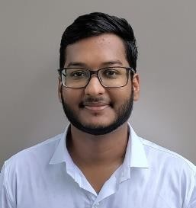
Photo:

Email: sanketasole786@gmail.com
Enrollment Number: 21070404
Contact Number: 7796004860
Semester: VIII
Section: A
Group Id: 28
Guide: Prof. Chanchla Tripathi
Project Title: Speak2Summarise: Daily Task Recap
Abstract:
The hardware-software integrated system called Speak2Summarise combines speech-to-text (STT) and text summarization. It captures spoken words and generates context-aware summaries with relatively high accuracy. Recall and content retention pertaining to memory transcription pose significant challenges. This is of particular importance to people suffering from memory-related disorders. The invention includes a hardware component consisting of a MAX9814 microphone for speech capturing, Arduino Nano (ATmega328P) for processing audio signals and saving the .wav file in sdcard, a DS1302 Real Time Clock (RTC) for time stamping the time of audio capture start time, and an SD card module for retaining the recorded audio. The provided power management subsystem operates successfully for portable and embedded applications. The system incorporates advanced features like WhisperX for ASR which ensure high accuracy speech to text conversion over the cloud. The system provides adaptations for English and extends its reach beyond assistive technologies and virtual assistance, such as business transcriptions and education. Abstract summarization methods using BERT are used to attain relevant summaries which are devoid of redundancy and provide clarity.

Keywords — Speech-to-Text, WhisperX, Noise Reduction, Audio Segmentation, Diarization, Text Summarization
Name: Yuvraj Rajesh Chavan
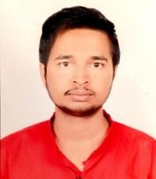
Photo:

Email: yuvichavan968@gmail.com
Enrollment Number: 21070338
Contact Number: 9309119399
Semester: VIII
Section: A
Group Id: 28
Guide: Prof. Chanchla Tripathi
Project Title: Speak2Summarise: Daily Task Recap
Abstract:
The hardware-software integrated system called Speak2Summarise combines speech-to-text (STT) and text summarization. It captures spoken words and generates context-aware summaries with relatively high accuracy. Recall and content retention pertaining to memory transcription pose significant challenges. This is of particular importance to people suffering from memory-related disorders. The invention includes a hardware component consisting of a MAX9814 microphone for speech capturing, Arduino Nano (ATmega328P) for processing audio signals and saving the .wav file in sdcard, a DS1302 Real Time Clock (RTC) for time stamping the time of audio capture start time, and an SD card module for retaining the recorded audio. The provided power management subsystem operates successfully for portable and embedded applications. The system incorporates advanced features like WhisperX for ASR which ensure high accuracy speech to text conversion over the cloud. The system provides adaptations for English and extends its reach beyond assistive technologies and virtual assistance, such as business transcriptions and education. Abstract summarization methods using BERT are used to attain relevant summaries which are devoid of redundancy and provide clarity.

Keywords — Speech-to-Text, WhisperX, Noise Reduction, Audio Segmentation, Diarization, Text Summarization

