Name-Rishabh Omar (25MCMC27)
Functionality of Wikipedia Database
Revision / Edit Flow
- Insert text content for a page.
insert into text(old_text)values('Fundamental of Physics');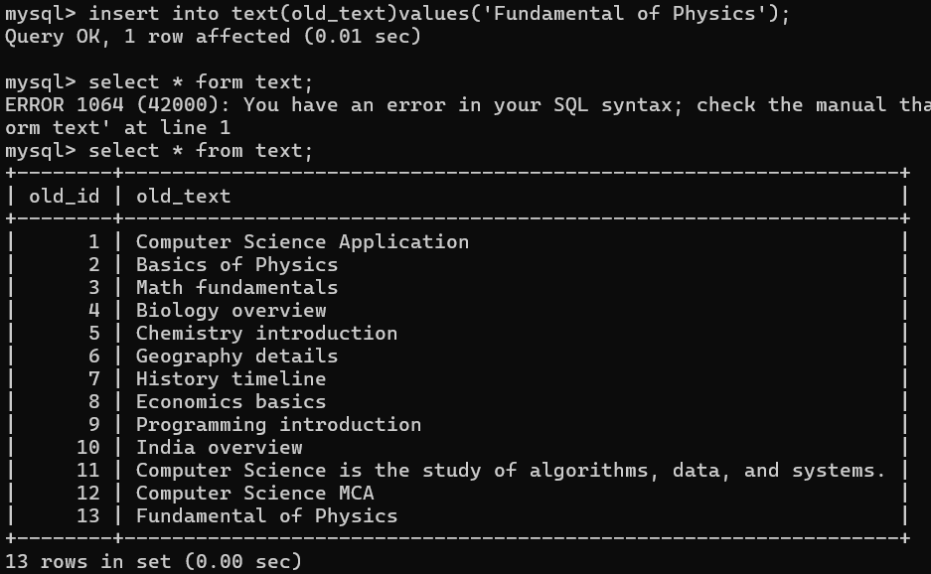
- Add a revision for a page.
INSERT INTO revision (page_id, text_id, user_id, description) VALUES (2, 13, 2, 'change the topic of physics');
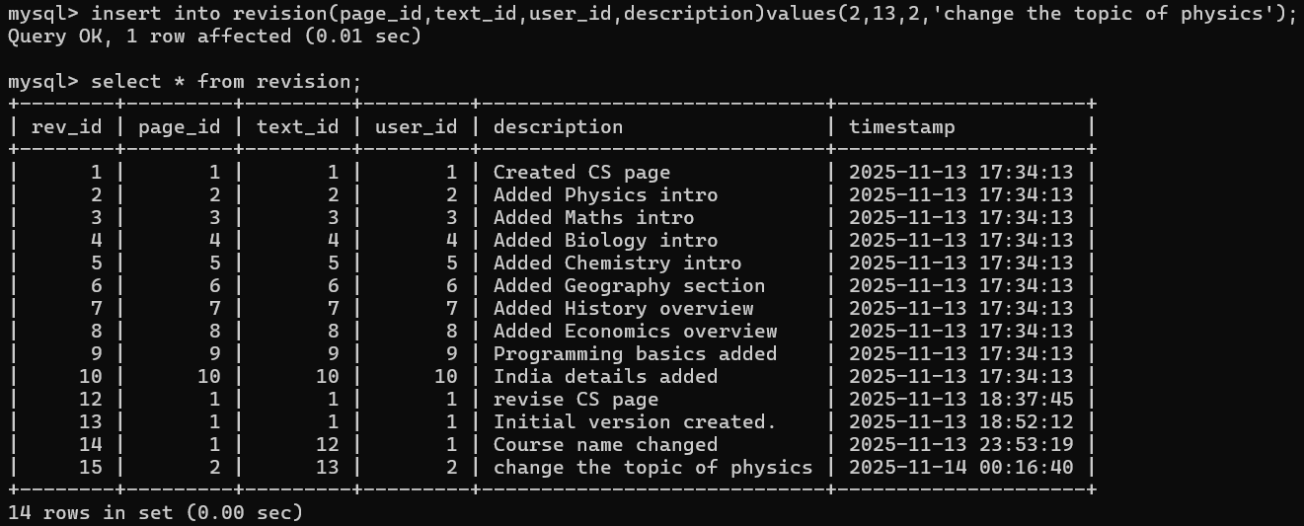
- Update the page’s latest revision.
UPDATE page SET page_latest_id = 15 WHERE page_id = 2;
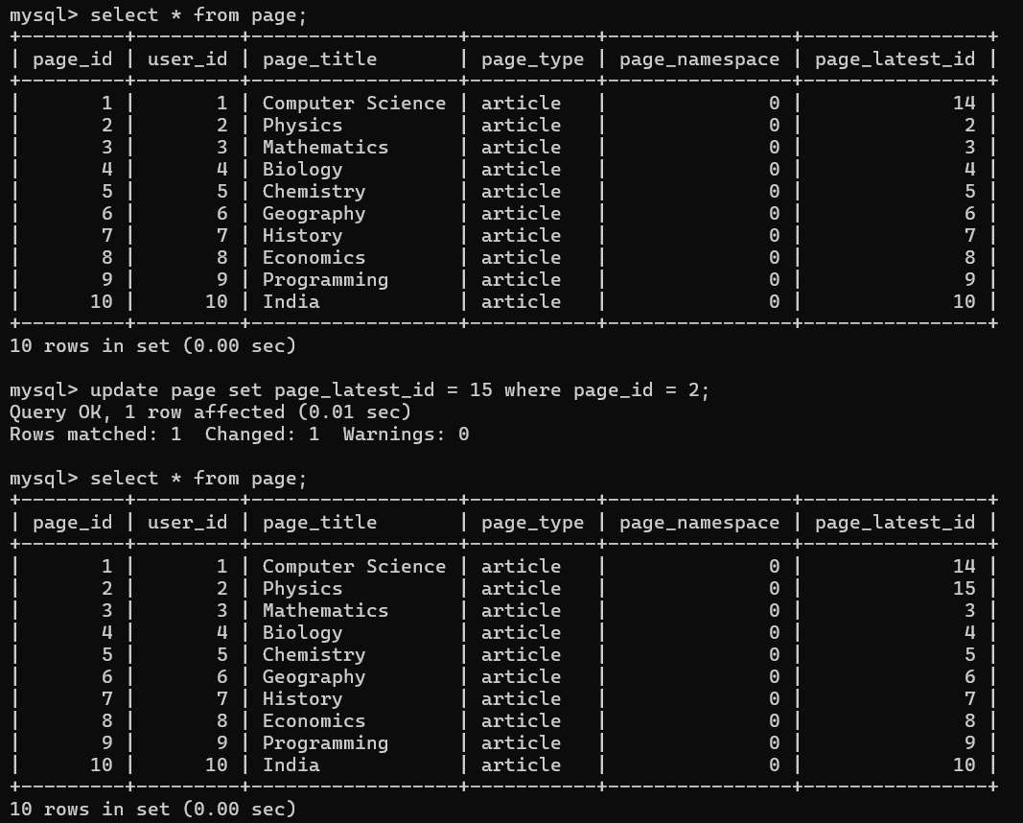

Result of Edit Work Flow
Before edit page content .
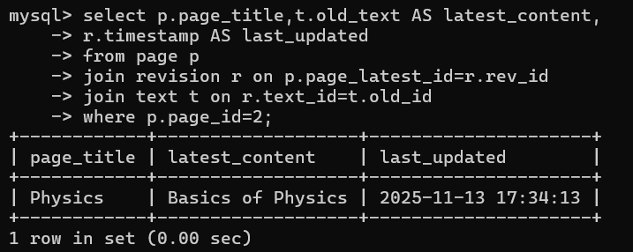

After update page content
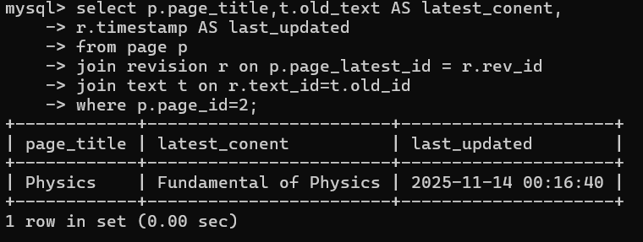

- View the revision history of a page.
SELECT r.rev_id, u.user_name, r.description, r.timestamp
FROM revision r
JOIN user u ON r.user_id = u.user_id
WHERE r.page_id = 1;
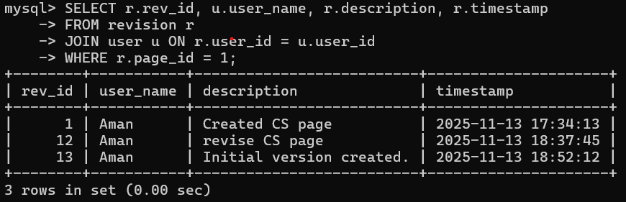
Page Restriction
1.View all restrictions on pages.
select p.page_title,pr.type_restrict,pr.level,pr.reason from page_restrictions pr join page p on pr.page_id = p.page_id;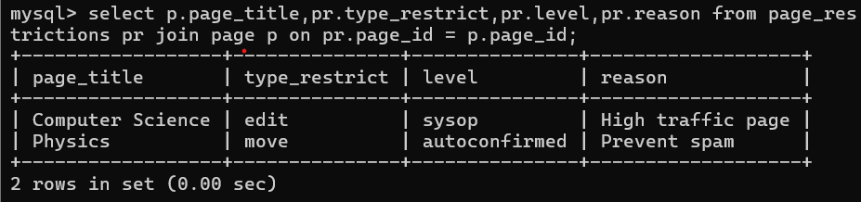

View All blocked users with admin details
SELECT b.block_id, u.user_name AS blocked_user, u.email AS blocked_user_email, a.user_name AS admin_name, a.email AS admin_email,b.reason, b.timestamp FROM block b JOIN user u ON b.user_id = u.user_id -- blocked user JOIN user a ON b.admin_id = a.user_id; -- admin details
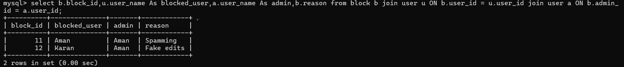
Display all pages and their categories.
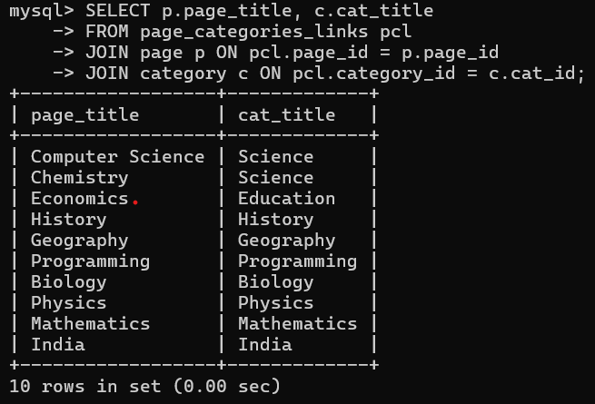
Show all internal links between pages.
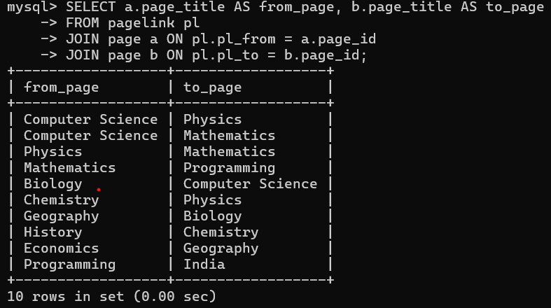
View users and their roles.
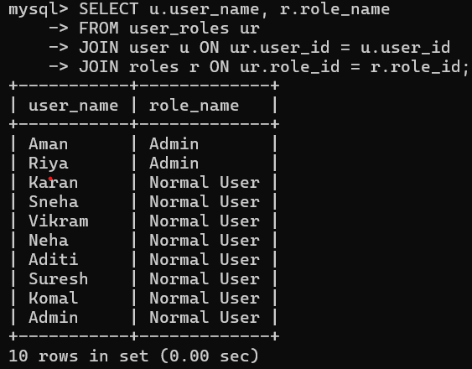
Talk Pages (Discussions)
SELECT l.log_id, u.user_name, l.log_type, l.log_action, l.log_description, l.log_timestamp FROM logging l JOIN user u ON l.log_user_id = u.user_id;
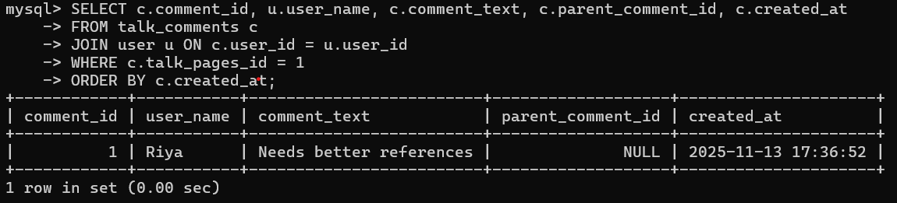
Log/Activity Tracking
select l.log_id,u.user_name,l.log_type,l.action,l.description,l.timestamp from log l join user u on l.user_id = u.user_id;
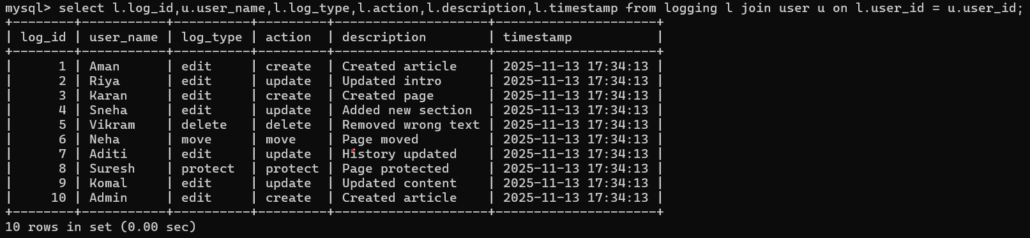

Combined Queries
Show pages with their latest revision text.
select p.page_title,t.old_text,r.timestamp from page p join revision r on p.page_latest_id = r.rev_id join text t on r.text_id = t.old_id;
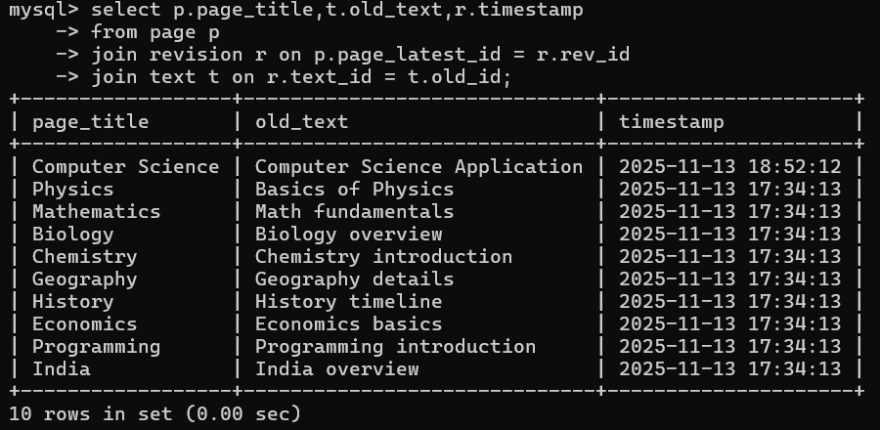
Show permissions for a specific user.
SELECT p.permission_name FROM user_roles ur JOIN role_permissions rp ON ur.role_id = rp.role_id JOIN permissions p ON rp.permission_id = p.permission_id WHERE ur.user_id = 1;
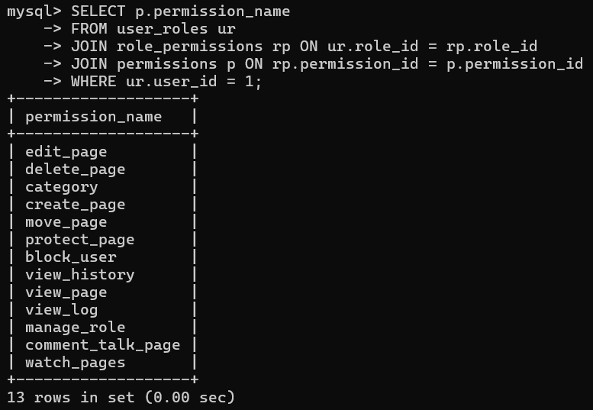
Show which admin blocked which user and why.
SELECT a.user_name AS admin, u.user_name AS blocked_user, b.reason, b.timestamp FROM block b JOIN user a ON b.admin_id = a.user_id JOIN user u ON b.user_id = u.user_id;
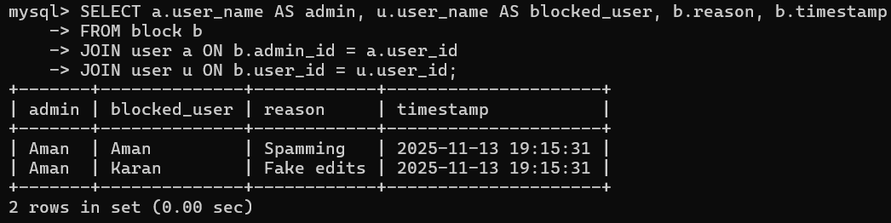
List all comments and their replies for each talk page.
SELECT tp.talk_id, u.user_name, c.comment_text, c.parent_comment_id FROM talk_comments c JOIN user u ON c.user_id = u.user_id JOIN talk_pages tp ON c.talk_pages_id = tp.talk_id ORDER BY tp.talk_id, c.parent_comment_id;
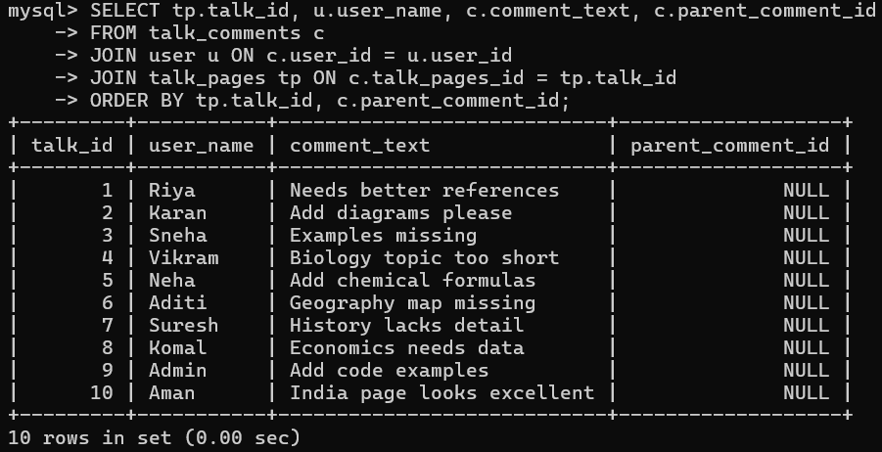
Search Functionality
Allow users to search for pages or users by keyword.
SELECT page_title FROM page WHERE page_title LIKE '%science%';
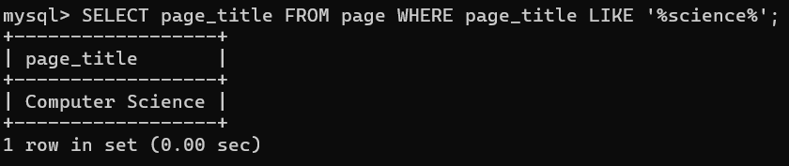

Admin Dashboard Statistics:
