guided by
Dr. satish narayana srirama

submitted by
rishabh omar (25mcmc27)
DBMS PROJECT
Blog Management System (Wikipedia database)
DDL Commands:
Create database Wikipedia:
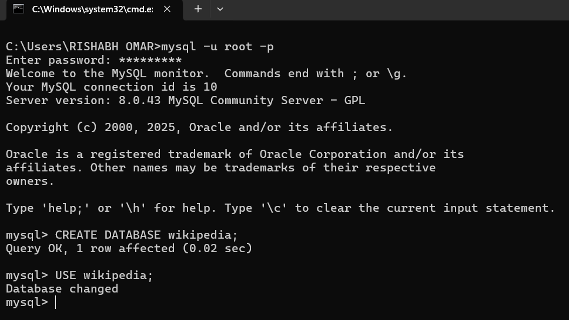

- CREATE TABLE user
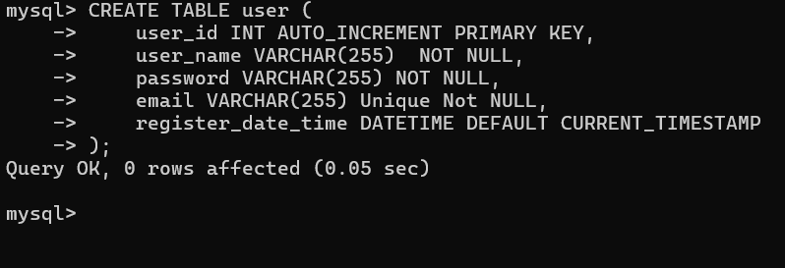

- CREATE TABLE page
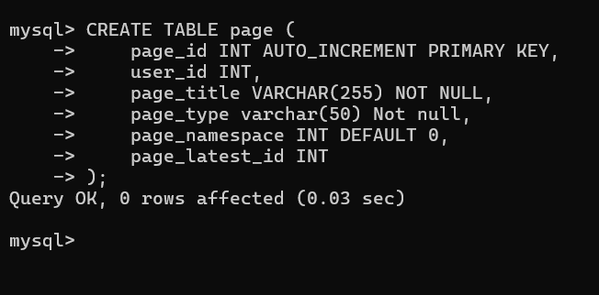
- CREATE TABLE page_restrictions
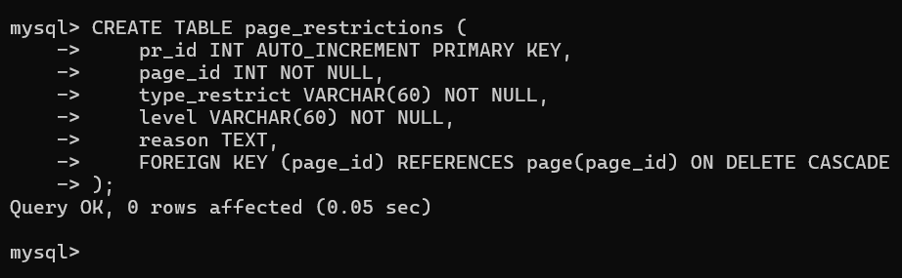
- CREATE TABLE block
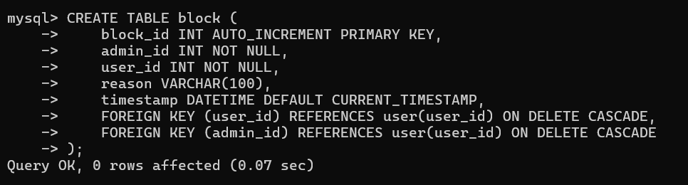

- CREATE TABLE text
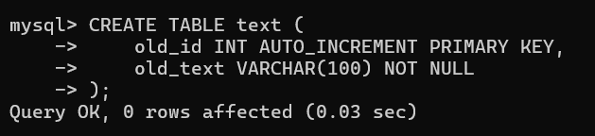
- CREATE TABLE revision
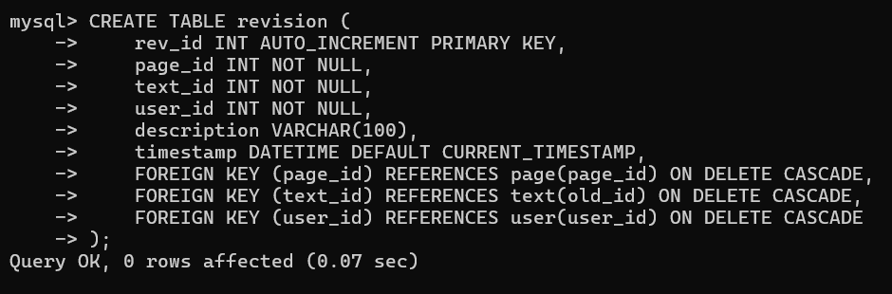
- CREATE TABLE log
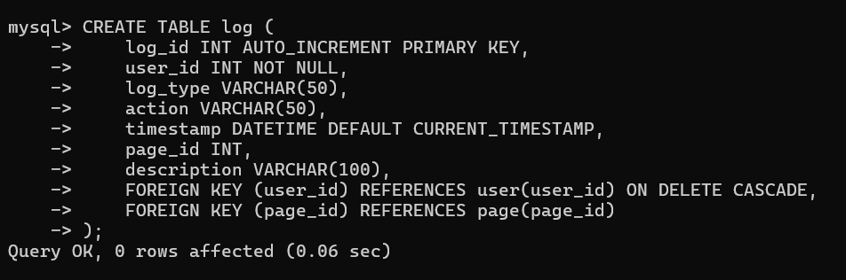

- CREATE TABLE watchlist
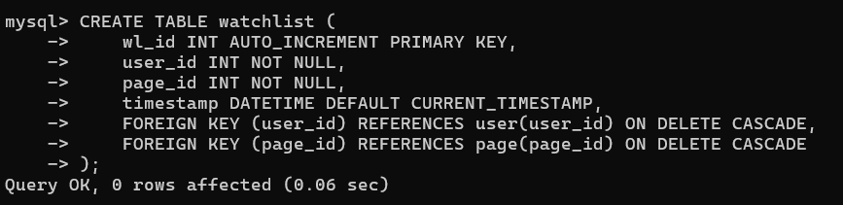
- CREATE TABLE category
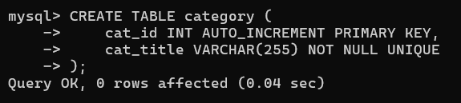
- CREATE TABLE page_categories_links
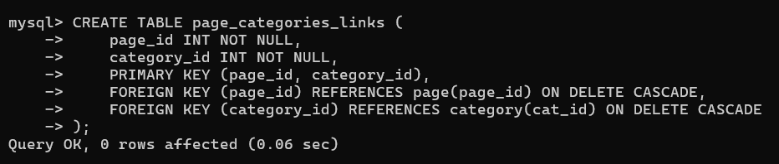
- CREATE TABLE pagelink
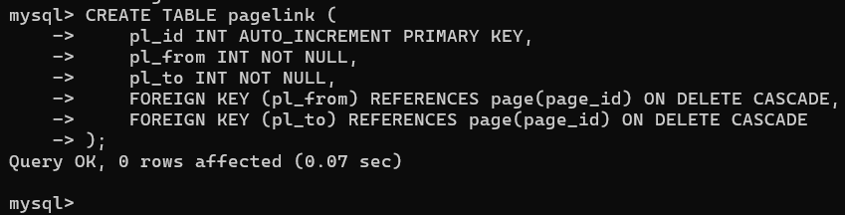

- CREATE TABLE roles
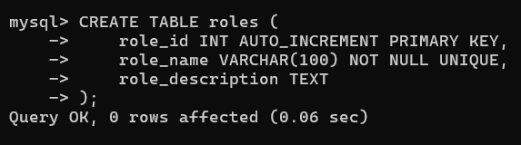

- CREATE TABLE user_roles
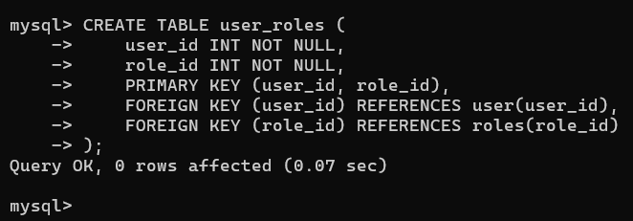
- CREATE TABLE permissions
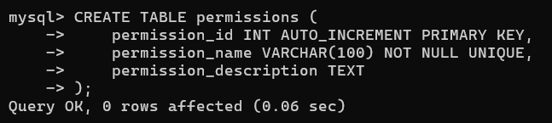

- CREATE TABLE role_permissions
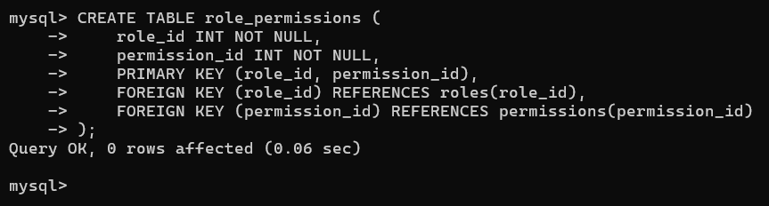
- CREATE TABLE talk_pages
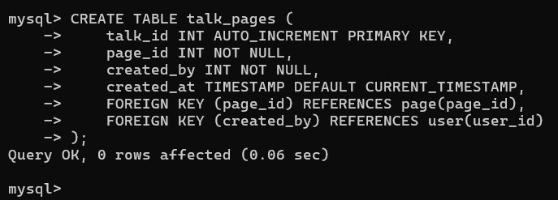
- CREATE TABLE talk_comments
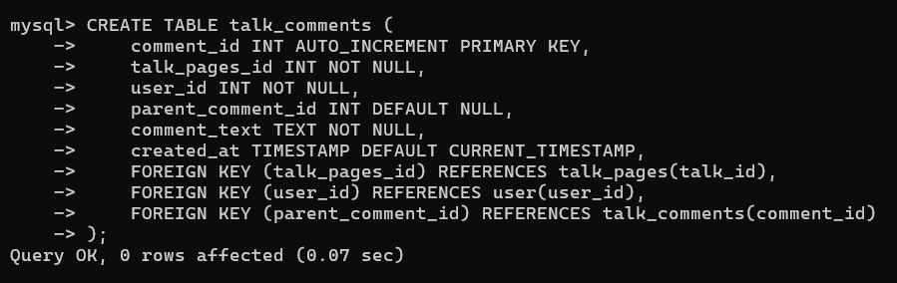

All Tables:
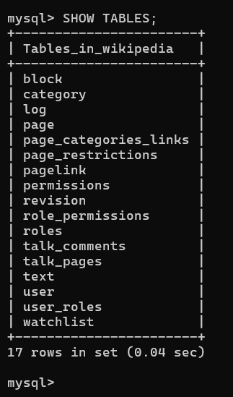

DML Commands:
- insert data in user table
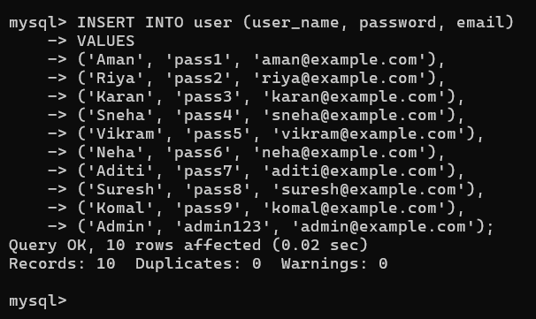
Output
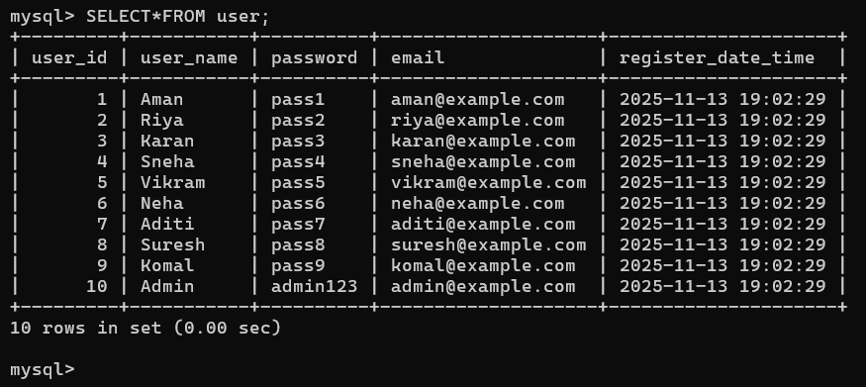

- Insert data in page table
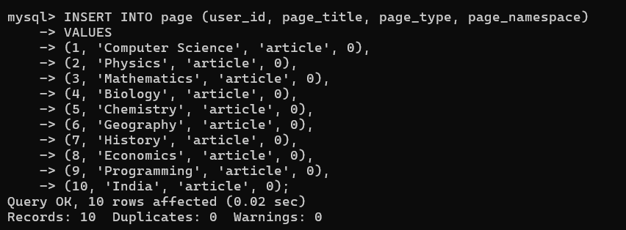
Output:
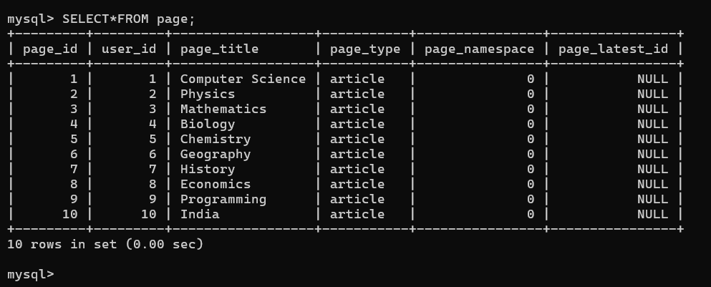

- Insert data in page_restrictions table
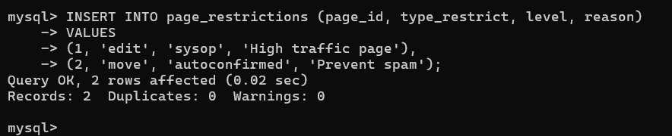

Output:
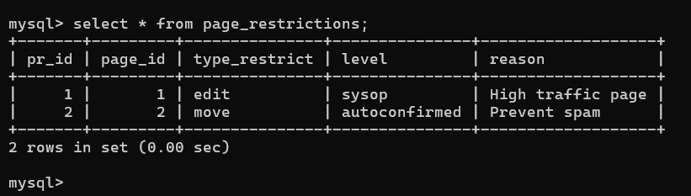

- Insert data in block table
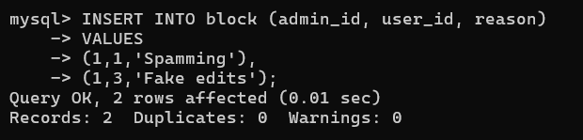

Output:
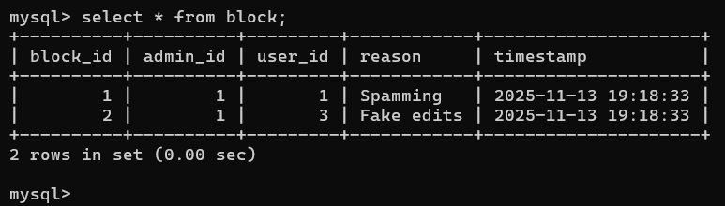

- Insert data in text table
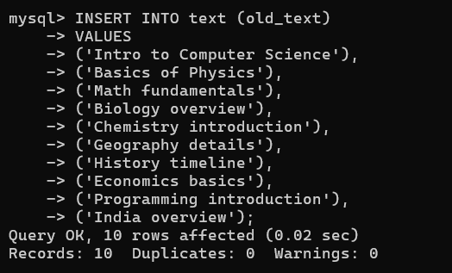

Output:
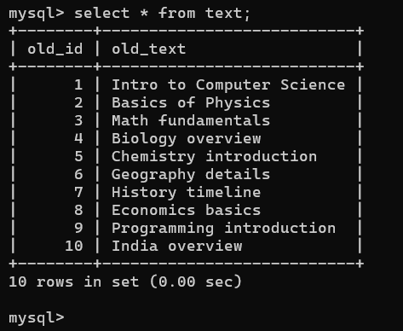

- Insert data in revision table
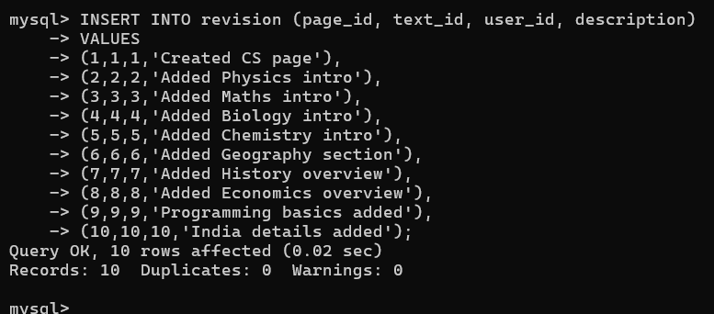

Output:
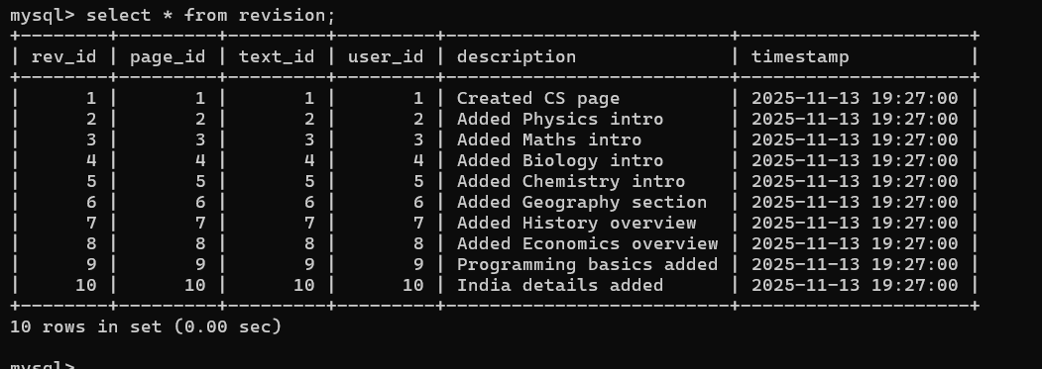

Update the latest page id when revision change
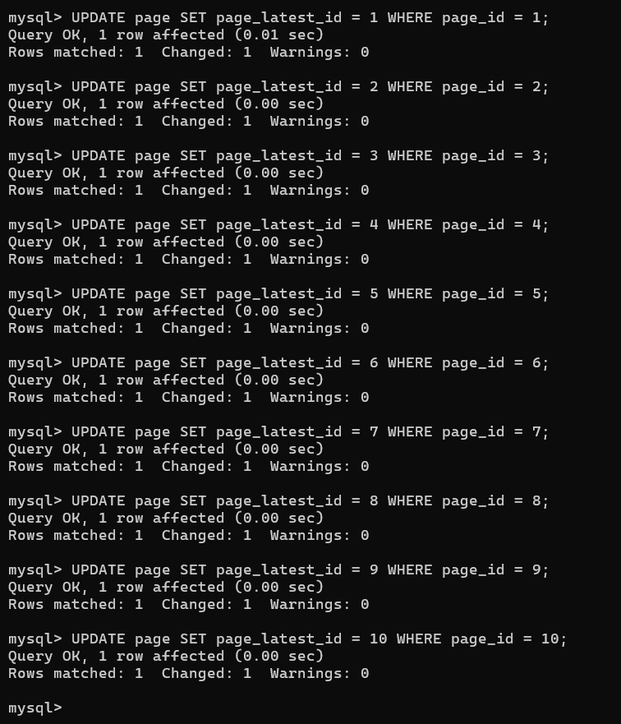

Updated page table Output:
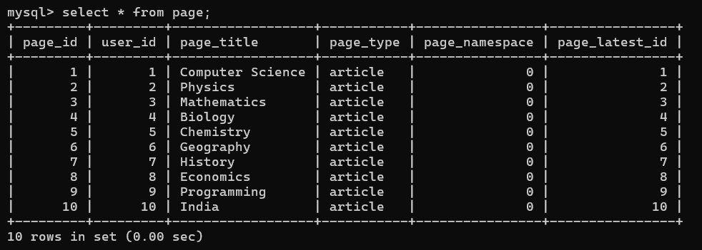

- Insert data in log table
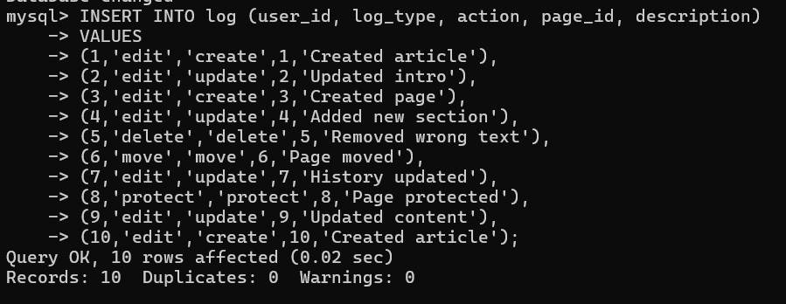

Output:
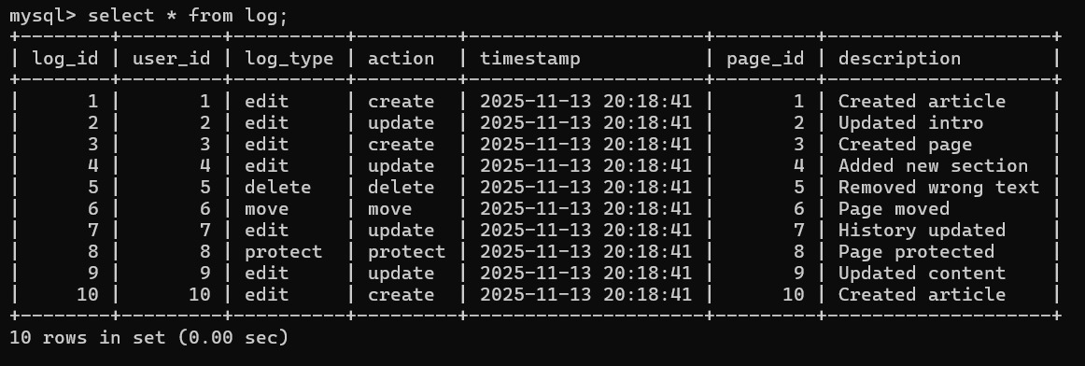
- Insert data in watchlist
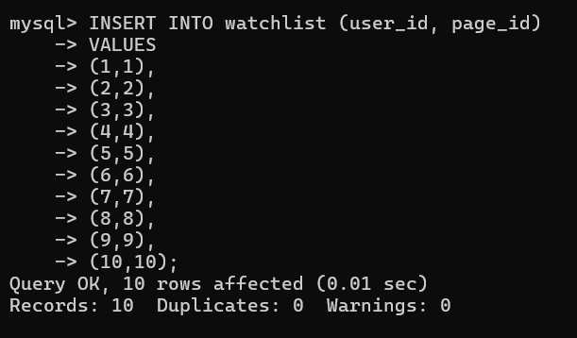

Output:
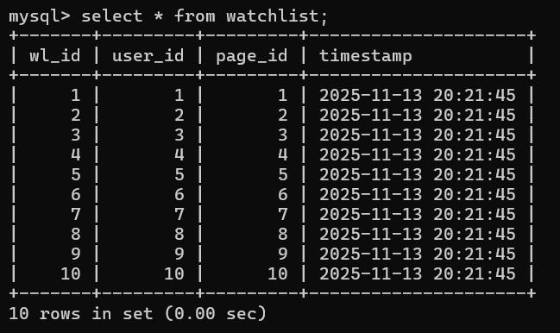

- Insert data in category table
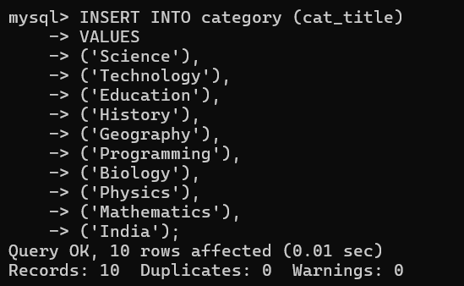

Output:
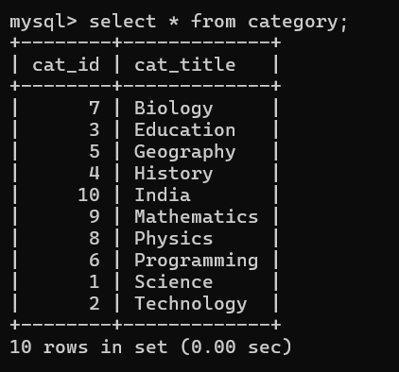

- Insert data in page_categories_links
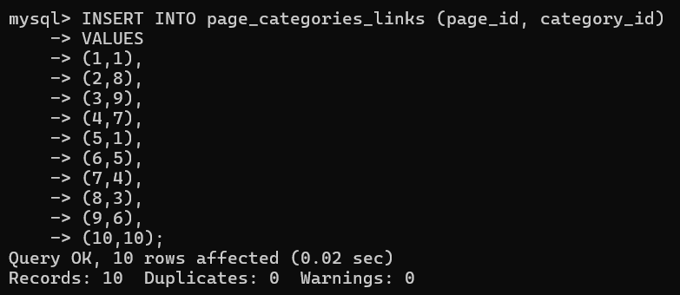

Output:
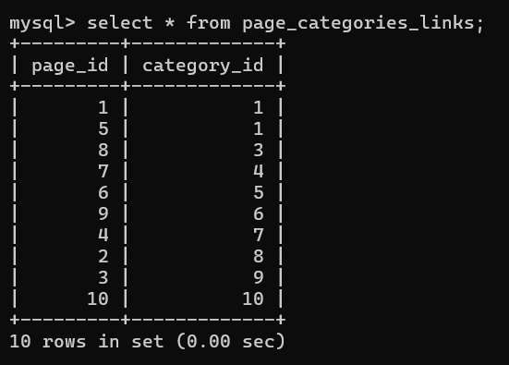

- Insert data in pagelink table
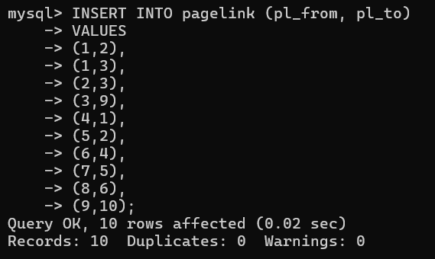

Output:
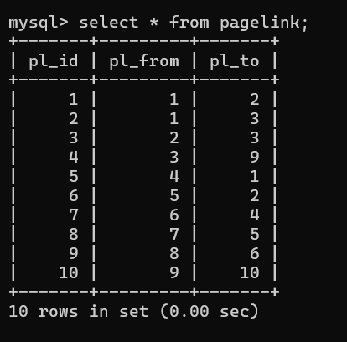

- Insert data in roles table
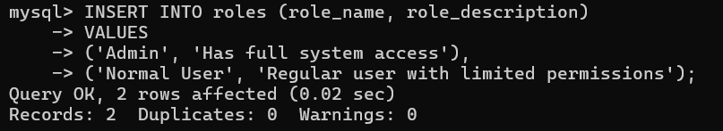

Output:
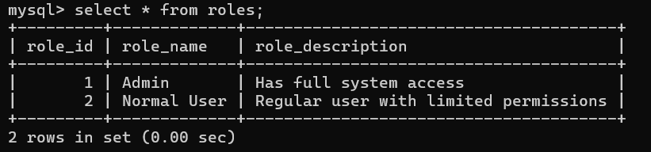

- Insert data in user_roles table
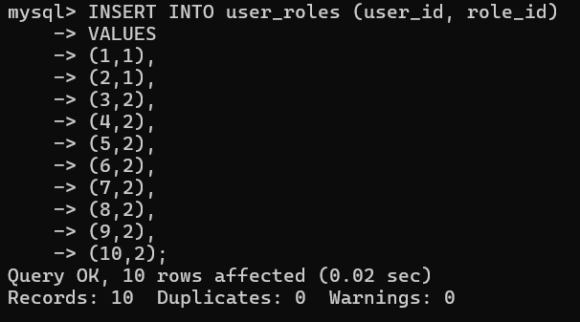

Output:
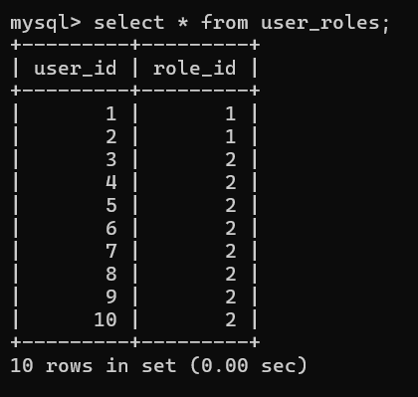

- Insert data in permission table
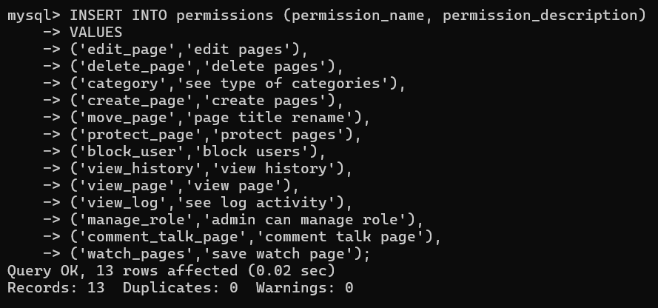
Output:
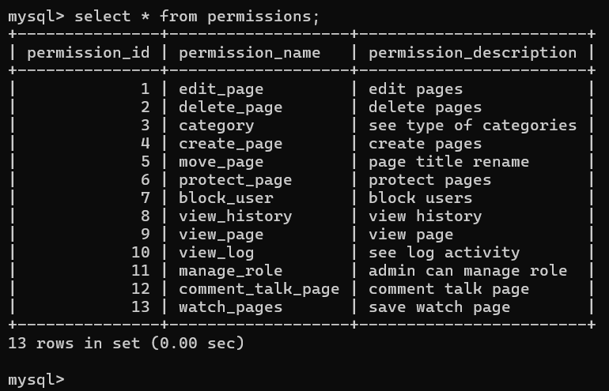

- Insert data in role_permission table
Assign permission to admin:
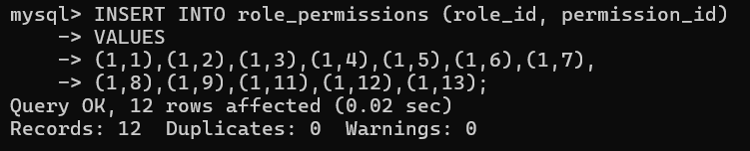

Assign permission to user:
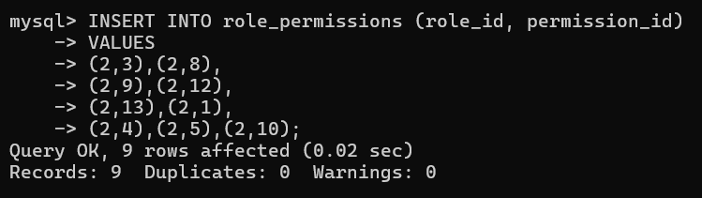

Output:
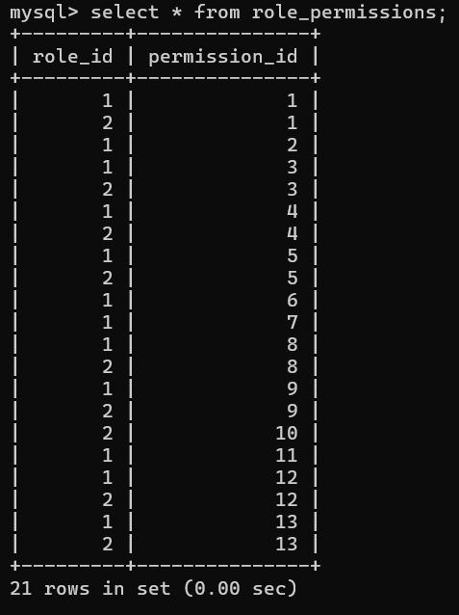

- Insert data in talk_pages
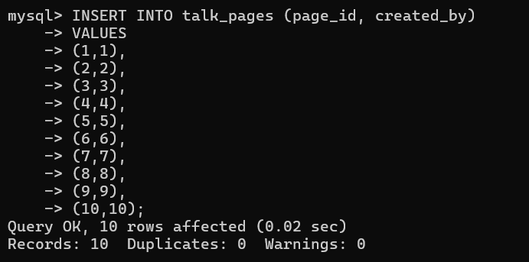

Output:
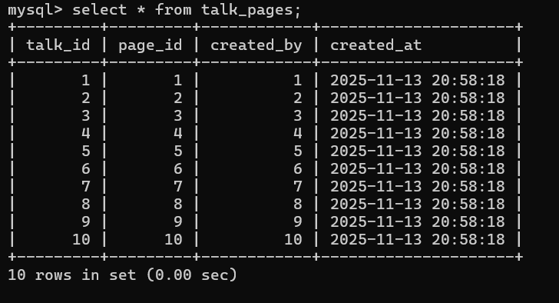

- Insert data in talk_comments
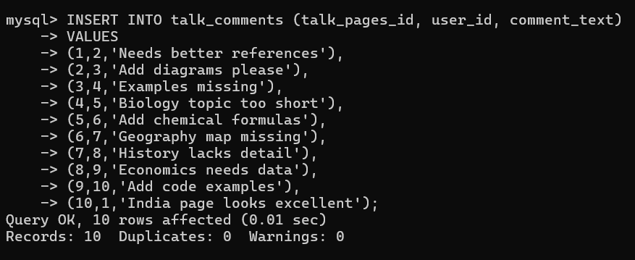

Output:
