**A Project Report**

**On**

**“ANALYSIS OF UBER TRIP DATA”**

Mentor: Ms. Akanksha Kaushik Submitted By:

(THE NORTHCAP UNIVERSITY) Rishabh Saini: 18csu172



**Department of CSE & IT**

**The NorthCap University**

**Gurugram**

**Problem Statement:** Analyse/Manage the Uber Trip Data using Data Visualisation.

The main reason for choosing this project was to establish, learn and identify the ways in which we can simplify and manage loads of data. For that we chose the topic “Uber Trip Data”.

As we all know in the world of growing technology needs of customer are increasing and so is the need for travelling in day to day life. All people cannot afford the cost of personal vehicles or the time required for public transport. Therefore Uber is a great option over taxis and public transport.

But as the facilities and requirements are increasing the amount of data and statistics is also increasing so there is a need to manage the data, plot graphs or in short use visualization to as to predict the possibilities and summarize lot of information in one picture.

**Problem Analysis:**

The problem is basically a lot of data and it is difficult for the users to have a look at all the data and choose the one which they require. To solve this we have used data visualization.

We have given various choices to the users e.g. month, weekday, hours according to which they can choose how they want their data to be displayed and accordingly various heatmaps and graphs are plotted which give a better understanding of the data.

We have also specified the earnings and number of trips of the employee to give a better scenario of the profit.

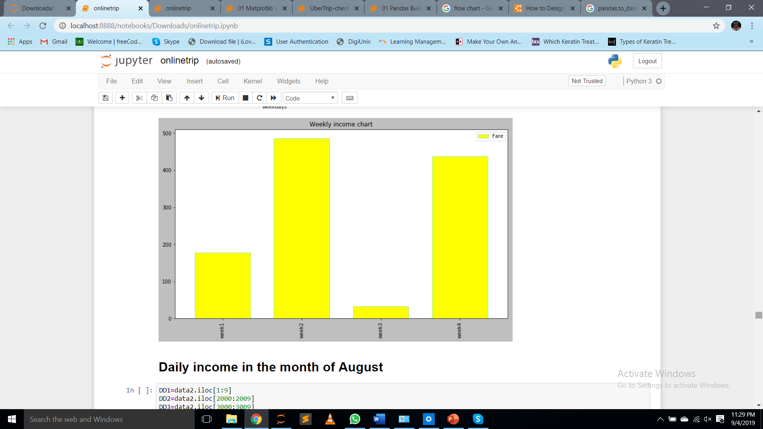

**Program Design:**

**Programming Requirements:**

1. Software Configuration:
2. Client Environment: Windows
3. Display: Intel(R) HD Graphics 520
4. Installations:
5. Anaconda Navigator
6. Numpy
7. Pandas
8. Matplotlib
9. Seaborn
10. Hardware Configuration:
11. Operating System: Microsoft Windows 10 Enterprise
12. Processor: Intel(R) Core(TM) i3-6006U CPU @ 2.00GHz, 2000 Mhz
13. System Model: HP Laptop 15-bs0xx
14. System Type: 64-bit Operating System, x64-based processor
15. Installed Memory(RAM): 4.00 GB

**Data Input/ Output Description:**

1. Data Input:
2. Data Name: Uber Trip Data
3. Year: 2014
4. Duration:
5. April
6. May
7. June
8. July
9. Source: GitHub
10. Storage: csv file
11. Contents of Data (Columns/Topics):
12. Date and Time
13. Latitude
14. Longitude
15. Base
16. Data Output:

Income of the employee shown according to

1. Month
2. Weekday
3. Hour

In the form of

1. Histogram
2. Bar graph
3. HeatMap
4. ScatterPlot

**Algorithm:**

**Implementation and Testing:**

**Output:**