EXPERIMENT - 6

AIM
To create a stored procedure transfer_employee(emp_id, new_dept_id) with validation and error handling, implement triggers for salary validation and audit logging, and test important edge cases.

OBJECTIVES
• To create a stored procedure for transferring an employee between departments.
• To validate employee and department identifiers before performing a transfer.
• To use transaction control and error handling inside a stored procedure.
• To validate salary values using a trigger before INSERT or UPDATE.
• To maintain an audit log whenever an employee salary is changed.
• To test successful and invalid transfer and salary-update cases.

DATABASE USED
The queries use the CompanyDB database and the Employee–Department–Project schema. Department names and employee names have been changed from the reference data; IDs remain unchanged so the existing relationships continue to work.
USE CompanyDB;

SOURCE CODE / SQL QUERIES
1. SALARY AUDIT TABLE
Create an audit table to store old and new salary values whenever an employee salary changes.
CREATE TABLE IF NOT EXISTS Employee_Salary_Audit (
audit_id INT AUTO_INCREMENT PRIMARY KEY,
emp_id INT NOT NULL,
old_salary DECIMAL(10,2),
new_salary DECIMAL(10,2),
changed_at TIMESTAMP DEFAULT CURRENT_TIMESTAMP,
action VARCHAR(30)
);

2. SALARY VALIDATION TRIGGER
Reject salary values outside the allowed range of 30,000 to 1,50,000.
DELIMITER //
CREATE TRIGGER validate_employee_salary
BEFORE INSERT ON Employee
FOR EACH ROW
BEGIN
IF NEW.salary < 30000 OR NEW.salary > 150000 THEN
SIGNAL SQLSTATE '45000'
SET MESSAGE_TEXT = 'Salary must be between 30000 and 150000';
END IF;
END//
DELIMITER ;

3. SALARY UPDATE VALIDATION TRIGGER
Validate salary changes before an existing Employee row is updated.
UPDATE Employee
SET salary = 20000
WHERE emp_id = 6;

Valid Update:

UPDATE Employee
SET salary = 85000
WHERE emp_id = 6;

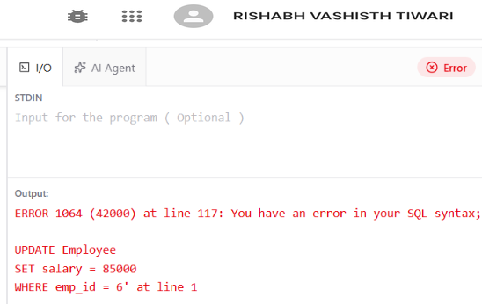

4. SALARY AUDIT TRIGGER
Store the old and new salary values after a successful salary update.
Trigger code:
DELIMITER //
CREATE TRIGGER audit_salary_update
AFTER UPDATE ON Employee
FOR EACH ROW
BEGIN
IF OLD.salary <> NEW.salary THEN
INSERT INTO Employee_Salary_Audit
(emp_id, old_salary, new_salary, action)
VALUES
(NEW.emp_id, OLD.salary, NEW.salary, 'SALARY UPDATE');
END IF;
END//
DELIMITER ;

CODE To Check Trigger:
DELIMITER //
-- Test salary update
UPDATE Employee
SET salary = 51000
WHERE emp_id = 31;

-- Display salary audit record
SELECT audit_id, emp_id, old_salary, new_salary,
changed_at, action
FROM Employee_Salary_Audit
ORDER BY audit_id;
DELIMITER ;
Output
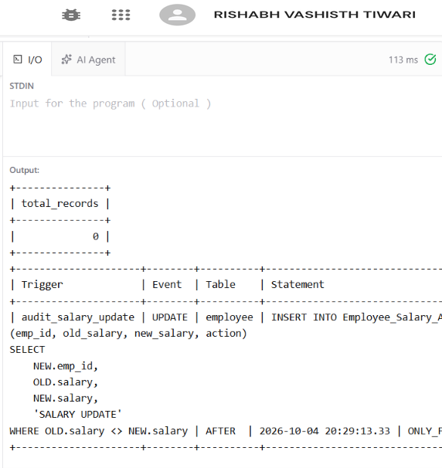

5. STORED PROCEDURE – TRANSFER EMPLOYEE
Transfer an employee to a new department after validating both IDs. The transaction is rolled back if an SQL exception occurs.
DELIMITER //
CREATE PROCEDURE transfer_employee(
IN p_emp_id INT,
IN p_new_dept_id INT
)
BEGIN
DECLARE v_emp_count INT DEFAULT 0;
DECLARE v_dept_count INT DEFAULT 0;
DECLARE v_old_dept_id INT;

DECLARE EXIT HANDLER FOR SQLEXCEPTION
BEGIN
ROLLBACK;
RESIGNAL;
END;

START TRANSACTION;

SELECT COUNT(*) INTO v_emp_count
FROM Employee
WHERE emp_id = p_emp_id;

IF v_emp_count = 0 THEN
SIGNAL SQLSTATE '45000'
SET MESSAGE_TEXT = 'Employee does not exist';
END IF;

SELECT COUNT(*) INTO v_dept_count
FROM Department
WHERE dept_id = p_new_dept_id;

IF v_dept_count = 0 THEN
SIGNAL SQLSTATE '45000'
SET MESSAGE_TEXT = 'Department does not exist';
END IF;

SELECT dept_id INTO v_old_dept_id
FROM Employee
WHERE emp_id = p_emp_id;

IF v_old_dept_id = p_new_dept_id THEN
SIGNAL SQLSTATE '45000'
SET MESSAGE_TEXT = 'Employee is already in this department';
END IF;

UPDATE Employee
SET dept_id = p_new_dept_id
WHERE emp_id = p_emp_id;

COMMIT;
END//
DELIMITER ;

6. TEST SUCCESSFUL TRANSFER
Transfer employee 6 from Development to Sales.
CALL transfer_employee(6, 4);

SELECT e.emp_id, e.emp_name,
d.dept_name
FROM Employee e
JOIN Department d ON e.dept_id = d.dept_id
WHERE e.emp_id = 6;
Output
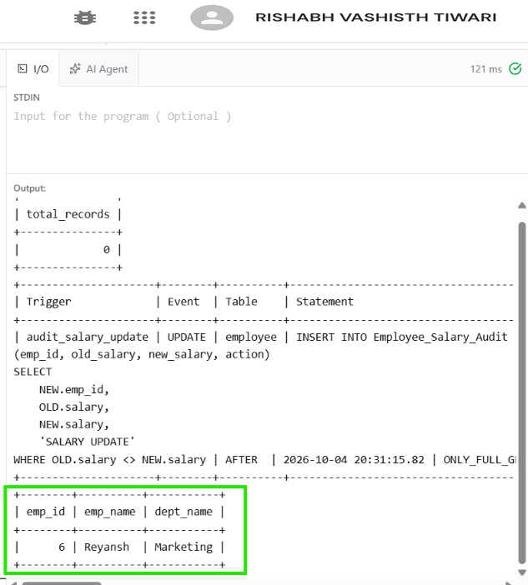
The procedure validates the employee and department, updates the department and commits the transaction.
7. TEST EDGE CASES
-- Invalid employee
CALL transfer_employee(99, 4);

-- Invalid department
CALL transfer_employee(6, 99);

-- Same department
CALL transfer_employee(6, 4);

Output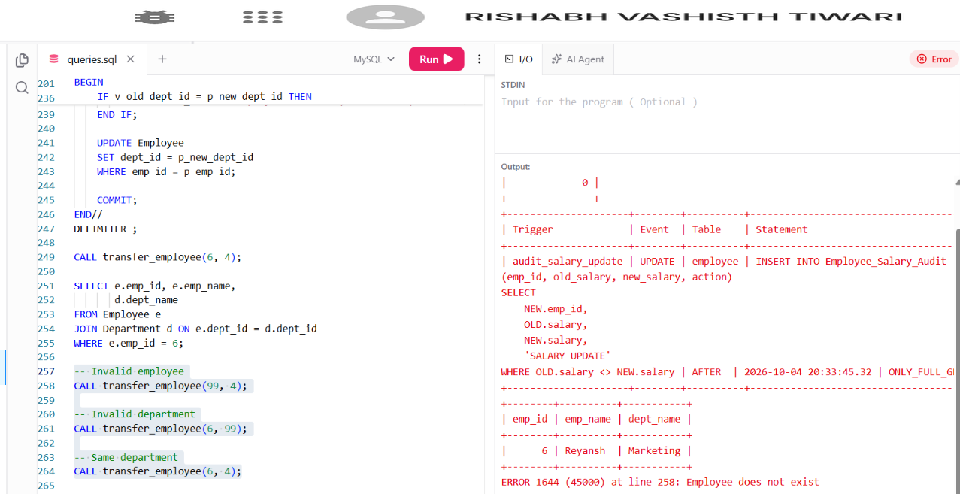
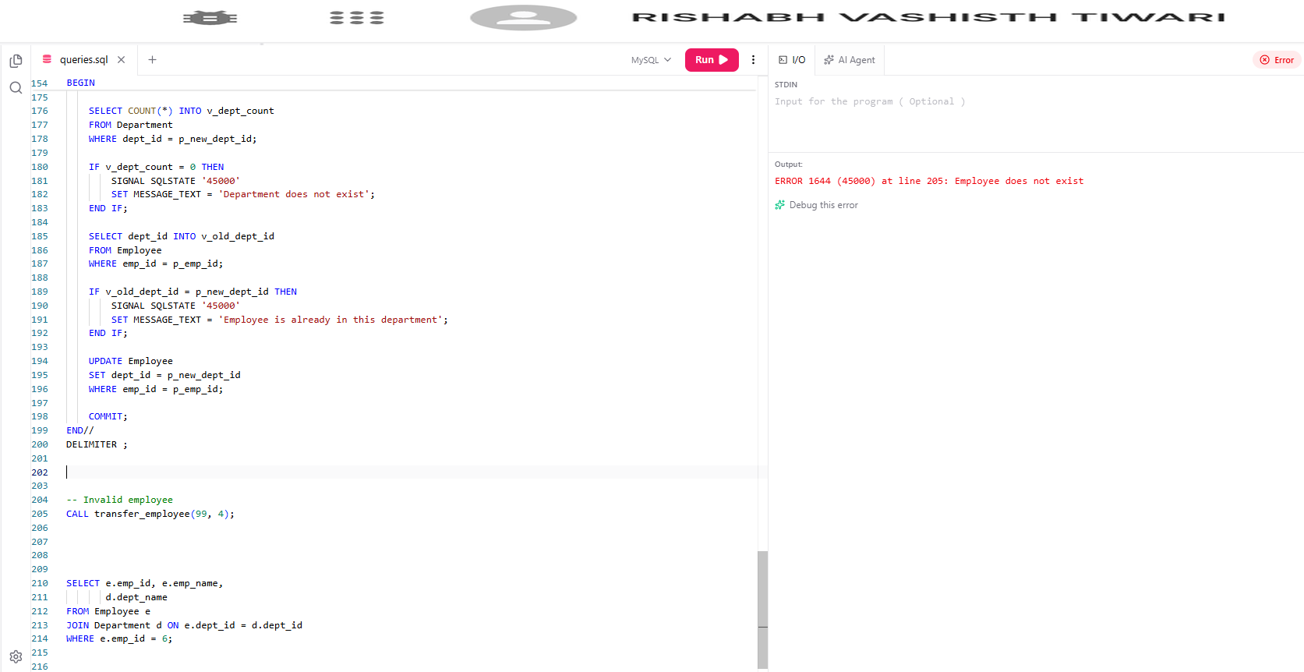
8. TEST SALARY VALIDATION
Attempt to insert or update a salary outside the allowed range.
UPDATE Employee
SET salary = 20000
WHERE emp_id = 6;

UPDATE Employee
SET salary = 85000
WHERE emp_id = 6;

Output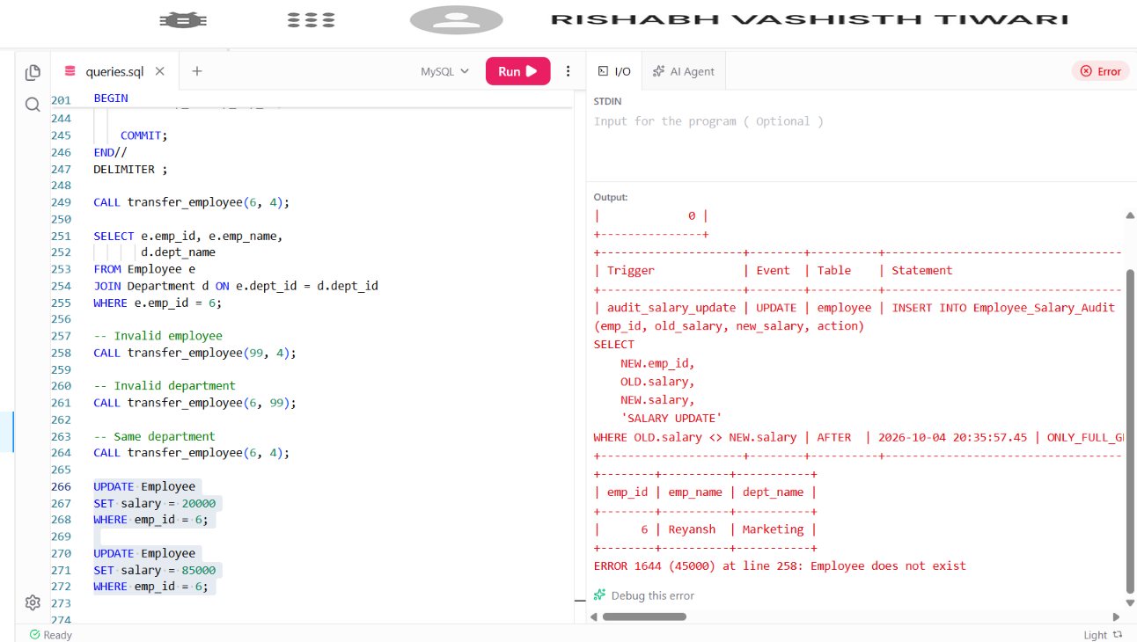
9. TEST SALARY AUDIT LOG
Display the audit entries created by successful salary changes.
SELECT audit_id, emp_id, old_salary, new_salary,
changed_at, action
FROM Employee_Salary_Audit
ORDER BY audit_id;
Output
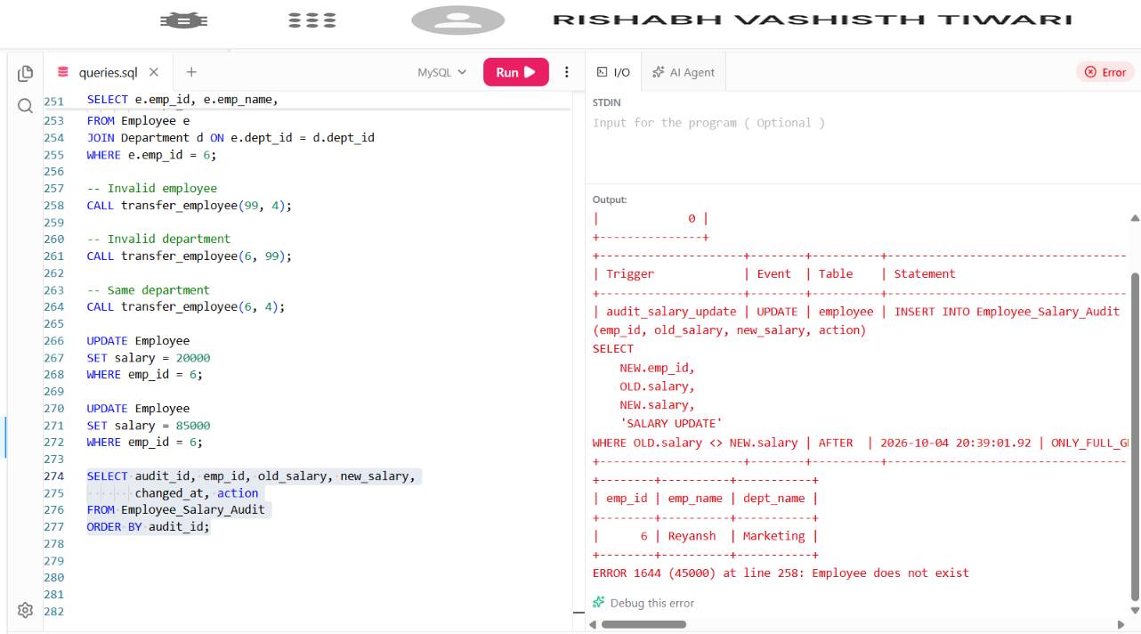

RESULT
The transfer_employee procedure was created with validation, transaction control and error handling. Salary validation and audit triggers were implemented and edge cases were tested.

CONCLUSION
Stored procedures centralize controlled database operations, while triggers automatically enforce validation rules and maintain an audit trail for important changes.

