
e-Yantra Robotics Competition
e-YRC#1044-WS
Team leader name | Rishabh Sanjiv Sheth
College | Dharmsinh Desai University
Email | rishabhsheth.0@gmail.com
Theme assigned | Waste Segregating
Date | 17-Dec-2014

Scope (5)
Waste is unnecessary byproduct of various human activities. Because of unawareness of people, waste segregation, storage, recycling and disposal are big questions and it seems difficult also for government to resolve it. With the help of waste segregation robot we can smartly solve this problem without depending on others.
Applications :
- For colony : Instead of waste scavengers we can allot one area to robot which serves as door-to-door collector and also segregate it.
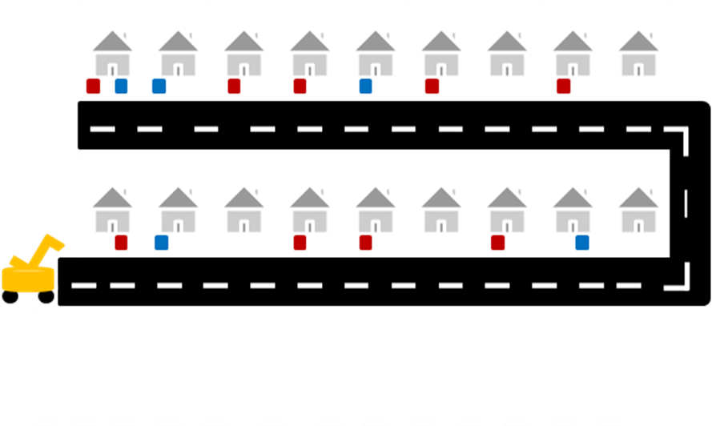
Robot for waste collection and segregation .

Way to waste recycling plant

Indicate non-bio degradable waste

Indicate bio degradable waste

FIG.1 Door to Door waste collection and segregation robot

- For Industry: waste segregating robot is faster & cheaper solution .

- In Future-city: With help of GPS we can find waste in particular area and send robot connected with it to that place for collection.

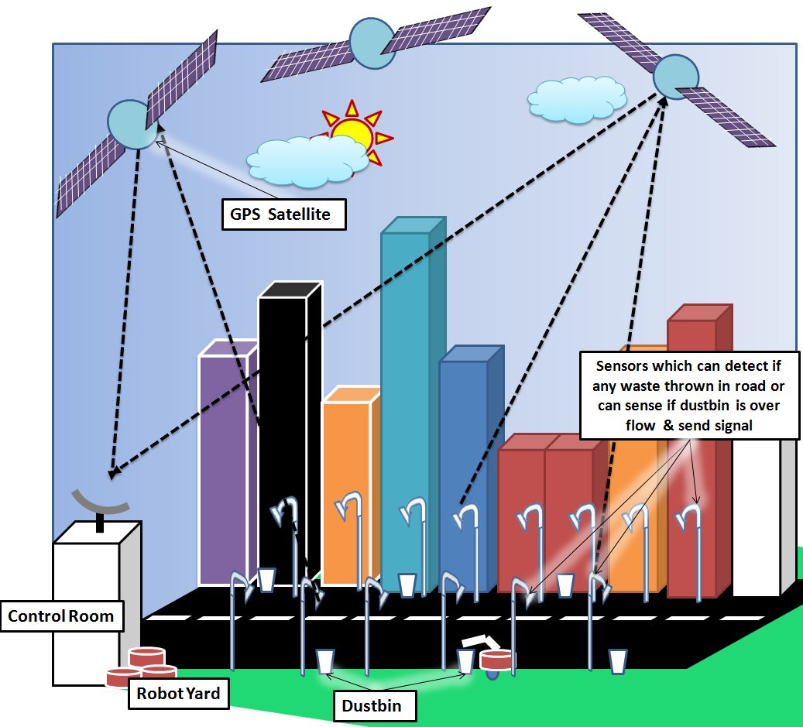

FIG.2 In Future city : GPS , Sensor & Waste segregating robot connected together

Building Modules (5)

Electronic systems:
- Sensors: In our robotic system there are four sensor which are as below :
- Sharp IR Range Sensor : In theme assigned to us we have to differentiate two different height of blocks which can be done with help of Sharp IR Range Sensor by putting it to different height .
- IR Proximity Sensors : This sensor works on intensity of reflected light by white and black surface. So with the help of it we can differentiate between type of blocks having different color.

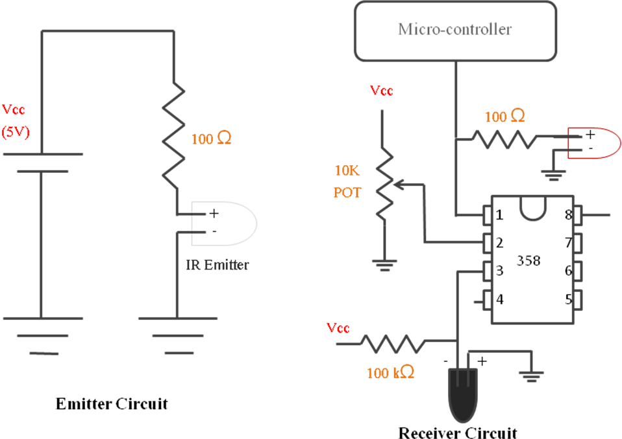
FIG.3 Basic working of IR Proximity & White line Sensor circuit

- White Line Sensors : This sensor is used for movement/navigation in arena.
- Position Encoder : We can use this sensor if we need precise movement or position's where white or black lines are not available.
- Microcontroller : It is use to control the robot according to sensors and give appropriate command to perform specific task there are two microcontroller in our robot.
- Atmega2560 ( Master microcontroller )
- Atmega8 ( Slave microcontroller )
- LCD : It is used for monitoring robot behavior while it is working.
- Communication Ports :
- USB : It is main port for communication between Robot and Computer.
- Buzzer : To give indication at the completion of a specific task.
Electrical system:
- Actuators:
- DC motor : It is mainly used for locomotion of robot in arena.
- Servo motor : In our application it is used for making robotic arm for picking & placing mechanism.
- Battery : It is used to supply power to system.

Mechanical systems:
- Wheels : In the given robot two type of wheels are there
- Normal wheel: This type of two wheels are present at the back side of robot , only with help of these two wheels we can move our robot in any direction
- Caster wheel: It has very simple mechanism , so gives us facility to move the robot in all the directions and we have to think only of controlling the two backside DC motors. It reduce complexity and power consumption of robot .

Actuators (10)
List all the actuators present on Fire Bird V robot.

- Actuators that are already present on Fire Bird V robot :
There are two 60 RPM DC geared motor already present on Fire Bird V robot at the back side and it also has provision for connecting other two DC motors on it

- Actuators that we need to have to interface with the robot :
In our theme we need three extra servo motors for making robotic arm. According to our observation and calculation we need two grippers to pick two block in single run so we need two servo motors here and other one is used for movement of arm.

Explain the mechanism for controlling the actuators on your robot.

1. Two 60 RPM DC motor for traversing in arena:

At its maximum value (Logic High) microcontroller gives 5V as output which is not able to drive the motor at its maximum rating as given DC motor has rating of 6V. This problem can be easily solved with the help of L293D Motor driver IC which is operated on Logic of microcontroller Atmega2560 and will provide voltage which we are giving to its PIN No. 6 ( Vcc2 ).

Example : To understand working of L293D IC with microcontroller assume that White line sensor detect condition for moving forward. For that we have to drive both motor in forward direction .
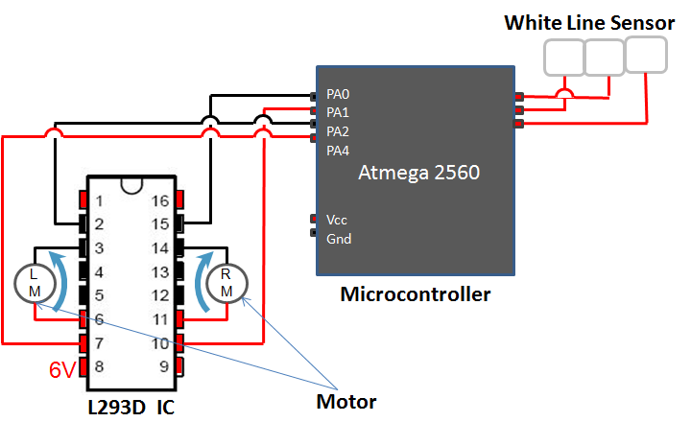

FIG.4 Working : Straight Line follower

So as shown in fig Microcontroller Atmega 2560 will give output PA0 = 0 , PA1 = 1 , PA2 = 0 , PA3 = 1 . For this condition L293D IC will give supply in such a way that both motors will move forward .

2. Two micro servomotor for gripper mechanism : We are planning to connect two gripper at a time so we can pick two blocks in single run. Our gripper mechanism is as follow
At the backside of this gripper there is
one micro servomotor of 9gm

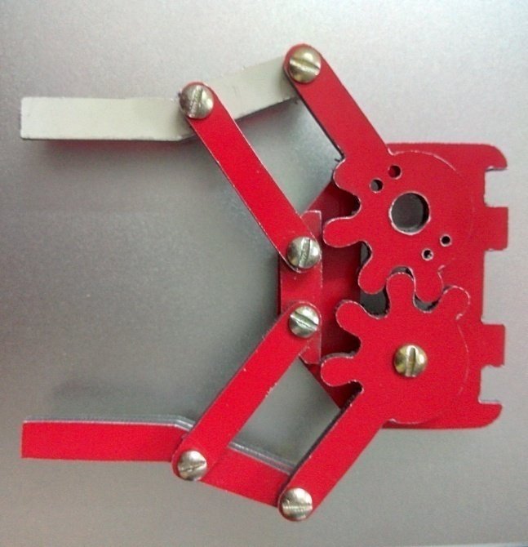
FIG.5 Actual image of gripper, working on Micro servomotor (made by us in college workshop ) weoshop

3. One servomotor for movement of arm : With the help of one powerful servomotor we can move up and down the two arms using gear mechanism .

The angle of each of the two servos will be controlled by the microcontroller with PWM by Timer1. The servo angle is set by varying the length of the on-pulse and that is why PWM is used. Servo motor on the micro controller board is powered by 5V supply.

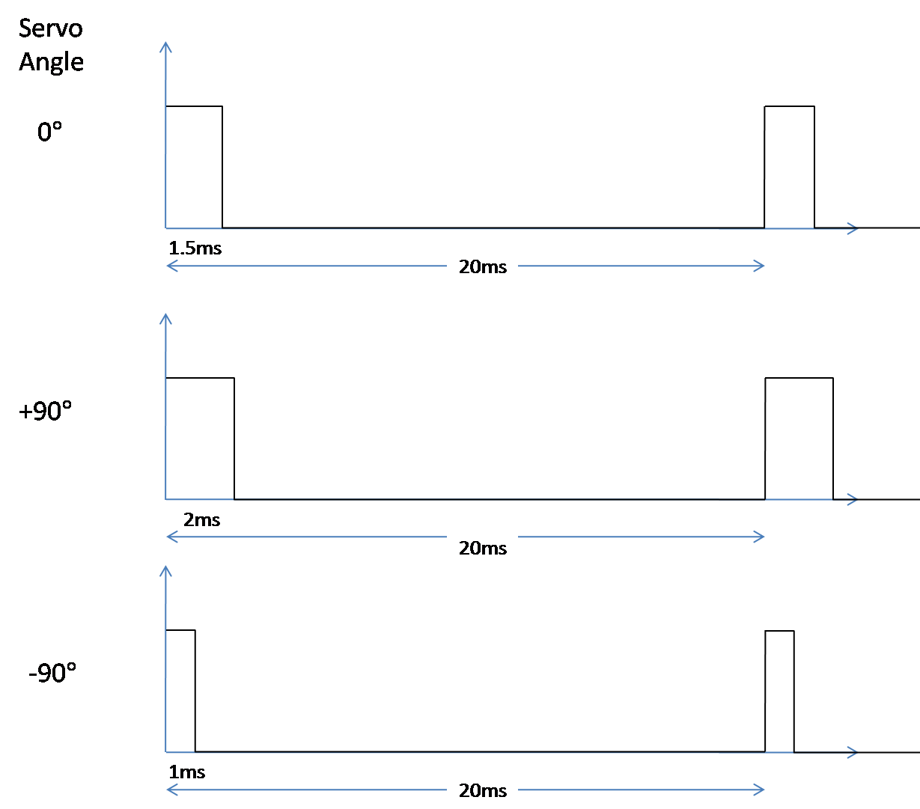

FIG.6 Servo angle control with PWM

To instruct the servo to maintain a specific angle, a continuous pulse of time period 20ms has to be sent with the on time varying between 1ms and 2ms for a rotation of -90° to +90°. Any angle can be obtained by varying the on time in linear proportion to the required angle.

Environment sensing (10)

- White Line sensors: Three white line sensors will be used for navigation on the black line on the white background as well as for navigation on the white line on the black background. Using these sensors, we can slow down left/right side motors if we see that robot is moving towards right/left side. This observation is made using sensor values.

- Sharp IR Range Sensor : As per the theme waste segregation of four blocks A,B,C,D can be done because of its two properties i.e. Its Height & Color. From this two properties Height can be differentiate with help of Sharp IR Range Sensor as shown in FIG.7. For more detail you can refer FIG.11, FIG.12 & FIG.13 .

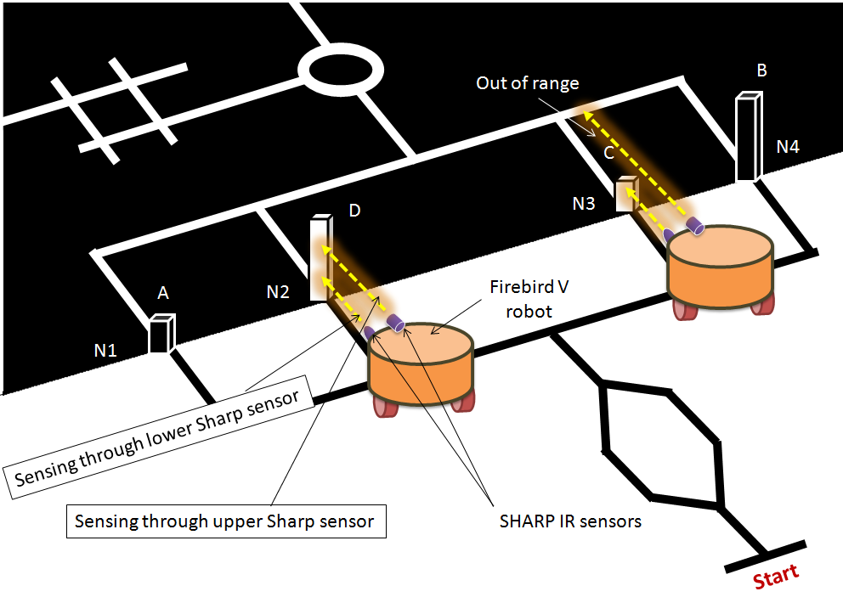
FIG.7 Sensing of waste in given environment

- IR Proximately Sensors : The other property of given waste to differentiate is its color, BLACK or WHITE. There are eight such kind of IR Proximity sensors available on Fire Bride V . But we need only one of them which is No.3 IR Proximity sensor. For more detail you can refer FIG.11, FIG.12 & FIG.13 .
- Position Encoder : They are connected to ATmega2560 controller through PE4 and PE5 pins. They generate external interrupts to controller so that left and right wheel counts are incremented in Interrupt Service Routine. This sensor can measure how much distance robot traverse or how much angle it rotates . We can use this sensor if we need precision movement or at places where white or black lines are not there.
i.e. In our task there are some points were line follower may not work , like in below fig when we want to cross Node 1 (N1) then it is not a white or black line so we can give robot precise movement of 4cm to cross node.
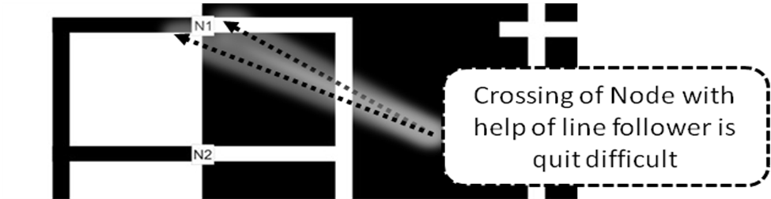
FIG.8 Use of position Encoder in given task

Power Management (5)

Following power requirement/distribution in systems

- 5V MCU supply: Maximum of 400mA current is provided for microcontroller, ICs, sharp IR sensor and LCD.
- Supply For Two DC motor: High current and voltage is required for DC. Typically 6-12V, 500mA-1A for single DC motor.
- 5V servo supply: This is used to operate the servo motors.
- 3.3V sensor supply: Maximum of 100mA current is used by 8 IR proximity sensors and 3 white line sensors.
- Total Battery supply: Maximum current that can be provided by battery is 2000mA.

To save power, switching of sensors and other circuits are used, so that unnecessary power is not consumed. We are planning to build robot which can put two waste in a single run so that the power consumption also reduces. We will prefer Battery mode for our robot because it gives freedom for the movement of the robot without bothering about the distance. For this type of application auxiliary mode is impractical.

Navigation Scheme (10)
As we are planning to use two arm on our robot so in single shuttle robot can take two block To Understand Navigation we take one example according to the given sequence in rule-book: S-(1,2,5,6)-F

PART-1
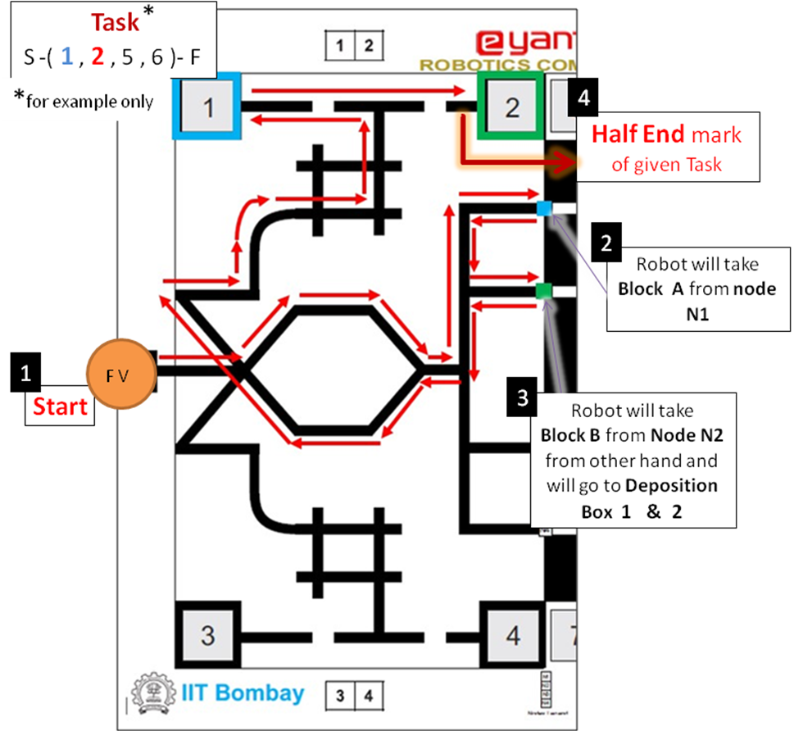
FIG.9 Part 1 of given task S-(1,2,5,6)-F .

As shown in figure Robot starts from Start Mark and goes to Node-N1 and take block-A then it will go to Node-N2 and pick block-B. Then it will go towards Deposition box 1 & 2. Refer FIG.9.

PART-2

After putting blocks A & B in deposition box 1 & 2 robot will again go to disposition site at node N3 & N4 to pick blocks C & D and place them in deposition box 5 & 6. Refer FIG.10 .

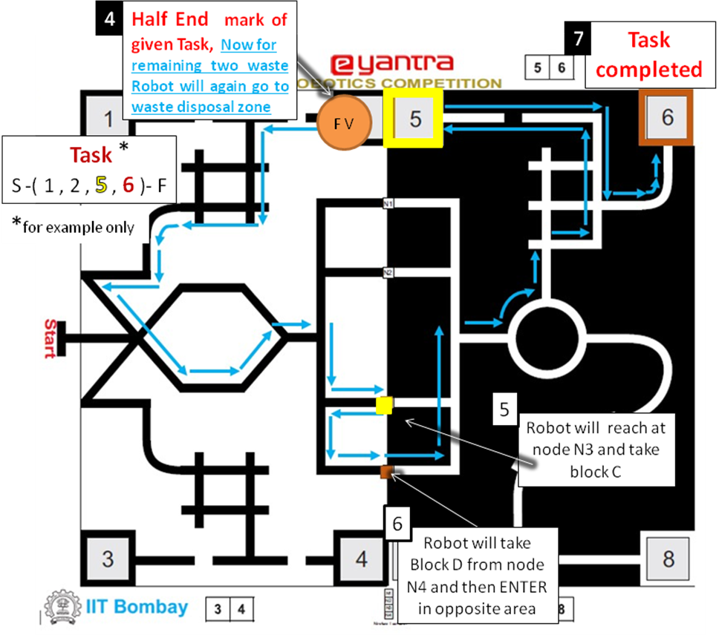

FIG.10 Part-2 of given task S-(1,2,5,6)-F

Testing your knowledge (Based on theme and rulebook) (10)
Four types of waste in this theme :
- Type 1: Glass
- Type 2: Plastic
- Type 3: Paper
- Type 4: Metal
These four types of waste are represented in theme by Two different feature i.e. height and color also given name as BLOCK A , B , C & D. From four of them , two are of same size of 6cm height and having different color white and black while the other two having height 12cm, one white and the other black in color.

Explain how will you identify the type of waste and list the components required for it.

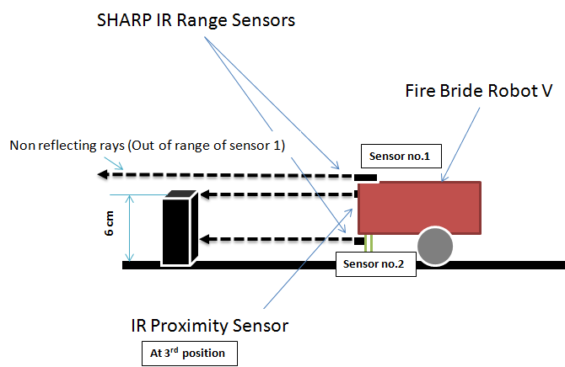
FIG.11.1 Identification of waste ( height 6cm) with different sensors

To identify the type of waste we will use two different type of sensors i.e. 1) Sharp IR Range Sensor &
2) IR Proximity Sensor. As we have four different type of waste so for height sensing we are using Sharp IR range sensor at different height and for sensing of color we will use IR Proximity Sensor. As shown in FIG.11.1 because of low height of waste, rays from Sharp range sensor which is at higher position can't reflect. For other condition you can refer FIG 11.2
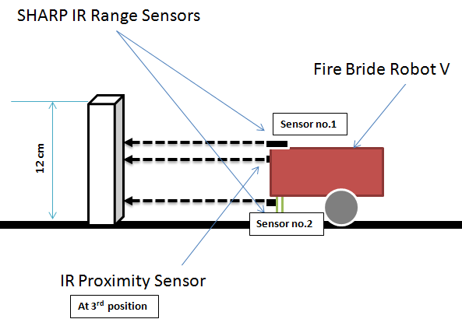
FIG.11.2 Identification of waste ( height 12cm) with different sensors

Figure drown below ( FIG.12 ) gives actual picture of height difference between various blocks and sensors in given system which will be used to differentiate waste.

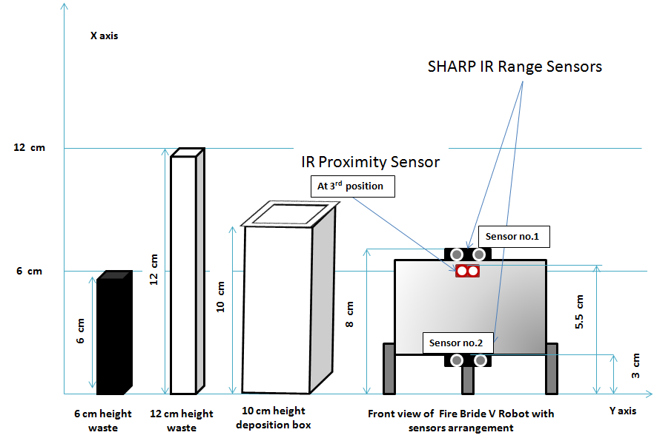
FIG.12 height difference between various blocks and sensors in given system

Challenges (5)
- Traversal of path using Line Follower: The track of our theme is a very complex track , it has many junctions and closed loop where the robot can be confused about where to go. So we will have to program it very carefully. Also there are some breaks in between the track color is same as the background color and whole arena divided into two parts in one there is white background and black lines where as in other part in black background white lines are there so it is also challenging to write program in such way that it will work well in both side or can easily change over when it will cross one part.

- Sunlight interference: The white-line sensors being sensitive to infrared rays fail to detect the lines in moderate to high sunlight. Restricting the usage of the robot to a dark confined room is not feasible as a farm needs sunlight. This means we would have to make the sensors work even in sunlight. We can achieve satisfactory immunity to moderate sunlight by making a covering of black paper around the white line sensor arrangement.

- Making of Arm : For waste segregation theme robotic arm is necessary additionally we decided to pick two blocks in single run from waste disposition zone to save time and power. In Fire Bird V robot maximum three servo motors can be mounted so it is quite difficult for us to make two arms with the help of only three servo motors. Also in arm for making gripper mechanism and to control it in such a way that it does not damage any blocks is a challenging task for us.

