

**e-Yantra Robotics Competition**

**eYRC-HD#1263**

|  |  |
| --- | --- |
| **Team leader name** | **Neil Vijay Shah** |
| **College** | **Dharmsinh Desai University** |
| **e-mail** | **neilshah40@hotmail.com** |
| **Theme assigned** | **Hazardous Waste Disposal** |
| **Date** | **20 - Dec – 2015** |

**Scope (5)**

**State the scope of the theme assigned to you.**

In our theme “Hazardous Waste Disposal” we have to transfer different type of hazardous wastes indicated by colored blocks from city area (CA) to isolated area (IA) separated by river.

Among the many justifications for using robotics, the most important is to shield people from working in dangerous environments and from handling hazardous materials. From dealing with chemicals that are explosive to handling radioactive substances, robots are routinely used to perform tasks that would kill or maim people.

This theme can be applied for Hazardous wastes coming from different sources and environments classified as follows:

* Industrial waste: As the number of chemicals used in industry continues to increase along with the potential health and environmental risks associated with them, the demand for robots to handle these chemicals will increase.
* Medical waste: Contagious and infectious medical waste can be safely deposited in isolated areas.
* Radio-active wastes: Wastes from nuclear plants and other sources have high radiation content which can cause severe and fatal diseases.
* Explosive chemicals: These can be dangerous if not handled carefully.

Robots are ideal for use in hazardous environments by removing people from direct exposure to unfriendly conditions such as materials that are radioactive or highly explosive.

**Building Modules (5) Identify the major components required for designing the robotic system for the solution of the theme assigned to you.**

**Electronic systems:**

1. **Sensors:** In our robotic system there are four sensor which are as below :

* **Color Sensors:** In theme assigned to us we have to differentiate three different colors of blocks which can be done with help of color Sensor by putting it in front of the block.
* **IR Proximity Sensors:** This sensor works on intensity of reflected light by white and black surface. So with the help of it we can differentiate between blocks having different color.

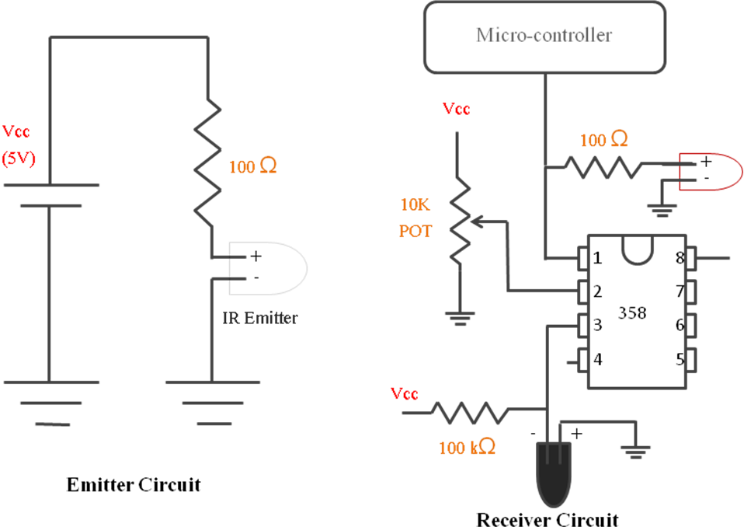

**Basic working of IR Proximity & White line Sensor circuit**

* **White Line Sensors:** This sensor is used for movement or navigation in arena.
* **Position Encoder:** We can use this sensor if we need precise movement or positioning where white or black lines are not available.
* **Sharp IR Range Sensors:** This sensor can be used to predict distance of any obstacle.

1. **Microcontroller :** It is use to control the robot according to sensors and give appropriate command to perform specific task there are two microcontroller in our robot.

* Atmega2560 ( Master microcontroller )
* Atmega8 ( Slave microcontroller )

1. **LCD:** It is used for monitoring robot behavior while it is working.
2. **Communication Ports :**

* **USB:** It is main port for communication between Robot and Computer.

1. **Buzzer:** To give indication at the completion of a specific task.

**Electrical system:**

1. **Actuators:**

* **DC motor:** It is mainly used for locomotion of robot in arena.
* **Servo motor:** In our application it is used for making robotic arm for picking & placing mechanism.

1. **Battery:**  It is used to supply power to system.

**Mechanical systems:**

1. **Wheels :** In the given robot two type of wheels are there

* **Normal wheel:** This type of two wheels are present at the back side of robot , only with help of these two wheels we can move our robot in any direction
* **Caster wheel:** It has very simple mechanism, so gives us facility to move the robot in all the directions and we have to think only of controlling the two backside DC motors. It reduces complexity and power consumption of robot.

**Actuators (10)**

**List all the actuators present on Fire Bird V robot.**

1. **Actuators that are already present on Fire Bird V robot :**

There are two 60 RPM DC geared motor already present on Fire Bird V robot at the back side and it also has provision for connecting other two DC motors on it

1. **Actuators that we need to have to interface with the robot :**

In our theme we need two extra servo motors for making robotic arm. According to our prediction we need a gripper to pick waste & weight blocks. We need another servo motor for movement of the arm.

**Explain the mechanism for controlling the actuators on your robot.**

**Ans.**

**1. Two 60 RPM DC motor for traversing in arena**:

**At its maximum value (Logic High) microcontroller gives 5V** as output which is **not able to drive the motor** at its maximum rating as given DC motor has rating of 6V. This problem can be easily solved with the help of L293D Motor driver IC which is operated on Logic of microcontroller Atmega2560 and will provide voltage which we are giving to its PIN No. 6 ( Vcc2 ).

**Example:** To understand working of L293D IC with microcontroller assume that White line sensor detect condition for moving forward. For that we have to drive both motor in forward direction.

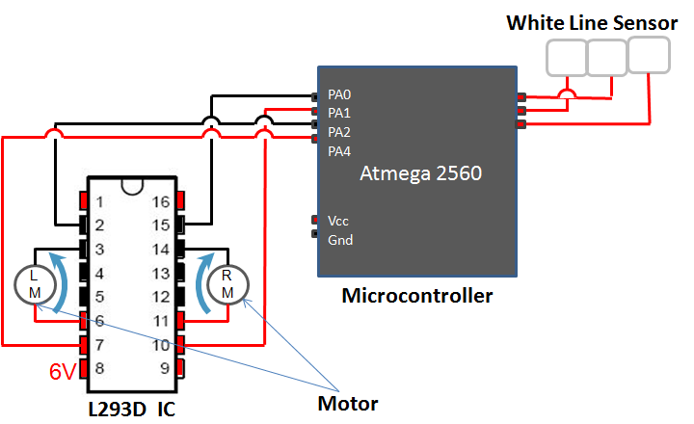

**Working: Straight Line follower**

So as shown in fig Microcontroller Atmega 2560 will give output **PA0 = 0, PA1 = 1, PA2 = 0, PA3 = 1**. For this condition L293D IC will give supply in such a way that both motors will move forward.

**2. One Servomotor for gripper mechanism:**

**3. One servomotor for movement of arm:** With the help of one powerful servomotor we can move the arm up and down using gear mechanism.

The angle of each of the two servos will be controlled by the microcontroller with PWM by Timer1. The servo angle is set by varying the length of the on-pulse and that is why PWM is used. Servo motor on the micro controller board is powered by 5V supply.

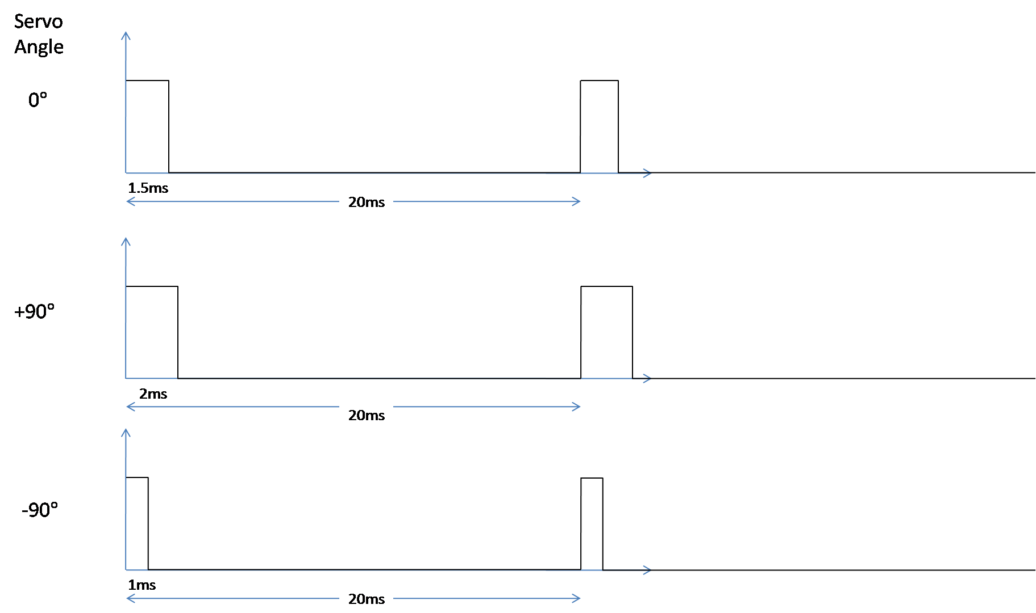

**Servo angle control with PWM**

To instruct the servo to maintain a specific angle, a continuous pulse of time period 20ms has to be sent with the on time varying between 1ms and 2ms for a rotation of -90° to +90°. Any angle can be obtained by varying the on time in linear proportion to the required angle.

**Environment sensing (5)**

**Explain the functioning of environment sensing technique used by Firebird V robot in your theme.**

There are various sensors in Fire Bird V robot described as follows

1. **White Line sensors:** Three white line sensors will be used for navigation on the black line on the white background. Using these sensors, we can slow down left/right side motors if we see that robot is moving towards right/left side. This observation is made using sensor values.
2. **Sharp IR Range Sensor:** As per our theme “Hazardous Waste Disposal” we can use these sensors to predict the distance of the waste and weight blocks from the robot so that we can place the robot according to the arm mechanism so that the arm can pick the blocks properly.
3. **IR Proximity Sensors:** The otherproperty of given waste to differentiate is its color. There are eight such kind of IR Proximity sensors available on Fire Bride V. also we can use these sensors to detect obstacles in lower proximity
4. **Position Encoder:** They are connected to ATmega2560 controller through PE4 and PE5 pins. They generate external interrupts to controller so that left and right wheel counts are incremented in Interrupt Service Routine. This sensor can measure how much distance robot has traversed or how much angle it rotates. We can use this sensor if we need precision movement or at places where black lines are not there.

In our task there are some points were line follower may not work so we can give robot precise movement to the robot using position encoders.

**Power Management (5)**

**Explain the power management system required for a robot in general and for Firebird V robot in particular.**

**Following power requirement/distribution in systems**

1. **5V MCU supply:** Maximum of 400mA current is provided for microcontroller, ICs, sharp IR sensor and LCD.
2. **Supply for Two DC motor:** High current and voltage is required for DC. Typically 6-12V, 500mA-1A for single DC motor.
3. **5V servo supply:** This is used to operate the servo motors.
4. **3.3V sensor supply:** Maximum of 100mA current is used by 8 IR proximity sensors and 3 white line sensors.
5. **Total Battery supply:** Maximum current that can be provided by battery is 2000mA.

To save power, switching of sensors and other circuits are used, so that unnecessary power is not consumed. We will prefer Battery mode for our robot because it gives freedom for the movement of the robot without bothering about the distance.

**Navigation Scheme (10)**

**Explain in brief the basic navigation technique for path traversal in the arena. Explain the concept and list the components required for basic navigation.**

For path traversal in the arena the basic navigation technique is using the three white line sensors attached on Fire Bird V for following the black lines on the arena. Also different sensors such as IR Proximity Sensors, Sharp IR Range Sensors and color sensors are used to decide where to go.

Suppose we want to transfer a waste block from city area to isolated area and the bridge is tilted towards the isolated area. This can be done as shown in figures below.

1. **Tilting the Bridge:** First figure shows how the robot tilts the bridge towards city area by using weight block from W2 and comes back to start position.
2. **Pick and place the waste block:** Second figure shows how the robot picks up the waste block from IP and traverses to Isolated Area through the bridge where it can place the waste block at any of the three designated places.

From here it can again use the weight block to tilt the bridge towards Isolated Area and traverse back to city area to get another waste block. Note that it can also use Sorting Zones indicated by black boxes to separate different blocks from the stack at IP.

**Testing your knowledge (related to rule-book and sensors) (20)**

**List the steps involved to travel from City Area (CA) to Isolated Area (IA) and vice versa**

**Steps to travel from City Area (CA) to Isolated Area (IA)**

1. From given condition or initial position robot has to decide whether bridge is tilted towards city area or not.
2. If robot needs to put weight to tilt the bridge than first it has to decide how many block it requires for tilting the bridge.( **i.e.** For first time only '**one'** 100gm block is enough to tilt the bridge but for second time it requires more than one weight blocks. )
3. After deciding the number of blocks required robot has to pick & drop weights to tilt the bridge.
4. Now to pick waste it needs to go to IP & identify required waste.
5. If waste needs to be hold then put waste in sorting zone
6. Now to travel from city area to isolated area robot has to cross the bridge.

* Steps to travel from Isolated Area (IA) to City Area (IA) are same as above i.e. decide number of block required and pick and drop them in container to tilt bridge towards Isolated area so that robot can travel to city area for picking next waste block.

**How many weight blocks are present in the arena? How many in City Area and in Isolated Area?**

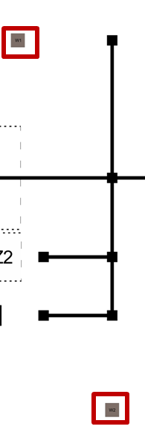 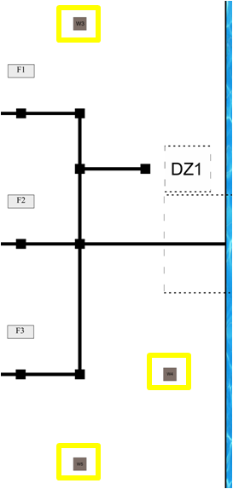

3

2

1

2

1

CA

IA

There are two weight blocks present in City Area (CA) which you can see in above figure which are highlighted by red boxes.

Three weight blocks are present in Isolated Area which are named as W3, W4, W5 in arena. In above figure these blocks are highlighted by yellow boxes.

**What is the principle of operation of the color sensor? Explain how you differentiate the different colored blocks using color sensors.**

The color sensor provided to us in the kit is a RGB photo diode based color sensor. It can be used to identify Red, Blue, Green and Black colors. The basic principle of this sensor is using a square wave form of different frequencies. And the frequency of this square wave form varies in accordance with the color to which the sensor is exposed.

Pins 1 & 2 of the color sensor are used for output frequency scaling. As the frequency of the wave form generated by the color sensor is very high, we need to scale it down and this can be done by providing different logics (low and high) to pins 1 & 2 according to the amount of scaling required.

Pins 7 & 8 are used for selecting the photo diode. Here also we can provide different logics to select appropriate diode.

Now to differentiate the colored blocks using the color sensor, first the sensor is placed at a distance of 2 to 4 cm in front of the colored block then the numbers of pulses received for different photo diodes selected are stored and these values are compared. If all the three values are below the calculated threshold value then the color of the block is black and if not then the values are compared and the photo diode with the highest number of pulses is the color of the block placed in front of the color sensor.

**Challenges (5)**

**What are the major challenges that you anticipate in addressing this theme?**

**Ans. The major challenges which we may anticipate in our theme are as follows:**

1. **Travel between CA & IA:** To deposit waste in isolated area (IA) first we have check that whether bridge is already tilted towards city area (CA) or not. If it tilted towards IA and say in previous run ( i.e. when we robot try to deposit second or third waste block ) if there are 'n' 100gm weight blocks already at IA then we have to add other 2 weight blocks so that bridge can tilt towards city area. So it is quit complex thing for programming and major challenge for us.
2. **Sunlight interference**: The white-line sensors being sensitive to infrared rays fail to detect the lines in moderate to high sunlight. Restricting the usage of the robot to a dark confined room is not feasible as a practical field may be open. This means we would have to make the sensors work even in sunlight. We can achieve satisfactory immunity to moderate sunlight by making a covering of black paper around the white line sensor arrangement.
3. **Making of Arm:** For hazardous waste disposal theme robotic arm is necessary additionally we to pick 100gm weight blocks to tilt the bridge in either side so arm must be capable of lifting heavy block and different size of blocks. In Fire Bird V robot there are some restriction for maximum servo motors can be mounted and also there is current limitation so it is quite difficult for us to make arm having good strength. Also in arm for making gripper mechanism and to control it in such a way that it does not damage any blocks is a challenging task for us.