

**e-Yantra Robotics Competition - 2015**

**Implementation Analysis – Hazardous Waste Disposal**

**<Team ID>**

|  |  |
| --- | --- |
| **Team leader name** |  |
| **College** |  |
| **Email** |  |
| **Date** |  |

<This report contains three sections:

1. Preparing the Arena

2. Design Analysis

3. Algorithm Analysis

Teams have to answer question/s from these sections according to their understanding of the theme and the given Firebird V robot. >

**Preparing the Arena (5)**

<

Prepare the arena according to the steps given in Section 3: Arena, of the rulebook. Take a photo of the completed arena such that the entire arena is clearly visible in the photo. Insert the image here

>

**Design Analysis**

**Q-1. How will you detect the Low CCL and High CCL Hazardous Wastes? (10)**

<

List the sensor(s) you would use to detect the Hazardous Wastes. Give a brief description of the working of the sensors

>

**Q-2. Draw a labeled diagram to explain how you have planned to place the sensors on/around the robot? (10)**

<

Draw a neat diagram to show the positions of sensors on and around the robot. Show all the sensors you are using in designing the theme. Justify placement of the sensors shown in your diagram

>

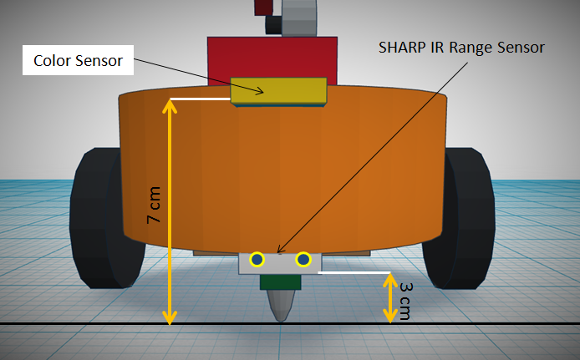

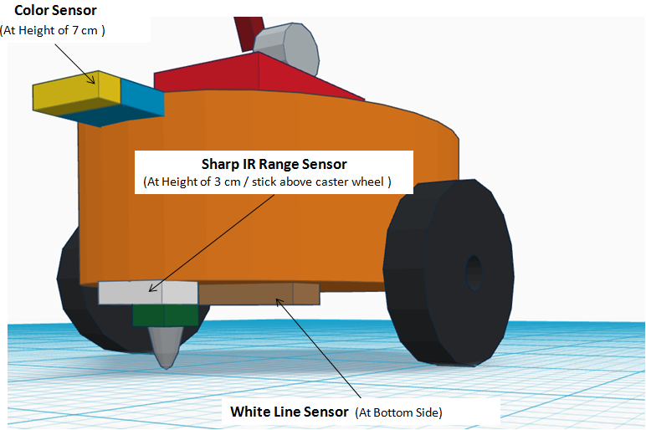

**Q-3. Teams have to make the robotic arm for picking up/placing the Hazardous Wastes in the arena.**

1. **Choose an option you would like to use to position the robotic arm on the robot and why? (5)**

1. **Front 2. Back 3. Right/Left 4. On both sides**

**Answer: ____________________**

<

Justify your choice for placement of the robotic arm.

Word-limit: 300 words

>

1. **Draw a diagram to show the robotic arm and how it is mounted on the robot. Also show the mounting of the color sensor. (10)**

<

Draw figure(s) to show how you are planning to mount the robotic arm and the color sensor on the robot>

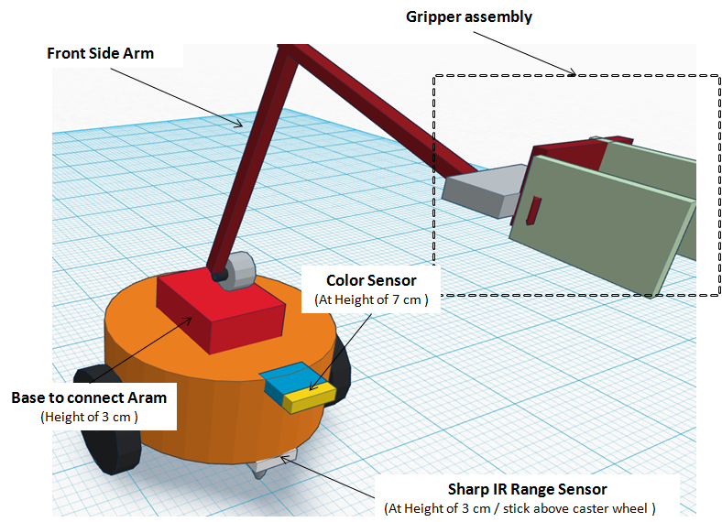

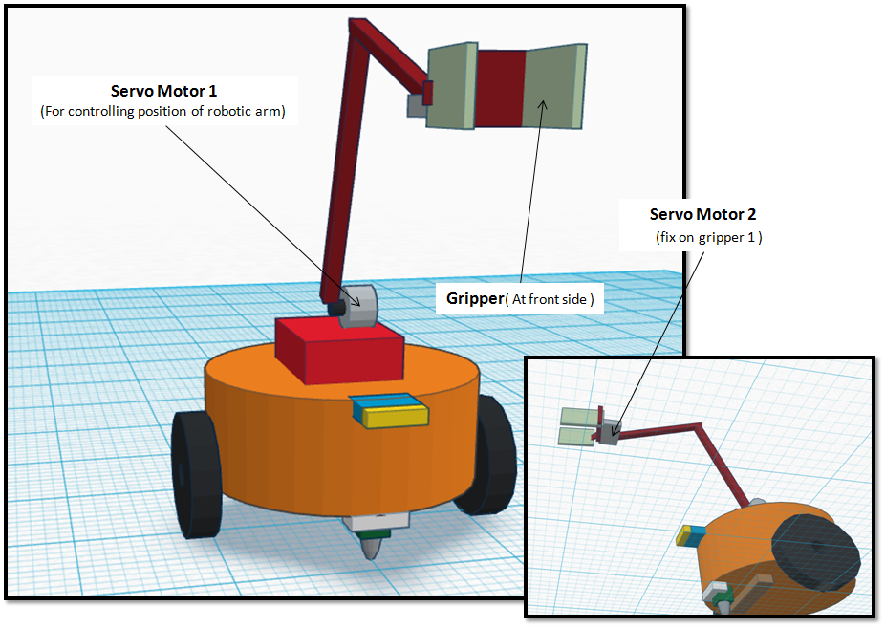

**Q-4. Choose the actuator you will use to design the robotic arm. (5)**

1. **DC-Motor 2. Servo Motor 3. Stepper Motor 4. Others**

**Answer: _________________**

**Justify your answer by stating the advantage of the chosen actuator over others. Also give reasons for not using other actuators.**

**Q-5. How will you identify Red, Blue and Green colors from the values you get from the color sensor? Explain your algorithm to identify the three colors (Red, Blue and Green). (10)**

<

Answer format: Bulleted form

Step 1:

Step 2:

Step 3…etc.

>

**Q-6. (15)**

**a. How will you determine the Orientation of the Bridge?**

<

List the sensors and explain the mechanism used to determine the orientation of the Bridge. Write the answer in your own words

>

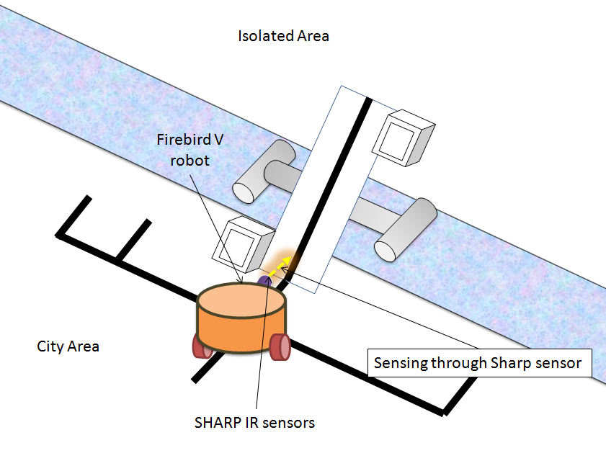

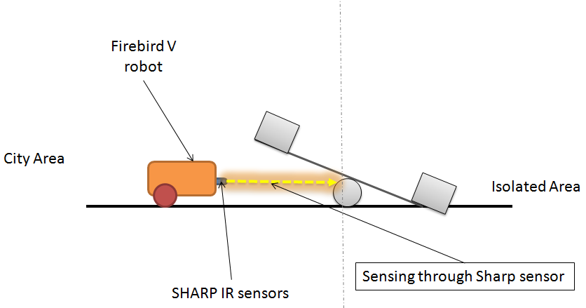

**b. How many times will the orientation of the Bridge change to complete the entire task, as per your solution? Explain in steps, how many Weight Blocks are added to Containers at DZ1 and DZ2 each time the robot changes the Orientation of the Bridge, considering the following cases:**

**Case 1. If the bridge is initially “tilted toward CA”**

**Case 2. If the bridge is initially “tilted toward IA”**

<

Answer format:

Case 1:

Write the number of times the orientation of the Bridge needs to be changed.

Step 1: At DZ2/1 –number of Weight Blocks added

Step 2: At DZ1/2–number of Weight Blocks added

Step 3…etc.

Similarly write the steps for Case 2.

>

**c. The maximum number of Weight Blocks required if the bridge is initially:**

**1. “tilted toward CA”= _____________**

**2. “tilted toward IA”=**  _____________

<

Based on the logic, determine the maximum number of Weight Blocks required to complete the entire task.

>

**Algorithm Analysis**

**Q-1 Draw a flowchart illustrating the major that are used. (10)**

<

The flowchart should elaborate on every possible function that you will be using for completing the assigned theme. Example: lineFollowing(), colorDetection() etc.

Follow the standard pictorial representation used to draw the flowchart.

>

**Q-2 Draw a flowchart illustrating main function of your code. (20)**

<

The flowchart should explain how you will be using the functions defined in the main program for completing the theme assigned to you.

Follow the standard pictorial representation used to draw the flowchart.

>